Digital Culture Network Resources: How to stream a Zoom meeting to YouTube

Introduction

This guide describes the steps to be taken in order to stream a Zoom meeting via YouTube for webinars. It outlines how you can use the powerful functionality of Zoom alongside the unrestricted options and benefits of YouTube.

Platforms Overview

Zoom is good for video encoding and presenting functionality. There is other software available for this, such as Open Broadcaster Software (OBS) but it isn’t as intuitive to use. However, areas to consider around Zoom are:

- Some users have had difficulty downloading and using Zoom to watch webinars and are wary of privacy concerns
- Zoom Pro accounts have a limit of 100 attendees
- There is an additional cost for the Webinar add on for view-only attendees

The benefits of streaming a Zoom meeting via YouTube for attendees to watch it include:

- No need to see the attendees
- It has a built-in chat facility for 2-way live communication
- There is no cap on the view-only attendees
- Users most likely have the app installed already or are familiar with the web interface
- The recording is automatically saved for you to edit and publish afterwards

Note: A YouTube account needs 24 hours to activate live streaming for the very first time you use it. Do a test run in advance of your actual webinar.

Enabling Live Streaming in Zoom

In the Zoom account settings scroll down to In Meeting (Advanced) section to Allow live streaming meetings. Toggle the button on the right to turn this service on.

There are four options given in this section. The first three are if you want to be able to stream any meeting live on the platforms at any time on an ad-hoc basis. For the purposes of this setup you need to tick the last option, Custom Live Streaming Service as this is for a scheduled live streamed webinar.

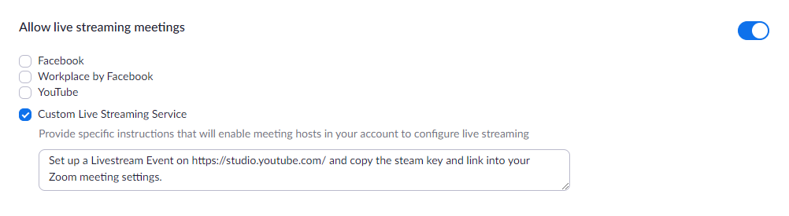

Set up a scheduled livestream in YouTube

Go to YouTube, click the camera+ icon in the top right and click Go live from the dropdown options.
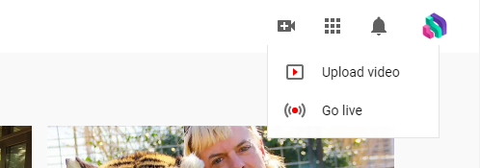

Note: If you do not already have a YouTube channel you will be asked to create one. This will need verifying via phone/text message.

Here you will be asked to enter the details of your new stream.

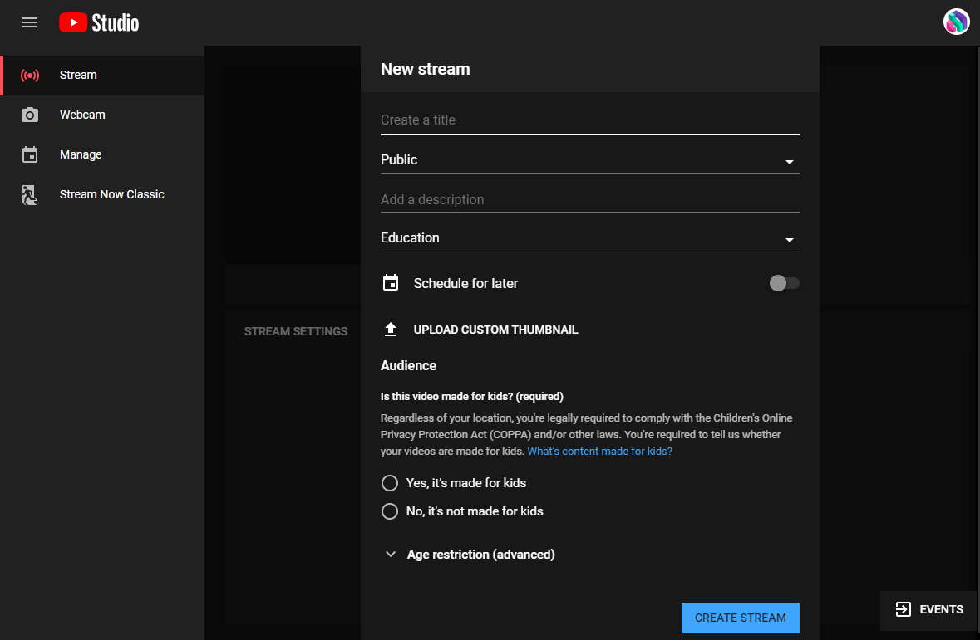

- Title – The name of the webinar
- Visibility
  - Public – It is searchable by anyone on YouTube and appears on your channel
  - Unlisted – Only people with the direct link will find it. (This is the option we have used for our webinars as we want people to register in advance. We then switch it to Public once the event has passed and it has been transcribed).
  - Private – Only you can view it
- Category – Choose what type of content it is e.g. Educational
- Description – What is the webinar about? This appears under the video.
- Schedule for later – Toggle this to yes and set the date and time of your webinar
- Upload a custom thumbnail – If you have created a holding slide or have a suitable image it can be added. The size needs to be 1280 × 720 pixels.
- Audience – Select if the webinar is specifically made for children or not

Click Create Stream.

This will load the control room where you can set the webinar to Go Live and moderate the live chat. For now, we need the stream key (the unique ID for your feed – do not share this with anyone) and the stream URL (e.g. rtmp://a.rtmp.youtube.com/live2).

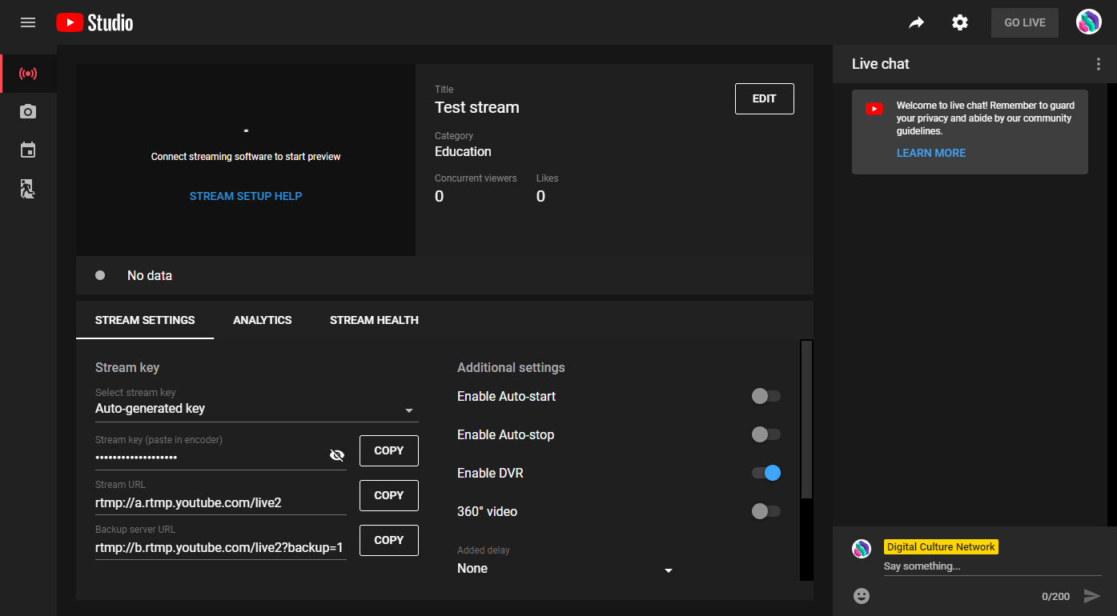

You will also need the sharable link for the YouTube livestream. Click the arrow icon in the top right and copy the URL.

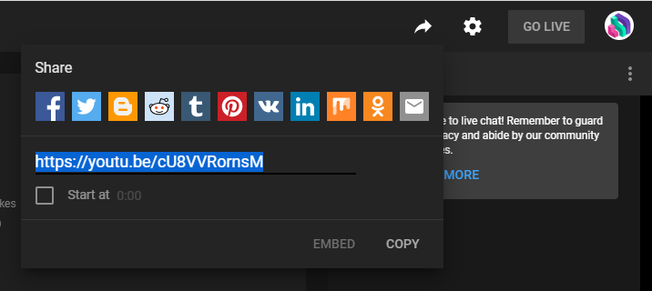

Setting up a scheduled webinar in Zoom

Over on Zoom, schedule a meeting for the date and time required. From the Upcoming Meetings page, click into your new meeting.

Scroll down to the bottom and click the Live Streaming tab. Underneath the LIVE icon, click the link to configure the stream settings.

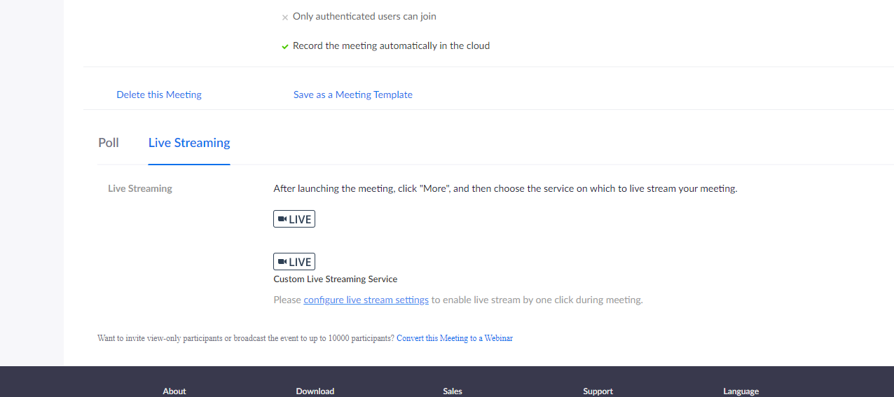

The popup window will ask you to paste in the settings we copied from YouTube.

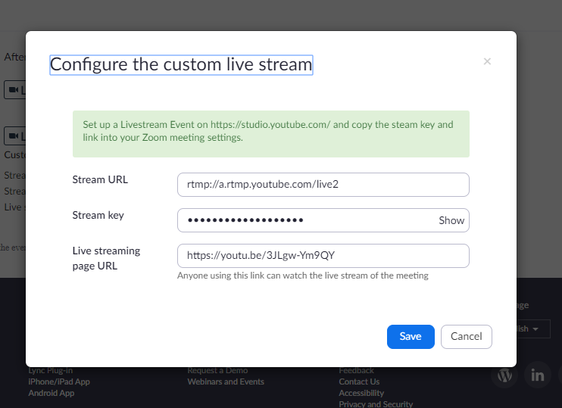

Note: If you have browser autofill settings on for login, it may paste in your email and password. Clear these before pasting in the settings from YouTube.

Going live

When your webinar date and time comes around, get Zoom up and running 15 minutes before you are due to go live on YouTube. Click Start This Meeting on Zoom. At this point, only you can see the video feed so you can test out sharing your screen and if your microphone is working correctly.

When you are happy with everything, click on the three dots/More button in the Zoom options bar and click Live on Custom Live Streaming Service. This will start sending the stream to the YouTube control room. The audience cannot see you yet!

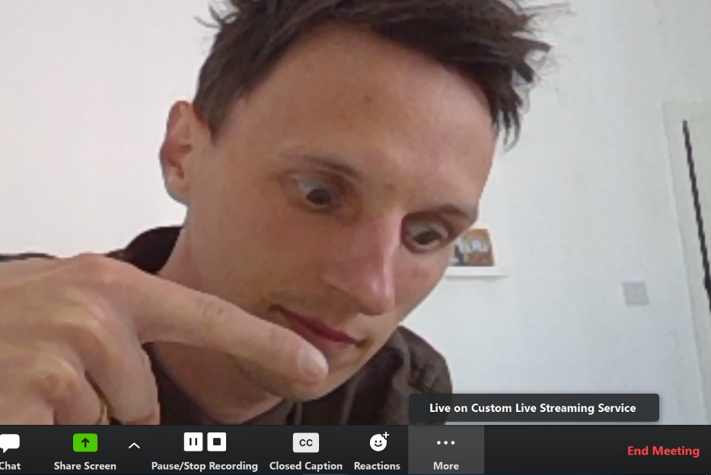

The Zoom video feed will then appear in the YouTube control room.

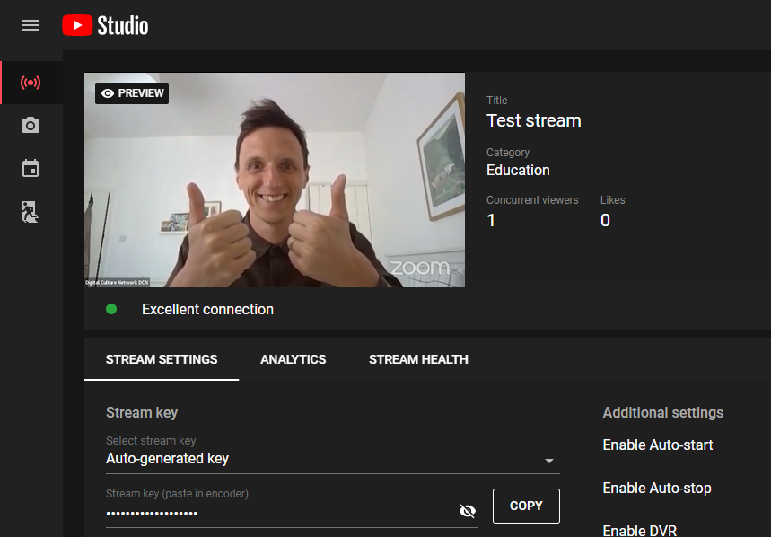

Ideally you would have a second person looking after the YouTube control room. It is operated via the website so no need to use the same device or be in the same location.

Note: There is a lag of about 18 seconds from what you are doing on Zoom and what appears in YouTube.

Meanwhile, this is what users see when they are waiting on YouTube:

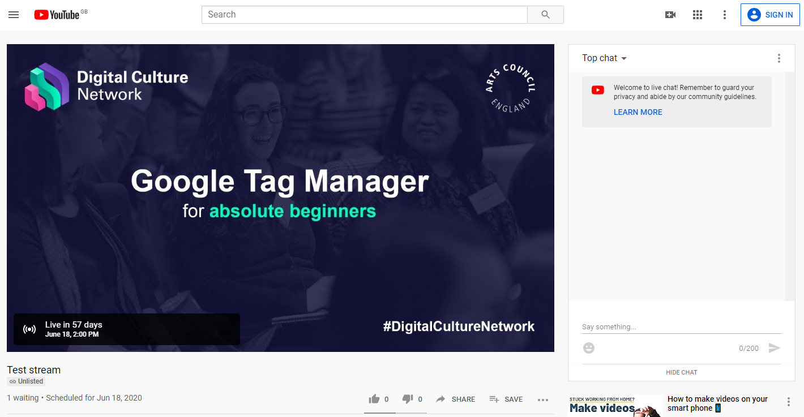

Note: This is why a good thumbnail image is important!

When you’re ready, get your assistant to press GO LIVE in the YouTube control room.

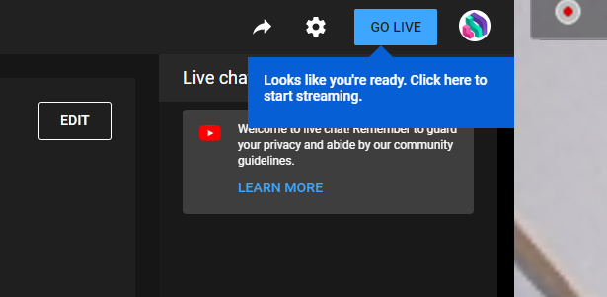

Your attendees will now be able to see the live broadcast on YouTube:

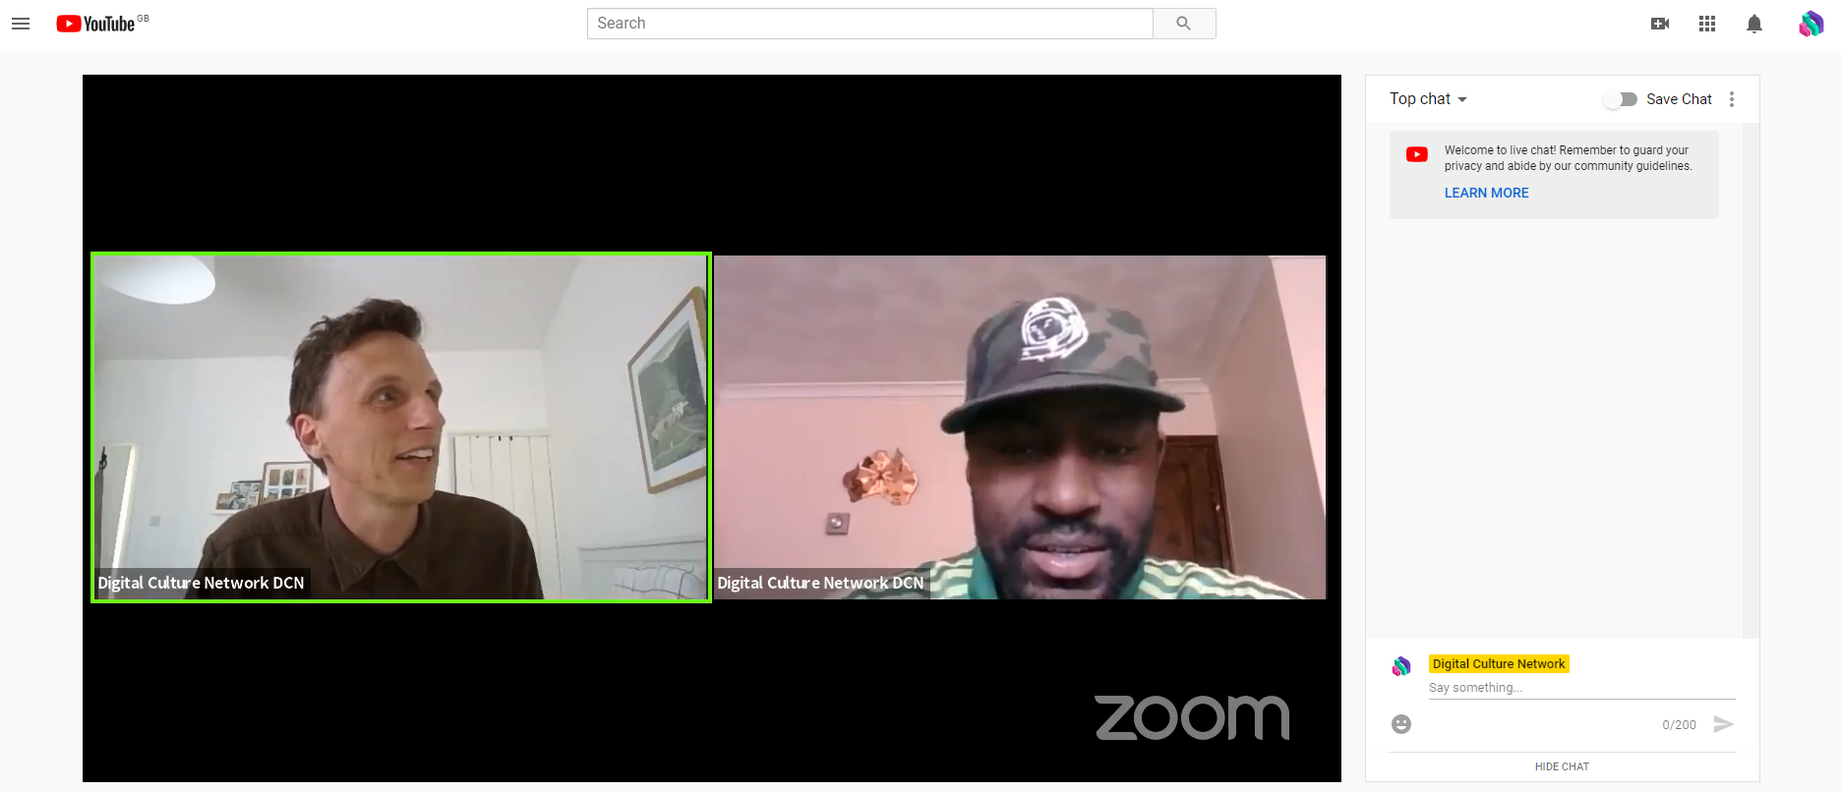

Any messages that are put in the chat by users are visible in the YouTube control room where your assistant can delete and ban any comments if necessary. You can also send replies as your channel.

For our webinars, we use a phone with the YouTube stream on it (with volume off) so we can keep track of any comments in the live chat and respond to them as part of my webinar content. Remember, there is an 18 second lag between what your audience are seeing and what you are doing on Zoom.

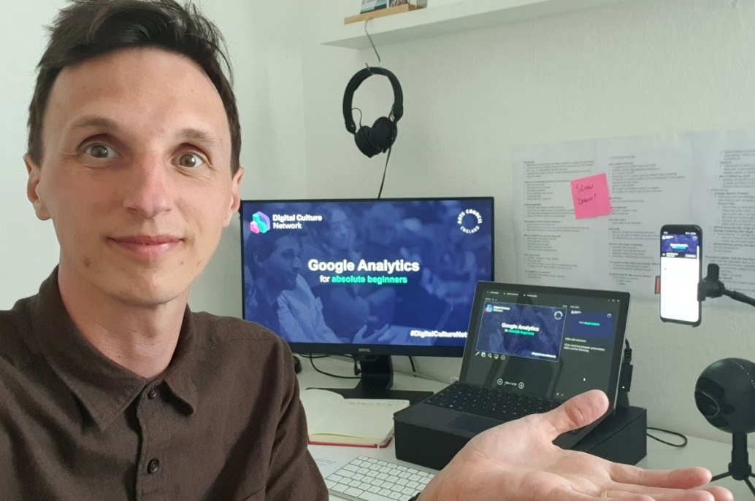

When your webinar is finished, click the END STREAM button in the YouTube control room. You can then leave the Zoom meeting.

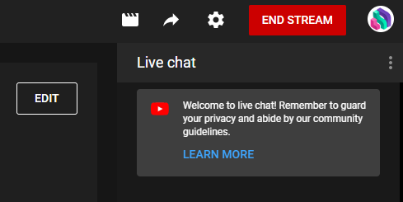

The recording will automatically save to YouTube studio where you can edit the video, add extra information such as description and tags, and (importantly) transcribe the audio.

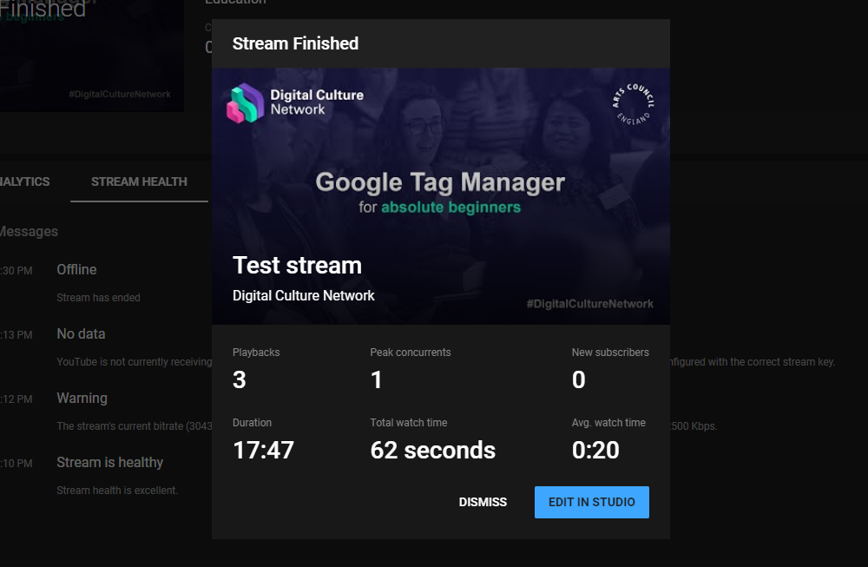

Congratulations! You’ve just a streamed a fantastic webinar to YouTube. Sit back, relax and have a nice cup of tea.

Further Support:

The Digital Culture Network is here to support you and your organisation. If you need help or would like to chat with us about any of the advice we have covered above, please get in touch. Email digitalnetwork@artscouncil.org.uk with some background information about you, your location and your current dilemma, and we will connect you with one of our 9 Tech Champions for some in-depth 1-2-1 support.

Sign up to the DCN newsletter and follow us on Twitter @ace_dcn for latest updates.

