Music Education Hubs: Working with Schools

Published 1 June 2023

Arts Council England

Supported using public funding by
- Department for Education
- Arts Council England

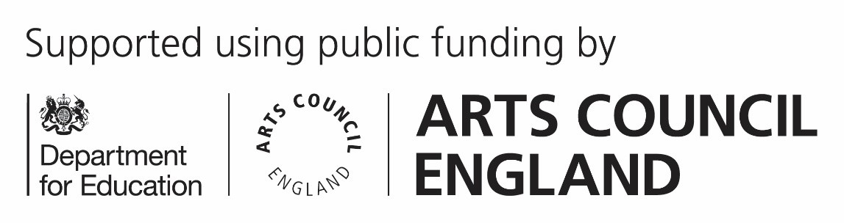

Contents

Introduction: page 3 Expectations of schools: page 4 Expectations of Hubs: page 5 Evidence and monitoring: page 9

Introduction

For 2023-24, the Department for Education (DfE) has asked that Hubs respond to the vision, three aims and five strategic functions outlined in The power of music to change lives: a national plan for music education (NPME) (https://www.gov.uk/government/publications/the-power-of- music-to-change-lives-a-national-plan-for-music-education).

This includes a new strategic function covering how Hubs work with schools. This guidance is intended to support Hubs in understanding expectations around school engagement and articulating their approach in their Local Plan for Music Education (LPME).

This document refers to the ‘Music Education Hub’ or ‘Hub’, when referring to the whole partnership, and ‘Hub Lead Organisation’ (HLO) or ‘lead organisation’ when referencing specific responsibility of the HLO. Reference is often made to ‘schools’ and by this we mean all state-funded educational establishments in the Hub’s area, including, for example, colleges, Pupil Referral Units and special schools.

This document is primarily aimed at Music Education Hubs delivering against the requirements for the 2023-24 funding period. However, it may also be helpful for anyone applying to lead a Music Hub as part of the Music Hub Investment Programme, to understand our reporting requirements and expectations for Hubs.

Expectations of schools
The NPME places central emphasis on the role of schools in providing high-quality music education for children and young people. It sets an expectation of high-quality provision across three interlinked areas:

- curriculum music, compulsory from key stages 1-3, then optional for examination classes (eg GCSE, vocational and technical qualifications and A-level)

- instrumental and vocal lessons, and ensemble membership
- musical events and opportunities, such as singing in assembly, concerts and shows, and trips to professional concerts

It advocates for senior leadership to support training and development to empower staff to deliver music effectively, and to conceive of this broadly.

The NPME encourages schools to articulate their approach to delivering high-quality music education and supporting pupils to progress within a School Music Development Plan (SMDP), which is tied into the school’s broader improvement plans, and mirrored at trust level for schools that are part of an academy trust.

Schools should regularly review their SMDPs and they should contain clear information about the opportunities and services that the Hub can/will offer to the school and its pupils, to help execute the plan.

While the NPME is clear that it is the responsibility of all schools to deliver music well, it is also clear that Hubs should support and empower them to excel.

Expectations of Hubs

The NPME sets out a next phase in the approach to Hubs and, while working with schools has always been a key area of Hub activity, the plan renews the emphasis on this through its vision and aims for Hubs, which is summarised in a new schools strategic function:

"To support all state-funded schools in their area through ongoing relationships that help them to deliver high-quality music education, including a quality curriculum support offer, specialist tuition, instruments and ensembles, and a broad range of progression routes and musical experiences for all pupils."

The NPME sets an expectation of proactive relationship- building by Hubs with all schools in their area (including specialist settings such as special schools or alternative provision) and, where relevant, academy trusts.

The 2023-24 Relationship Framework (http://www.artscouncil.org.uk/musiceducationhubs/guidance) and Additional conditions (http://www.artscouncil.org.uk/ musiceducationhubs/guidance) expect Hubs to have a ‘clear, well considered approach to engaging schools, with clear targets and ambition, which demonstrates a diverse offer based on a thorough understanding of the needs of schools.’ As such, Hubs are expected to engage in regular conversations with schools and to draw on consultation and feedback in order to ensure their understanding of school needs and priorities is comprehensive and up to date.

Hubs are also expected to develop SMART plans to engage with every school, targeting those schools that have been historically disengaged. Key features of a strong offer to schools should include, but not be limited to:

- supporting the development of SMDPs, including resources or support in evaluating and evidencing the impact of their curriculum

- providing curriculum support (including using the Model Music Curriculum)

- providing opportunities for workforce development, continuing professional development (CPD), and networking

- considering the support provided for both specialist and non- specialist school-based workforce

- providing support with music education provision (eg provision of classroom instrumental lessons, specialist tuition, ensembles, choirs and group music-making opportunities)

- providing support with access to instruments and equipment, including accessible and adapted/adaptive instruments, where possible and appropriate, for young people with special educational needs or disabilities

- facilitating links between in and out of school provision, alongside access to other projects and performance opportunities for school pupils

- ensuring clear and accessible information is available to schools and teachers via the Hub website or online platform, which includes sharing advice to schools on how to use Pupil Premium (aligned with current government advice)

  - signposting and aligning to the work of Teaching School Hubs and Ofsted where appropriate

  - signposting to other school development tools such as Artsmark Award (http://www.artsmark.org.uk/), which supports embedding arts across the curriculum, and the Governor Guide for Music (https://www.artscouncil.org.uk/ developing-creativity-and-culture/children-and-young- people/cultural-education-guides-governors), produced by Music Mark and the National Governors Association

Hub Lead Organisations (HLOs) will be responsible for ensuring that relationships with state-funded schools and multi-academy trusts are developed and appropriately monitored through the work of the Hub partnership. It will be the responsibility of the HLO to identify and commission partners that can support each school to develop and execute their plans to deliver a high- quality music education offer that is responsive to their specific needs and the needs of their learners.

The specific detail of a Hub’s work with schools should be responsive to local context and to the needs of the children and young people, teachers and school leaders in their area. The programme of activity will vary not only between Hubs, but between schools within a Hub’s given area. As such, a Hub will not be expected to offer all of the elements above to every school, or indeed to limit their offer to the activity listed.

The expectation is that each Hub will proactively approach every school in their area, and work with them to tailor an offer of support and engagement to their needs. These conversations and resulting programmes of work should align to a school’s SMDP, so that the Hub’s input complements the school’s internal approach, its curriculum and workforce support.

Discussions should be two-way, considering also what the school could offer its wider community, through and in partnership with the Hub. While the NPME outlines plans for new Lead Schools within Hub partnerships, these will not be introduced for 2023-24. Hubs should, however, consider how they can bring schools interested in a more strategic relationship into the Hub partnership. This type of relationship represents as valid and strong an instance of engagement with the school as another in which the Hub delivers activity with or for the school.

In a similar spirit, as well as building strong links with local state-maintained schools and colleges, the NPME states that Hubs should connect with independent schools, including specialists in music education such as Cathedral music foundations and Cathedral schools, as well as further and higher education institutions.

Evidence and monitoring

For 2023-24, HLOs are required to submit their approach to school engagement as part of their Local Plan for Music Education (LPME), describing how you will engage and develop relationships with all schools in your area. Full information and requirements can be found in Section 7 of the additional conditions for 2023-24 (http://www.artscouncil.org.uk/ musiceducationhubs/guidance).

HLOs are not required to provide this information in a specific format. It could be submitted separately or as part of a Hub’s LPME. Where a Hub feels it can cover the points above using an existing School Music Education Plan (SMEP) or similar templates, those can be annexed to the LPME.

School engagement is monitored nationally through the ongoing relationship between the Relationship Manger and the HLO and though the annual data survey for Hubs. The annual survey data guidance (https://www.artscouncil.org.uk/developing- creativity-and-culture/children-and-young-people/music- education-hubs/music-education-0) provides details of how school engagement will be measured.

Transcribed into Large Print by: A2i Transcription Services Unit 4 Montpelier Central, Station Road, Bristol BS6 5EE 01179 44 00 44 info@a2i.co.uk www.a2i.co.uk
We welcome feedback so please get in touch! Ref number: 37015

