Safeguarding and child protection helpful document – Music Hub Investment Programme
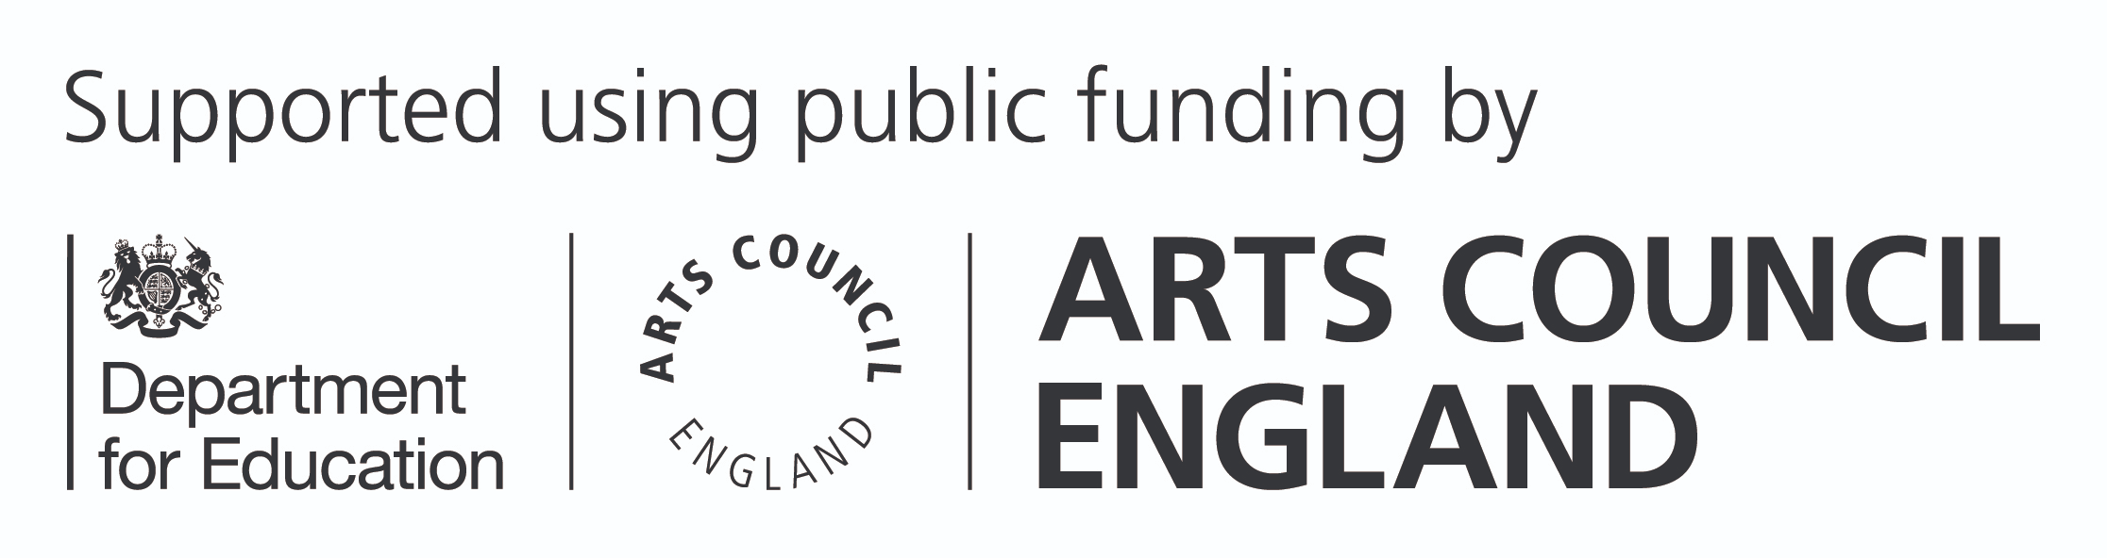

Requirements for grant holders

By signing a grant agreement with the Arts Council, Hub Lead Organisations (HLOs) will be expected to meet all requirements set out in our terms and conditions for funding. This includes having your own tailored policy for safeguarding and protecting children, young people and adults at risk, which is proportionate and relevant to your Music Hub’s activities and has been agreed by your own organisation’s board / trustees and the Music Hub’s board or equivalent oversight group.

This policy must be reviewed regularly, and staff (on all types of contracts), volunteers and trustees must be regularly trained on its contents.

You must also ensure that all Music Hub partners and subcontractors have appropriate safeguarding and child protection policies and procedures in place that, as a minimum, meet the requirements and expectations of the safeguarding policies and procedures of the Music Hub.

Appropriate safeguarding policies and procedures

Appropriate and effective safeguarding policies and procedures should, as a minimum (though not an exhaustive list):

- outline the organisation’s commitment to safeguarding and protecting children, young people and adults at risk and to developing a safeguarding culture
- provide a named Safeguarding Lead, who has the knowledge and skills to promote safe environments for children, young people and adults at risk, and is able to respond to concerns and disclosures
- clearly define the roles and responsibilities of all staff, volunteers, trustees, partners or contractors who will supervise, care for, or otherwise have significant direct contact with children, young people and adults at risk in respect of safeguarding and child protection
- demonstrate that there are safe recruitment procedures in place, including regular background checks for all staff, volunteers, trustees, partners or contractors who will supervise, care for, or otherwise have significant direct contact with children and adults at risk (for example, checks with the Disclosure and Barring Service
(https://www.gov.uk/government/organisations/disclosureand-barring-service))
- ensure appropriate and regular training is offered to all employees, volunteers, trustees, partners or contractors who will supervise, care for, or otherwise have significant direct contact with children and adults at risk
- demonstrate how robust risk assessment processes are carried out, with appropriate guidance to help ensure a safe and inclusive environment is made available to children, young people and adults at risk
- explain the steps that will be taken in the event of a concern being raised, or incident taking place, including appropriate escalation measures to external agencies, where applicable (for example, children’s services, police, Prevent or NSPCC for support and advice)
- demonstrate and evidence clear connectivity to other appropriate organisational polices (for example, Code of Conduct, HR and whistleblowing policy)

3

Ensuring best practice

Any organisation that has been appointed to supervise, care for, or otherwise have significant direct contact with children, young people or adults at risk as part of the Music Hub’s activity should, as a minimum, be meeting the standards outlined in the out-of-school settings set out by the Department for Education – ‘Keeping children safe in out-of-school settings: code of practice’ (https://www.gov.uk/government/publications/ keeping-children-safe-in-out-of-school-settings-code-ofpractice).

You should also ensure that other relevant statutory guidance is being followed and/or complied with, for example:

- Safeguarding for charities and trustees – guidance for charities and trustees (https://www.gov.uk/guidance
/safeguarding-for-charities-and-trustees)
- Working together to safeguard children – statutory guidance on inter-agency working to safeguard and promote the welfare of children. (https://www.gov.uk/government/ publications/working-together-to-safeguard-children--2)
- Keeping children safe in education – statutory guidance for schools and colleges on safeguarding children and safer recruitment (https://www.gov.uk/government/ publications/keeping -children-safe-in-education--2)

Incident reporting

From time to time, safeguarding incidents may occur during any of the activities provided by a Music Hub. In the first instance, these incidents should be dealt with via the specific organisation’s safeguarding policy and then raised, logged, managed and escalated (if applicable) through the safeguarding policy and procedures set out by the HLO, on behalf of its Music Hub.

Any serious or significant incidents should also be reported to Arts Council England immediately for information purposes and to provide advice on any reputational risk implications for the HLO (or one or more of its delivery partners), Arts Council England and/or the Department for Education.

Transcribed into Large Print by: A2i Transcription Services
Unit 4 Montpelier Central, Station Road, Bristol BS6 5EE
01179 44 00 44 info@a2i.co.uk www.a2i.co.uk

We welcome feedback so please get in touch!
Ref number: 37243

5

