Lead Schools for Music essential document – Music Hub Investment Programme

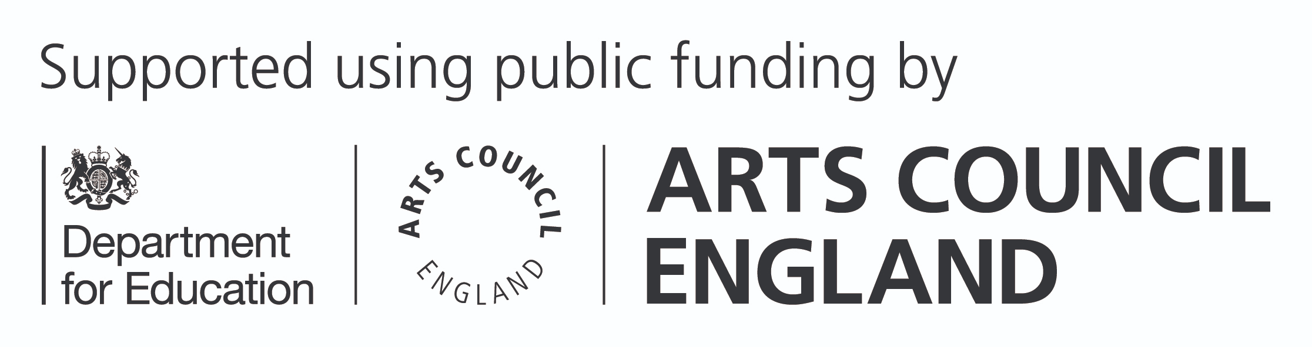

This is the Lead Schools for Music essential document and will cover their purpose and role, criteria for them and how this relates to an application to become a Hub Lead Organisation (HLO). Please read it alongside the Guidance for Applicants (https://www.artscouncil.org.uk/our-open-funds/music-hub- investment/music-hub-investment-programme-making-your- application#t-in-page-nav-3).

As set out in The power of music to change lives: a national plan for music education (https://assets.publishing.service. gov.uk/government/uploads/system/uploads/attachment_data/ file/1086619/The_Power_of_Music_to_Change_Lives.pdf) (NPME), HLOs will be expected to invite schools to join their Music Hub partnerships as Lead Schools for Music.

For each local authority area a Hub covers, the HLO will be expected to appoint at least one primary and one secondary Lead School. Where a Lead School is an academy, the NPME (https://assets.publishing.service.gov.uk/government/uploads
/system/uploads/attachment_data/file/1086619/The_Power_of_ Music_to_Change_Lives.pdf) expects that their academy trust should also be involved in the Hub’s work. Where appropriate, HLOs should additionally appoint specialist Lead Schools (a special school and/or alternative provision for example).

While applicants are not expected to identify proposed Lead Schools in their application to lead a Hub, they will be asked to outline how they propose to identify, appoint and work with Lead Schools if successful. This information sheet provides guidance to support that.

The purpose and role of Lead Schools

The NPME (https://assets.publishing.service.gov.uk/ government/uploads/system/uploads/attachment_data/file/1086 619/The_Power_of_Music_to_Change_Lives.pdf) emphasises the role of Hubs in supporting school music improvement, embedding stronger practice and supporting effective professional development for teachers. As part of this, the Department for Education (DfE) would like Hubs “to support stronger links between local schools and academy trusts, and broker opportunities for peer-to-peer learning”. Lead Schools are designed to drive this by embedding schools within the Music Hub, not only as customers of the Hub, but as co- creators and delivery partners for elements of its work.

These named Lead Schools will not take the place of the connections all Hubs should seek to build with all schools within their Hub area, but rather should play a distinct and additional role in supporting other schools to improve their music provision.

Lead Schools should have a specific role in the Hub’s support offer for schools which should be outlined in the Hub’s School Engagement Strategy. They should seek new and stronger ways for teachers to support and learn from each other and build these into the Hub’s programme of activity. They should be key collaborators in the creation of place-responsive programmes and initiatives that connect schools. This could include (but is not limited to) learning networks, CPD courses, mentoring and peer support activity, collaborative music projects, and practice and resource sharing.

As partners within the Hub, Lead Schools should also bring school-based expertise and experience of school-to-school support to wider Hub partnership discussions and strategies. By

doing so, they should help to ensure Hubs understand and are able to respond to the present challenges and opportunities within local schools and can adapt their offers and ways of working to achieve maximum impact in these settings. This should include contributing to the development of a strategic approach to inclusion.

Within these parameters, the specific role of Lead Schools in a Hub, the approach to identifying and appointing them, and the work they are commissioned to undertake, should be driven by the needs of pupils, teachers, and schools within the Hub area.

Criteria

The NPME sets out that Lead Schools should exemplify high- quality music teaching and champion best practice in their area, showing commitment to:
- strong curriculum delivery, with significant timetable time, using the Model Music Curriculum or a clearly sequenced curriculum that is at least comparable in breadth and ambition
- a rich musical culture and co-curricular offer in the school, with vocal or instrumental ensembles
- for secondary schools, building a pathway to and enabling the study of music at key stage 4 and beyond, including
provision of music GCSE, A level and/or technical awards wherever applicable/possible
- supporting pupil progression across the whole school community, understanding the opportunities available and
how to enable pupils to access them
- supporting an inclusive musical culture, with all pupils able to progress their musical interests and potential

  - aligning curriculum and professional development to wider government policy (eg subject specific support complements broader teacher development reforms (see note 1)) and evidence (eg Ofsted research review (see note 2))
  - investment in staff development

It will be important that Lead Schools can exemplify this excellence in music education within a broader, strong education offer. While more specific criteria will be provided to successful HLOs before Lead Schools are appointed, in outlining the approach to Lead Schools as part of their application, prospective HLOs should consider how they would ensure that they exemplify excellent music provision as part of a broad and balanced education. HLOs might wish to consider, for example, Ofsted reports, test or examination results, as well as schools’ track record in supporting their peers in other schools to strengthen their delivery of music.

Lead Schools should already be, or be willing to commit to, working closely with their local Teaching School Hubs to build networks of best practice in their areas, supporting the Teaching School Hub with specific music training provision where needed.

Note 1: https://assets.publishing.service.gov.uk/ government/uploads/system/uploads/attachment_data/file/1076 587/Delivering_world_class_teacher_development_policy_ paper.pdf

Note 2: https://www.gov.uk/government/publications/research- review-series-music/research-review-series-music#pedagogy

Application

As part of an HLO application, applicants are asked to set out:
- their approach to understanding the context and needs of schools which Lead Schools might address
- how they will identify and appoint appropriate Lead Schools in each local authority area the Music Hub will cover
- indicative plans for the roles and responsibilities of Lead Schools as part of the Music Hub
- how the HLO will ensure there is remuneration or support in kind for schools to take on this role
- the HLO’s approach to monitoring the impact of Lead Schools
The requirements for Lead Schools should respond to needs analyses and be articulated as part of the HLO’s Local Plan for Music Education and School Engagement Strategy. We expect HLOs to provide remuneration or support in kind for Lead Schools.

Impact, outcomes and monitoring

We expect HLOs to demonstrate that their plans for Lead Schools are based on their understanding of the needs of pupils, teachers and schools across the Hub area, and to monitor their impact appropriately.

HLOs will also need to demonstrate how, and in which circumstances they will act to replace or appoint new Lead Schools. This could be in response to issues around performance or quality, because of the changing circumstances of a school, or because local need has evolved in some way.

