Gender pay gap analysis – Arts Council England
Figures as at 31 March 2023

 |  |  |  |  |  |  |  | %
1. Mean gender pay gap - Ordinary pay |  |  |  |  |  |  |  | 8.2%
2. Median gender pay gap - Ordinary pay |  |  |  |  |  |  |  | 4.7%
3. Mean gender pay gap - Bonus pay in the 12 months ending 31 March |  |  |  |  |  |  |  | 11.4%
4. Median gender pay gap - Bonus pay in the 12 months ending 31 March |  |  |  |  |  |  |  | 0.0%
5. The proportion of male and female employees paid a bonus in the 12 months ending 31 March |  |  |  |  |  |  | Male | 86.8%
 |  |  |  |  |  |  | Female | 81.0%
6. Proportion of male and female employees in each quartile:
Quartile |  |  | Female % |  |  | Male %
First (lower) quartile |  |  | 69.9% |  |  | 30.1%
Second quartile |  |  | 72.1% |  |  | 27.9%
Third quartile |  |  | 71.4% |  |  | 28.6%
Fourth (upper) quartile |  |  | 61.0% |  |  | 39.0%

Changes from the March 2022 return

Overall changes in pay from female to male staff | %
Mean | +1.4%
Median | +2.6%
Bonus - Mean | +0.8%
Bonus - Median | 0.0%
Quartile (increase in male staff representation) | %
First (lower) quartile | -7.7%
Second quartile | -2.7%
Third quartile | -2.7%
Fourth (upper) quartile | +10.0%

Changes in Bonus receipt levels | %
% Bonus - M | 10.2%
% Bonus - F | 7.7%

The median gender pay gap has increased from 2.2% at 2022 year-end to 4.7% at 2023 year-end. This reflects an increase in male staff in the highest salary quartile by 10% and a fall in their numbers in the lowest salary quartile of 7.7%.
There are still more female than male staff in the highest paying quartile (61% compared to 39% respectively) but this proportion is not fully representative of the overall percentage of female staff (which is 68.6% of total headcount).

As 2022-23 was a year of business-as-usual staff headcount turnover, without any major new starter or leaver events, this change reflects day to day hiring and promotion decisions. To help attract candidates from the broadest possible range of backgrounds we’ve introduced more skills-based recruitment, and reviewed the platforms we advertise on.

As in the previous years, a bonus was paid to all non-executive staff as a flat cash rate of £266. This explains why the median is zero. However, the gender gap in the mean bonus figure reflects the fact that we do not pay this bonus to staff who are still in their probationary period (in their first six months of service). This then reflects the larger number of new employees who were female in 2022-23.

As a comparator, the Civil Service median pay gap in 2023 is 9.6% and its mean pay gap is 8.1%. The data is available here on GOV.UK
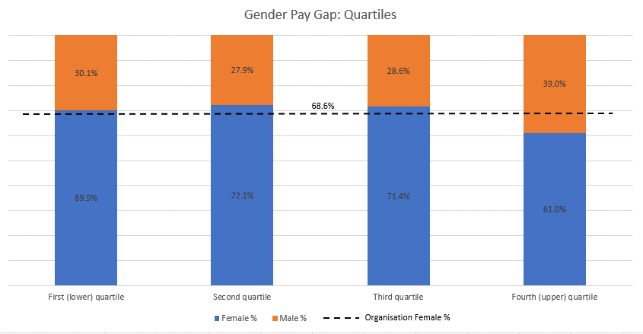
Ethnicity Pay Gap Analysis – Arts Council England
31 March 2023

 |  |  | %
1. Mean ethnicity pay gap - Ordinary pay |  |  | -7.2%
2. Median ethnicity pay gap - Ordinary pay |  |  | -5.0%
3. Mean ethnicity pay gap - Bonus pay in the 12 months ending 31 March |  |  | 5.8%
4. Median ethnicity pay gap - Bonus pay in the 12 months ending 31 March |  |  | 0.0%
5. The proportion of employees paid a bonus in the 12 months ending 31 March |  | White British / European background | 83.6%
 |  | Black, Asian & Ethnically Diverse | 77.0%
6. Proportion of employees in each quartile:
Quartile | Black, Asian & Ethnically Diverse | White, British & European background
First (lower) quartile | 12.6% | 87.4%
Second quartile | 9.3% | 90.7%
Third quartile | 10.6% | 89.4%
Fourth (upper) quartile | 17.8% | 82.2%

Changes from the March 2022 return

Overall figures | %
Mean | -3.2%
Median | +0.6%
Bonus - Mean | -10.6%
Bonus - Median | 0.0%
Quartile | %
First (lower) quartile | 1.3%
Second quartile | 3.0%
Third quartile | -5.6%
Fourth (upper) quartile | -4.6%

In both tables, minus figures represent swings in pay from White, British & European to Black, Asian, and Ethnically Diverse colleagues.

While, unlike with the gender pay gap, there is no statutory requirement to report an ethnicity pay gap, the Arts Council has been doing this for the last three years as an example of forward-looking good practice around equality and diversity. This does mean however that there is no commonly accepted nationwide guidance on how to construct the dataset. Here, we have used the same principles of pay calculation used in the gender pay figures and applied them to two separate staff groups of i) white British or European origin and ii) Black, Asian, or other Ethnically Diverse colleagues. We accept that dividing this data into a binary presentation does come with a level of generalisation but is nonetheless a useful metric to consider in an organisation of a size in which breaking down pay gaps further into different sub-groups risks a loss of statistical significance.

Both the mean and median pay gaps for 2023 are negative – meaning that the average pay for Black, Asian & Ethnically Diverse staff exceeds that for group White British and European staff by 7p and 5p in every pound of salary respectively.

The median figure is largely unchanged from 2022, while the mean has swung further towards Black, Asian and Ethnically diverse colleagues. This reflects growth in their proportions in the two highest pay quartiles.

At 12.6% of organisational headcount, Black, Asian, and ethnically diverse staff constitute a proportionally smaller group than the two groups in the gender pay analysis (i.e. male and female) and so this pay gap figure is likely to be more volatile year to year, as it can be affected by small changes in headcount.

The annual bonus is only paid as a £266 flat rate to all non-executive staff (hence the median being zero). However, the 5.8% pay gap in favour of White British / European background staff for the mean bonus reflects the fact that we do not pay a bonus to staff in their probationary period probation (in their first six months of service) and so reflects the large number of new employees who were Black, Asian and ethnically diverse in 2023.

As a comparator, information on the Civil Service ethnicity pay gap can be found here although the Civil Service take a different approach to calculation.

