Transforming Governance Case Studies

The following document provides a series of Case Studies for participants of the Transforming Governance Programme.

Recruiting Trustees and Succession Planning
This module provides an overview of how to improve trustee recruitment and succession planning. The following Case Studies provide examples of good practice across the charity sector in relation to trustee recruitment and succession planning.

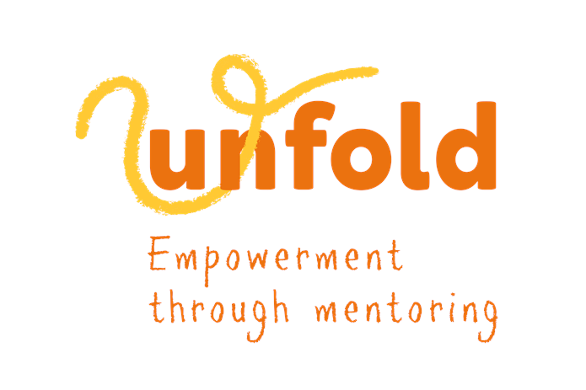
Unfold
Unfold, established 34 years ago, is a local organisation focused on mentoring marginalised individuals in Westminster and neighbouring boroughs, with a special emphasis on refugees and asylum seekers. Unfold's core program, Broadening Horizons, provides 12-24 mentoring sessions to young people (ages 10-25) and women with children (ages 5+). Unfold also run peer support groups for women seeking asylum.

Following cuts to youth services and the continued impact of the Covid-19 pandemic, the board recognised young people were facing severe challenges and feelings of disempowerment. In response to this, Unfold's board prioritised enhancing youth voice and agency, launching a Young Ambassadors programme in 2021 and securing a grant to increase youth involvement in governance. Through the programme, the board collaborated with the Young Ambassadors to establish a Youth Advisory Council, aiming to advise on strategic direction and contribute to local decision-making.

To mitigate the risks of miscommunication between the Council and Board, governance sessions for trustees and preparatory workshops for youth council members were introduced. At the time of writing, the Youth Advisory Council consists of 12 current and former mentees, including young women, men, and asylum seekers. Structured meetings with the board and senior management help develop leadership and communication skills among council members and the organisation continues to invest in trustee training for effective engagement with the Youth Advisory Council.

More information here.

Clean Break
Clean Break, founded in 1979, is a women's theatre company focused on empowering women and supporting them to reach their full potential free from criminalisation. The charity believes in the transformative power of theatre to challenge injustice and create lasting change.

The board emphasises diversity and inclusion, with a focus on representing the diverse needs of service users. The board has three trustees in the criminal justice system and others representing minority communities who contribute to inclusive and well-informed decision-making. To safeguard the board’s diversity, there is annual succession planning and recruitment efforts including a skills audits with a diversity focus to ensure there is continuous and strong representation of service users' experiences. A co-chair model was introduced to broaden the leadership of the board and a Lived Experience Trustee training programme identifies and develops future trustees from the charity’s core audience.

To evaluate the board’s performance and impact, an external consultant was engaged to prioritise anti-racism, develop action plans, and monitor progress. These efforts have brought Clean Break recognition across the sector.

Full article here.

