

How to Guide:

The Investment Principles Plan for

2023-26 Investment Programme

2024/25

Contents

Introduction 3

What is the Investment Principles Plan? 3

Why are we using it? 3

Completing the Template 5

Contents Page and Key 5

Investment Principle – Ambition & Quality 7

3-Year Ambition & 12-Month Priorities 7

Actions 9

Skills Development 11

People and Representation 12

Planning 14

Tools and Monitoring 15

Update on progress 17

Completed Template 18

Uploading the template to Grantium 18

# Introduction

Welcome to the guide for the Investment Principles Plan. This will show you how to complete the Investment Principles Plan as part of your funding agreement for the 2023-26 Investment Programme either as a National Portfolio Organisation or as an Investment Principles Support Organisation.

Each applicant will need to complete three revised templates on an annual basis to form part of their funding agreement:

* [The financial template](https://www.artscouncil.org.uk/media/22090/download?attachment)
* [The Investment Principles Plan](https://www.artscouncil.org.uk/media/22091/download?attachment)
* [The Activity Plan for Outcomes](https://www.artscouncil.org.uk/media/22088/download?attachment) or [The Activity Plan for Investment Principles Support Organisations](https://www.artscouncil.org.uk/media/22089/download?attachment)

You will need to complete the [Investment Principles Plan template](https://www.artscouncil.org.uk/media/22091/download?attachment) to form part of your funding agreement.

This guide will show you how to complete the Investment Principles Plan and will outline:

* What the Investment Principles Plan is
* Why we are using it
* Resources available to help you
* And what you need to tell us when you’re filling it in

# What is the Investment Principles Plan?

The Investment Principles Plan is a tool that will help you to demonstrate how your organisation plans to embed our four Investment Principles in your own organisation and what actions you will take to achieve this.

# Why are we using it?

We request this information as part of your funding agreement using a template to ensure the information we receive is consistent and comparable. We need an updated template at the start of every funding year that will form part of your funding agreement, so that we are clear on the activity we are funding and what you will need to report progress against.

As a reminder of our four Investment Principles, we advise you to take a look through our strategy Let’s Create, where we outline and define our four Investment Principles. You can find this on our [website](https://www.artscouncil.org.uk/lets-create/strategy-2020-2030/investment-principles).

# Completing the Template

The template consists of four pages, one for each of the four Investment Principles. This document will provide a step-by-step guide for completing the first page, the Ambition & Quality Investment Principle. However, each Investment Principle page is identical in layout and in the type of information it is requesting from you. **You must complete the pages for all four Investment Principles.**

# Contents Page and Key

When you open this template, it will always open on the contents page.

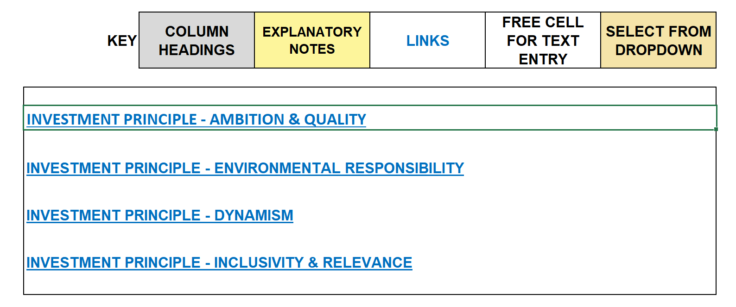

You will find a key at the top of the template. Follow the links in blue to navigate your way around the template. You can also use the tabs visible at the bottom of the template window to navigate to each Investment Principle tab. You can enter text in cells highlighted white and you will need to use a drop down in cells coloured beige. Please remember you will not be able to make changes to the cells in grey, yellow or those marked with a cross.

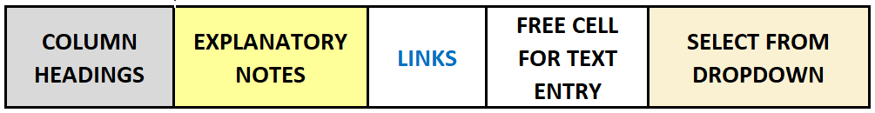

If you wish to alter your view of the pages, you can use the zoom function to the bottom right of your screen.

This contents page links to each of the four pages you’ll need to complete. These pages are:

* Ambition & Quality
* Environmental Responsibility
* Dynamism
* Inclusivity & Relevance

The layout of each page is exactly the same. However, the information you provide for each page will differ depending on which Investment Principle you are responding to.

For example, this is the page for the Ambition & Quality Investment Principle, as you can see from the heading at the top of the page.

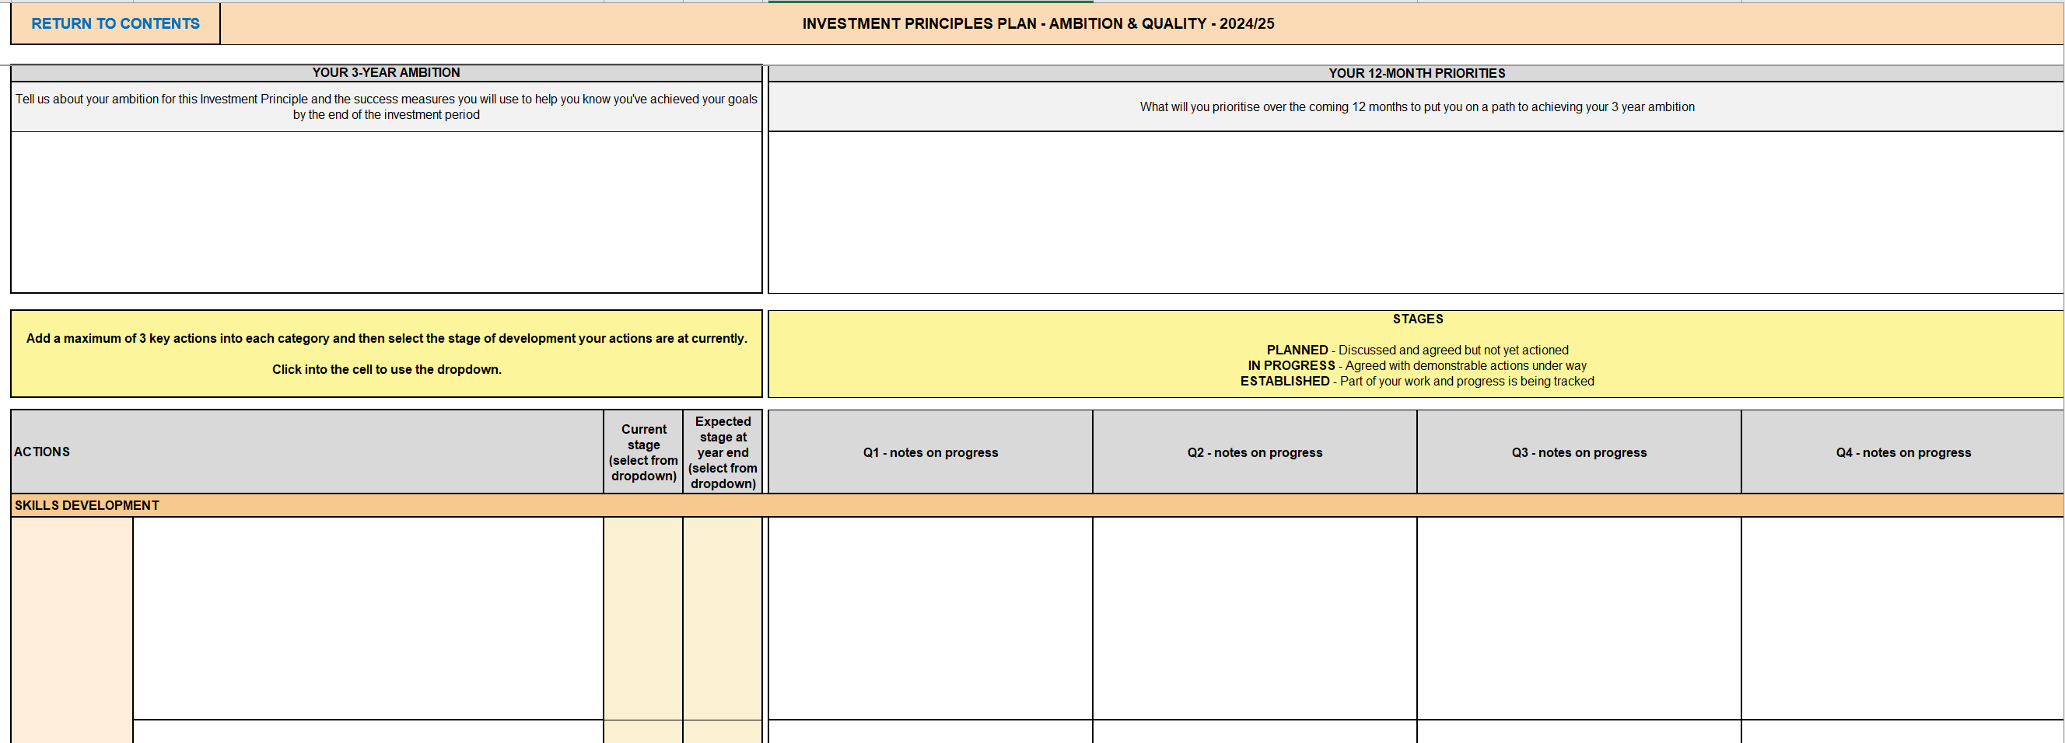

You will then need to complete the page in line with your response to the Investment Principle you have selected. In the next section of this guide, we will provide the step-by-step process of completing the Ambition & Quality Investment Principle, including examples.

# Investment Principle – Ambition & Quality

From the contents page, click ‘Investment Principle – Ambition & Quality’.



# 3-Year Ambition & 12-Month Priorities

At the top of the page is a box titled ‘Your 3-Year Ambition’. You should write about your aims and objectives to improve Ambition & Quality for your organisation over the 3-year investment period.



You should also tell us what success measures you will use to indicate when you have achieved your goal at the end of the 3-year investment period.

A second box at the top of the page is labelled ‘Your 12-Month Priorities’.

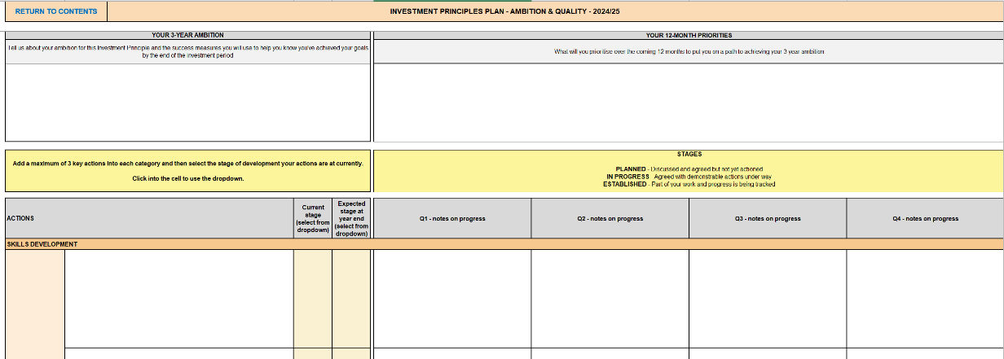

\\\\\\

You should outline what you will prioritise over the first 12 months of the investment period to ensure you are progressing towards your 3-year objectives to embed Ambition & Quality within your organisation.

# Actions

Once you have completed those two boxes you can move down to the rest of the page, which focuses on **Actions**. The yellow boxes contain guidance on how to complete the boxes below.



Beneath that are the four Actions sub-headings to complete: **Skills Development**, **People & Representation**, **Planning**, and **Tools & Monitoring**.

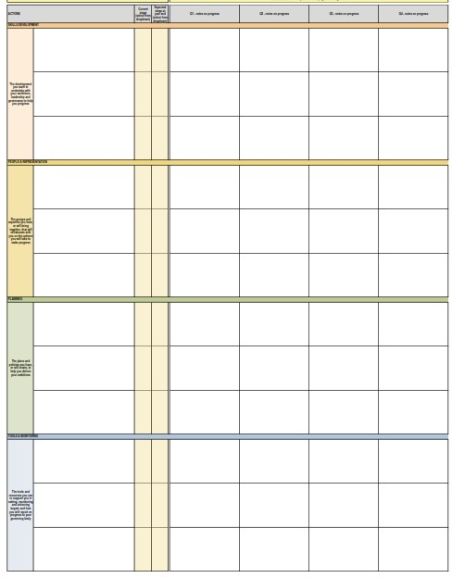

In the boxes provided, we would like you tell us what actions you will take in relation to these sub-sections, to meet your 12-month priorities and progress towards your 3-year ambition.

You will need to respond to each of the sub-headings. **You can provide up to** **three actions per heading**. It is important to only include actions that relate to the chosen Investment Principle. We will go into more detail about how to respond to each action on pages 10-14 of this guide.

Once you have outlined your action, to the right of the page you will see a column titled ‘Current Stage’. The stages are:

* Planned – Discussed and agreed but not yet actioned
* In Progress – Agreed with demonstrable actions under way
* Established – Part of your work and progress is being tracked

Click into the relevant cell to use the dropdown and select the relevant stage that best describes the current status of this action within your organisation.

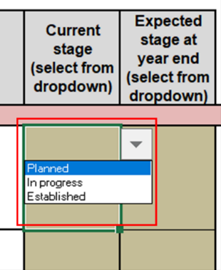

The next column is titled ‘Expected stage at year end’. Click into the relevant cell to use the dropdown and select the relevant stage that best describes the expected status of this action within your organisation at the end of the first year of funding.

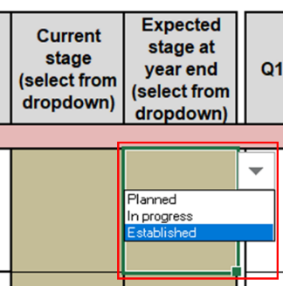

In the next section of this guide, we will explore the four sub-headings in the context of the Ambition & Quality Investment Principle, providing examples for how these could be completed.

# Skills Development

The first Action sub-heading is **Skills Development**. In the lefthand box we provide a description of what this means for your organisation.

In the example below we have listed two actions the organisation will take to meet their 12-month priorities and progress towards their 3-year ambition.

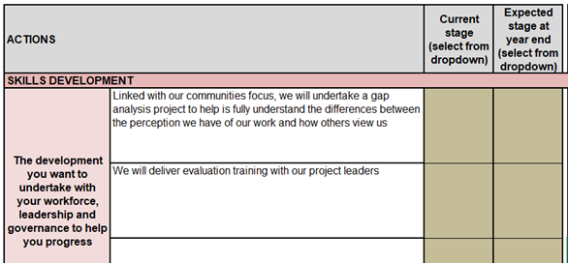

The next step is to complete the ‘Stage’ columns, to indicate whether each action is planned, in progress or established, using the dropdown menu. For this example, we have selected ‘Planned’ for current stage for both Actions, and ‘in progress’ for expected stage at year end.

# People and Representation

The second Action sub-heading is **People and Representation**. In the green box we provide a description of what this means for your organisation.

In the example below we have listed an action the organisation will take to meet their 12-month priorities and progress towards their 3-year ambition.

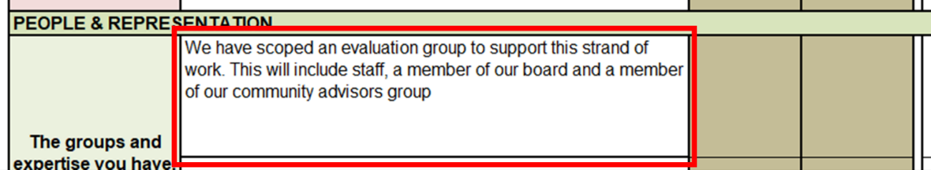

The next step is to complete the ‘Stage’ columns, to indicate whether each action is planned, in progress or established, using the dropdown menu. For this example, we have selected ‘Planned’ for the current stage of the Action, and ‘Established’ for expected stage at year end.

# Planning

The third Action sub-heading is **Planning**. In the blue box we provide a description of what this means for your organisation.

In the example below we have listed an action the organisation will take to meet their 12-month priorities and progress towards their 3-year ambition.

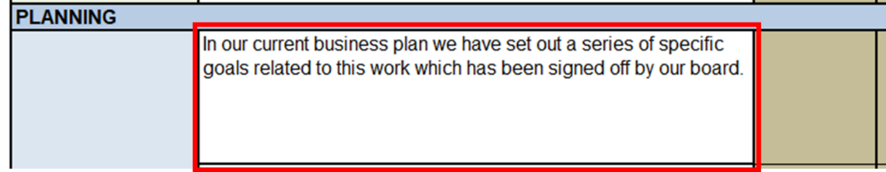

The next step is to complete the ‘Stage’ columns, to indicate whether each action is planned, in progress or established, using the dropdown menu. For this example, we have selected ‘Established’ for the current and expected stages of this Action.

# Tools and Monitoring

The fourth and final Action sub-heading is **Tools and Monitoring**. In the orange box we provide a description of what this means for your organisation.

In the example below we have listed an action the organisation will take to meet their 12-month priorities and progress towards their 3-year ambition.

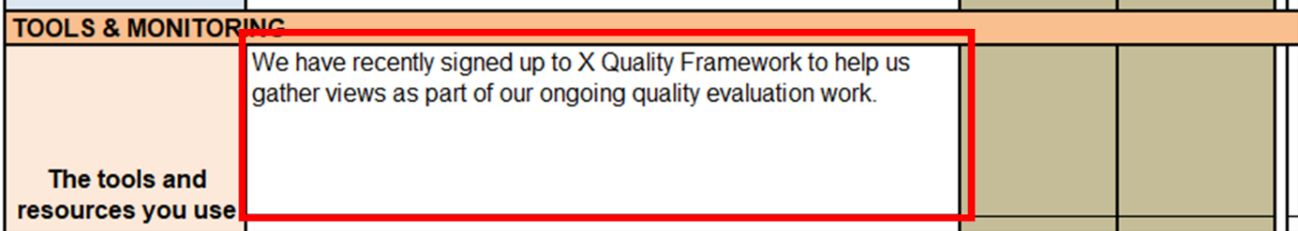

The next step is to complete the ‘Stage’ columns, to indicate whether each action is planned, in progress or established, using the dropdown menu. For this example, we have selected ‘In Progress’ for the current stage of this Action, and ‘Established’ for the expected stage at year end.

# Update on progress

To the right of the Stages columns there is a section for quarterly updates on progress.

We require quarterly progress reports against the targets and success measures set out in your Arts Council funding agreement (annual agreed Activity and Investment Principles Plans) which, where applicable, should identify any areas of activity where insufficient progress is being made and include appropriate plans and actions that have been approved by your board to help mitigate risks and/or increase progress and performance. We strongly encourage you to use the Arts Council Activity Plan (Outcomes or Investment Principles) and Investment Principles Plan templates for updates and reporting to your board.

In the screenshot below, you can see there are columns where you will add notes on progress per quarter.

# Completed Template

Once you have completed the page, click Return to Contents in the top left corner to return to the contents page.



You can then select the next Investment Principle that you will need to respond to.

**You must complete the pages for all four Investment Principles.**

# Uploading the template to Grantium

Once you have completed the template, you will need to upload it as an attachment as part of your payment request on our online system Grantium.

To upload your completed template, click on the blue hyperlink titled ‘Investment Principles Plan’, as shown below.

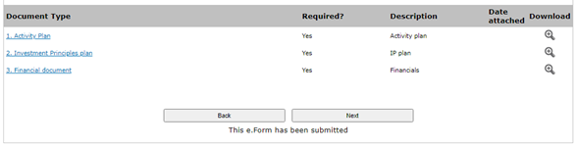

After following the link, you should be taken to the page shown below. Here you’ll be able to attach your completed template to Grantium. Once you have uploaded the file, click ‘Save & Back to List’ to return to the previous page and continue with your payment request.

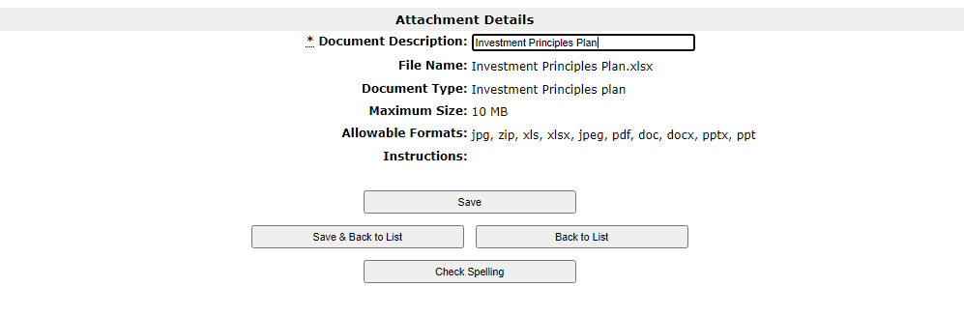

For further guidance on how to use Grantium, read the Grantium guidance on [our website](https://www.artscouncil.org.uk/grantium-support).