

How to guide: The Finance Template for

2023-26 Investment Programme and Transfer Programme

2024/25

Contents

Introduction 2

What are the financial templates and why are we using them? 2

Annual Budget 3

Cashflow Forecast 6

Uploading the template to Grantium 11

Glossary of Financial Terms 12

# Introduction

Welcome to the How to Guide for the 2023-26 Investment Programme Financial Template document.

Each applicant will need to complete three revised templates on an annual basis to form part of their funding agreement:

* [The financial template](https://www.artscouncil.org.uk/media/22090/download?attachment)
* [The Investment Principles Plan](https://www.artscouncil.org.uk/media/22091/download?attachment)
* [The Activity Plan for Outcomes](https://www.artscouncil.org.uk/media/22088/download?attachment) or [The Activity Plan for Investment Principles Support Organisations](https://www.artscouncil.org.uk/media/22089/download?attachment)

This guide will outline:

* What the financial templates are and why we’re using them
* The functions of each template
* And what you need to tell us when you’re filling them in

We also have additional resources that sit alongside this guidance to help you. These include a glossary of financial terms.

# What are the financial templates and why are we using them?

You will need to complete the new [financial templates](https://www.artscouncil.org.uk/media/22090/download?attachment) on an annual basis to form part of your funding agreement.

The financial templates are a tool for you to tell us about your organisation’s financial information through an Annual Budget, and a Cashflow Forecast.

We understand that many organisations will have their own ways of monitoring and reporting financial activity and progress, and that reporting formats can vary greatly. It is for this reason that organisations are only required to submit information in our financial templates once annually at the April payment submission.

# Annual Budget

From the tabs select ‘Annual Budget’.

The annual budget is split into sections of Income and Expenditure, as shown in the images below. You can zoom in to get a clearer view of the text in each cell.

You are required to populate the annual budget column with your organisation’s detailed annual budget figures, there is also a column where you can include any relevant supporting notes.

You should include your budgeted income and expenditure within the headings provided in the template, these include:

We understand that some organisations may budget and report in a different format than is set out here. This might mean you’ll need to group types of income or expenditure together to include within the headings provided. We have added some additional lines if you feel you wish to add extra detail.

As an example, Direct Activity costs may include fees for freelancers and production costs such as room hire and materials, where relevant. You may add detail in each section to be more specific about your Direct Activity costs.

You should provide budget information at the same level as your business plan and proposed activity. For most applicants, this will mean a whole organisational budget that includes income and expenditure that is not associated with the activity you are applying for.

In some circumstances, a budget may be more appropriate at a department level. This should be exceptional and would normally only apply to Local Authority organisations or universities.

For consortiums, your budget template should be completed for consortium activity.

# Cashflow Forecast

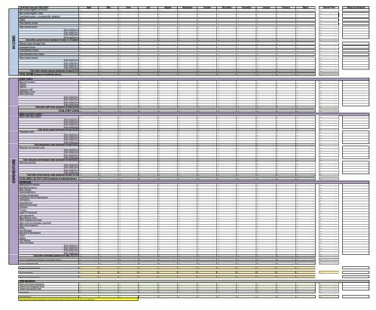The whole cashflow forecast is shown in the image below – you can zoom in to get a clearer view of the text in each cell.

The cashflow forecast should be completed for the period 1 April 2024 to 31 March 2025.

Your cashflow forecast should indicate the anticipated sources of cash income and expenditure for each month, showing the impact on your organisation’s cash position. The cash flow forecast should be a summary of all cash transactions from 1 April 2024 to 31 March 2025. You should include your projected cash income and expenditure within the headings provided in the template, as depicted below:

As with the annual budget, we understand that your organisation may not report in exactly the way we’re asking you to. This may mean you need to group types of cash income or expenditure together within the headings provided.

For many organisations, your cashflow totals will reflect your budget. This will vary depending on the scale and nature of your business.

You should forecast your cashflow as accurately as possible. For example, if your annual rent is £12,000 and you pay it quarterly, include the four payments of £3,000 in the months you expect to pay it.

There is an Annual Total column that will auto-populate as information is entered across the cashflow;

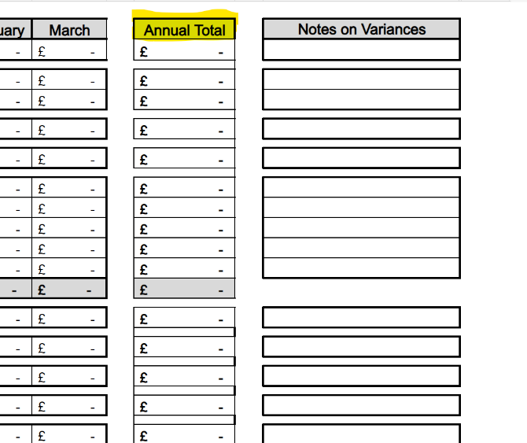

The balance brought forward figure for April, as highlighted below, should be your anticipated opening cash balance at the start of that month.

This figure should include all cash held by your organisation at the end of March 2024, for example all cash in your bank account (whether positive or negative) and petty cash accounts held by different members of your team.

Please note, the orange cell for April is the only cell where you will need to input a figure. All other orange cells will automatically populate as you complete the cashflow forecast.

The closing cash balance for each month should be broken down in the ‘Fund Balances’ section as shown below. This is to make clear whether the sources of the monthly cash balance are restricted, meaning you can’t use it for general purposes:

Please see the glossary of financial terms to help you with these definitions.

* **For local authorities and universities**, the cashflow forecast template should be completed for the service for which you are applying, for example a museum. Whilst Local Authorities and Universities should submit a cash flow at departmental/organisational level (to align with their budget) once a year as part of their financial template, we would not expect to see one submitted as part of board papers for ongoing monitoring where they are not able to provide a cashflow at the department level that we fund.
* **For libraries** which are not local authority run, you should provide financial information for the organisation as a whole, in line with requirements for all other organisations.

* **For consortiums**, the cash flow forecast template should be completed for consortium activity.

# Uploading the template to Grantium

Once you have completed the template, you will need to upload it as an attachment as part of your April payment request on our online system Grantium.

To upload your completed template, click on the blue hyperlink titled ‘Financial document’, as shown below.

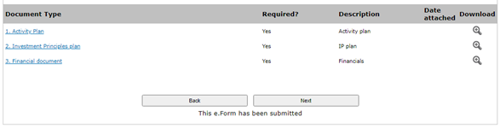

After following the link, you should be taken to the page shown below. Here you’ll be able to attach your completed template to Grantium. Once you have uploaded the file, click ‘Save & Back to List’ to return to the previous page and continue with your application.

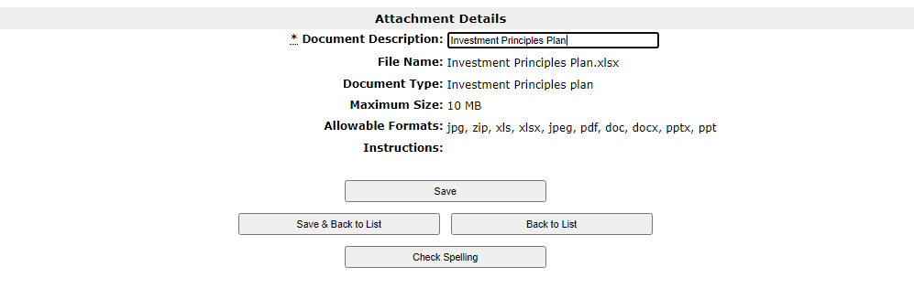

For further guidance on how to use Grantium, read the Grantium guidance on [our website](https://www.artscouncil.org.uk/grantium-support).

# Glossary of Financial Terms

|  |  |
| --- | --- |
| Budget | A plan of income and expenditure for a future period. |
| Business plan | A business plan is a written document that describes your business. It covers objectives, strategies, sales, marketing and financial forecasts. A helpful guide to business planning can be found here: [‘Business planning guidance for arts and cultural](https://www.artscouncil.org.uk/sites/default/files/download-file/Business%20Planning%20Guidance%20for%20arts%20and%20cultural%20organisations.pdf) [organisations’](https://www.artscouncil.org.uk/sites/default/files/download-file/Business%20Planning%20Guidance%20for%20arts%20and%20cultural%20organisations.pdf) |
| Cash flow forecast | Report on the estimated sources of an organisation’s income, how it plans to spend cash, when it will receive and spend cash, and the resulting change in the organisation’s cash balance |
| Current assets | Current assets are all the assets of a company that are expected to be sold or used because of standard business operations over the next year. Current assets include cash, cash equivalents, accounts receivable, stock inventory, marketable securities, pre-paid liabilities, and other liquid assets |
| Current liabilities | Current liabilities are a company's debts or obligations that are due to be paid to creditors within one year |
| Direct activity cost | Direct costs are those for all aspects of a project or programme of activity. They include salaries (and on-costs) and fees for permanent and temporary staff working on the (creative and cultural) programme, freelancers, materials and production costs |
| Endowment funds | Endowment funds are restricted assets held to benefit an organisation long-term. Endowments are property, cash or other investments that are held by a charity in the long term. These assets do not have to be spent on delivering your purpose but can be held to generate income. The income can be spent in line with the purpose of endowment  **Examples:** heritage buildings, general endowments to support ongoing costs, endowments to support bursaries, scholarships or specific posts |
| Financial Statements | Also known as: audited/unaudited accounts, annual accounts, statutory accounts. A statutory report on an organisation’s financial activities and performance over a fixed period (normally a year), and financial position at a point in time ie balance sheet, profit and loss statement (also known as income statement) |

|  |  |
| --- | --- |
| Fixed assets | Fixed assets are long-term assets that a firm owns and uses to produce income and is not expected to be used or sold within a year. Fixed assets include land, property, equipment,  investments, tangible and intangible assets |
| Free reserves | Unrestricted undesignated funds not tied up in fixed assets and investments, therefore freely available for use essentially ‘liquid  assets’ |
| Management accounts | Management accounts are an internal monitoring tool and present information for planning and control in the most helpful form for management and board |
| Non-current liabilities/Long-term  liabilities | Non-current liabilities, also known as long-term liabilities, are obligations listed on the balance sheet not due for more than a  year |
| Overheads | Overhead refers to the ongoing business expenses not directly attributed to creating a product or service. It is important for budgeting purposes but also for determining how much a company must charge for its products or services to make a profit. In short, overhead is any expense incurred to support the business while not being directly related to a specific  product or service |
| Restricted funds | Restricted funds are those funds that are donated or granted for specific purposes stated by the funder. Restricted funds can only be used for the purposes for which they were given **Examples:** project grants, capital funding, public appeals for restoration of a venue |
| Salaries | Salaries are those staff costs not directly working on the project or programme of activity. Salaries are incurred regardless of a project or programme of activity. **Examples:** marketing,  general management/administration staff |
| Unrestricted Designated funds | Designated funds are unrestricted funds that the trustees have set aside for a particular purpose. Such funds can be undesignated or re-designated.  **Examples:** funds set aside for a major project in the next one or two years, a development fund set aside to provide seed corn or match funding for projects or a fund to support innovation within the organisation |

|  |  |
| --- | --- |
| Unrestricted general funds | Unrestricted general funds are funds which are available for general use to spend on charitable objects at the trustee’s discretion.  **Examples:** core grants from public funders,  trading income, interest on main bank accounts |