How to Guide:

The Activity Plan

for Investment Principles Support Organisations

2024/25
Contents

Introduction 3
What is The Activity Plan for Investment Principles Support Organisations and who needs to complete it? 3
Why are we using it? 3
What information do you need when completing the template? 4
Investment Principles 6
Activity 7
Output/s 7
Proposed Targets and Success Measures 8
Location Form 9
If your Activity is not location-specific 10
Digital Activity 10
Local Authorities 11
Activity with National Reach 13
Activity outside of England 15
Number of days 15
Return to Activity Plan 17
Update on progress 17
Uploading the template to Grantium 18
Calculating the number of delivery days for your proposed activity 19

Introduction

Welcome to the How to Guide for The Activity Plan for Investment Principles Support Organisations.

Each applicant will need to complete and provide three updated templates on an annual basis as part of their funding agreement:
- The financial template
- The Investment Principles Plan
- The Activity Plan for Investment Principles Support Organisations

This guide will show you how to complete The Activity Plan and will outline:
- What the Activity Plan is and who needs to complete it
- Why we are using it
- Resources available to help you
- And what you need to tell us when you’re filling it in

What is The Activity Plan for Investment Principles Support Organisations and who needs to complete it?

You will need to complete the Activity Plan template annually as part of your funding requirements, to form the basis of your ongoing monitoring for each funding year.

The Activity Plan is a template that enables you to tell us about the activities you propose to deliver to other organisations and individuals to help them in the use of our Investment Principles.

There is only one template, whether you have applied to support use of one, two, three or four of the Investment Principles. You’ll be able to tell us about a total of up to ten activities, so you’ll need to think about how best to present your activity. Remember this activity is only for 2024-2025.

If you are a National Portfolio Organisation you will need to complete The Activity Plan for Outcomes 2024/25 rather than The Activity Plan for Investment Principles Support Organisations 2024/25. You can find all the resources and information you need to complete this template on our website.

Why are we using it?

We request this information using a template to ensure the information we received is consistent and comparable. We need an updated template at the start of each funding year, so that we are clear on the activity we are funding and what you will need to report progress against.

As a reminder of our four Investment Principles, you can take a look through our strategy Let’s Create, where we outline and define our four Investment Principles. You can find this on our website.

What information do you need when completing the template?

When you open this template, it will always open on the main page depicted below.

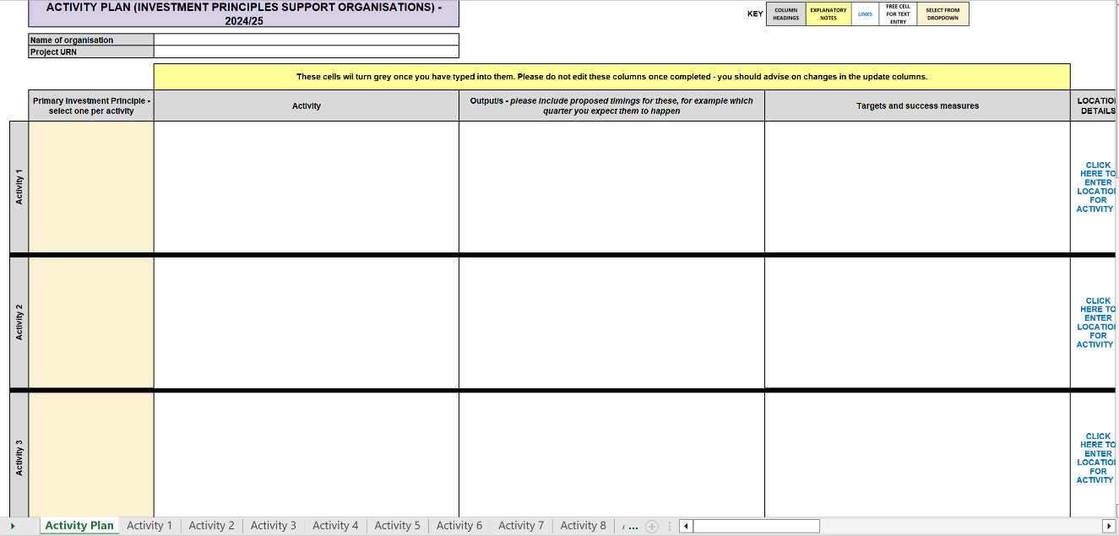
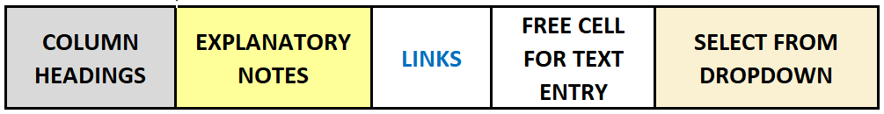
You will find a key at the top of the template. Follow the links in blue to navigate your way around the template. You can enter text in cells highlighted white and you will need to use a drop down in cells coloured beige. Please remember you will not be able to make changes to the cells in grey, yellow or those marked with a cross.

If you wish to alter your view of the template, you can use the zoom function to the bottom right of your screen.
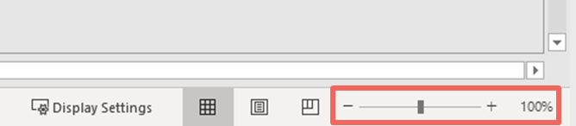

In this box in the top left of the main Activity Plan, you’ll need to state the name of the organisation. In the space below, you’ll need to quote your Project Unique Reference Number, which was generated when you began making your application on Grantium. This number should start with NPIP (or NPTP if you are a Transfer organisation).

Investment Principles

To begin, use the drop down highlighted below to select which of our Investment Principles the Activity you are going to deliver will contribute to. This can be either:

- Inclusivity & Relevance
- Environmental Responsibility
- Dynamism
- Ambition & Quality
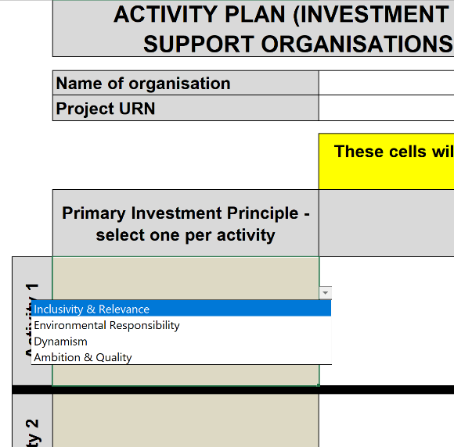

You can only select one Investment Principle per Activity entered, so only include Activities where contributions to the selected Investment Principle are clear and demonstrable.
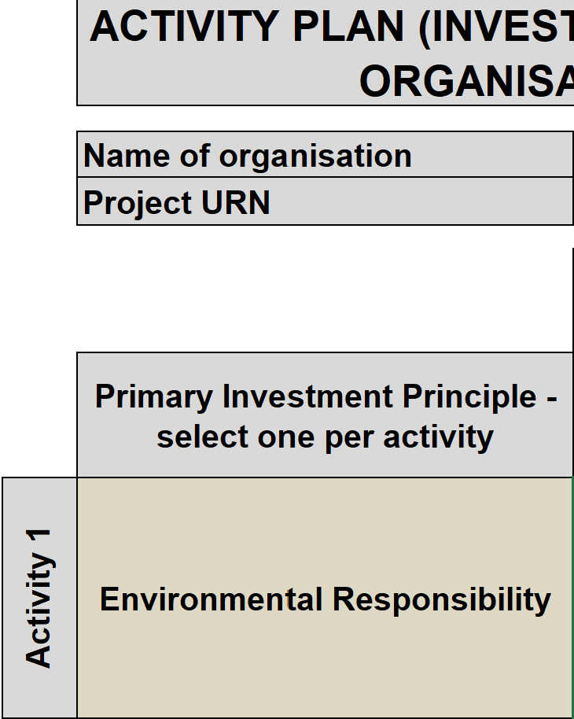

Activity

You then have a free text box to describe your proposed Activity in the box highlighted below. The Activity should link to the Investment Principle you have selected. There is no character limit on this text box.

Please include additional investment activity if your award includes additional investment.
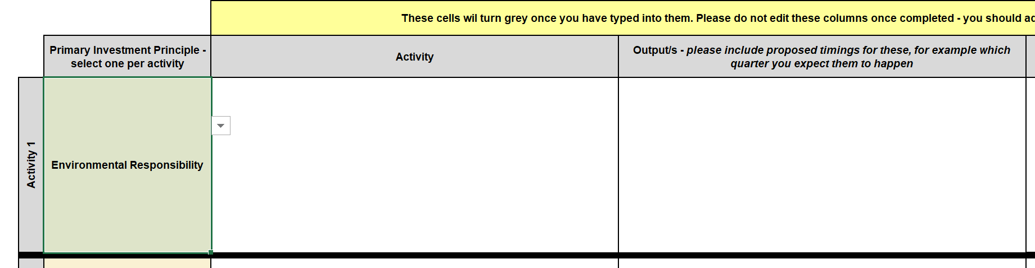

Output/s

To the right of the Activity column is a box for your Output/s. By Output we mean what your activity will produce, such as a publication, training, or workshop. Whilst there aren't any character count limits in this template, we would advise you to be concise in your responses. You can list your Output or Outputs in the box highlighted below.

Proposed Targets and Success Measures

For each Activity, we then ask you to write your Targets and Success Measures.

A target might use figures or percentages to quantify your aim - who might benefit, how many people etc. A success measure might be the change you aim to achieve and how you might measure it.
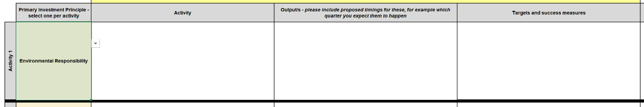

We then need you to provide location details for each Activity you detail in this template. By clicking the link, as shown below, you will be taken to the Location Form.
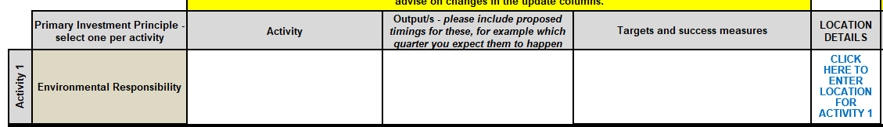

You can also navigate to the Location Forms using the tabs that are visible at the bottom of the spreadsheet window.
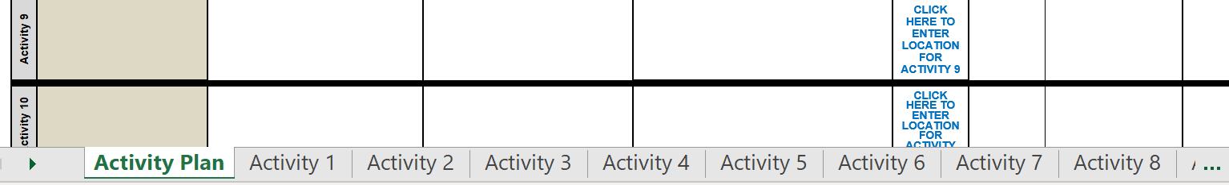

Location Form

You will see that there is a separate Location Form link for each proposed Activity, and you will need to complete these for every Activity you have entered, even if the location of your Activity is the same.
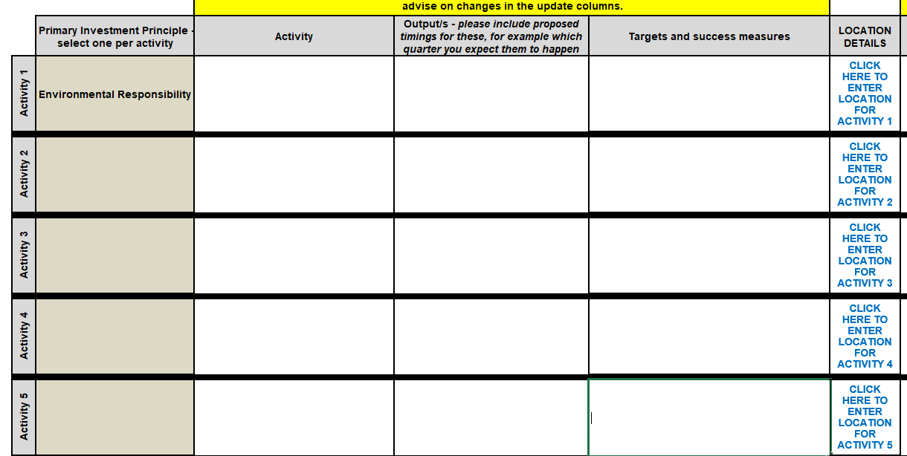

When you follow the link or tab to the Location Form, it will take you to this page:
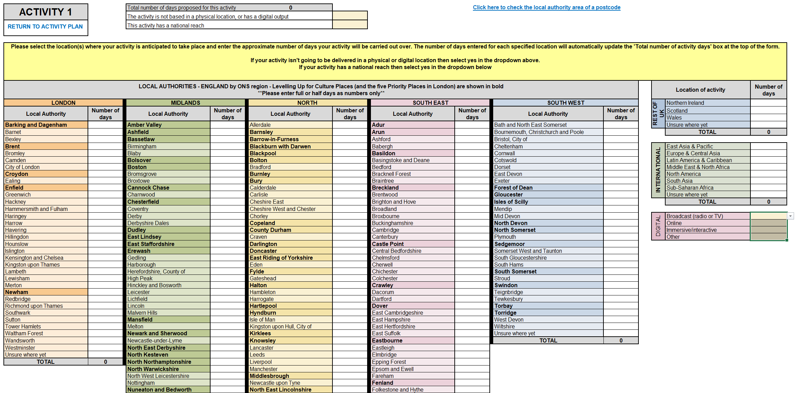

Please provide as much detail as you can about the location/s of your Activities.

If your Activity is not location-specific

If the Activity you have entered is not location-specific – for example, it is a product or physical resource – and it does not have a digital output, then you can Select ‘Yes’ at the top of the form as highlighted below.

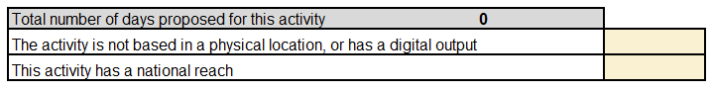

Digital Activity

If your Activity will be delivered and published digitally, please use the tick boxes to the right of the location form.

In the Digital tick box, you can tell us what type of digital products you will be creating as part of your activity. A ‘Broadcast’ might include TV or Radio broadcast, an ‘Online’ product might be a video on YouTube, use of streaming platforms, seminars using Zoom, podcasts, or web-based publication/performance. Immersive/Interactive activity might be AR, VR, XR or Gaming.
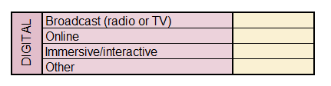

Local Authorities

In the middle of the Location Form, highlighted below, you will see a list of Local Authorities split into the five English regions: London, North, Midlands, South East and South West. These regions have been categorised using the Office for National Statistics regional definitions.
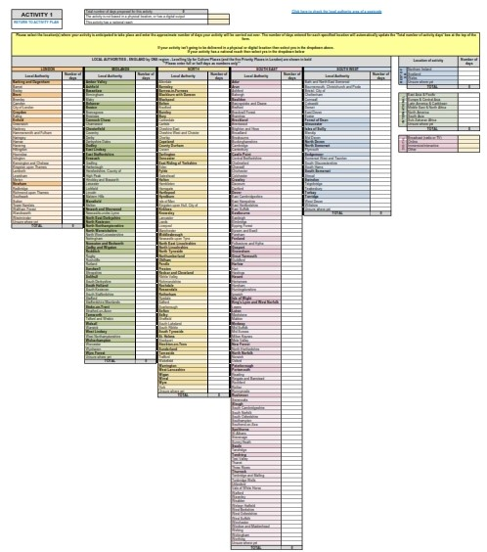

As shown below, the Local Authorities that are in bold are the Arts Council’s Priority Places, 54 places across the five English regions, we have identified where we want to increase both our staff, resources, and financial investment.

We’d like you to tell us which local authorities you anticipate your proposed activity will take place in. We’d also like you to calculate how many days of activity you are planning to hold in each local authority and enter that figure in the ‘Number of days’ column shown below. For more guidance on calculating the number of days for different types of Activity, read the guidance found at the end of this guide.

If you know the postcode of your location but not the Local Authority in which it sits, there is a link to the gov.uk website top right corner of the form, where you can search a postcode to find out which Local Authority it belongs to.

Where you know the region your activity will take place in but not the specific Local Authority, you can provide the number of days in the box shown below, next to ‘Unsure where yet. You will find this box at the bottom of each region.

Activity with National Reach
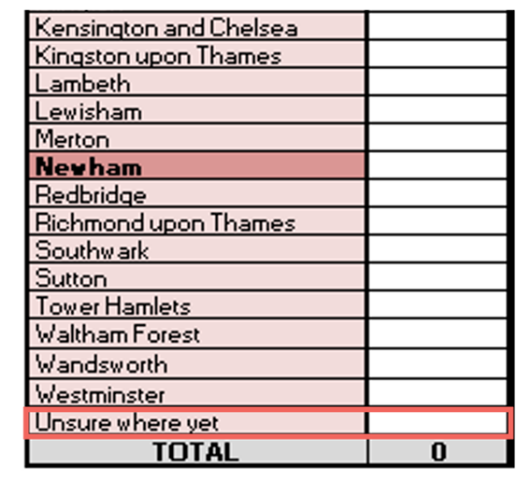
By National Reach, we are referring to Activity that takes place in every Local Authority across England. (ie the whole of England, rather than in a number of specific Local Authorities). If your Activity meets this definition then select ‘Yes' at the top of the form that says, ‘This activity has national reach’. You should not select ‘Yes’ if your Activity takes place in specific Local Authorities or has disproportionately more coverage in on or more Local Authorities.

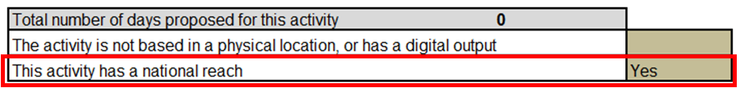

Example

Q: I am a company that is planning to deliver activity that will have national coverage in at least forty different Local Authorities across England, some of which are Priority Places. Should I tick the box that says this activity has a national reach?

A: No. You should provide the number of days you expect to deliver in each of the forty Local Authorities where Activity is being planned.

Activity outside of England

If any part of your activity is happening outside of England, use the boxes provided to the right of the form, to outline the number of days of planned activity in the Rest of the UK or Internationally.
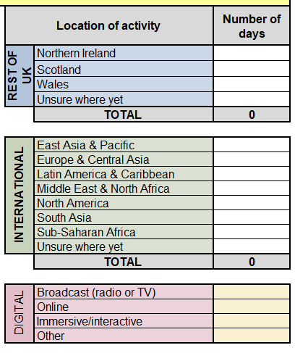

Number of days

Remember that, where possible, the figures included in the ‘Number of days’ column should correspond to the Outputs, Targets and Success Measures that you provided on the main activity form.

If you would like to indicate that your activity will take place for half a day, you can reference it using decimals, as shown below.

Once you have added the estimated number of days for each of your selected locations, the total number of days proposed for your activity will appear in this box at the top of the location form.
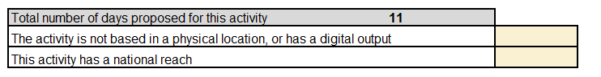

The total number of days proposed in each region, in the Rest of the UK and Internationally can be found at the bottom of each column.
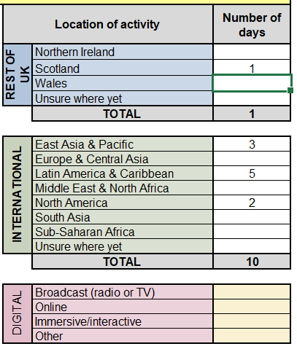

Return to Activity Plan

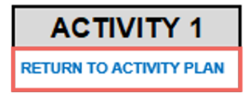
When you have provided the location information for your activity, click ‘Return to Activity Plan’ or navigate using the tabs at the bottom of the window. Then you can move on to repeat the process to add your next activity if you have one.

Update on progress

To the right of location details there is a section for quarterly updates on progress.

We require quarterly progress reports against the targets and success measures set out in your Arts Council funding agreement (annual agreed Activity and Investment Principles Plans) which, where applicable, should identify any areas of activity where insufficient progress is being made and include appropriate plans and actions that have been approved by your board to help mitigate risks and/or increase progress and performance. We strongly encourage you to use the Arts Council Activity (Investment Principles) and Investment Principles Plans templates for updates and reporting to your board.

In the Activity Plan, there is a box for an update on progress that has been made per activity. There is a separate box for notes on significant variations against planned activity (for example, a significant change in activity days).
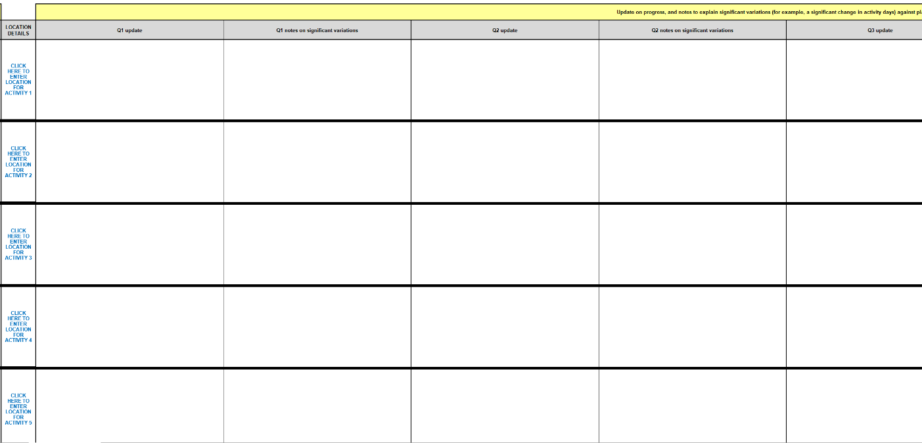

Uploading the template to Grantium

Once you have completed the template, you will need to upload it as an attachment as part of your April 2024 payment request on our online system Grantium.

To upload your completed template, click on the blue link titled ‘Activity Plan’, as shown below.
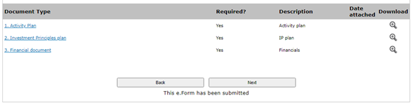

After following the link, you should be taken to the page shown below. Here you’ll be able to attach your completed template to Grantium. Once you have uploaded the file, click ‘Save & Back to List’ to return to the previous page and continue with your payment request.
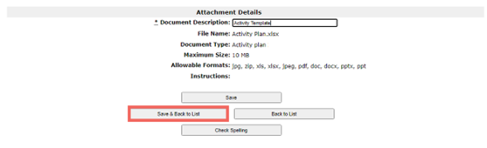

For further guidance on how to use Grantium, see the Grantium guidance on our website.

Calculating the number of delivery days for your proposed activity

The updated Activity Plan that you need to complete requires you to determine both the location(s) you expect your activities to be delivered in and the number of days of delivery you expect this activity to produce.

The examples and definitions provided in the table below are there to act as guideline for applicants completing the location elements of the template. The list of example activities is not exhaustive, and applicants can propose to deliver a wide range of activity types designed to support the use of our Investment Principles. Some of these may not be location-specific.

For the purposes of the Location Form, we are looking for location information to be entered for activities that are designed to support individuals or organisations embed our Investment Principles. For these activities, you will be asked to enter the estimated number of delivery days these activities will produce – you can use the definitions and example in the table below to help you calculate this figure.

Applicants should use their own judgement when completing this part of the template and we will only use this information as a metric for understanding the potential reach and engagement of your proposed activity, and how the best possible value of our investment can be achieved.

Activity type | Definition | Calculating the number of delivery days
Live event / conference etc | An event with a live audience. These may be delivered in a single venue or across multiple locations  The activity may take place over a single day or over a number of days. | Each event day should be classed as one day of activity (ie if there are 2 or 3 iterations of the same event in one day, then these should be grouped as a single day of activity). If for instance an event is repeated three times on separate days then you should show this as 3 days in the Location Form
An exhibition | An exhibition (eg an exhibition in a museum) that is accessed by a live audience.  Exhibitions may take place in a single location or visit multiple venues/locations, either simultaneously or consecutively. | Exhibitions are usually classed as one day of activity for every day the exhibition or event is open to audiences (ie if it is open for 14 days then it should be classed as 14 days of activity).
Digital experience, stream or broadcast | A creative event or asset that is designed to be distributed and/or experienced through digital platforms or hardware (eg headsets or personal devices). This may include events and conferences that are streamed live or broadcast as a recording of a live event.  Typically, these activities will not be location-specific (ie if they can be experienced widely online, on personal devices or via broadcast).  However, there may be occasions where digital activities are more location specific (ie site specific immersive experiences and exhibitions, digital tours and online participatory work with specific communities) | If your activity meets the description for a digital experience, stream or broadcast then please tick the relevant box/es in the digital section of the location from.  If your activity is also location specific, then please ensure you tick the relevant digital activity box/es and provide the number of presentation days in each location.
Participatory sessions/training workshops | These activities will usually focus on engaging individuals and communities for a specific purpose related to the relevant Investment Principles | Sessions will often be variable in nature, but as a general rule, each participatory session can be expressed as half a day of activity (eg 20 workshops would be classed as ten days’ activity).
Development activity | You should only include development activity that results in an output that is public facing eg a publication | If your development activity is product-based with a defined purpose or output (eg publishing research), then for the purpose of the location form you should select the ‘none of the activity is based in a physical location, or has a digital output' box. If your development activity results in some form of public presentation or event, then you should treat it as an event as outlined above.

