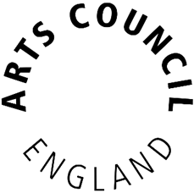

How to Guide:

The Activity Plan

for Outcomes

for National Portfolio Organisations

2024/25

Contents

Introduction 3
What is The Activity Plan for Outcomes and who needs to complete it? 3
Why are we using it? 4
What information do you need when completing the template? 4
Outcomes 5
Elements 6
Activity 7
Output/s 8
Proposed Targets and Success Measures 8
Location Form 10
Digital Activity 12
Local Authority Locations 13
Activity with National Reach 15
Activity outside of England 16
Number of days 17
Return to Activity Plan 18
Update on progress 18
Uploading the template to Grantium 19
Calculating the number of delivery days for your proposed activity 20

Introduction

Welcome to the How to Guide for the Activity Plan for Outcomes for National Portfolio Organisations.

Each applicant will need to complete three updated templates on an annual basis to form part of their funding agreement:
- The financial template
- The Investment Principles Plan
- The Activity Plan for Outcomes

This guide will show you how to complete the Activity Plan and will outline:
- What the Activity Plan is and who needs to complete it
- Why we are using it
- Resources available to help you
- And what you need to tell us when you’re filling it in

What is The Activity Plan for Outcomes and who needs to complete it?

The Activity Plan is a template for you to use to tell us how your organisation’s proposed activity for the 2024-2025 funding year will contribute to our Let’s Create Outcomes and their associated Elements.

There is only one Activity Plan template to complete, whether you have applied to deliver against one, two or three of the Outcomes. You’ll be able to tell us about a total of up to ten activities, so you’ll need to think about how best to present your activity. Remember this activity is only for 2024-2025.

You will need to complete the Activity Plan template annually as part of your funding requirements, to form the basis of your ongoing monitoring for each funding year.

If you are an Investment Principles Support Organisation you will need to complete the Activity Plan for Investment Principles Support Organisations rather than the Activity Plan for Outcomes. You can find all the resources and information you need to complete this template on our website.

Why are we using it?

We request this information as part of your funding agreement using a template to ensure the information we receive is consistent and comparable. We need an updated template at the start of each funding year that will form part of your funding monitoring, so that we are clear on the activity we are funding and what you will need to report progress against.

As a reminder of our three Outcomes, we advise you to take a look through our strategy Let’s Create, where we outline and define our three Outcomes. You can find this on our website.

What information do you need when completing the template?

When you open this template, it will always open on the main page depicted below.
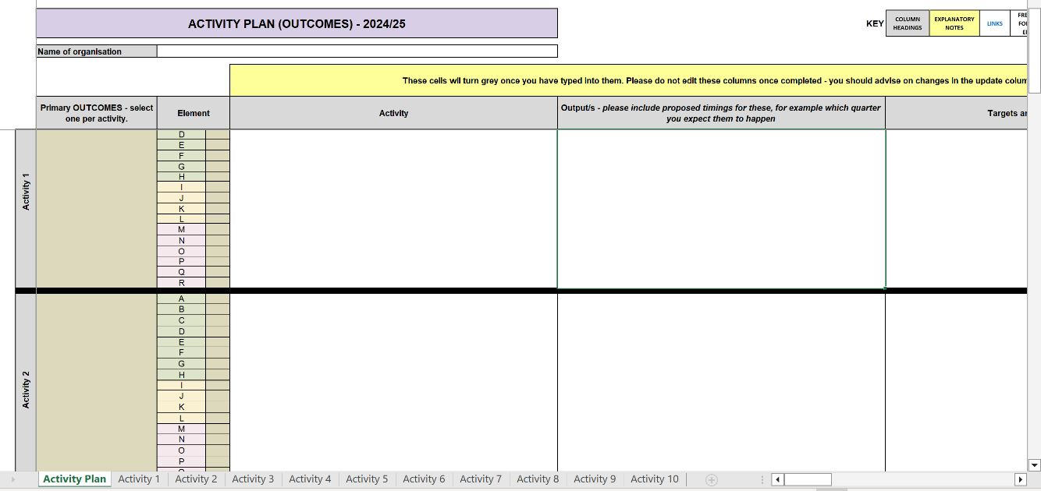

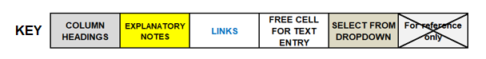
You will find a key at the top of the template. Follow the links in blue to navigate your way around the template. You can enter text in cells highlighted white and you will need to use a drop down in cells coloured beige. Please remember you will not be able to make changes to the cells in grey, yellow or those marked with a cross.

If you wish to alter your view of the template, you can use the zoom function to the bottom right of your screen.
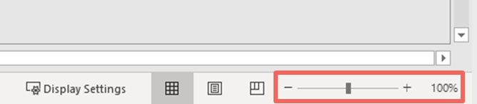

In this box in the top left of the main Activity Plan, you’ll need to state the name of the organisation.

Outcomes

To begin, use the drop down highlighted below to select which primary Outcome the activity you are going to deliver will contribute to. This can be either:

- Creative People
- Cultural Communities or
- A Creative and Cultural Country

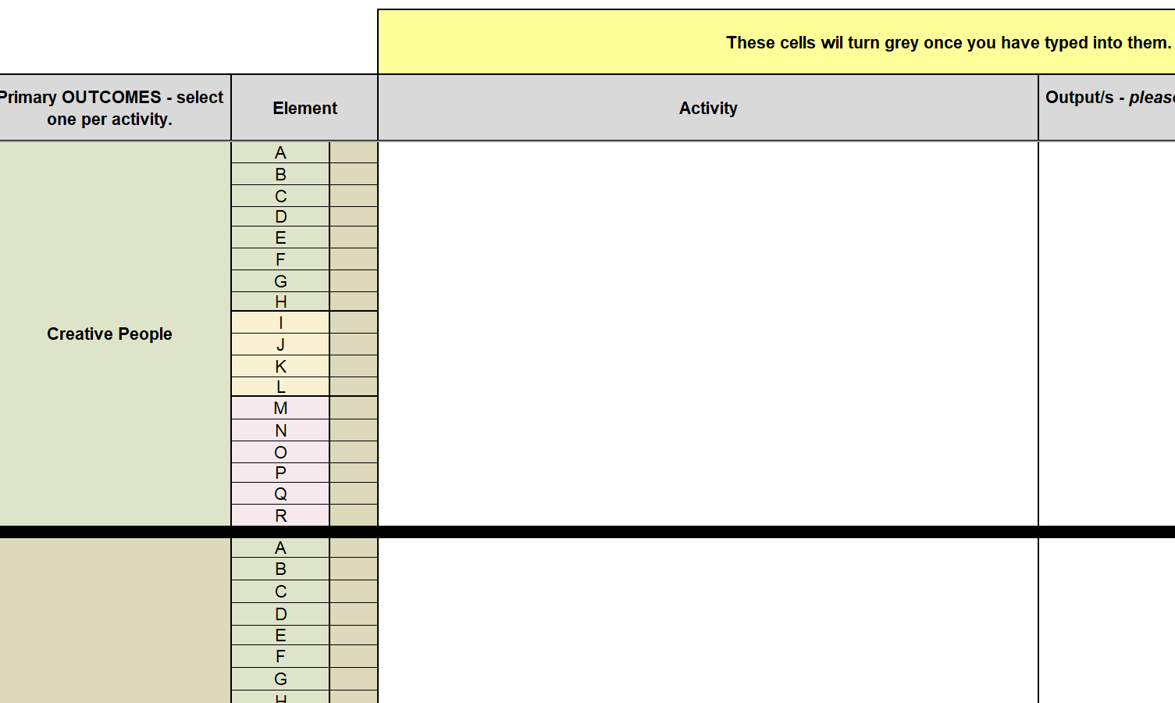
You can only select one Outcome per activity entered, so only include Activities where contributions to the selected Outcome are clear and demonstrable.

Elements

Once you have selected the primary Outcome, you must indicate which associated Elements of the selected Outcome your Activity will fulfil by selecting ‘Yes’ or ‘No’ from the dropdown menu beside each Element. You can select multiple elements, but you should ensure you only select those that relate to the primary Outcome you chose for that Activity. You must select at least one Element.
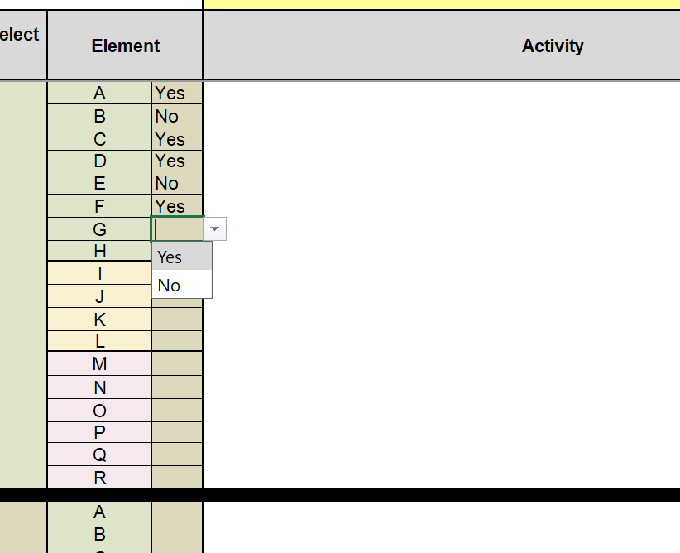

On the right of the template, you will see the list of all of the Elements. We have provided a screenshot of the Outcome and Element descriptors below.
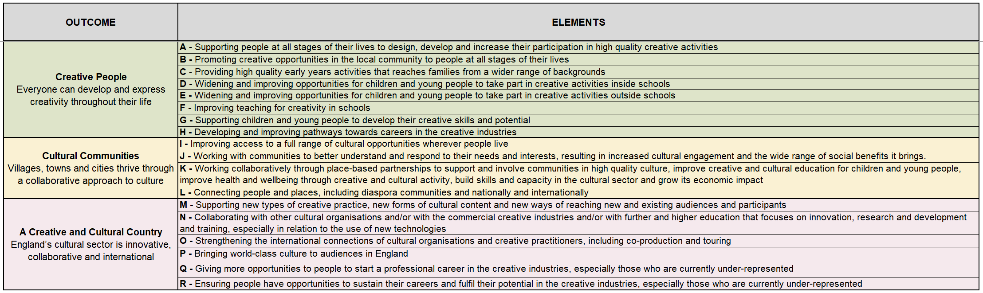

Activity

You’ll then have a free text box to describe your proposed Activity in the box highlighted below. The Activity should link to the Outcome and Elements you have selected.

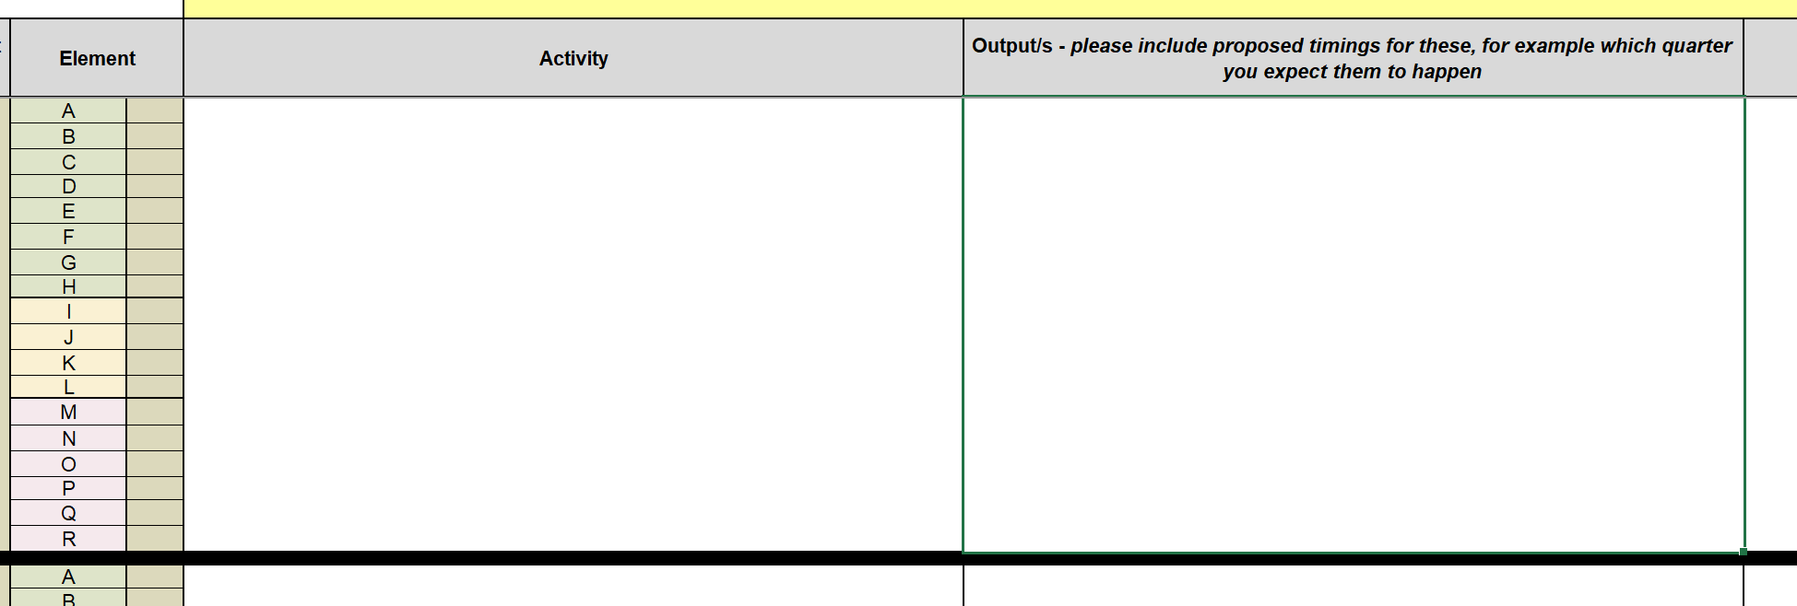
Please include additional investment activity if your award includes additional investment.

Output/s

To the right of the Activity text box is a box for your Output/s. By Outputs we mean what your Activity will produce, such as a performance, publication, exhibition, or workshop. Whilst there aren't any character count limits in this template, we would advise you to be concise in your responses. You can list your Output or Outputs in the box highlighted below.

Proposed Targets and Success Measures

For each Activity, we then ask you to write your Targets and Success Measures.
A target might use figures or percentages to quantify your aim - who might benefit, how many people etc. A success measure might be the change you aim to achieve and how you might measure it.

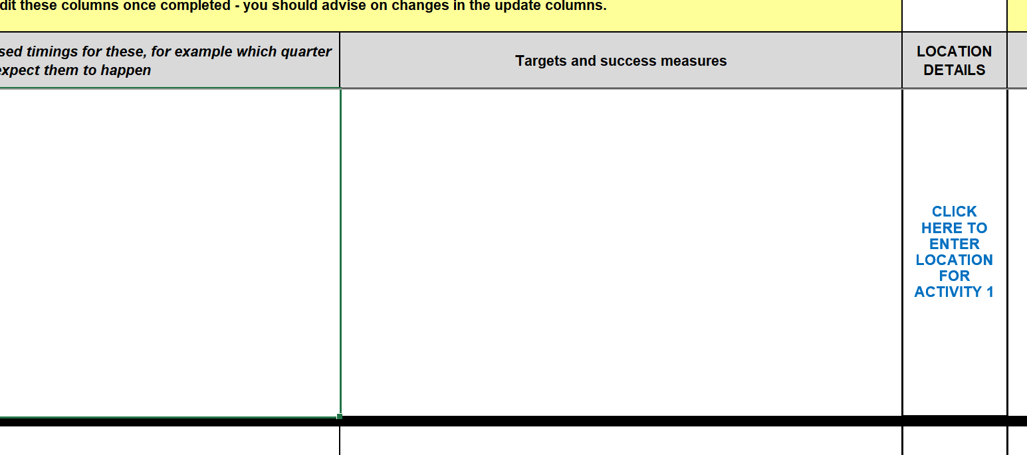

We then need you to provide location details for each Activity you detail in this template. By clicking the link, as shown below, you will be taken to the Location Form.

You can also navigate to the Location Forms using the tabs that are visible at the bottom of the spreadsheet window.

Location Form

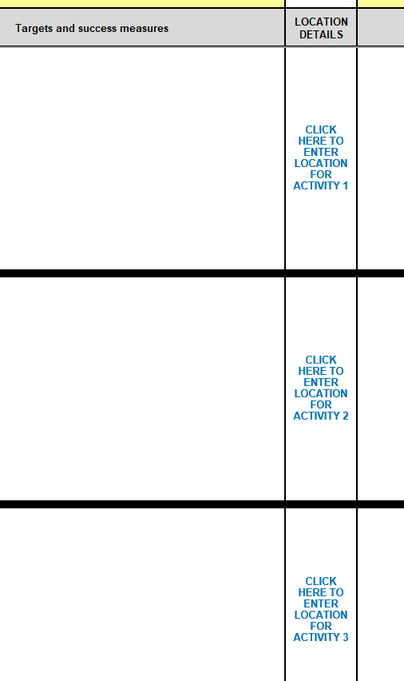
You will see that there is a separate Location Form link for each proposed Activity, and you will need to complete these for every Activity you have entered, even if the location of your Activity is the same.

When you follow the link to the Location Form, it will take you to this page:
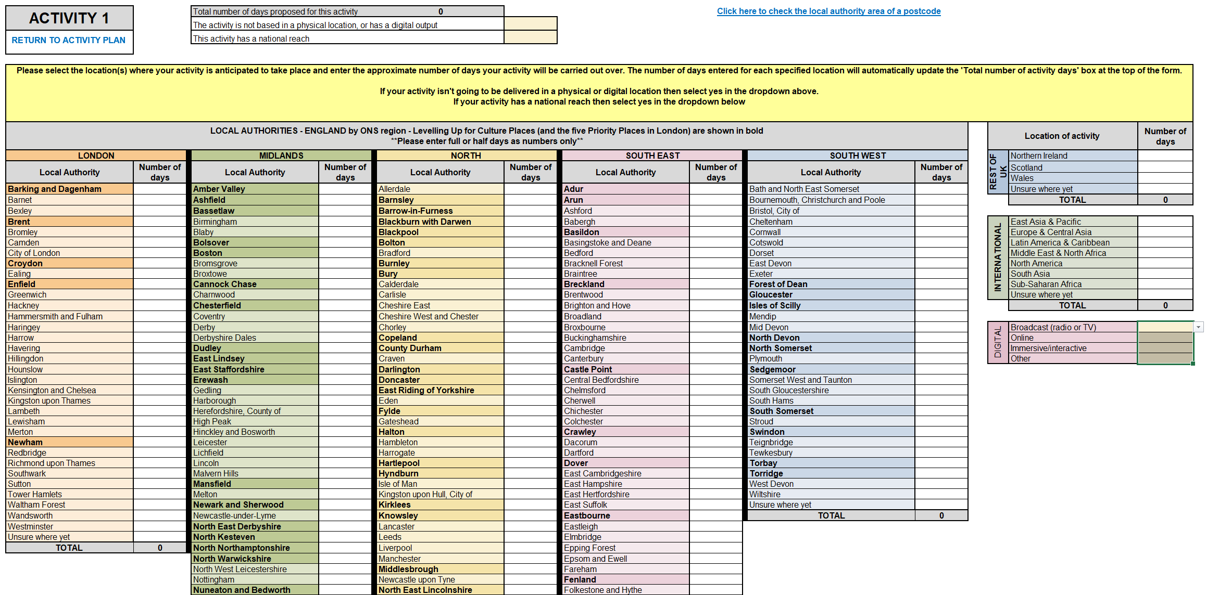

Provide as much detail as you can about the location/s of your Activities.

If the Activity you have entered is not location-specific – for example, it is a product or physical resource – and it does not have a digital output, then you can tick the box at the top of the form as highlighted below.

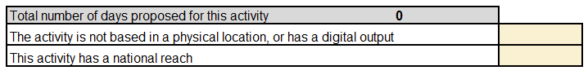

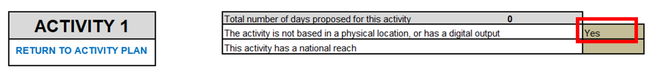

Digital Activity

If your Activity will be delivered and published digitally, please use the boxes to the right of the location form.
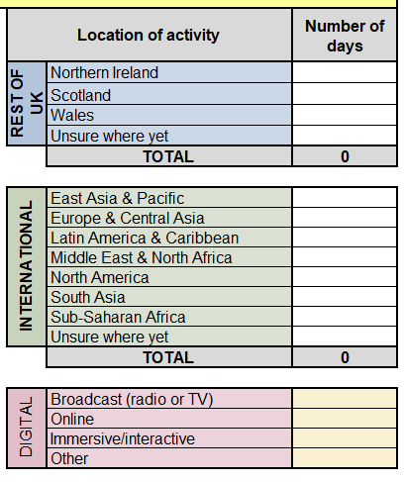

In the Digital box, you can tell us what type of digital products you will be creating as part of your activity. A ‘Broadcast’ might include TV or Radio broadcast, an ‘Online’ product might be a video on YouTube, use of streaming platforms, seminars using Zoom, podcasts, or web-based publication/performance. Immersive/Interactive activity might be AR, VR, XR or Gaming.
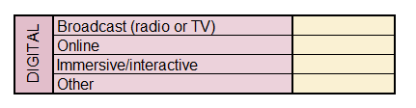

Local Authority Locations

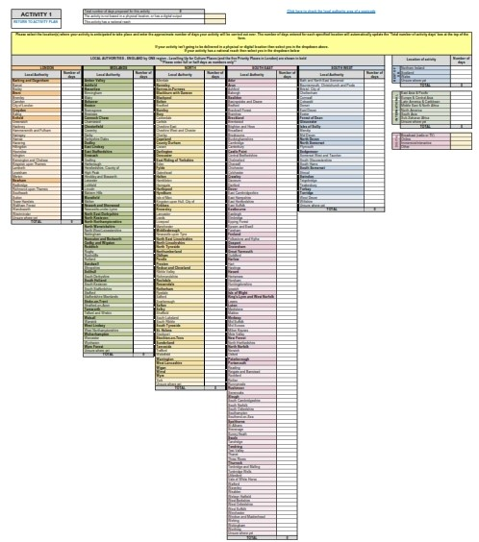
In the middle of the Location Form, highlighted below, you will see a list of Local Authorities split into the five English regions: London, North, Midlands, South East and South West. These regions have been categorised using the Office for National Statistics regional definitions.

As shown below, the Local Authorities that are in bold are the Arts Council’s Priority Places, 54 places across the five English regions, we have identified where we want to increase both our staff, resources, and financial investment.

We’d like you to tell us which Local Authorities you anticipate your proposed Activity will take place in. We’d also like you to calculate how many days of Activity you are planning to hold in each Local Authority and enter that figure in the ‘Number of days’ column shown below. For more guidance on calculating the number of days for different types of Activity, read the guidance found at the end of this guide.

If you know the postcode of your location but not the Local Authority in which it sits, there is a link to the gov.uk website top right corner of the form, where you can search a postcode to find out which Local Authority it belongs to.

Where you know the region your Activity will take place in but not the specific Local Authority, you can provide the number of days in the box shown below, next to ‘Unsure where yet’. You will find this box at the bottom of each region.
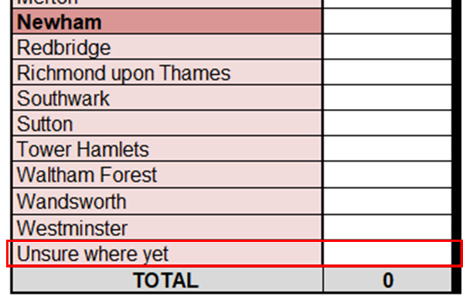

Activity with National Reach

By National Reach, we are referring to Activity that takes place in every Local Authority across England. (ie. the whole of England, rather than in a number of specific Local Authorities). If your Activity meets this definition then select 'Yes’ at the top of the form that says, ‘This activity has national reach’. You should not select ‘Yes’ if your Activity takes place in specific Local Authorities or has disproportionately more coverage in one or more Local Authorities.
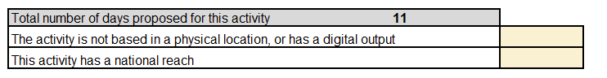

Example

Q: I am a touring company that is planning to deliver activity that will have national coverage in at least forty different Local Authorities across England, some of which are Priority Places. Should I tick the box that says this activity has a national reach?

A: No. You should provide the number of days you expect to deliver in each of the forty Local Authorities where Activity is being planned.

Activity outside of England

If any part of your Activity is happening outside of England, use the boxes provided to the right of the form, to outline the number of days of planned activity in the Rest of the UK or Internationally.

Number of days

Remember that, where possible, the figures included in the ‘Number of days’ column should correspond to the Outputs, Targets and Success Measures that you provided on the main Activity Form.

If you would like to indicate that your Activity will take place for half a day, you can reference it using decimals, as shown below.
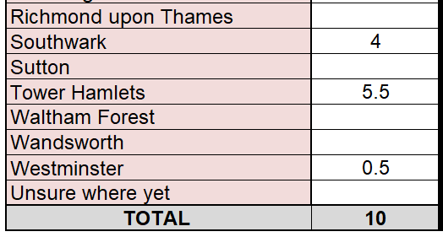

Once you have added the estimated number of days for each of your selected locations, the total number of days proposed for your Activity will appear in this box at the top of the location form.

The total number of days proposed in each region, in the Rest of the UK and Internationally can be found at the bottom of each column.
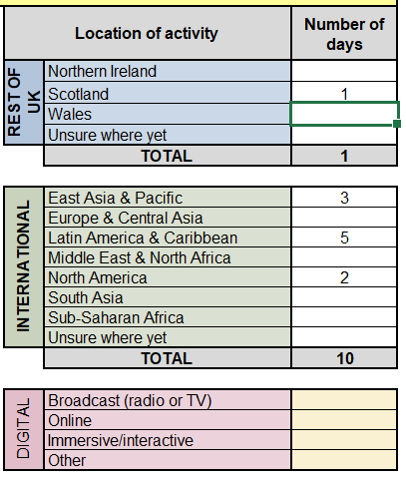

Return to Activity Plan

When you have provided the location information for your activity, click ‘Return to Activity Plan’ or use the tabs at the bottom of the window to navigate back to the Activity Plan. Then you can move on to repeat the process to add your next activity if you have one.
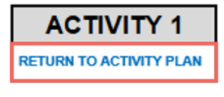

Update on progress

To the right of location details there is a section for quarterly updates on progress.

We require quarterly progress reports against the targets and success measures set out in your Arts Council funding agreement (annual agreed Activity and Investment Principles Plans) which, where applicable, should identify any areas of activity where insufficient progress is being made and include appropriate plans and actions that have been approved by your board to help mitigate risks and/or increase progress and performance. We strongly encourage you to use the Arts Council Activity (Outcomes) and Investment Principles Plans templates for updates and reporting to your board.

In the Activity Plan, there are boxes available for quarterly updates on progress that has been made per activity. There is a separate box for notes on significant variations against planned activity (for example, a significant change in activity days).
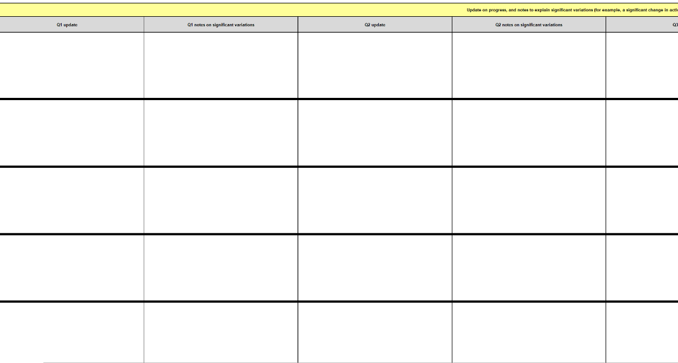

Uploading the template to Grantium

Once you have completed the template, you will need to upload it as an attachment as part of your April 2024 payment request on our online system Grantium.

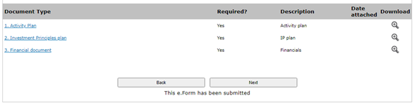
To upload your completed template, click on the blue link titled ‘activity template’, as shown below.

After following the link, you should be taken to the page shown below. Here you’ll be able to attach your completed template to Grantium. Once you have uploaded the file, click ‘Save & Back to List’ to return to the previous page and continue with your payment request.

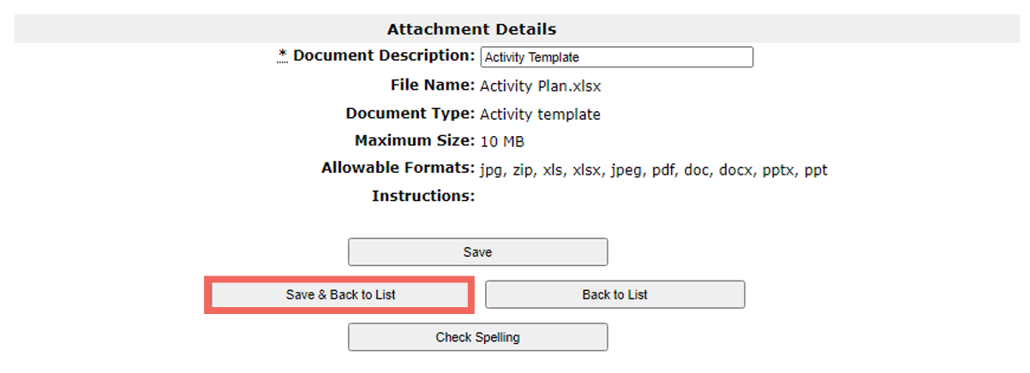

For further guidance on how to use Grantium, see the Grantium guidance on our website.

Calculating the number of delivery days for your proposed activity

The updated Activity Plan that you will be asked to complete to form part of your funding agreement requires you to determine both the location(s) you expect your activities to be delivered in and the number of days of delivery you expect this activity to produce.

The examples and definitions provided in the table below are there to act as guideline for applicants completing the location elements of the template. The list of example activities is not exhaustive, and applicants can propose to deliver a wide range of activity types that may contribute to the delivery of the Let’s Create Outcomes. Some of these may not be location-specific.

For the purposes of the Location Form, we are looking for location information to be entered for activities that are considered to be ‘public-facing’. For these activities, you will be asked to enter the estimated number of delivery days these activities will produce – you can use the definitions and example in the table below to help you calculate this figure.

Applicants should use their own judgement when completing this part of the template and we will only use this information as a metric for understanding the potential reach and engagement of your activity, and how the best possible value of our investment can be achieved.

Activity type | Definition | Calculating the number of delivery days
Live show / performance | A creative show or performance (eg a show in a theatre) with a live audience. These may be delivered in a single venue or across multiple locations (i.e. a tour).  The activity may take place over a single day or over a number of days. | Shows and performances should be classed as one day of performance activity (ie if there are 2 or 3 performances in one day, then this should be counted as a single day of performance activity). If for instance there are 24 performance days, then you should show this as 24 days in the Location Form.
Live event / exhibition | A creative event or exhibition (eg an exhibition in a museum) that is accessed by a live audience.  Exhibitions and events may take place in a single location or visit multiple venues/locations, either simultaneously or consecutively. | Exhibitions and events are usually classed as one day of activity for every day the exhibition or event is open to audiences (ie if it is open for 14 days then you should include 14 days in the Location Form).
Digital experience, stream or broadcast | A creative event or asset that is designed to be distributed and/or experienced through digital platforms or hardware (eg headsets or personal devices). This may include creative events and performances that are streamed live or broadcast as a recording of a live event.  Typically, these activities will not be location-specific (eg if they can be experienced widely online, on personal devices or via broadcast).  However, there may be occasions where digital activities are more location specific (eg site specific immersive experiences and exhibitions, digital tours and online participatory work with specific communities) | If your activity meets the description for a digital experience, stream or broadcast then please tick the relevant box/es in the digital section of the location from.  If your activity is location specific, then please ensure you tick the relevant digital activity box/es and provide the number of performance days in each location.
Participatory sessions | These activities will usually focus on engaging individuals and communities for a specific creative or cultural purpose (eg artistic workshop). | Sessions will often be variable in nature, but as a general rule, each participatory session can be expressed as half a day of activity (eg 20 workshops would be classed as ten days’ activity).
Development activity | You should only include development activity that results in an output that is public facing eg a publication or a public ‘try out’. | If your development activity is product-based with a defined purpose or output (eg publishing research), then for the purpose of the location form you should select the ‘none of the activity is based in a physical location, or has a digital output' box. If your development activity results in some form of public presentation then you should treat it as a performance as outlined above.

