Transforming Governance Case Studies

The following document provides a series of Case Studies for participants of the Transforming Governance Programme.

Overview of Governance for Charity Trustees
This module provides an overview of good governance, as well as the roles, responsibilities and needs of Trustees. The following Case Studies provide examples of good practice across the charity sector.

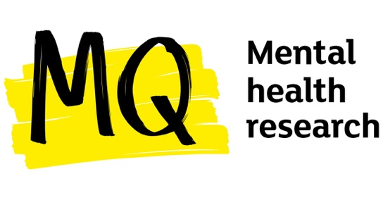
MQ Mental Health Research

MQ Mental Health Research (MQ) is a leading mental health research charity, with a vision to create a world where mental illnesses are understood, effectively treated, and eventually prevented. The charity does this by launching research into the detection, treatment, and prevention of mental illness while ensuring long-lasting impact.
The organisation’s board led the charity through considerable change during the Covid-19 pandemic, recognising that there would be both immediate and long-lasting impact on the charity’s cause and mission.
The board reacted quickly and decisively and embraced its position as the UK’s leading mental health research charity and as a respected broker between the academic, public and third sector. It quickly moved to convene senior scientific leaders and people with lived experience of mental illness to lay out the research priorities for mental health in the pandemic.
This was followed by convening an expert group, developing a robust research paper, and influencing some of the largest UK funders to activate change in the sector. This organisation shows a positive example of a board of Trustees focusing on leading strategy in turbulent times.
More information here

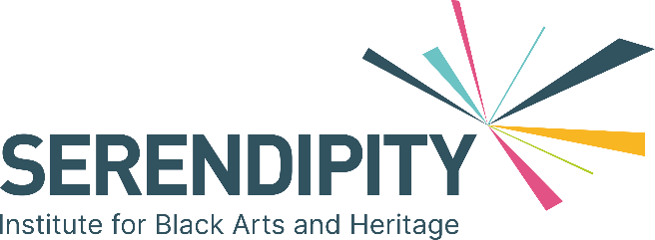

Serendipity

Serendipity Institute for Black Arts and Heritage is a cultural organisation with a profound mission: to place the perspectives of the African and African Caribbean Diaspora at the forefront of cultural experiences for all.

Founded in 2010, Serendipity has forged a significant presence in the cultural landscape, both locally and internationally. The organisation offers a diverse range of programmes, including the renowned Let’s Dance International Frontiers dance festival, participation in Black History Month, and hosting the annual Windrush Day Lecture.

Furthermore, its legacy initiatives are vital components of the charity’s work, encompassing the Living Archive, publication of works by Black arts practitioners, nurturing emerging artists, and mentoring young individuals.

Serendipity's journey has been one of evolution and recognition. It transitioned into a charitable organisation in 2015 and achieved National Portfolio Organisation status in 2018. The governance model of Serendipity revolves around a dedicated board of trustees who act as the guardians of the organisation's mission and purpose.

This board comprises industry leaders with expertise in arts and festival management, education, and artistic practice. The board's composition aligns with Serendipity's primary objective of championing diversity within the arts. The wealth of knowledge and experience guides the organisation in ensuring that its work reflects the demographics of the UK and maintains a high standard of quality and ambition.

Serendipity Institute for Black Arts and Heritage is an influential force in promoting and celebrating the cultural contributions of the African and African Caribbean Diaspora, with a governance model rooted in strong leadership, a commitment to diversity, and a dedication to producing high-quality cultural programming and activities.

More information here

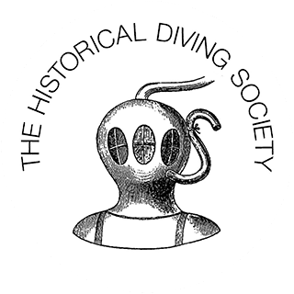
Historical Diving Society

The Historical Diving Society was founded in 1990 by enthusiasts with an interest in the history of diving.
The Society is based in Gosport, a naval town with significant links to the history of diving over the past 200 years. One of their core aims was to create a museum which they did in 2011 and they began to amass a collection of diving related objects, records and books.
Over time, the Society achieved charitable status. It remains an entirely volunteer organisation, with eight trustees and many volunteers taking responsibility for collections care, fundraising and partnership development as well as opening the museum to visitors.
The board consists of individuals from a range of backgrounds and experience, from education, heritage, finance, consultancy, environment, and more, and is supported by an expert advisory panel to provide further strategic guidance.
The organisation has been undergoing a major capital and revenue fundraising campaign and has participated in the national Heritage Compass Programme to support this work. A key focus was to ensure that governance and financial management procedures were in place, whilst also ensuring that all plans were focused on the needs of the charity’s audience and the local community. To support future development, the Board and volunteers participated in a series of training programmes based around business development and fundraising, and also received support from a Critical Friend to help drive forward the charity’s aims and ambitions.
When asked what advice to give others, the organisation said that it is important to be open to learning from others by talking to peers and visiting other attractions.

More information here

