

National Portfolio Organisations

Key data from the 2017/18 annual submission

March 2019

V2 May 2019

**CONTENTS**

|  |  |  |
| --- | --- | --- |
| 1 | **INTRODUCTION** | 3 |
| 1.1 | About the annual submission | 3 |
| 1.2 | Report layout | 4 |
| 1.3 | Other uses of the data | 5 |
|  |  |  |
| 2 | **OVERVIEW OF THE PORTFOLIO** | 6 |
| 2.1 | Organisations by region | 6 |
| 2.2  2.3 | Organisations by discipline  Organisations by organisation size | 7  8 |
|  |  |  |
| 3 | **DATA OVERVIEW** | 9 |
| 3.1 | Regional overview | 9 |
| 3.2  3.3 | Discipline overview  Organisation size overview | 9  10 |
|  |  |  |
| 4 | **FINANCIAL STATEMENTS** | 11 |
| 4.1 | Income | 11 |
| 4.2 | Expenditure | 19 |
|  |  |  |
| 5 | **ACTIVITIES AND AUDIENCES** | 23 |
| 5.1 | Headline results: total arts activities and audiences | 23 |
| 5.2 | New work commissioned | 30 |
| 5.3 | Performances, productions and presentations | 32 |
| 5.4  5.5 | Ticketed events  Children and Young People’s activities | 34  37 |
| 5.6 | Publications | 39 |
| 5.7 | Education, learning and participation | 41 |
|  |  |  |
| 6 | **ANALYSIS OF INCOME BY ATTENDANCE** | 45 |
| 6.1 | Subsidy per attendance | 45 |
| 6.2 | Earned income per attendance | 48 |
|  |  |  |
| 7 | **TOURING DATA** | 50 |
| 7.1 | Regional and discipline distribution of touring organisations | 50 |
| 7.2 | Reach of touring activities | 51 |
|  |  |  |
|  | **APPENDIX 1: GLOSSARY OF DEFINITIONS** | 56 |
|  |  |  |
|  | **APPENDIX 2: LIST OF TABLES AND FIGURES** | 60 |
|  |  |  |

**1 INTRODUCTION**

**1.1 About the annual submission**

Each year, arts organisations and museums that receive annual funding from Arts Council England as part of the national portfolio are invited to provide information on organisation profile, financial statements, number of performances, exhibitions, festivals, film screenings and educational activities, known and estimated attendance figures for these activities and touring activity (where relevant). This is known as an annual submission.

A two-part online submission form was made available to all National Portfolio Organisations (NPOs) from May 2018 to June 2019. Guidance notes were provided, and the Arts Council provided further support while organisations were completing their submission.

In total, 680 NPOs were asked to complete the annual submission and 657 responses were analysed.

**1.1.1 Why the Arts Council collects data from its National Portfolio Organisations**

The annual submission shows how Arts Council England’s NPO funding is used. The evidence is used in:

* Reporting to government and key stakeholders
* Informing our monitoring of the whole national portfolio, as this is a major strand of our funding
* Informing our policies, aims and ambitions

**1.1.2 What the Arts Council does with the data**

The annual submission is used to monitor:

* Arts Council England’s stated objectives and government targets

**1.1.3 Official statistics**

On 1 April 2009 Arts Council England became a provider of official statistics under the extended scope of the Statistics and Registration Act of 2008. This means that when we produce, manage and disseminate official statistics we strive to abide by the Code of Practice for Official Statistics published by the UK Statistics Authority in January 2009.

In accordance with the code, the aggregate data collected by Arts Council England during the 2017/18 submission process has only been seen by analysts for production, publication and quality assurance purposes. Relationship Managers have used individual annual submissions for annual review monitoring with individual organisations.

On 10 October 2018, Arts Council England released headline tables detailing the work of NPOs from the 2017/18 annual submission. The headline tables were released as official statistics according to the arrangements approved by the UK Statistics Authority. They are contained in a single Excel spreadsheet with filters to select regional and discipline breakdowns of the data and can also be filtered by organisation size. The spreadsheet can be downloaded from the Arts Council England website: <http://www.artscouncil.org.uk/annual-submissions-report>

More information on the Arts Council’s official statistics, including a publication timetable, is available on the Arts Council England website: <http://www.artscouncil.org.uk/research-and-data>. The individuals with access to the data before its release as official statistics is limited to the Senior Manager, Senior Officer and four Data Reporting Officers from the Data Analysis and Reporting Team. The headline tables are shared with the Executive Board under an embargoed 24-hour pre-release. For more information on the Code of Practice for Official Statistics see [www.statisticsauthority.gov.uk](http://www.statisticsauthority.gov.uk)

**1.1.4 NPO data**

The annual submission asks organisations to submit financial data based on Arts Council England’s financial year, which ran from 1 April 2017 to 31 March 2018. National Portfolio data was taken from Arts Council England’s own records rather than the data submitted by the organisations, to ensure consistent assumptions were being used. Total Arts Council investment and total income were recalculated accordingly.

**1.1.5 Data verification**

We check organisation’s data to ensure that it is as accurate as possible. The verification process involves cross-checking an organisation’s responses in related fields and comparing it with data from last year’s submission to identify any large or unexpected year-on-year changes.

Estimated attendance is the section of the submission with the greatest potential for error. Organisations employ different methods in assessing and reporting their estimated attendances and their methods can change on a year-by-year basis. It is particularly difficult to estimate attendances at non-ticketed events such as carnivals. This report includes data provided by a number of carnival organisations which make a substantial contribution to total estimated audiences. Subsidy per attendance is calculated using actual and estimated attendances combined.

**1.1.6 Excluded records**

Occasionally it has been necessary to exclude extreme responses to ensure that the trend displayed in the tables is an accurate reflection of the portfolio. Sometimes these were responses to questions that were considered unlikely to be accurate. In other cases, they were responses that were verified as correct by analysis but were considered extreme enough to obscure the trends for the portfolio as a whole. In the report these excluded figures will be referred to as ‘outliers’.

**1.1.7 Constant sample**

Where possible, analysis has been undertaken comparing NPOs responding to the annual submissions in 2016/17 and 2017/18. There are 630 organisations in the constant sample for this two-year span.

**1.2 Report layout**

This report gives an overview of the NPOs in section 2, and an overview of the key data in section 3. The analysis then follows the sequence of questions in the annual submission for 2017/18 for sections 4 (financial statements) and 5 (activities and audiences). Income per attendance data is presented in section 6, and touring activities are analysed in section 7.

**1.2.1 About the charts**

In charts that show the results as percentages, some percentages have been rounded to the nearest 1%, therefore percentage breakdowns may not always total 100%.

For this report, we have included National organisations, so that data can be presented in the tables consistently. These organisations are defined as having a significant national reach beyond the region of their home base. The group consists of Birmingham Royal Ballet, English National Ballet, Northern Ballet, Opera North, Royal National Theatre, Royal Opera House, Royal Shakespeare Company, Southbank Centre and Welsh National Opera.

It was necessary to use short forms of region and discipline categories for some of the graphs in the report. The following tables give details of the abbreviations used.

Table 1: Regional abbreviations list Table 2: Discipline abbreviations list

|  |  |  |  |  |  |
| --- | --- | --- | --- | --- | --- |
| Abbreviation | Full Name | Area |  | Abbreviation | Full Name |
| L | London | London |  | CA | Combined Arts |
| EM | East Midlands | Midlands |  | DA | Dance |
| WM | West Midlands |  | LI | Literature |
| NE | North East | North |  | MUS’M | Museums |
| NW | North West |  | MU | Music |
| Y | Yorkshire |  | ND | Not discipline specific |
| E | East | South East |  | TH | Theatre |
| SE | South East |  | VA | Visual Arts |
| SW | South West | South West |  |  |  |
| NAT | National | National |  |  |  |

**1.3. Other uses of data**

Other reports have been produced in relation to the National Portfolio annual survey data.

**1.3.1 Headline Tables**

The tables are released the October after submission and contain headline interactive data analysis on finance, activities, diversity and leadership. It is available to download from our website here: <http://www.artscouncil.org.uk/annual-submissions-report>. The dataset presented in this report is the same as that used to prepare the headline tables (ie the same outliers have been removed). Additional tables around activities and attendances may have added outliers excluded.

**1.3.2 Workforce**

Our annual diversity report contains information received from the annual survey with regards workforce. It is available to download from our website here: <https://www.artscouncil.org.uk/our-data/diversity-data>

**2 OVERVIEW OF THE PORTFOLIO**

**2.1 Organisation by region**

In this year’s analysis there were 657 NPOs. These are classified under nine different regions throughout England. ‘Region’ refers to the area covered by Arts Council England and its regional offices. An organisation’s region is determined according to the postcode of its ‘home base’, which refers to the premises owned by a particular organisation or where the organisation holds a long-term lease. Within this report, regions are ordered by their Arts Council areas as listed above. The regions are shown in the map in Figure 1.

Figure 1: Regional map of England

**Yorkshire**

**North East**

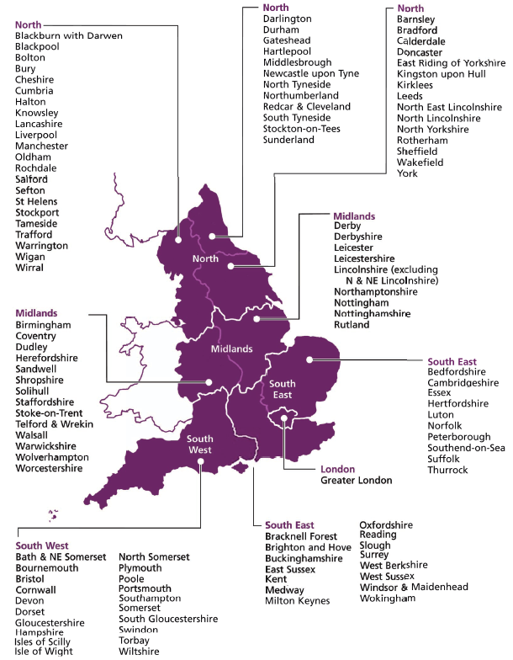

**North West**

**East Midlands**

**West Midlands**

**East**

**London**

**South East**

**South West**

Table 3 shows the breakdown of NPOs that responded to the annual submission, by region, and the breakdown of the regular funding by region. London, with 236 organisations, has the highest number of NPOs, making up 36% of the total portfolio. The North West (77), South West (74) and Yorkshire (72) follow. The East region has the fewest organisations (33) representing 5% of the annual submission responses.

Table 3: Breakdown of NPOs by region 2017/18 (N=657)

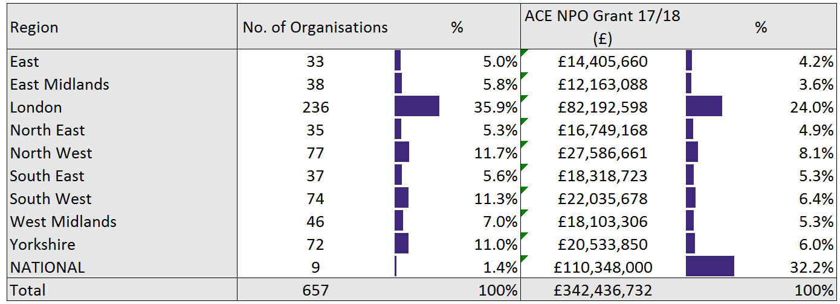

**2.2 Organisations by discipline**

National Portfolio Organisations are classified under one of eight different discipline categories, as shown in Table 2. The discipline assigned to an organisation relates to the principal area of work that the Arts Council England’s funding supports.

For example, if Arts Council England funds an organisation that engages in dance, music and theatre, it will be classified under the discipline towards which the Arts Council’s funding is primarily directed. If Arts Council funding is distributed to more than one discipline in an organisation, then this organisation’s discipline will be classified as combined arts. Combined arts also include organisations and practices that do not fit within one arts genre and includes organisations serving particular cultural or geographical communities. Combined arts are multidisciplinary and include arts centres, rural touring, carnival arts, festivals and participatory organisations. ‘Not discipline specific’ describes those organisations that cannot be specifically categorised into the other seven disciplines.

Table 4 shows the breakdown of NPOs and the breakdown of regular funding by discipline. The most highly represented disciplines in the sample are theatre and combined arts, which makes up 25% of the portfolio, with 163 and 161 organisations respectively. Visual arts (115) follow. Not discipline specific organisations have the lowest representation in the sample with 4 organisations (0.6%).

Table 4: Breakdown of NPOs by discipline 2017/18 (N=657)

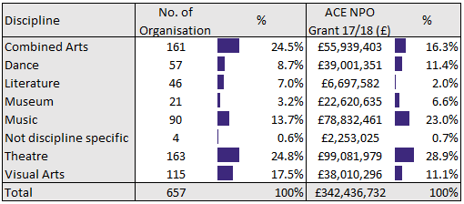

**2.3 Organisations by size**

National Portfolio Organisations are classified under one of three different size categories; small, medium and large. The size is dependent on the organisation’s total income as reported in the first survey of the funding round. For this funding round, the first survey was 2015/16. If an organisation did not submit a survey in 2015/16, their size is dependent on their total income as reported in their 2016/17 or 2017/18 survey.

The categories are as follows:

|  |  |
| --- | --- |
| Small Organisation | Total annual income is less than £250,000 |
| Medium Organisation | Total annual income is between £250,000 and £750,000 |
| Large Organisation | Total annual income is greater than £750,000 |

Table 5 shows the breakdown of NPOs and the breakdown of regular funding by organisation size. The most highly represented size in the sample is large organisations, which makes up 44% of the portfolio with 291 organisations. Small organisations have the lowest representation in the sample with 145 organisations (22%).

Table 5: Breakdown of NPOs by organisation size 2017/18 (N=657)

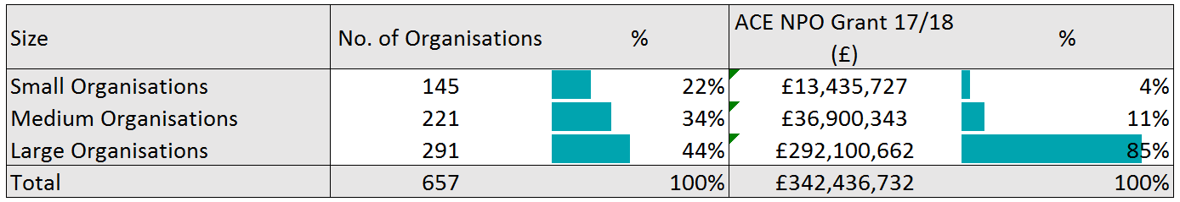

**3 DATA OVERVIEW**

This section presents an ‘at a glance’ overview of three key statistics from the 2017/18 annual submission compared by region and by discipline. The statistics compared in this section are the total Arts Council England subsidy, the total number of activities taking place in England (which includes performances, exhibition days, festivals and film screenings) and the total audience for these activities. Each of these statistics is then discussed in more detail in the subsequent sections of this report, along with other data from the annual submission.

**3.1 Regional overview**

For each of the key statistics, Figure 2 presents a percentage breakdown of the portfolio that is ascribed to each region to provide a direct comparison.

Figure 2 shows that London accounts for the highest proportion of the total for each statistic, apart from Arts Council investment, which was highest for national organisations at 32%. London received 24% of the total Arts Council England investment. In terms of activities and audiences, organisations based in London reported 24% of the total number of activities and reached 32% of the total audiences for these activities. The East and East Midlands received the lowest proportion of Arts Council investment (4%). The East recorded the lowest attendances with 3% each, whilst the National organisations had the lowest proportion of activities at 4%.

Figure 2: Key statistics by region 2017/18 (N=657)

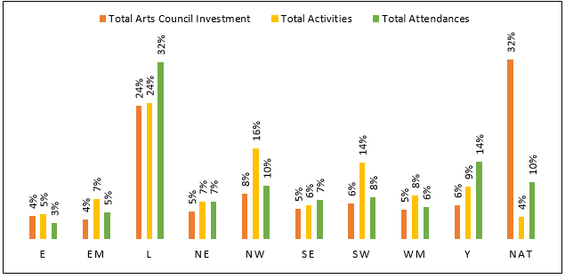

**3.2 Discipline overview**

As in the regional overview, Figure 3 presents a percentage breakdown of the total for each statistic separated by discipline [2]. Theatre organisations receive the highest proportion of Arts Council investment at 29% of the total. Combined arts organisations reported the highest proportion of the portfolio’s total performances, exhibition days, festivals and film screenings, with 30% of the total.

The highest proportion of attendances at performances, exhibitions, festivals and film screenings is also seen at combined arts organisations, representing 29% of the total across the portfolio. Discounting the not discipline specific organisations, the lowest proportion of activities is seen in literature organisations with 3%, whilst the lowest attendance figures are with dance organisations with 3%. The lowest proportion of Arts Council investment is also seen in literature organisations, with 2%.

Figure 3: Key statistics by discipline 2017/18 (N=657)

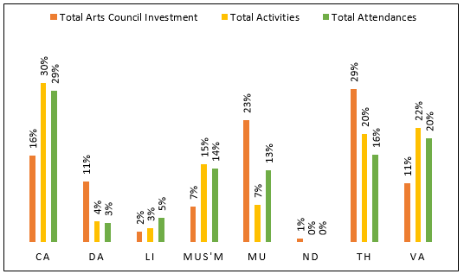

**3.2 Organisation size overview**

As above, Figure 4 presents a percentage breakdown of the total for each statistic separated by organisation size. Small organisations receive the lowest proportion of Arts council investment at 4%, but yield 11% of the total attendances. Large organisations receive the highest proportion of Arts Council investment at 85% and yield 66% of total attendances.

Figure 4: Key statistics by organisation size 2017/18 (N=657)

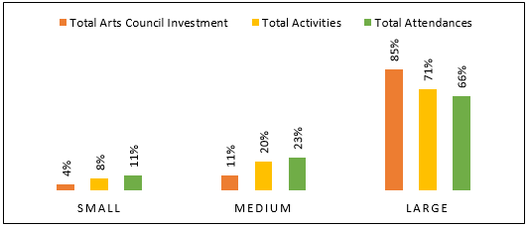

Section 3 Notes: [1] See section 2 for details of regional classifications [2] See section 2 for details of discipline classifications

**4 FINANCIAL STATEMENTS**

Arts Council England collected financial information from the National Portfolio Organisations (NPOs) for the 2017/18 financial year, 1 April 2017 to 31 March 2018. All data presented in this section comes from each organisations’ actual or provisional accounts for 2017/18. NPOs were required to report financial information for this period, irrespective of their own financial year. Estimates were accepted where precise financial data was not yet available.

**4.1 Income**

The largest source of revenue for the NPOs was earned income. This includes revenue from core activity, which includes ticket sales, workshop fees, merchandising and membership fees. Earned income also includes sales generated from educational activity as well as from supplementary activity, such as funds generated from catering, bank interest and any other earned income.

Earned income represented 55% of total income for the 2017/18 portfolio. Arts Council investment represented 20% and funding from local authorities represents 7% of the total, and other public subsidy 4%. Contributed income, which includes sponsorship, trusts and donations, made up the remaining 13% of the portfolio’s total income.

Figure 5: Sources of income 2017/18 (N=657)

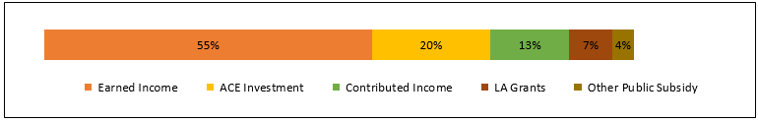

**4.1.1 Breakdown of total income by region, discipline and size**

Table 6 shows the breakdown of total income by region. Earned income makes up the largest proportion of total income for all regions. The highest is East Midlands at 61%, followed by National organisations at 60%.

The largest proportion of Arts Council investment can be seen in the East and National organisations at 24% each, and the least reliance on Arts Council investment is seen in the South East at 14%. London organisations received the highest amount of contributed income at 18%, and the East Midlands saw the lowest contributed income at 6%.

The highest proportion of local authority income was seen in Yorkshire (14%) and the lowest in National organisations (0%.) The East showed the highest proportion of other public subsidy at 22%, whilst National again showed the least at 1%.

Table 6: Breakdown of total income by region 2017/18 (N=657)

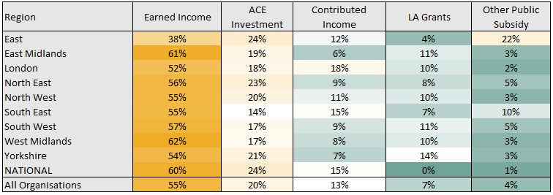

Colour key - High to Low:



Figure 6: Breakdown of total income by region 2017/18 (N=657)

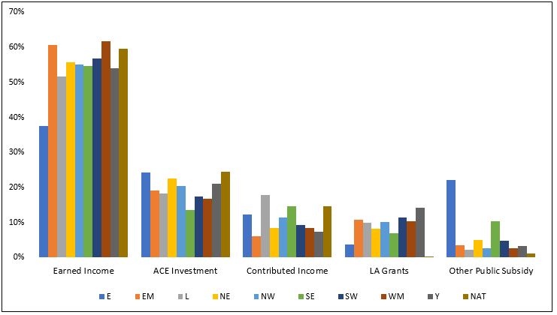

Table 7 shows the breakdown of total income by discipline. Compared to the overall portfolio, not discipline specific organisations relied most heavily on Arts Council investment, with 55% of income. Museums were least reliant on Arts Council investment, at 17% of their income.

Literature and music organisations reported the highest proportion of contributed income at 19%, and museums and not discipline specific organisations received the least, with 7% of their total income being contributed.

Theatre organisations acquired most of their revenue from earned income, making up 65% of their total income. Not discipline specific organisations received the least earned income, at 14%.

The proportion of income from local authorities is highest in museums organisations (27%) and lowest in literature and dance organisations, at 1% each. Not discipline specific organisations received the highest proportion of other public subsidy at 27%, whilst theatre organisations received the least at 1%.

Table 7: Breakdown of total income by discipline 2017/18 (N=657)

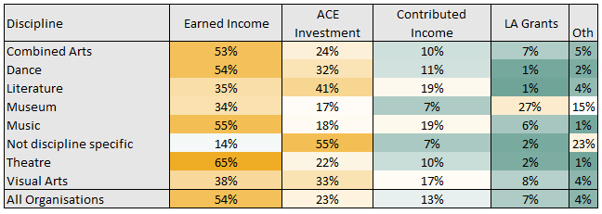

Colour key - High to Low:



Figure 7: Breakdown of total income by discipline 2017/18 (N=657)

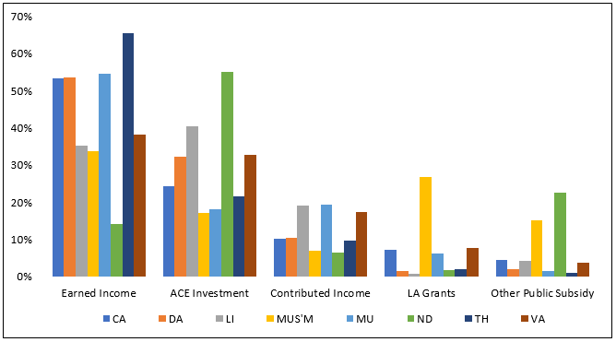

Table 8 shows the breakdown of total income by organisation size. Compared to the overall portfolio, small organisations relied most heavily on Arts Council investment, with 44% of income. Large organisations were least reliant on Arts Council investment, at 21% of their income.

Medium organisations secured the highest proportion of contributed income, at 15% and small organisations received the least, with 10% of their total income being contributed.

Large organisations acquired most of their revenue from earned income, making up 56% of their total income. Medium and small organisations received 30% of their income from earned sources.

The proportion of income from local authorities is highest in small organisations (10%) and lowest in medium organisations, at 6%. In contrast, medium organisations received the highest proportion of other public subsidy at 6%.

Table 8: Breakdown of total income by organisation size 2017/18 (N=657)

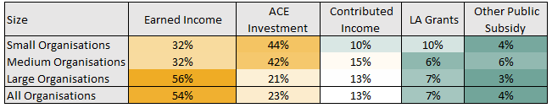

Colour key - High to Low:



Figure 8: Breakdown of total income by organisation size 2017/18 (N=657)

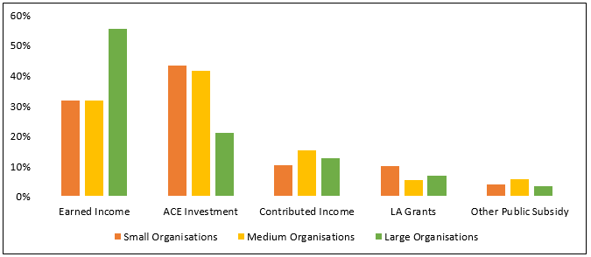

**4.1.2 Income changes since 2016/17**

Table 9 shows that of the 630 organisations that completed the annual submission in 2016/17 and 2017/18, total income has increased by 4%. The biggest increase was seen in local authority subsidy with 7%. The smallest increase has been in contributed income, which has remained relatively static, with a 1% increase.

Table 9: Percentage change in breakdown of total income 2016/17 and 2017/18 constant sample (N=630)

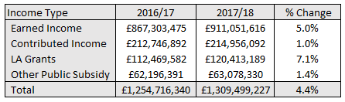

Figure 9: Comparison of total income breakdown 2016/17 and 2017/18 constant sample (N=630)

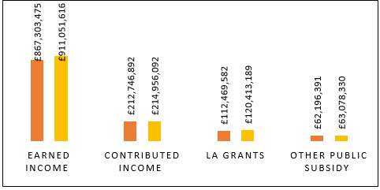

Figure 10 shows the percentage of organisations within the constant sample that increased, decreased or showed no change across the different income sources between 2016/17 and 2017/18. Earned income shows the highest number of organisations reporting an increase, with 58% of all organisations. Contributed income showed the largest number of organisations reporting a decrease, with 43% of all organisations.

Figure 10: Income change between 2016/17 and 2017/18 constant sample (N=630)

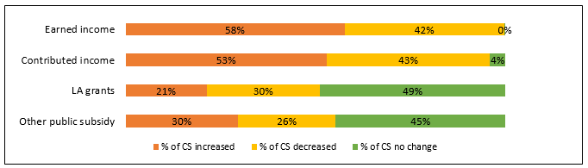

**4.1.3 Contributed income**

Tables 10 and 11 show the breakdown of contributed income by region. Trusts offered the highest proportion of contributed income for all regions except South East and National, where one-off donations represented the highest proportion at 51% and 40% respectively. Fundraising events offered the lowest proportion, averaging at 3% across all regions.

Table 10: Breakdown of contributed income by region 2017/18 (N=657)

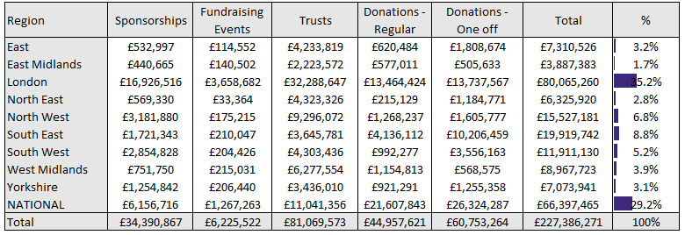

Table 11: Percentage breakdown of contributed income by region 2017/18 (N=657)

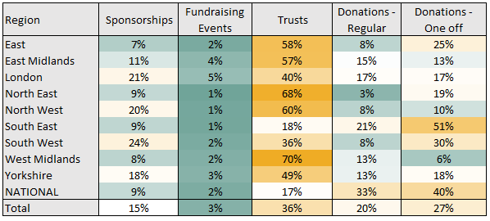

Colour key - High to Low:



Tables 12 and 13 show the breakdown of contributed income by discipline. Music had the highest share of contributed income, with 40%. Not discipline specific organisations had the lowest amount with 0%.

Table 12: Breakdown of contributed income by discipline 2017/18 (N=657)

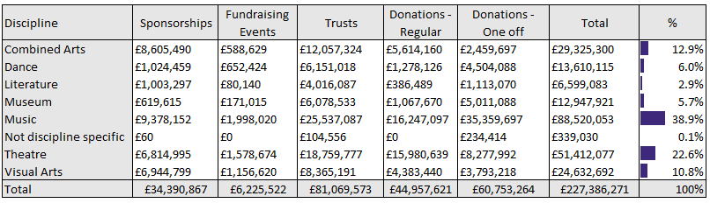

Table 13: Percentage breakdown of contributed income by discipline 2017/18 (N=657)

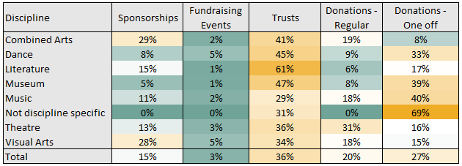

Colour key - High to Low:



Tables 14 and 15 shows the breakdown of contributed income by organisation size. Large organisations had the highest share of contributed income, with 91%. Small organisations had the lowest amount with 2%.

Table 14: Breakdown of contributed income by organisation size 2017/18 (N=657)

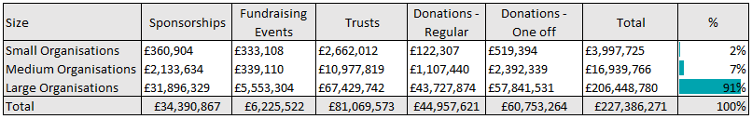

Table 15: Percentage breakdown of contributed income by organisation size 2016/17 (N=657)

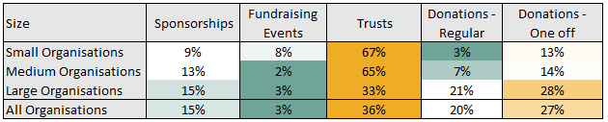

Colour key - High to Low:



As shown in Table 9, 2017/18 saw a 1% increase in contributed income from 2016/17. Table 16 and Figure 11 look in more detail at the different types of contributed income among the portfolio in the constant sample for 2016/17 and 2017/18.

Table 16: Breakdown of contributed income in 2016/17 and 2017/18 constant sample (N=630)

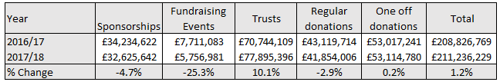

Contributed income from sponsorships has fallen since 2016/17 by almost 5%. Income from trusts has increased by 10% in 2017/18. Regular donations have decreased by 3% since 2016/17, whilst one-off donations have remained stable, showing a very small increase. Fundraising events have shown the highest year on year decrease of 25%, though represent the smallest income figure.

Figure 11: Breakdown of contributed income in 2016/17 and 2017/18 constant sample (N=630)

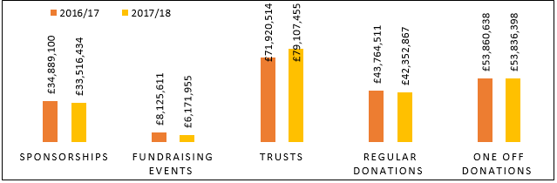

**4.2 Expenditure**

Total expenditure is broken down into nine categories of costs:

|  |  |
| --- | --- |
| Artistic programme or other main activity | This means any spending related to an organisation’s main programme of activity, whether or not that activity involves the direct production or creation of artistic product. Costs for artistic product include production costs and exhibition and venue hire |
| Marketing | This includes both production-specific marketing and generic marketing |
| Education programme | This expenditure deals with any costs relating to an organisation’s education programme |
| Cost of generating funds | This includes costs that are associated with generating incoming resources from all sources other than from undertaking charitable activities. Primarily, this is costs of fundraising and generating voluntary income, but also of managing investments |
| Governance costs | Governance costs include items such as internal and external audit, legal advice and costs associated with constitutional and statutory requirements |
| Collections care and conservation | Costs directly involved in the care and conservation of collections (museums only) |
| Collections acquisitions | Costs that are involved in the acquisitions of collections (museums only) |
| Overheads | This includes the costs of overheads, such as administration costs (post, telephone, insurance, etc.) and premises costs (rent, heating, lighting, etc.) |
| Other costs | This expenditure includes all costs not included in the other categories, including irrecoverable VAT |

Most of the total expenditure (52%) was directed at artistic or other programme costs. Overheads represented the second largest expenditure at 23% of all spending.

Figure 12: Expenditure breakdown 2017/18 (N=657)

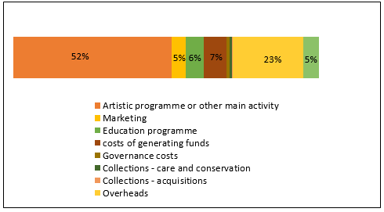

**4.2.1 Breakdown of total expenditure by region, discipline and size**

Table 17 shows the breakdown of total expenditure by region for the 2017/18 annual submissions. London had the largest expenditure of all the regions, representing 26%. Organisations based in the East and East Midlands had the lowest levels of expenditure with 4% of the total expenditure in the year each.

Table 17: Breakdown of total expenditure by region 2017/18 (N=657)

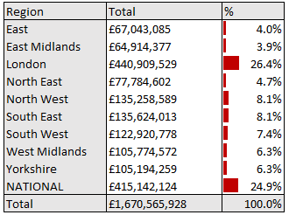

Table 18 shows the breakdown of total expenditure by discipline for the 2017/18 annual submission. Theatre organisations accounted for the largest share of all the disciplines, with 31%. Not discipline specific had the lowest expenditure, with 0.3% of the total expenditure of the portfolio.

Table 18: Breakdown of total expenditure by discipline 2017/18 (N=657)

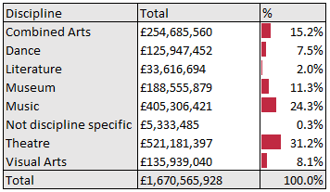

Table 19 shows the breakdown of total expenditure by organisation size for the 2017/18 annual submission. As expected, large organisations accounted for the largest share of expenditure with 91%, whilst small organisations had the lowest at 2%.

Table 19: Breakdown of total expenditure by organisation size 2017/18 (N=657)

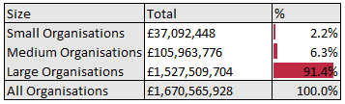

Table 20 presents a breakdown of total expenditure by region. In all regions, spending on artistic programming constituted most of the expenditure in 2017/18. The second largest proportion of expenditure was on overheads. National organisations expenditure on artistic programming was the highest at 56%, followed by the South West and West Midlands at 54% each. The lowest was seen in the East, at 35%. East organisations had the highest proportion of spend on their education programme, at 16%. National organisations had the lowest proportion of spend on education, at 3%.

Table 20: Breakdown of total expenditure categories by region 2017/18 (N=657)

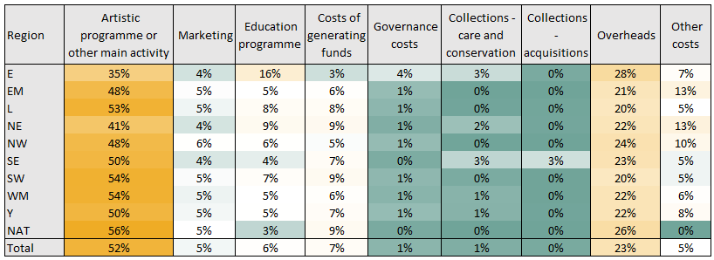

Table 21 shows that dance organisations had the highest proportion of expenditure on artistic programming, with 63%. Museums spent the lowest proportion on artistic programming or other main activity, with 30%, whilst having the highest proportion of expenditure on overheads at 31%. Literature and Not discipline specific organisations spent the highest proportion on their education programme, with 13% each, and the lowest proportion of educational expenditure was seen in theatre with 4%.

Table 21: Breakdown of total expenditure categories by discipline 2017/18 (N=657)

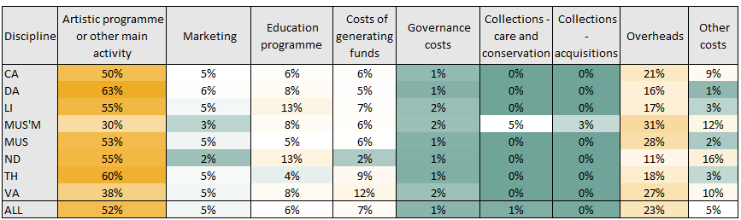

Table 22 shows that large organisations had the highest proportion of expenditure on artistic programming, with 52%. Small organisations spent the lowest proportion on artistic programming or other main activity, with 46%. Medium organisations spent the highest proportion on their education programme, with 8%, and the lowest proportion of educational expenditure was seen in large organisations with 6%. Large organisations were able to attribute the largest proportion of expenditure to costs of generating funds at 8%. Small organisations had a comparatively high proportion of expenditure against other costs at 17%.

Table 22: Breakdown of total expenditure categories by organisation size 2017/18 (N=657)

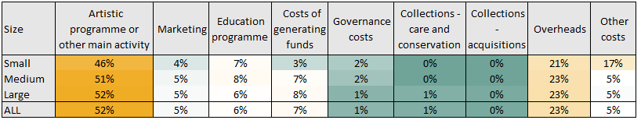

**4.2.2 Changes in expenditure since 2016/17**

Table 23 presents the percentage change in total expenditure for the 630 organisations that completed the annual submission in 2016/17 and 2017/18. Since 2016/17, expenditure has remained static, with less than 1% increase.

Table 23: Percentage change in total expenditure 2016/17 and 2017/18 constant sample (N=630)

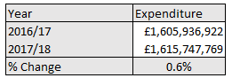

**5 ACTIVITIES AND AUDIENCES**

This section presents data about the activities and audiences in 2017/18. For activities that directly present artistic content to their audience such as productions, exhibition days, film screenings, festivals and education activities, the numbers are broken down by region, discipline classification and by organisation size. When activities by the NPOs cannot be measured in terms of numbers of activities and audience data, such as publications, these are presented as numbers available and numbers sold/distributed, broken down by discipline.

The attendance figures have been presented as known attendance (an actual audience count measured by a precise method such as the sale of tickets) and estimated attendance (applies to non-ticketed events such as festivals, carnivals etc.) minus any attendance to events outside England.

Activity and audience data are difficult to use for making year on year comparisons, because many factors can contribute to extreme changes, such as biennial programmes, capital works, building closures and programme changes. Extreme outliers have been removed where possible.

**5.1 Headline results: total arts activities and audiences**

This section looks at the total number of arts activities across the portfolio. NPOs responding to the annual submission in 2017/18 put on 310,469 productions, exhibition days, film screenings and festivals. Of these, 265,244 took place in England. NPOs responding to the annual submission in 2017/18 generated 85,570,070 (known plus estimated) attendances to productions, exhibition days, film screenings and festivals held in England over the year (including schools and CYP performances). This is the headline attendance figure for the portfolio’s arts activities. Other activities, such as education work, may generate additional attendances.

**5.1.1 Total activities and audiences by region**

Figures 13 and 14 shows the breakdown of performances, exhibition days, film screenings and festivals per region, alongside the attendance figure for these activities.

Figure 13: Regional breakdown of performances, exhibition days, film screenings and festivals 2017/18 (N=657)

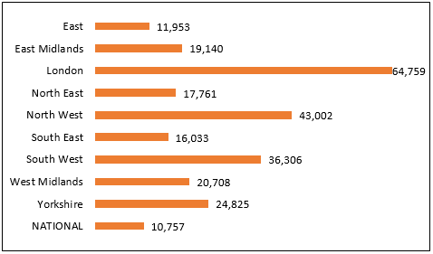

Figure 14: Regional breakdown of attendances at performances, exhibition days, film screenings and festivals 2017/18 (N=657)

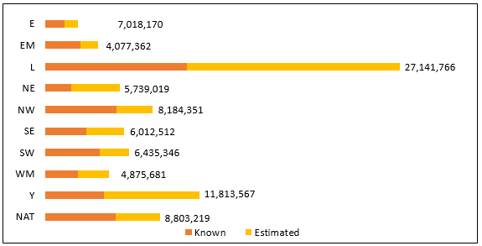

Figure 15 shows the percentage breakdown for known and estimated attendance in each region. North East organisations have the highest proportion of estimated attendances against known attendances at 66%, whilst North West organisations had the lowest at 33%.

Figure 15: Percentage breakdown of attendances at performances, exhibition days, film screenings and festivals 2017/18 within region (N=657)

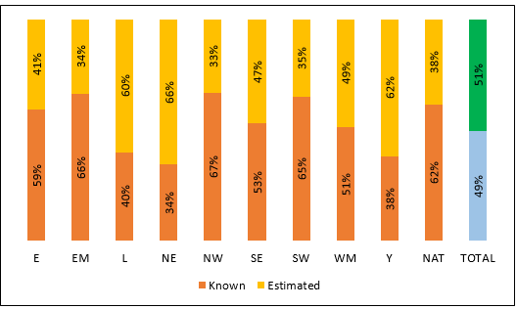

Figure 16 compares the number of performances, exhibitions days, film screenings and festivals put on in England in 2016/17 and 2017/18 among the constant sample of 630 organisations that completed the annual submission in each year. On average, activities have increased by 12% since 2016/17. National organisations saw the greatest decrease in the one-year period, with 36%. The South West saw the largest increase in their activities of 54%.

Figure 16: Percentage change in the number of performances, exhibition days, film screenings and festivals per region 2016/17 and 2017/18 constant sample (N=630)

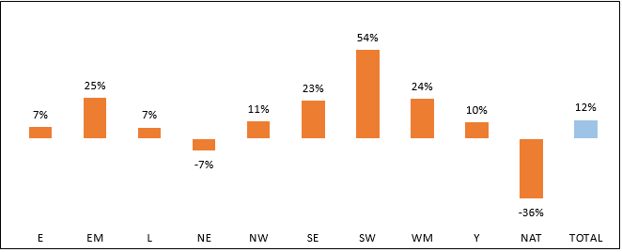

Figure 17 shows the percentage change for the total levels of attendance (known plus estimated) grouped by region for the constant sample of organisations that completed the annual submission in 2016/17 and 2017/18. Overall, there has been a 16% increase in attendances since 2016/17. National organisations saw the highest increase in attendance figures with an increase of 40%. The greatest decrease in attendance levels was seen in the East at 23% since 2016/17. Last year, National organisations had the greatest decrease compared to 2015/16, and the East the greatest increase, suggesting these organisations had a substantial change in one of the years, and these figures are less extreme than they may seem at first glance.

Figure 17: Percentage change in the number of attendances at performances, exhibition days, film screenings and festivals per region 2016/17 and 201/18 constant sample (N=630)

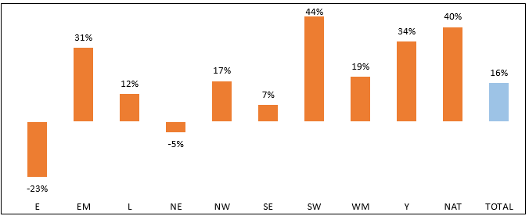

**5.1.2 Total activities and audiences by discipline**

Figure 18 shows the percentage breakdown of performances, exhibition days, festivals and film screenings in 2017/18 by discipline. An organisation’s discipline classifier is given to them by the Arts Council and reflects the artistic activity for which they primarily receive funding. It may not cover all artistic output.

Combined arts organisations had the highest number of activities, with 30% of the total. The lowest number of arts activities were put on by literature organisations (3% of the total). Not discipline specific organisations did not put on any activities.

Figure 18: Breakdown of performances, exhibition days film screening days and festivals per discipline 2017/18 (N=657)

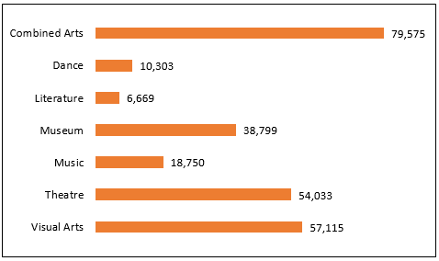

Figure 19 shows that the highest proportion of audiences attended arts activities at organisations within the combined arts portfolio, which accounted for 30% of total audiences in 2017/18. Dance organisations had the lowest attendances, with 4% of the total.

Figure 19: Discipline breakdown of attendances at performances, exhibition days, film screenings and festivals 2017/18 (N=657)

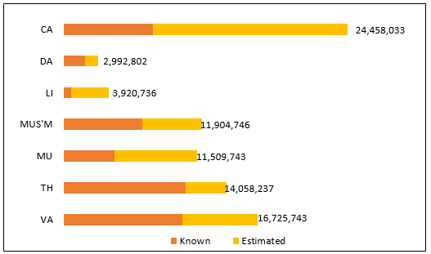

Figure 20 shows the percentage breakdown for known and estimated attendance in each discipline. Literature organisations have the highest proportion of estimated attendances against known attendances at 82%, whilst Theatre organisations had the lowest at 25%.

Figure 20: Percentage breakdown of attendances at performances, exhibition days, film screenings and festivals 2017/18 within discipline (N=657)

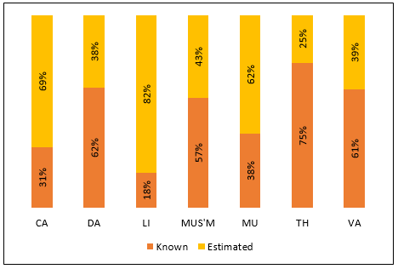

Figure 21 compares the number of arts activities by discipline for the organisations that completed the annual submission in 2016/17 and 2017/18. The biggest change was for Combined arts organisations, with an increase of 37% since 2016/17. Literature, museums and visual arts organisations all saw fewer activities, with reductions of 12% and 2% and 4% respectively.

Figure 21: Percentage change in activities by discipline 2016/17 and 2017/18 constant sample (N=630)

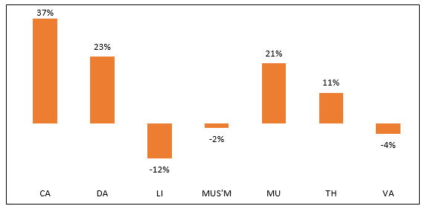

Figure 22 shows the change in audiences (known plus estimated) for disciplines since 2016/17 across the constant sample from the portfolio. Combined arts organisations had the greatest increase, with 50% since 2016/17. Attendance at visual arts organisations saw a no change in attendances.

Figure 22: Percentage change in the number of attendances at performances, exhibition days, film screenings and festivals 2016/17 and 2017/18 constant sample (N=630)

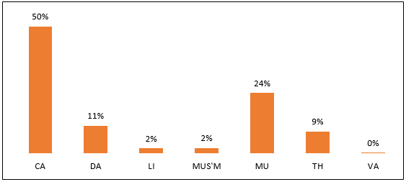

**5.1.3 Total activities and audiences by organisation size**

Figure 23 shows the breakdown of productions, exhibition days, film screenings and festivals per organisation size, alongside the attendance figure for these activities. Large organisations had the highest number of activities, with 71% of the total. The lowest number of arts activities were put on by small organisations (8% of the total).

Figure 23: Organisation size breakdown of performances, exhibition days, film screenings and festivals 2017/18 (N=657)

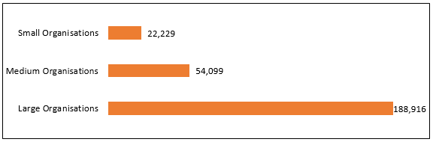

Figure 24 shows a similar distribution of attendances as activities, across the organisation sizes; with large organisations representing 67% and small organisations representing 11%.

Figure 24: Organisation size breakdown of attendances at performances, exhibition days, film screenings and festivals 2017/18 (N=657)

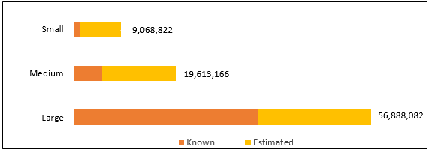

Figure 25 shows the percentage breakdown for known and estimated attendance in each organisation size. Small organisations have the highest proportion of estimated attendances against known attendances at 84%, whilst large organisations had the lowest at 38%.

Figure 25: Percentage breakdown of attendances at performances, exhibition days, film screenings and festivals 2017/18 within organisation size (N=657)

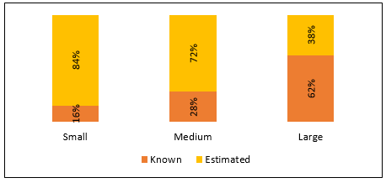

Figure 26 compares the number of performances, exhibitions days, film screenings and festivals put on in England in 2016/17 and 2017/18 among the constant sample of 630 organisations that completed the annual submission in each year. Small organisations saw the greatest increase in the 12-month period, with 30%.

Figure 26: Percentage change in the number of performances, exhibition days, film screenings and festivals by organisation size 2016/17 and 2017/18 constant sample (N=630)

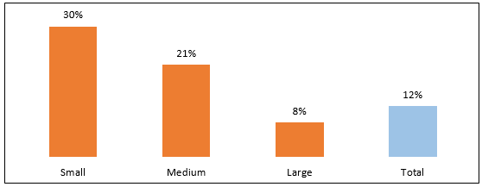

Figure 27 shows the percentage change for the total levels of attendance (known plus estimated) grouped by organisation size for the constant sample of organisations that completed the annual submission in 2016/17 and 2017/18. Small organisations saw the highest increase in attendance figures with an increase of 52%.

Figure 27: Change in the number of attendances at performances, exhibition days, film screenings and festivals by organisation size 2016/17 and 2017/18 constant sample (N=630)

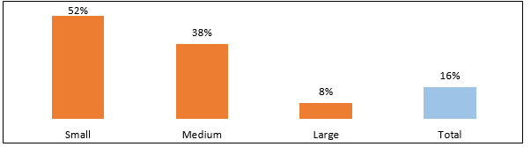

**5.2 New work commissioned**

By new work, we mean works commissioned and paid for by a National Portfolio Organisation. In the case of performing, producing and presenting organisations, it excludes new productions of established repertoire, new translations and adaptions. These types of productions are discussed in section 5.3.2.

Of the 657 NPOs who responded to the annual submission in 2017/18, 496 organisations (75%) commissioned at least one new work. Across the portfolio, a total of 12,098 new works were commissioned, involving 13,865 artists from the UK and 1,612 artists from outside the UK. These commissions vary considerably in size, including everything from individual poems to large-scale public artworks.

Of the sample that commissioned new work, 342 organisations (69%) commissioned fewer than 10 new works, 124 organisations (25%) commissioned between 10 and 100 new works, and the remaining 16 (3%) commissioned more than 100 new works.

Table 24 shows the percentage of total new works commissioned by each region. Organisations based in London commissioned the highest proportion (64%) of new works. London also commissioned the highest proportion of artists, both UK and Non-UK, as 55% each.

Table 24: Breakdown of new commissioned work by region 2017/18 (N=496)

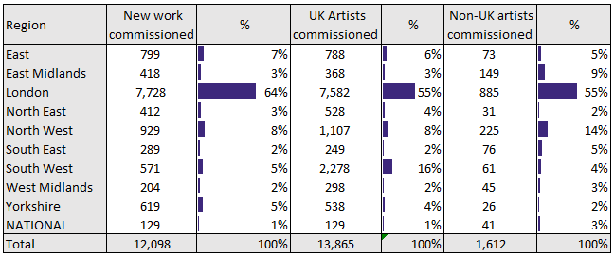

Table 25 shows how new work commissions are spread across the disciplines. Visual arts organisations commissioned the highest number of new works, with 53% of the total. These organisations also commissioned the most UK artists at 44%, and non-UK artists at 40%.

Table 25: Breakdown of new commissioned work by discipline 2017/18 (N=496)

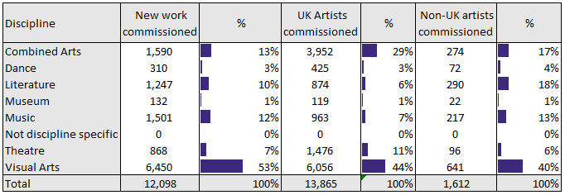

Table 26 shows how new work commissions are spread across the organisation sizes. Medium organisations commissioned the highest number of new works, with 59% of the total. These organisations also commissioned the most UK and non-UK artists at 51%. Large organisations commissioned the greatest number of Non-UK artists, with 45%.

Table 26: Breakdown of new commissioned work by organisation size 2017/18 (N=496)

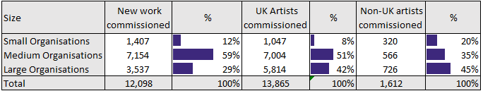

Figure 28 shows the percentage change in the number of new works, UK artists and non-UK artists commissioned in 2016/17 and 2017/18 by the constant sample. Since 2016/17 the number of new works commissioned has increased by 27%. The number of UK artists commissioned has increased by 68% and the number of non-UK artists has increased by 10%.

Figure 28: Percentage change in number of new works commissioned 2016/17 and 2017/18 constant sample (N=630)

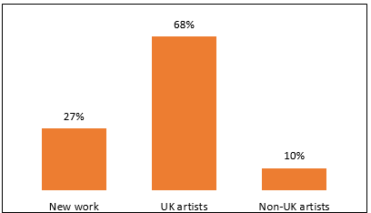

**5.3 Performances, productions and presentations**

In 2017/18, 490 organisations (75%) said that they had put on performances, productions and presentations, including readings and story-telling. This category is a subset of the total arts activities detailed in 5.1. For the purposes of this section, all these activities are referred to as ‘performances’ unless otherwise stated.

**5.3.1 Performances by types of production**

Organisations that put on performances were asked to break these down into new commissions, established repertoire, revivals and productions by visiting companies.

Table 27 shows the breakdown of production type by region. Productions by visiting companies account for the most performances in all regions, except for London, the South East having the highest of these with 74%. Most of the productions (70%) in Yorkshire were new commissions. Revivals make up the lowest proportion of all productions for all regions, apart from National organisations, which had a lower number of established repertoire productions.

Table 27: Production type by region 2017/18 (N=490)

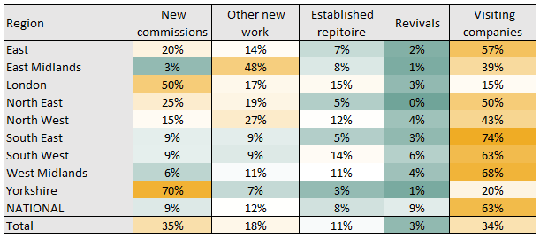

Table 28 shows the same production types broken down by discipline. Visiting companies are the highest proportion of productions for combined arts (65%), dance (46%) and theatre (63%) organisations. New work is greatest for literature (38%) organisations. Established repertoire is 22% of performances at literature and music organisations.

Table 28: Production type by discipline 2017/18 (N=490)

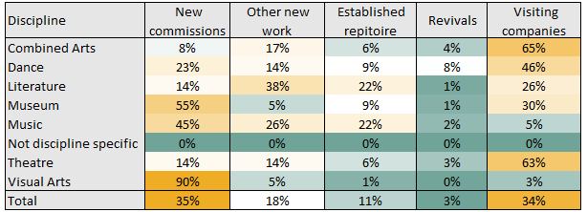

Table 29 shows the same production types broken down by organisation size. Visiting companies make up the highest proportion of productions for large (54%) organisations. New commissions are greatest for medium organisations at 52%. Small organisations saw the greatest proportion of other new work, at 30%.

Table 29: Production types by organisation size 2017/18 (N=490)

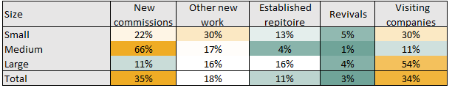

**5.4 Ticketed events**

The data in this section relates only to organisations that sold tickets for their events. A total of 452 organisations (65%) that put on activities sold tickets. There were 37,494,950 available tickets during 2017/18, of which 24,247,088 (65%) were sold. This generated a total ticket yield of £468,733,707 with an average ticket yield of £19.33.

The following charts show the average ticket yields and percentage of available tickets sold by region, discipline and organisation size.

As shown in figure 29, the highest average ticket yield (£28.26) was at national organisations. The lowest average ticket yield was at organisations in the North East (£11.49). National organisations sold the highest percentage of their available tickets at 79%, whilst the North West sold the least at 46%.

Figure 29: Average ticket sales and percentage of available tickets sold by region 2017/18 (N=452)

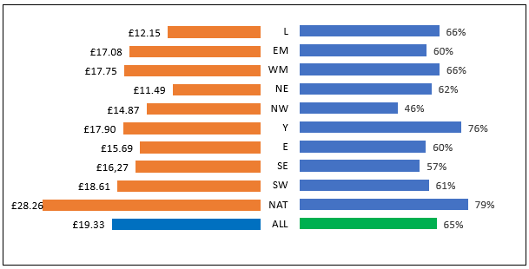

Figure 30 shows the proportion of full prices tickets against concessionary/discounted tickets sold by region. North West and East Midlands organisations sold the highest proportion of concessionary or discounted at 39% each, whereas 22% of tickers sold by national organisations were concessionary or discounted.

Figure 30: Percentage of full price tickets and concessionary/discounted tickets sold in region 2017/18 (N=452)

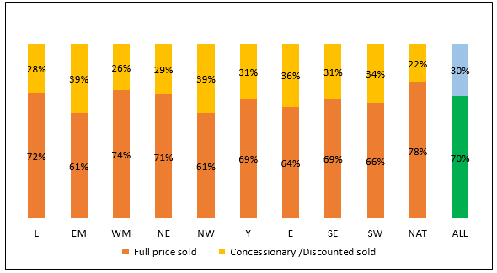

In relation to discipline, the highest average ticket yield (£29.22) was at music organisations, whilst the lowest average ticket yield was at museums (£5.35). Literature organisations sold the highest percentage of their available tickets at 78%, whilst visual arts sold the least at 50%.

Figure 31: Average ticket sales and percentage of available tickets sold by discipline 2017/18 (N=452)

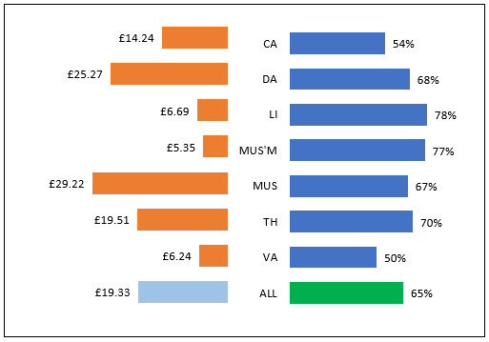

Almost half (46%) of the tickets sold by Museums were concessionary or discounted. Literature organisations had the smallest amount of concessionary/discounted tickets sold. At 15% of their total.

Figure 32: Percentage of full price tickets and concessionary/discounted tickets sold in discipline 2017/18 (N=452)

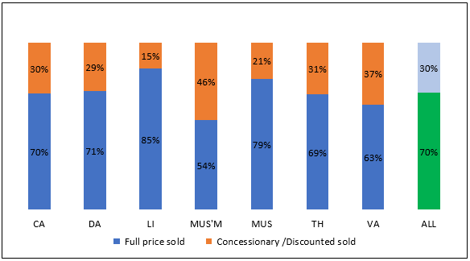

In relation to organisation size, the highest average ticket yield (£19.95) was at large organisations. The lowest average ticket yield was at small organisations (£4.94).

Figure 33: Average ticket sales and percentage of available tickets sold by organisation size 2017/18 (N=452)

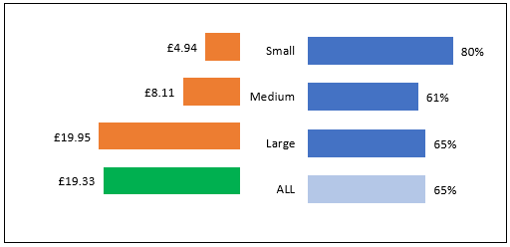

Across all three sizes of organisation, less than a third of all tickets sold were concessionary or discounted. The highest proportion was at medium organisations with 31%, and the lowest at small organisations (15%).

Figure 34: Percentage of full price tickets and concessionary/discounted tickets sold by organisation size 2017/18 (N=452)

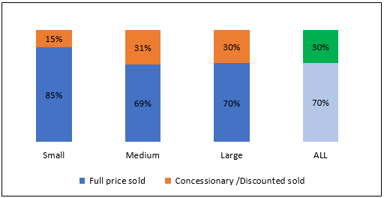

**5.5 Children and young people activities**

Of the 657 organisations that completed the survey, 425 (65%) reported that one or more of their activities were specifically for children and young people (CYP). Of the 265,244 activities that were put on in England in 2017/18, 42,708 (14%) were specifically for CYP. These activities are in addition to the education and learning sessions detailed in section 6.6.

Figure 35 shows the proportion of activity that was specific to CYP in each reported activity type. Performances has the highest proportion of CYP activities overall with 22%, whilst film screenings had the lowest at 7%.

Figure 35: Percentage of CYP specific activity by activity type 2017/18 (N=425)

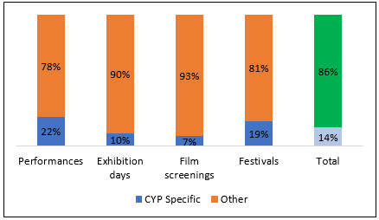

Table 30 shows that the London had the highest share of CYP activities, with 31% of the total, however the South East had the highest proportion of their own activities dedicated to CYP at 26%.

Table 30: CYP specific activities by region 2017/18 (N=425)

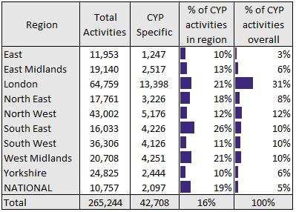

Table 31 shows that literature organisations had the highest share of CYP activities, with 65% of the total, however theatre organisations had the highest proportion of their own activities dedicated to CYP at 33%. Not discipline specific organisations had no relevant activities.

Table 31: CYP specific activities by discipline 2017/18 (N=425)

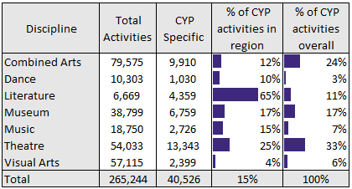

Table 32 shows that large organisations had the highest share of CYP activities, with 76% of the total, and also had the highest proportion of their own activities dedicated to CYP at 16%.

Table 32: CYP specific activities by organisation size 2017/18 (N=425)

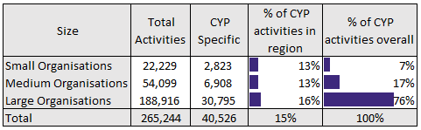

**5.6 Publications**

A total of 322 organisations said that they had produced publications during 2017/18. Publications include books, directories, magazines and educational resource packs. These organisations were asked for further details of the number of titles they had published, and the sales and distribution figures for these publications. Sales and distribution are measured by the number of copies rather than monetary value.

As publication is not restricted by geographical or regional boundaries, there are no regional breakdowns for these figures.

**5.6.1 Books**

Organisations had published a total of 834 new book titles over 2017/18, as well as maintaining 12,345 backlist book titles. Sales and distribution of new book titles totalled 558,534 and sales and distribution of backlist titles totalled 413,528.

Table 33 shows the publication of new and backlist title book publications by discipline. Literature organisations had the highest share of new titles available, with 60% of the total. Literature organisations also had the highest proportion of backlist titles available, with 65%, and the highest sales and distribution of new and backlist titles, with 65% and 70% respectively.

Table 33: Publications of new and backlist titles by discipline 2017/18 (N=162)

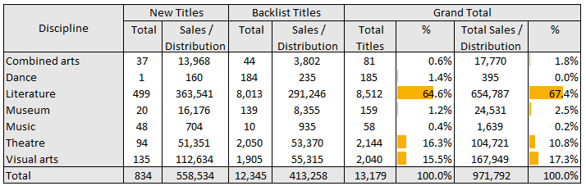

**5.6.2 E-books**

Organisations were also asked if they had produced any e-books. Table 34 shows the publication of new and backlist e-book titles by discipline. Literature organisations had the highest share of new titles available, with 60% of the total. Literature organisations also had the highest proportion of backlist titles available, with 85%. Visual arts organisations had the highest sales/distribution of new titles, with 83%, and literature organisations had the highest sales/distribution for backlist titles (63%).

Table 34: Publications of new and backlist e-book titles by discipline 2017/18 (N=55)

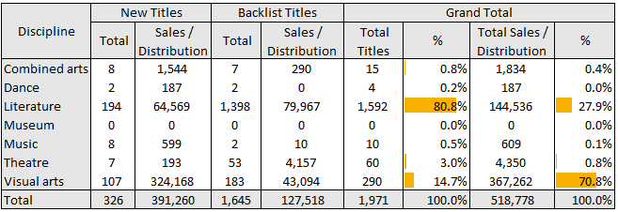

**5.6.3 Other publications**

Organisations were also asked if they had produced any other publications, such as directories, newsletters, journals, catalogues, exhibition publications or educational resource packs. These are referred to as paper-based publications in the section below.

A total of 2,480 paper-based publications were released in 2017/18, with total sales/distribution of 14,349,891. The highest number of paper-based publications was produced by literature organisations (39%), as shown in Table 35. The highest sales/distribution of paper-based publications was seen in, music organisations (35%).

Table 35: Paper-based publications by discipline 2016/17 (N=143)

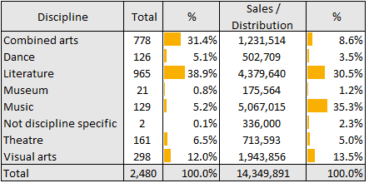

**5.7 Education, learning and participation**

There were 406 NPOs (62%) that employed someone specifically to deliver education and learning work. 426 organisations (65%) had a written education policy strategy. Of these, 366 organisations had both. Programmes of education involved 23,525 artists.

Figure 36 shows the distribution of sessions across the different age groups. The highest proportion of sessions were aimed at the 20 plus age group at 30%. The lowest proportion was with the 0-5 age group at 4%.

Figure 36: Distribution of learning and participation sessions across each key stage group 2017/18 (N=561)

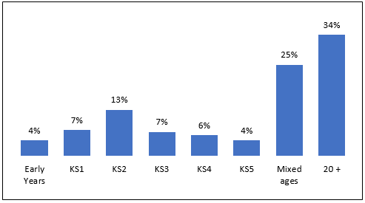

**5.7.1 Learning and participation sessions**

Figure 37 shows the regional distribution of learning and participation sessions. London organisations had the highest number of sessions, with 38%, followed by south west organisations with 10%. East organisations have the lowest number of sessions, with 3% of the total.

Figure 37: Learning and participation sessions by region 2017/18 (N=561)

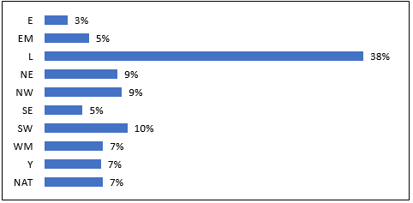

Figure 38 shows the proportion of organisations in each region that reported delivery of learning and participation sessions. 100% of national organisations delivered some learning and participation sessions in 2016/17.

Figure 38: Percentage of organisations delivering learning and participation sessions in region 2017/18 (N=657)

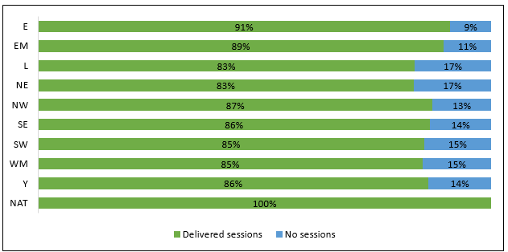

Figure 39 shows the discipline distribution of learning and participation sessions. Theatre organisations had the highest number of sessions, with 26%, followed by combined arts organisations with 19%. Not discipline specific organisations have the lowest number of sessions, with 0.05% of the total.

Figure 39: Learning and participation sessions by discipline 2017/18 (N=561)

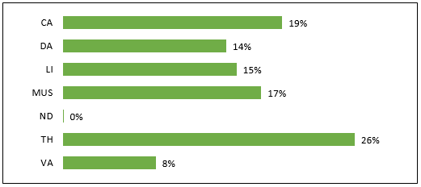

Figure 40 shows the proportion of organisations in each discipline that reported delivery of learning and participation sessions. 100% of dance organisations delivered some learning and participation sessions in 2017/18.

Figure 40: Percentage of organisations delivering learning and participation sessions in discipline 2017/18 (N=657)

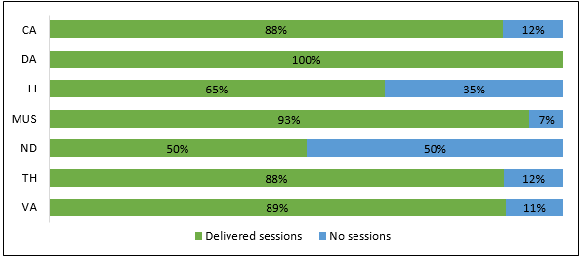

Figure 41 shows the distribution of learning and participation sessions by organisation size. Large organisations had the highest number of sessions, with 74%. Small organisations have the lowest number of sessions, with 6% of the total.

Figure 41: Learning and participation sessions by organisation size 2017/18 (N=561)

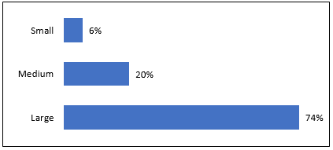

Figure 42 shows the proportion of organisations in each size that reported delivery of learning and participation sessions. 90% of medium organisations delivered some learning and participation sessions in 2017/18.

Figure 42: Percentage of organisations delivering learning and participation sessions in organisation size 2016/17 (N=649)

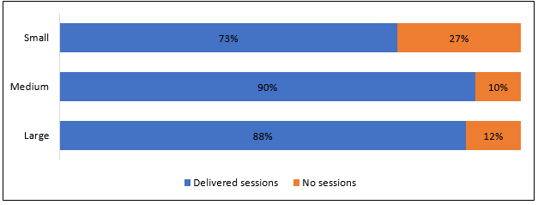

**6 ANALYSIS OF INCOME BY ATTENDANCE**

Income and subsidy per attendance are calculated for 2017/18 as presented in section 4.1, and total attendance data for activities in England as presented in section 5.1. Total attendance used to calculate income and subsidy per attendance includes known and estimated audiences for performances, productions, exhibition days, festivals and film screenings.

The average total subsidy per attendance, which includes Arts Council investment, local authority and other public subsidy for the same sample, was £6.88 per attendance.

**6.1 Subsidy per attendance**

Subsidy per attendance represents how much subsidy our NPOs receive in order to generate one attendance.

The total subsidy per attendance for all disciplines and regions of £7.32 breaks down as £4.69 per attendance coming from Arts Council investment, £1.44 from local authority funding and £0.75 per attendance from other public subsidy.

**6.1.1 Regional analysis**

Regional breakdown of subsidy per attendance in Figure 43 shows that organisations in the East had the highest levels of subsidy per attendance in 2017/18 with £13.83 spent per attendance. Yorkshire had the lowest subsidy, with £3.72 per attendance. A detailed analysis of subsidy per attendance, by subsidy category, is given in Figure 44.

Figure 43: Breakdown of total subsidy per attendance by region 2017/18 (N=657)

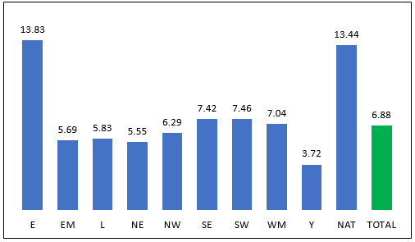

Figure 44: Detailed breakdown of subsidy per attendance by region 2017/18 (N=657)

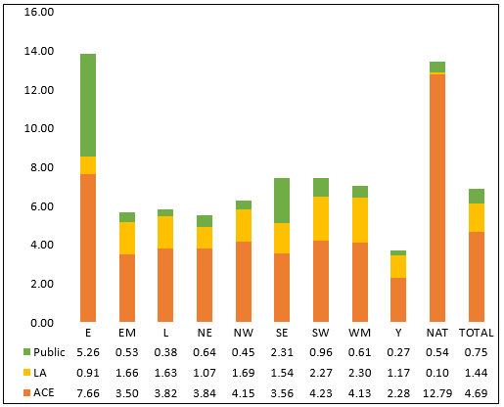

**6.1.2 Discipline analysis**

Figure 45 shows the breakdown of total subsidy per attendance by discipline. Dance organisations had the highest subsidy per attendance at £15.42. Visual arts organisations had the lowest subsidy per attendance, at £3.75. A more detailed breakdown of subsidy per attendance by subsidy category is given in Figure 46.

Figure 45: Breakdown of total subsidy per attendance by discipline 2017/18 (N=657)

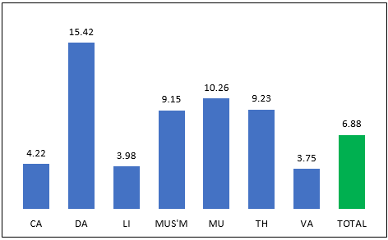

Figure 46: Detailed breakdown of subsidy per attendance by discipline 2017/18 (N=657)

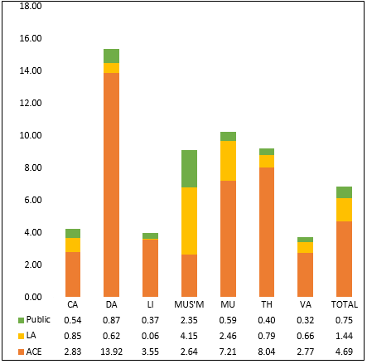

**6.1.2 Organisation size analysis**

Figure 47 shows the breakdown of total subsidy per attendance by organisation size. Large organisations had the highest subsidy per attendance at £8.93. Small organisations had the lowest subsidy per attendance, at £2.43. A more detailed breakdown of subsidy per attendance by subsidy category is given in Figure 58.

Figure 47: Breakdown of total subsidy per attendance by organisation size 2017/18 (N=657)

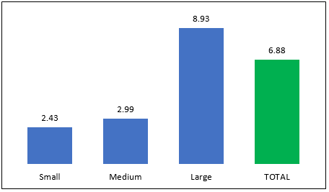

Figure 48: Detailed breakdown of subsidy per attendance by organisation size 2017/18 (N=657)

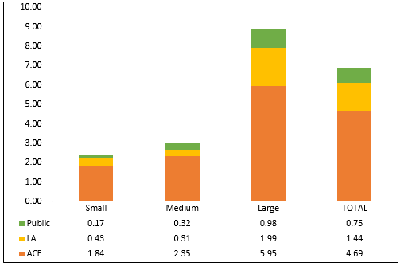

**6.2 Earned income per attendance**

Earned income per attendance represents how much (in £s) our NPOs earn from each attendance.

**6.2.1 Regional analysis**

Overall, the earned income per attendance for all organisations was £11.02 per attendance. Figure 49 shows the earned income per attendance in each region. National organisations had the highest earned income per attendance, with £30.58, followed by organisations in the West Midlands, with £13.62. The lowest earned income per attendance was recorded by organisations in Yorkshire with £4.46.

Figure 49: Earned income per attendance by region 2017/18 (N=657)

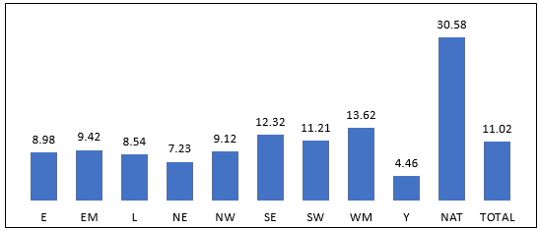

**6.2.2 Discipline analysis**

Figure 50 shows that theatre organisations have the highest earned income per attendance (£24.44). Literature organisations had the lowest income per attendance in 2017/18, with £3.20.

Figure 50: Earned income per attendance by discipline 2017/18 (N=657)

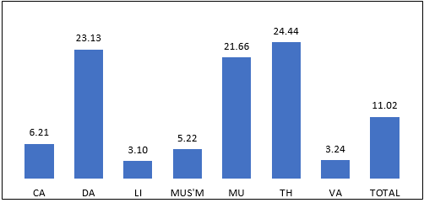

**6.2.2 Organisation size**

Figure 51 shows that large organisations have the highest earned income per attendance (£15.75). Small organisations had the lowest income per attendance in 2017/18, with £1.35.

Figure 51: Earned income per attendance by organisation size 2017/18 (N=657)

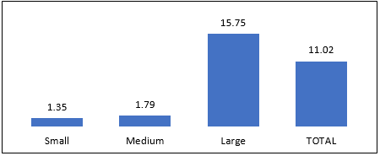

**7 TOURING DATA**

By touring activities, we mean work presented away from the home base or host venue of an organisation. Touring activities that are measured by the annual submission include performances, productions, readings, exhibition days and film screening days, but exclude education workshop sessions. Organisations that toured were asked for details of each touring activity including the number of times it was presented, the postcode of the venue (if in the UK), the country (if overseas) and the total audience at each venue.

There were 308 organisations that reported touring activities in 2017/18. We refer to these as touring organisations. Touring organisations represent 47% of the total number of organisations responding to the annual submission in 2017/18.

Some organisations were unable to provide full details of all their toured activity and therefore the data in this section can only give a partial picture of toured activities and audiences. It should also be recognised that organisations vary considerably in the amount of touring that they do. Some touring organisations will only do a few touring activities in a year, but for others touring is a significant part of their work, and the primary reason for why they receive Arts Council funding.

**7.1 Regional and discipline distribution of touring organisations**

Table 36 shows the number of touring organisations based in each region and the percentage that this represents of the total organisations based in that region. In numerical terms London has the highest number of touring organisations (119) which represents 50% of the organisations based there. All 9 National organisations reported some touring activity in 2017/18. Aside from National organisations, the North East has the smallest number of touring organisations, with 13, whilst Yorkshire has the lowest percentage of touring organisations, with 36%.

Table 36: Number and proportion of touring organisations by region 2017/18 (N=308)

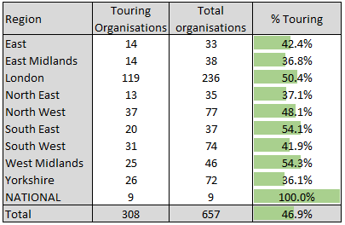

The discipline distribution of touring organisations is presented in Table 37. Theatre has the highest number of organisations (117) that have undertaken touring activities in 2017/18. This represents 72% of all theatre organisations in the portfolio. This is followed by dance organisations at 65%. No not discipline specific organisations reported any touring activity.

Table 37: Number and proportion of touring organisations by discipline 2017/18 (N=308)

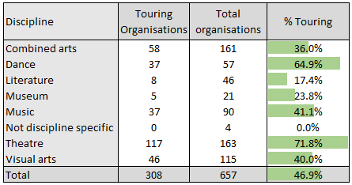

The organisation size distribution of touring organisations is presented in Table 38. In numerical terms large organisations had the highest number of touring organisations (150) which represents 52% of that size of organisation.

Table 38: Number and proportion of touring organisations by organisation size 2017/18 (N=308)

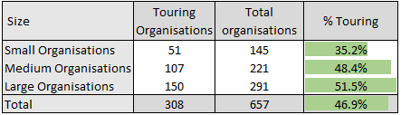

**7.2 Reach of touring activities**

This section considers the national and international reach of toured activities by NPOs. Table 39 presents a breakdown of the locations of the toured activities by NPOs, separated by the home region of the organisations doing touring activity within their home region, but away from their home base or venue. So, for example, organisations in London did 18% of their toured activity within the London region, but away from their home base venue.

Touring within an organisations home region is the most common form of touring activities for the North West, South West and Yorkshire, with 37%, 33% and 25% respectively. The South East had the highest percentage of international touring activity (30%), followed by the London (27%).

Table 39: Location of toured activity by home region of organisation 2017/18 (N=308)

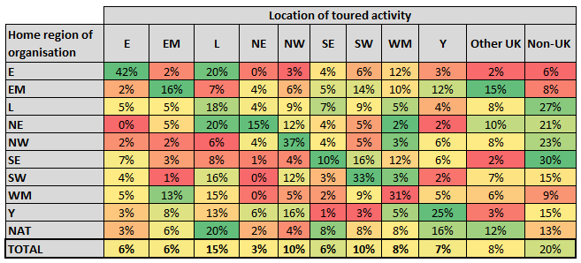

Table 40 shows the breakdown of the location of touring activities by discipline. Visual arts and Museums have the highest proportion of touring that took place outside of the UK, with 28% each, followed by dance with 26%. Most disciplines had a high proportion of their activity taking place in London apart from combined arts, where activities were more focused in the Midlands area.

Table 40: Location of toured activity by discipline of organisation 2017/18 (N=308) 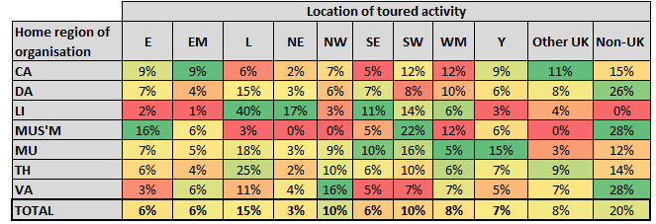

Figure 52 shows the percentage of activities that took place either in the home region or outside the home region of the organisations. Most activities took place outside the organisation’s home region (68%). Activities are counted as number of performances, exhibition days, film screenings and festival days.

Figure 52: Percentage of activities taking place inside or outside of home region 2016/17 (N=252)

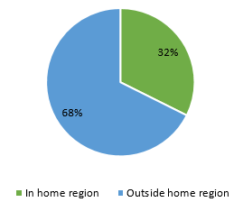

Table 41 shows the top 20 toured to local authorities in England, ranked in order of the number of touring activities (performances, exhibition days, festivals, film screenings) that took place there.

Table 41: Top 20 England Local Authorities in terms of number of toured activities 2017/18 (N=308)

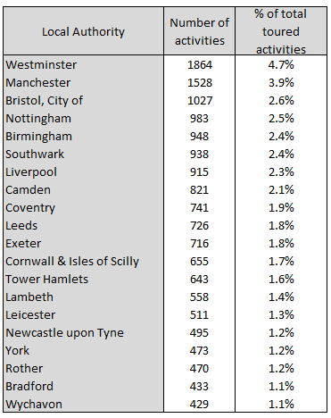

Table 42 shows the top 20 local authorities in England based on NPOs reporting touring activity within the local authority.

Table 42: Top 20 England Local Authorities in terms of NPOs reporting touring activity 2017/18 (N=308)

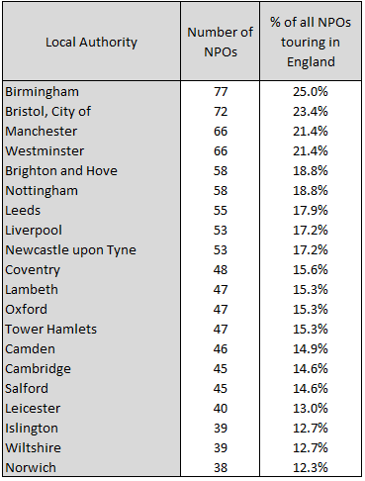

Table 43 shows the different venue types that were visited as part of tours taking place in England in 2017/18. Theatres represent the highest percentage with 28% of all venues, with community venues following with 23%.

Table 43: Types of venues toured to in England 2017/18 (N=308)

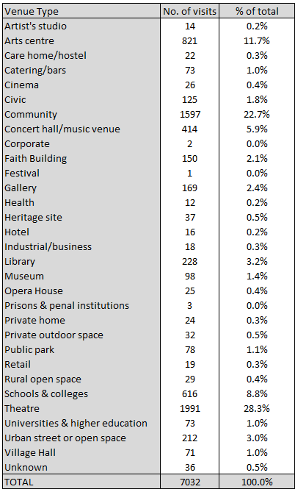

**APPENDIX 1 GLOSSARY OF DEFINITIONS**

**Activities**

The number of opportunities an organisation provides for audiences to attend or participate in. The numbers given refer to all activities taking place between 1 April 2014 and 31 March 2015.

**Discipline**

This is the main discipline that the organisation is funded for by the Arts Council. Regularly funded organisations are classified under one of seven different disciplines: combined arts, dance, literature, music, theatre, visual arts and not discipline specific. The discipline assigned to an organisation is related to the principal area of work that Arts Council England’s funding supports.

If Arts Council funding is distributed to more than one discipline in an organisation, then this organisation’s discipline will be classified as combined arts. Combined arts categorise organisations and practices that do not fit within one arts genre. It includes organisations serving particular cultural or geographical communities. Combined arts are multidisciplinary, and include arts centres, rural touring, carnival arts, festivals and participatory organisations.

Not discipline specific describes those organisations which cannot be specifically categorised into the six other disciplines.

**Artistic programme costs**

Expenditure on staff involved in an organisation’s artistic programme or main activity and on non-staff costs such as production costs and venue hire.

**Artistic staff**

This category refers to artists, dances, actors, singers, musicians, curators, directors, choreographers, producers, programmers, writers, composers, designers etc, and includes the artistic director. This category also includes educational, marketing and audience development staff.

**Arts Council England investment**

All investment received from Arts Council England, both grant-in-aid (government) funding, and lottery funding. Capital funding is excluded.

**Attendance**

This refers to the number of people attending activities. Attendance can be Known (an actual audience count which has been calculated using precise methods such as ticket sales) or Estimated (any estimated attendance over and above the known attendance, that cannot be precisely measured, such as audiences for festivals or carnivals.

**Contributed income**

All sponsorships from business organisations, income from corporate membership schemes, money from trusts or foundations and money received from the general public for which no benefit is received in return.

**Cost of generating funds**

Expenditure associated with generating incoming resources from all sources other than from undertaking charitable activities. This is primarily the costs associated with fundraising and generating voluntary income, but also the cost of managing investments.

**Disability Discrimination Act**

This defined a person with a disability as someone who has a physical or mental impairment that has a substantial and long-term adverse effect on their ability to carry out normal day to day activities.

**Earned income**

All income generated by an organisation’s artistic activity, educational activity and any supplementary activity including trading income and bank interest is included in earned income. This includes box office receipts, engagement and other fees, entrance charges, sales of books and magazines, workshop fees, individual membership fees etc.

**Education programme costs**

This is expenditure on staff and non-staff costs associated with an organisation’s education programme. For some organisations this may be their main or only activity. Educational activity is about learning in the arts (skills and techniques) about the arts (knowledge and appreciation) or through the arts (using the arts to develop in other areas, such as personal and social skills, or history.

**Exhibition days**

This refers to the number of days an exhibition is open to public view. Exhibition days are calculated for each separate exhibition then totalled, therefore where two (or more) exhibitions are presented on the same day, this will contribute two (or more) to the exhibition days total.

**Film screening days**

This refers to the number of days is film is exhibited. Film screening days are calculated for each separate film and then totalled, therefore where two (or more) films are presented on the same day, this will contribute two (or more) to the film screening days in total. Where a number of short films are shown in one programme at one session, this is counted as one film screening.

**Governance costs**

Expenditure on costs of governance for running the organisation, items such as internal and external audit, legal advice and costs associated with constitutional and statutory requirements.

**Home base or host venue**

These are the central premises owned or leased (long-term) by an organisation, which are the usual premises for the organisation’s activities. If an organisation works from several premises, its head office will be classed as its home base.

**Local authority subsidy**

All subsidies received from local authorities.

**Marketing costs**

Expenditure for marketing and promotion, including staff costs. This includes both production specific and generic organisation marketing.

**National company**

National companies are nine large organisations whose work has a significant reach beyond the region in which they are located.

**Other costs**

Expenditure on all other costs apart from artistic programme, education programme, marketing costs, costs of generating funds and overheads.

**Other public subsidy**

All subsidies received from sources other than Arts Council England and local authorities, including that received from other funding bodies, other government departments and EU funding sources.

**Outliers**

If one or more organisations provide figures that are extremely high or low, they can sometimes skew the data and misrepresent the overall figures. In these cases, the extreme numbers are removed.

**Overheads**

This includes all overheads, such as administration costs (post, telephone, insurance etc) and premises costs (rent, heating, lighting etc). It also includes expenditure on staff directly involved in the area of overheads, such as administrators and operations staff.

**Performances**

This is the total number of performances, productions, presentations, concerts and readings taking place in England. This covers all performances, including school performances, and broadcast (live or recorded) performances.

**Publications**

This refers to the production and distribution of books, directories, journals, catalogues, magazines, DVDs and CDs.

**Region**

This refers to the region where the organisations home base is located (or head office if it has more than one base). All regional classifications in this report use this definition, except for touring data, which can be precisely geographically located as well.

**Sales and distribution**

This is the total figure for sales and distribution figures of publications. This includes any complimentary/free publicity distribution. This is the number of publications that were sold/distributed, not a monetary (£) figure.

**Schools performances**

This is the number of performances, productions, presentations, concerts and readings etc for young people in the age range of 4 -19 in full-time education. This is a subset of the total number of performances put on by an organisation.

**Touring activity**

This refers to all work that was presented away from an organisations home base or host venue (temporary or permanent). The term ‘home-base’ refers to premises owned by the organisation or premises on which the organisation holds a long-term lease. Touring activity may include productions, exhibitions, readings, screenings etc. These figures include any school’s performances specifically for young people in full-time education (4-19 age group), but do not include workshops, seminars, lectures, residencies or courses.

**Workshop sessions**

This refers to all forms of learning or participatory activity, including formal and informal education sessions for people of all ages, and professional training sessions.

**APPENDIX 2 LIST OF TABLES AND FIGURES**

|  |  |  |
| --- | --- | --- |
| Table 1 | Regional Abbreviation list | 5 |
| Table 2 | Discipline Abbreviation list | 5 |
| Table 3 | Breakdown of NPOs by region 2017/18 (N=657) | 7 |
| Table 4 | Breakdown of NPOs by discipline 2017/18 (N=657) | 8 |
| Table 5 | Breakdown of NPOs by organisation size 2017/18 (N=657) | 8 |
| Table 6 | Breakdown of total income by 2017/18 (N=657) | 12 |
| Table 7 | Breakdown of total income by discipline 2017/18 (N=657) | 13 |
| Table 8 | Breakdown of total income by organisation size 2017/18 (N=657) | 14 |
| Table 9 | Percentage change in breakdown of total income 2016/17 and 2017/18 constant sample | 15 |
| Table 10 | Breakdown of contributed income by region 2017/18 (N=657) | 16 |
| Table 11 | Percentage breakdown of contributed income by region 2017/18 (N=630) | 16 |
| Table 12 | Breakdown of contributed income by disciple 2017/18 (N=657) | 17 |
| Table 13 | Percentage breakdown of contributed income by discipline 2017/18 (N=657) | 17 |
| Table 14 | Breakdown of contributed income by organisation size 2017/18 (N=657) | 17 |
| Table 15 | Percentage breakdown of contributed income by organisation size 2017/18 (N=657) | 18 |
| Table 16 | Breakdown of contributed income in 2016/17 and 2017/18 constant sample (N=630) | 18 |
| Table 17 | Breakdown of total expenditure by region 2017/18 (N=657) | 20 |
| Table 18 | Breakdown of total expenditure by discipline 2017/18 (N-657) | 20 |
| Table 19 | Breakdown of total expenditure by organisation size 2017/18 (N=657) | 21 |
| Table 20 | Breakdown of total expenditure categories by region 2017/18 (N=657) | 21 |
| Table 21 | Breakdown of total expenditure categories by discipline 2017/18 (N=657) | 22 |
| Table 22 | Breakdown of total expenditure categories by organisation size 2017/18 (N=657) | 22 |
| Table 23 | Percentage change in total expenditure 2016/17 and 2017/18 constant sample (N=630) | 22 |
| Table 24 | Breakdown of new commissioned work by region 2017/18 (N=496) | 31 |
| Table 25 | Breakdown of new commissioned work by discipline 2017/18 (N=496) | 31 |
| Table 26 | Breakdown of new commissioned work by organisation size 2017/18 (N=496) | 32 |
| Table 27 | Production type by region 2017/18 (N=490) | 33 |
| Table 28 | Production type by discipline 2017/18 (N=490) | 33 |
| Table 29 | Production types by organisation size 2017/18 (N=490) | 34 |
| Table 30 | CYP specific activities by region 2017/18 (N=425) | 38 |
| Table 31 | CYP specific activities by discipline 2017/18 (N=425) | 38 |
| Table 32 | CYP specific activities by organisation size 2017/18 (N=425) | 39 |
| Table 33 | Publications of new and backlist titles by discipline 2017/18 (N=162) | 39 |
| Table 34 | Publications of new and backlist e-book titles by discipline 2017/18 (N=65) | 40 |
| Table 35 | Paper-based publications by discipline 2017/18 (N=143) | 40 |
| Table 36 | Number and proportion of touring organisations 2017/18 (N=308) | 50 |
| Table 37 | Number and proportion of touring organisations by discipline 2017/18 (N=308) | 51 |
| Table 38 | Number and proportion of touring organisations by organisation size 2017/18 (N=308) | 51 |
| Table 39 | Location of toured activity by home region of organisation 2017/18 (N=308) | 52 |
| Table 40 | Location of toured activity by discipline of organisation 2017/18 (N=308) | 52 |
| Table 41 | Top 20 England Local Authorities in terms of numbers of toured activities 2017/18 (N=308) | 53 |
| Table 42 | Top 20 England Local Authorities in terms of NPOs reporting touring activities 2017/18 (N308) | 54 |
| Table 43 | Types of venues toured to in England 2017/18 (N=308) | 55 |
|  |  |  |
| Figure 1 | Regional map of England | 6 |
| Figure 2 | Key statistics by region 2017/17 (N=657) | 9 |
| Figure 3 | Key statistics by discipline 2017/18 (N-657) | 10 |
| Figure 4 | Key statistics by organisation size 2017/18 (N=657) | 10 |
| Figure 5 | Sources of income 2017/18 | 11 |
| Figure 6 | Breakdown of total income by region 2017/18 (N657) | 12 |
| Figure 7 | Breakdown of total income by discipline 2017/18 (N=657) | 13 |
| Figure 8 | Breakdown of total income by organisation size (N=657) | 14 |
| Figure 9 | Comparison of total income breakdown 2016/17 and 2017/18 constant sample (N=630) | 15 |
| Figure 10 | Income change between 2016/17 and 2017/18 constant sample (N=630) | 15 |
| Figure 11 | Breakdown of contributed income in 2016/17 and 2017/18 constant sample (N=630) | 18 |
| Figure 12 | Expenditure breakdown 2017/18 (N=657) | 19 |
| Figure 13 | Regional breakdown of performances, exhibition days, film screenings and festivals 2017/18 (N=657) | 23 |
| Figure 14 | Regional breakdown of attendances at performances, exhibition days, film screenings and festivals 2017/18 (N=657) | 24 |
| Figure 15 | Percentage breakdown of attendances at performances, exhibition days, film screenings and festivals 2017/18 within region (N=657) | 24 |
| Figure 16 | Percentage change in the number of performances, exhibition days, film screenings and festivals per region 2016/17 ad 2017/18 constant sample (N=630) | 25 |
| Figure 17 | Percentage change in the number of attendances at performances, exhibition days, film screenings and festivals per region 2016/17 and 2017/18 constant sample (N=630) | 25 |
| Figure 18 | Breakdown of performances, exhibition days, film screenings and festivals per discipline 2017/18 (N=657) | 26 |
| Figure 19 | Discipline breakdown of attendances at performances, exhibition days, film screenings and festivals 2017/18 (N=657) | 26 |
| Figure 20 | Percentage breakdown of attendances at performances, exhibition days, film screenings and festivals 2017/18 within discipline (N=657) | 27 |
| Figure 21 | Percentage change in activities by discipline 2016/17 and 2017/18 constant sample (N=630) | 27 |
| Figure 22 | Percentage change in the number of attendances at performances, exhibition days, film screenings and festivals 2016/17 and 2017/18 constant sample (N=630) | 28 |
| Figure 23 | Organisation size breakdown of performances, exhibition days, film screenings and festivals 2017/18 (N=657) | 28 |
| Figure 24 | Organisation size breakdown of attendances at performances, exhibition days, film screenings and festivals 2017/18 (N=657) | 29 |
| Figure 25 | Percentage breakdown of attendances at performances, exhibition days, film screenings and festivals 2017/18 within organisation size (N=657) | 29 |
| Figure 26 | Percentage change in the number of performances, exhibition days, film screenings and festivals by organisation size 2016/17 and 2017/18 (N=630) | 29 |
| Figure 27 | Change in the number of attendances at performances, exhibition days, film screenings and festivals by organisation size 2016/17 and 2017/18 constant sample (N=630) | 30 |
| Figure 28 | Percentage change in number of new works commissioned 2016/17 and 2017/18 constant sample (N=630) | 32 |
| Figure 29 | Average ticket sales and percentage of tickets sold by region 2017/18 (N=452) | 34 |
| Figure 30 | Percentage of full price tickets and concessionary/discounted tickets sold in region 2017/18 (N=452) | 35 |
| Figure 31 | Average ticket sales and percentage of available tickets sold by discipline 2017/18 (N=452) | 35 |
| Figure 32 | Percentage of full price tickets and concessionary/discounted tickets sold in discipline 2017/18 (N=452) | 36 |
| Figure 33 | Average ticket sales and percentage of available tickets sold by organisation size 2017/18 (N=452) | 36 |
| Figure 34 | Percentage of full price tickets and concessionary/discounted tickets sold by organisation size 2017/18 (N=452) | 37 |
| Figure 35 | Percentage of CYP specific activity by activity type 2017/18 (N=425) | 37 |
| Figure 36 | Distribution of learning and participation sessions across each key stage group 2017/18 (N=561) | 41 |
| Figure 37 | Learning and participation sessions by region 2017/18 (N=561) | 41 |
| Figure 38 | Percentage of organisations delivering learning and participation sessions in region 2017/18 (N=657) | 42 |
| Figure 39 | Learning and participation sessions by discipline 2017/18 (N=561) | 42 |
| Figure 40 | Percentage of organisations delivering learning and participation sessions in discipline 2017/18 (N=657) | 43 |
| Figure 41 | Learning and participation sessions by organisation size 2017/18 (N=561) | 43 |
| Figure 42 | Percentage of organisations delivering learning and participation sessions in organisation size 2016/17 (N=649) | 44 |
| Figure 43 | Breakdown of total subsidy per attendance by region 2017/18 (N=657) | 45 |
| Figure 44 | Detailed breakdown of subsidy per attendance by region 2017/18 (N=657) | 46 |
| Figure 45 | Breakdown of total subsidy per attendance by discipline 2017/18 (N=657) | 46 |
| Figure 46 | Detailed breakdown of subsidy per attendance by discipline 2017/18 (N=657) | 47 |
| Figure 47 | Breakdown of total subsidy per attendance by organisation size 2017/18 (N=657) | 47 |
| Figure 48 | Detailed breakdown of subsidy per attendance by organisation size 2017/18 (N=657) | 48 |
| Figure 49 | Earned income per attendance by region 2017/18 (N=657) | 48 |
| Figure 50 | Earned income per attendance by discipline 2017/18 (N=657) | 49 |
| Figure 51 | Earned income per attendance by organisation size 2017/18 (N=657) | 49 |
| Figure 52 | Percentage of activities taking place inside or outside of home region 2016/17 (N=252) | 53 |