Equality Analysis: 2023-26 Investment Programme
Headline Analysis of Applications
Applications from Black, Asian and Ethnically Diverse Led organisations (51% definition)
- A total of 220 NPO and 3 IPSO applications have been received with a total ask over 3 years of approximately £168m (£164m for NPO and £3m for IPSOs). This is approximately 8% of the total ask requested.
- 13% of all applications are from Black, Asian and Ethnically Diverse led organisations, of which 61% are new organisations and 39% existing NPOs.
- Of all Black, Asian and Ethnically diverse led applications received, 52% are from London, 19% Midlands, 13% North, 9% South East and 7% South West.
- For comparison, using the 51%+ definition in our 2018-22 NPO equality analysis of applications this showed that 74 (6% of all applications) were from Black, Asian and Ethnically Diverse led organisations of which 43% were new and 45% from London

Applications from Disability Led organisations (51% definition) NOTE: In 2018-22 NPO there was inconsistent data reporting for disability workforce data questions
- 48 NPO and 2 IPSO applications with a total ask over 3 years of £32m of which £28m is for NPO and £4m for IPSOs. This is 2% of the total application ask
- 3% of all applications are from Disability led organisations of which 72% are new organisations and 28% existing NPOs. Of all Disability led applications, 36% are from London, 14% Midlands, 30% North, 16% South East and 4% South West.

Applications from Female Led organisations (51% definition)
- 970 NPO and 37 IPSO applications with a total ask over 3 years of £1bn 169m for NPO and £26m for IPSOs. This is 59% of the total application ask
- 58% of all applications are from Female led organisations of which 53% are new organisations and 47% existing NPOs. Of all Female led applications, 28% are from London, 12% Midlands, 29% North, 17% South East and 14% South West.
- For comparison, using the 51%+ definition in our 2018-22 NPO equality analysis of applications from Female led organisations this showed that 450 (39% of all applications) were from Female led organisations of which 27% were from London

Applications from Lower socio economic led organisations* (51% definition)
NOTE: This is the first time that we are taking socio-economic data into consideration for the NPO/IPSO investment process, this means we do not have a comparative set of data available to benchmark against.
- 216 NPO and 4 IPSO applications with a total ask over 3 years of £153m for NPO and £2.6m for IPSOs. This is 8% of the total application ask
- 13% of all applications are from Lower socio-economic led organisations of which 65% are new organisations and 35% existing NPOs. Of all Lower socio-economic led organisations 20% are from London, 16% Midlands, 33% North, 16% South East and 15% South West.

Applications from LGBTQ+ led organisations (51% definition)

- 53 NPO and 2 IPSO applications with a total ask over 3 years of £27.6m for NPO and £2.2m for IPSOs. This is 1% of the total application ask
- 3% of all applications are from LGBTQ+ led organisations of which 73% are new organisations and 27% existing NPOs. Of all LGBTQ+ led organisations 42% are from London, 9% Midlands, 20% North, 16% South East and 13% South West.
- For comparison, using the 51%+ definition in our 2018-22 NPO equality analysis of applications from LGBTQ+ led organisations this showed that 14 (1% of all applications) were from LGBTQ+ led organisations of which 36% were from London

Uplift requests from current NPOs – 2023-26
- Nationally, 594 NPOs requested uplifts which is 75% of current NPO applicants
- 73 Black, Asian and Ethnically Diverse led NPOs requested uplifts which is 83% of current NPO Black, Asian and Ethnically Diverse led applicants
- 13 Disability led NPOs requested uplifts which is 93% of current NPO Disability led NPO applicants
- 373 Female led NPOs requested uplifts which is 78% of current NPO Female led applicants
- 66 Lower socio-economic led NPOs requested uplifts which is 85% of current NPO Lower socio-economic led applicants
- 10 LGBTQ+ led organisations requested uplifts which is 67% of current NPO LGBTQ+ led applicants

Headline Analysis of final portfolio
Headlines from the analysis of diverse led organisations (using our 51% definition) and diverse leadership representation in the final 2023-26 NPO are outlined below.

Black, Asian and Ethnically Diverse Led organisations (where 51% or more of the organisation’s Board and Senior Management are Black, Asian and Ethnically Diverse)
- There are 148 Black, Asian and Ethnically Diverse led organisations in the final portfolio (including 2 IPSO) which is 15% of the portfolio. This is an increase from 53 organisations (6.3%) in the 2018-22 portfolio
- The success rate for Black, Asian and Ethnically Diverse led organisations is 66% (based on 223 applications), compared to the overall success rate of 57%
- 42% (62 organisations) of Black, Asian and Ethnically Diverse led organisations are new to the portfolio
- The level of investment in Black, Asian and Ethnically Diverse led organisations is £37.67m per annum, totalling £113m over 3 years (compared to £10.7m per annum in 2018-22). This is 8.4% of the portfolio investment
- 14% of Black, Asian and Ethnically Diverse led organisations are receiving an investment of £100k and under, 55% between £101-£250k, 22% between £251k-£500k, 7% between £501-£750k and 3% over £750k
- 50 Black, Asian and Ethnically Diverse led organisations received an uplift, which is a 68% success rate for uplifts compared to a 30% success rate overall
- Of the 148 awards 67 are in London, 22 in the North, 29 in the Midlands, 15 in the South East and 9 in the South West, with 2 IPSO awards and 4 Transfer programme awards
- Combined Arts (38), Music (35) and Theatre (22) have the highest number of Black, Asian and Ethnically Diverse led organisations in their art forms/disciplines. Music (25%), Literature (24%) and Dance (23%) have the highest percentages of Black, Asian and Ethnically Diverse led organisations in their art form/disciplines
Black, Asian and Ethnically Diverse Leadership Representation
- 59% of awards are to organisations where the leadership is equal to or above area Black, Asian and Ethnically Diverse representation levels
- In awarded organisations, the percentage of organisations with a Black, Asian and Ethnically Diverse Artistic Director is 19%; Chief Executive Officer – 15%; Chair – 18% and Executive Director – 14%

Disability led organisations (where 51% or more of the organisation’s Board and Senior Management are disabled). NOTE: In 2018-22 NPO there was inconsistent data reporting for disability workforce data questions
- There are 32 Disabled led organisations in the final portfolio (including 1 IPSO) which is 3.2% of the portfolio. This is an increase from 2 organisations (less than 1%) in the 2018-22 portfolio (noting data caveat above)
- The success rate for Disability led organisations is 64% (based on 50 applications), compared to the overall success rate of 57%
- 56% (18 organisations) of Disability led organisations are new to the portfolio
- The level of investment in Disability led organisations is £7.25m per annum, totalling £21.7m over 3 years. This is 2% of the portfolio investment
- 19% of Disability led organisations are receiving an investment of £100k and under; 53% between £101-£250k; 25% between £251k-£500k and 3% over £750k
- 11 Disability led organisations received an uplift, which is an 85% success rate for uplifts compared to a 30% success rate overall
- Of the 32 awards 9 are in London, 11 in the North, 4 in the Midlands, 4 in the South East and 1 in the South West, with 1 IPSO award and 2 Transfer programme awards
- Combined Arts (9), Theatre (9) and Visual Arts (5) have the highest number of Disability led organisations in their art forms/disciplines. Not discipline specific (9%) and Theatre (5%) have the highest percentages of Disability led organisations in their art form/disciplines
Disabled Leadership Representation
- 26% of awards are to organisations where the leadership is equal to or above area Disabled representation levels
- In awarded organisations, the percentage of organisations with a Disabled Artistic Director is 12%; Chief Executive Officer – 12%; Chair – 10% and Executive Director – 10%

Female led organisations (where 51% or more of the organisation’s Board and Senior Management are female).
- There are 595 Female led organisations in the final portfolio (including 22 IPSOs) which is 60% of the portfolio. This is an increase from 330 organisations (40%) in the 2018-22 portfolio
- The success rate for Female led organisations is 59% (based on 1007 applications), compared to the overall success rate of 57%
- 28% (167 organisations) of Female led organisations are new to the portfolio
- The level of investment in Female led organisations is £276m per annum (compared to £99.2m per annum in 2018-22). This is 62% of the portfolio investment
- 16% of Female led organisations are receiving an investment of £100k and under, 50% between £101-£250k, 19% between £251k-£500k; 5% between 501-750k and 11% over £750k
- 116 Female led organisations received an uplift, which is a 31% success rate for uplifts compared to a 30% success rate overall
- Of the 595 awards to Female led organisations, 150 are in London, 170 in the North, 80 in the Midlands, 90 in the South East and 70 in the South West, with 22 IPSO awards and 13 Transfer programme awards
- Theatre (138), Combined Arts (128) and Visual Arts (96) have the highest number of Female led organisations in their art forms/disciplines. Dance (81%), Libraries (78%) and Literature (75%) have the highest percentages of Female led organisations in their art form/disciplines
Female Leadership Representation
- 60% of awards are to organisations where the leadership is equal to or above area Female representation levels
- In awarded organisations, the percentage of organisations with a Female Artistic Director is 41%; Chief Executive Officer – 44%; Chair – 44% and Executive Director – 46%

Lower Socio economic led organisations (where 51% or more of the organisation’s Board and Senior Management are from a lower socio economic background).
- There are 120 Lower socio economic led organisations in the final portfolio (including 1 IPSO) which is 12% of the portfolio.
- The success rate for Lower socio economic led organisations is 55% (based on 220 applications), compared to the overall success rate of 57%
- 43% (51 organisations) of Lower socio economic led organisations are new to the portfolio
- The level of investment in Lower socio economic led organisations is £30.6m per annum, totalling £91.9m over 3 years. This is 7% of the portfolio investment
- 19% of Lower socio economic led organisations are receiving an investment of £100k and under, 54% between £101-£250k, 19% between £251k-£500k; 3% between 501-750k and 5% over £750k
- 34 Lower socio economic led organisations received an uplift, which is a 52% success rate for uplifts compared to a 30% success rate overall
- Of the 120 awards to Lower socio economic led organisations, 20 are in London, 45 in the North, 20 in the Midlands, 19 in the South East and 14 in the South West, with 1 IPSO award and 1 Transfer programme awards
- Combined Arts (43), Theatre (22) and Visual Arts (15) have the highest number of Lower socio economic led organisations in their art forms/disciplines. Combined Arts (19%), Dance (17%) and Literature (14%) have the highest percentages of Lower socio economic led organisations in their art form/disciplines

Lower socio economic Leadership Representation
- In awarded organisations, the percentage of organisations with a Artistic Director from a lower socio economic background is 28%; Chief Executive Officer – 30%; Chair – 26% and Executive Director – 24%

LGBTQ+ Led organisations (where 51% or more of the organisation’s Board and Senior Management are LGBTQ+)
- There are 20 LGBTQ+ led organisations in the final portfolio, which is 2% of the portfolio. This is an increase from 6 organisations (less than 1%) in the 2018-22 portfolio
- The success rate for LGBTQ+ led organisations is 36% (based on 55 applications), compared to the overall success rate of 57%
- 45% (9 organisations) of LGBTQ+ led organisations are new to the portfolio
- The level of investment in LGBTQ+ led organisations is £3.7m per annum, (compared to £618.8k per annum in 2018-22). This is 1% of the portfolio investment
- 30% of LGBTQ+ led organisations are receiving an investment of £100k and under, 60% between £101-£250k, 5% between £251k-£500k, and 5% over £750k
- 4 LGBTQ+ led organisations received an uplift, which is a 40% success rate for uplifts compared to a 30% success rate overall
- Of the 20 awards, 8 are in London, 5 in the North, 1 in the Midlands, 5 in the South East and 1 in the South West
- Theatre (8), Combined Arts (5), Visual Arts (5) have the highest number of LGBTQ+ led organisations in their art forms/disciplines. Theatre (4%) and Visual Arts (3%) have the highest percentages of LGBTQ+ led organisations in their art form/disciplines
LGBTQ+ Leadership Representation
- In awarded organisations, the percentage of organisations with a LGBTQ+ Artistic Director is 13%; Chief Executive Officer – 14%; Chair – 10% and Executive Director – 10%

General
Elevate 2 (a programme launched in 2019 aiming to increase the resilience of diverse-led organisations and therefore increase the number in a stronger position to apply to the National Portfolio)
39 out of the 45 Elevate 2 organisations applied to the 2023-26 NPO, of which 33 have been awarded, representing a success rate of 85%
Black, Asian and Ethnically Diverse Led Organisations (51% definition)

Table 1 Areas and Artform/Discipline
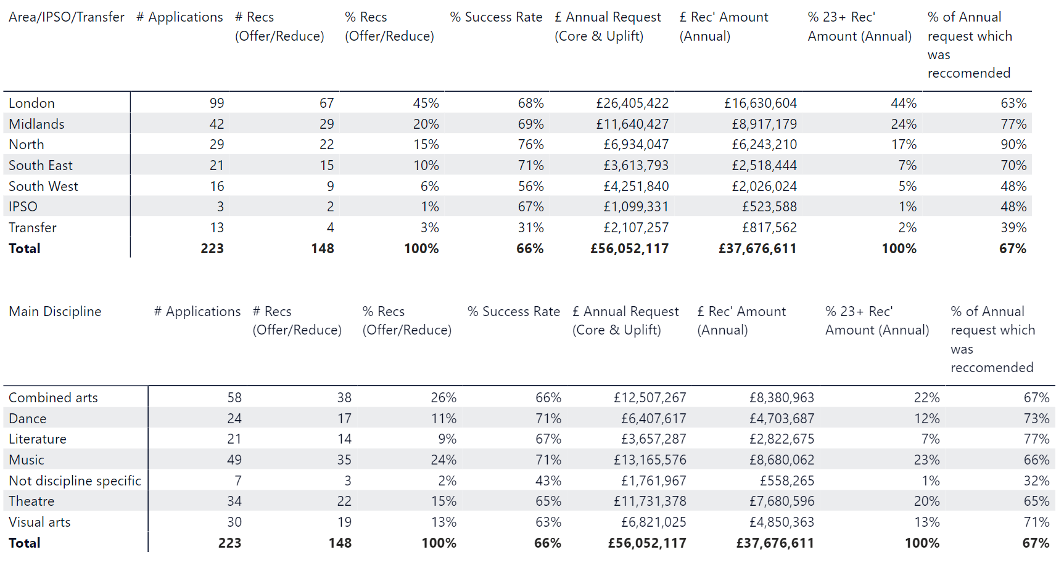

Table 2 Percentage of Investment/Portfolio and Levels of Investment
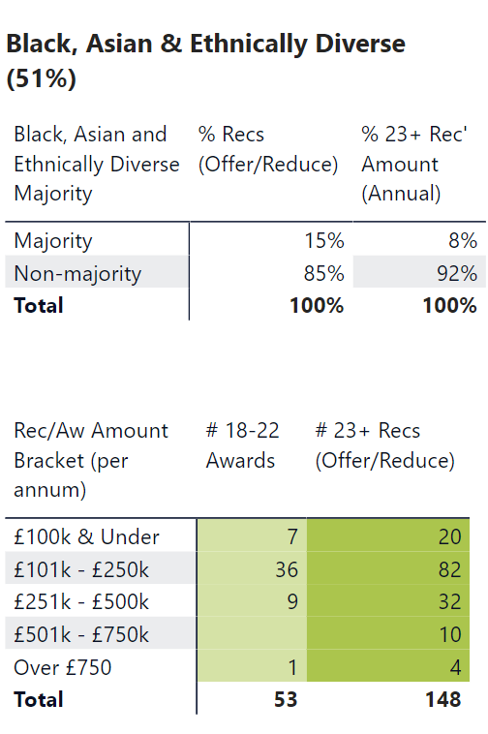

Table 3 New and Current
New
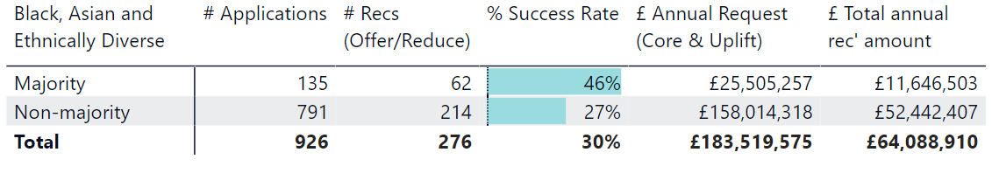
Current
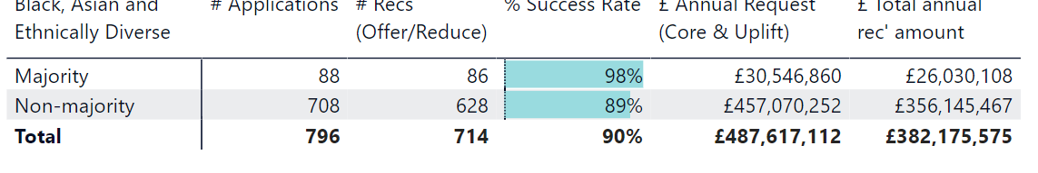

Table 4 Uplifts
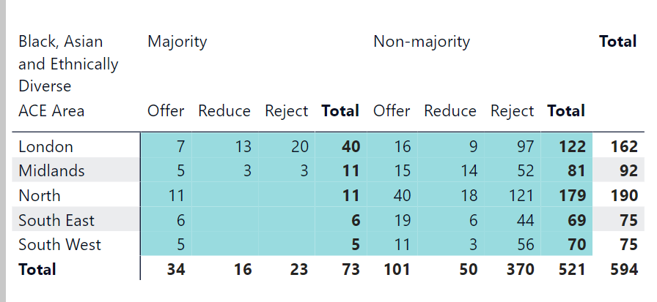
Black, Asian and Ethnically Diverse Leadership Representation

Table 5 Leadership Positions
Identifies as Black, Asian and Ethnically Diverse
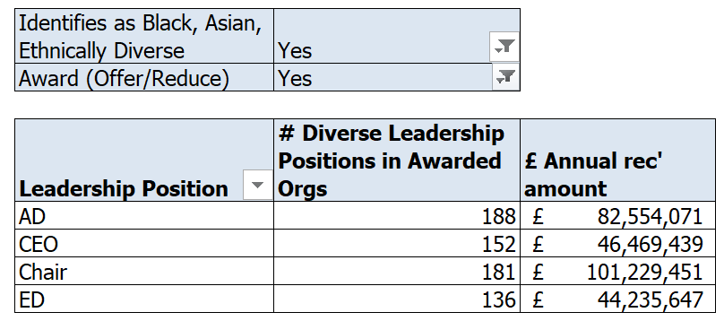

Table 6 Leadership Area Representation
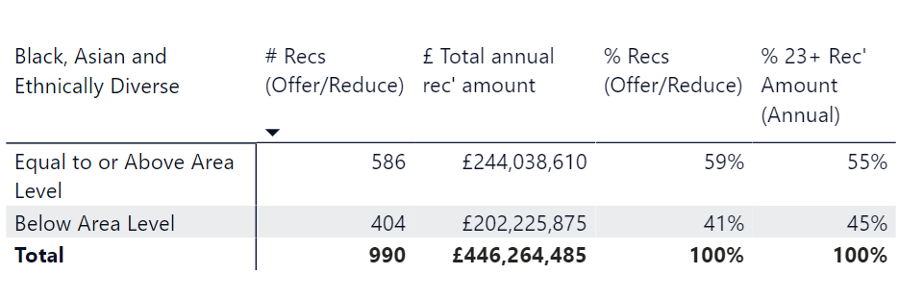

Disability Led Organisations (51% definition)
Table 7 Areas and Artform/Discipline
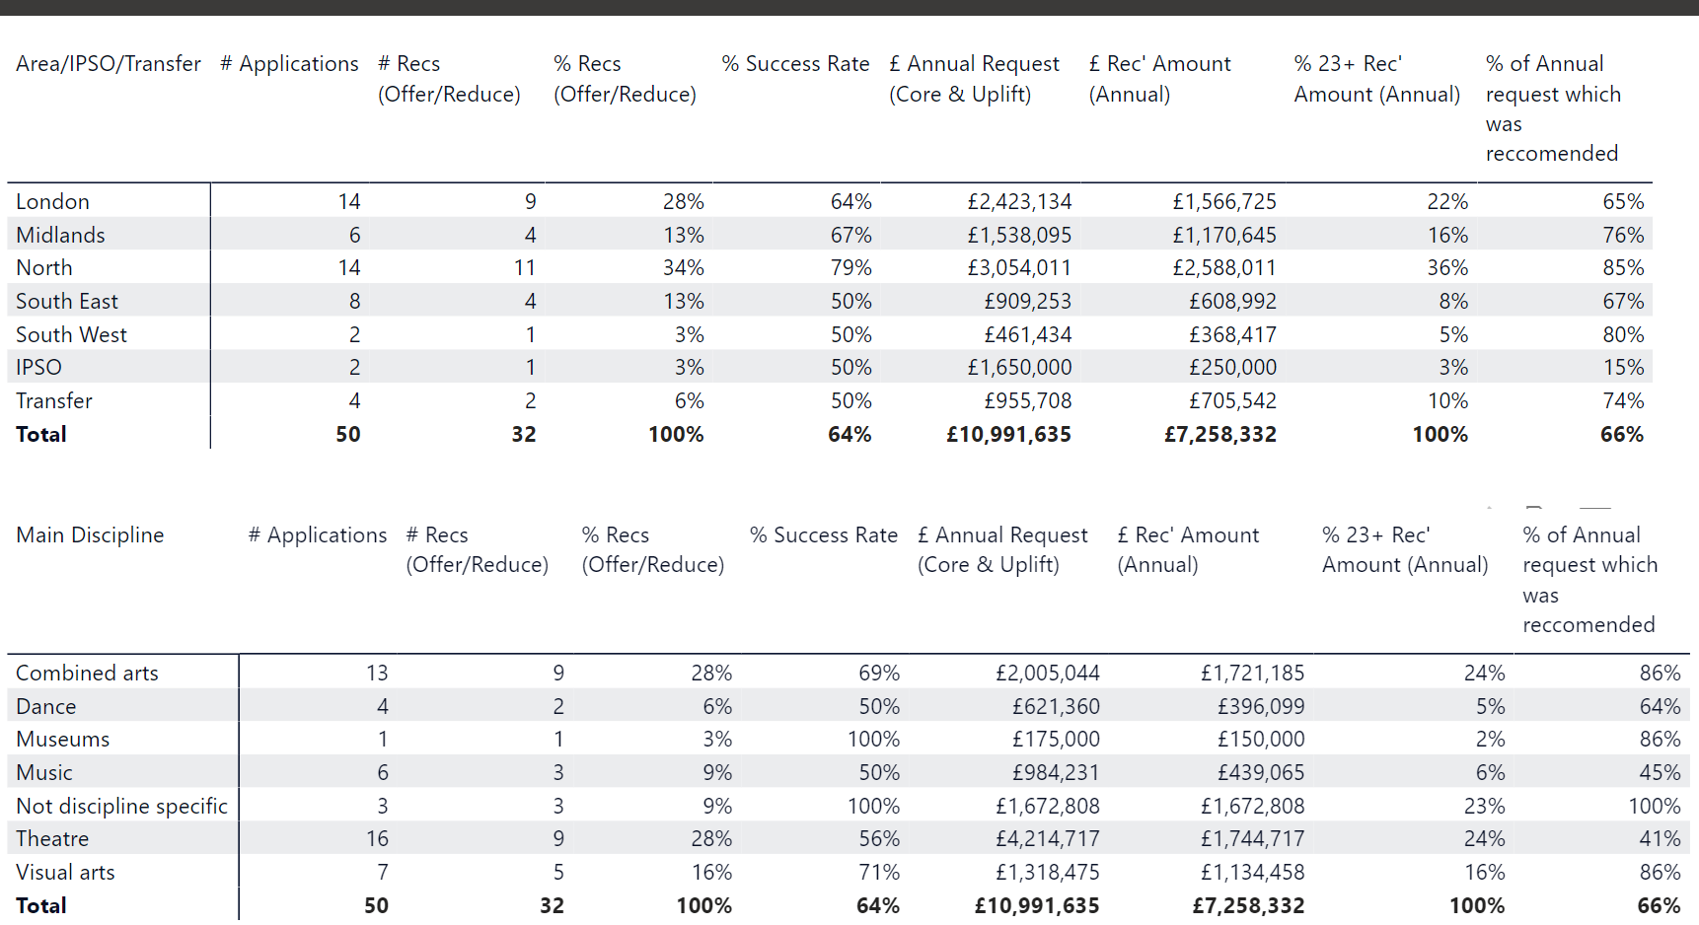

Table 8 Percentage of Investment/Portfolio and Levels of Investment
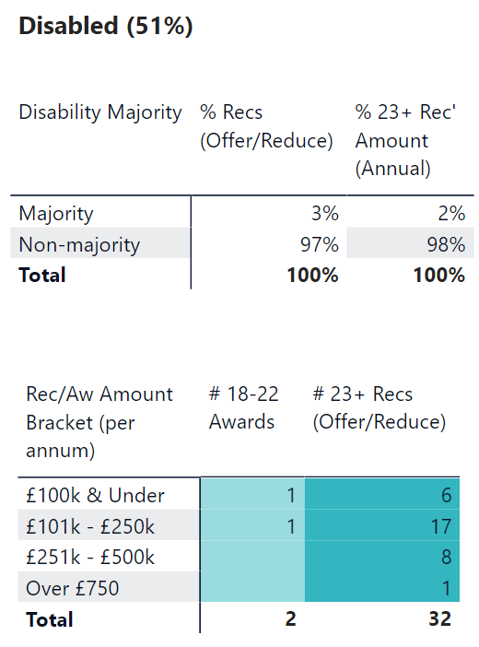

Table 9 New and Current
New
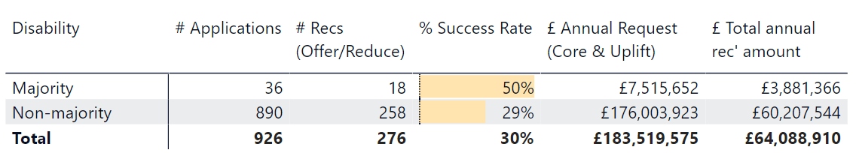
Current
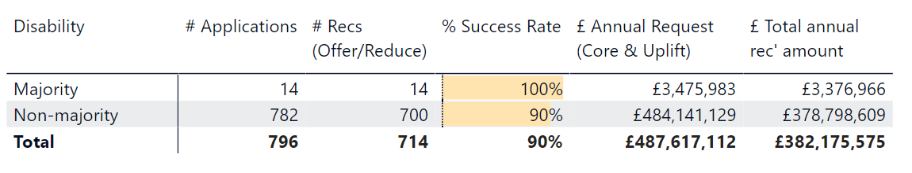

Table 10 Uplifts
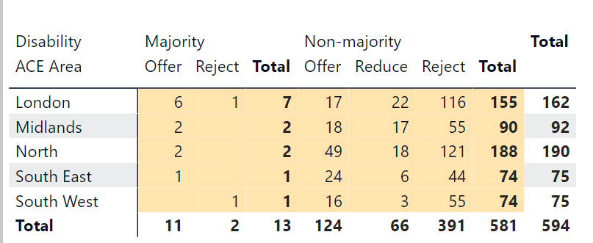

Disability Leadership Representation

Table 11 Leadership Positions
Identifies as Disabled
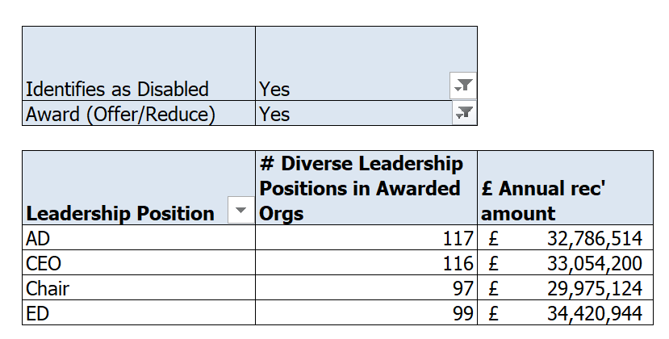
Table 12 Leadership Area Representation
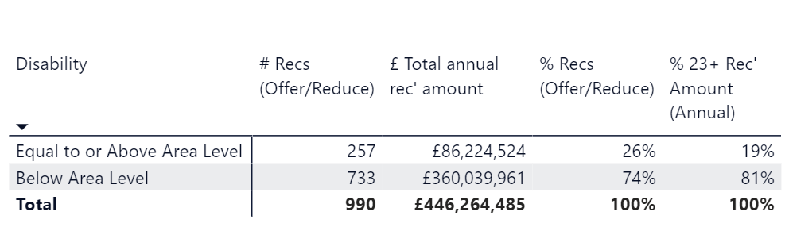

Female Led Organisations (51% definition)
Table 13 Areas and Artform/Discipline
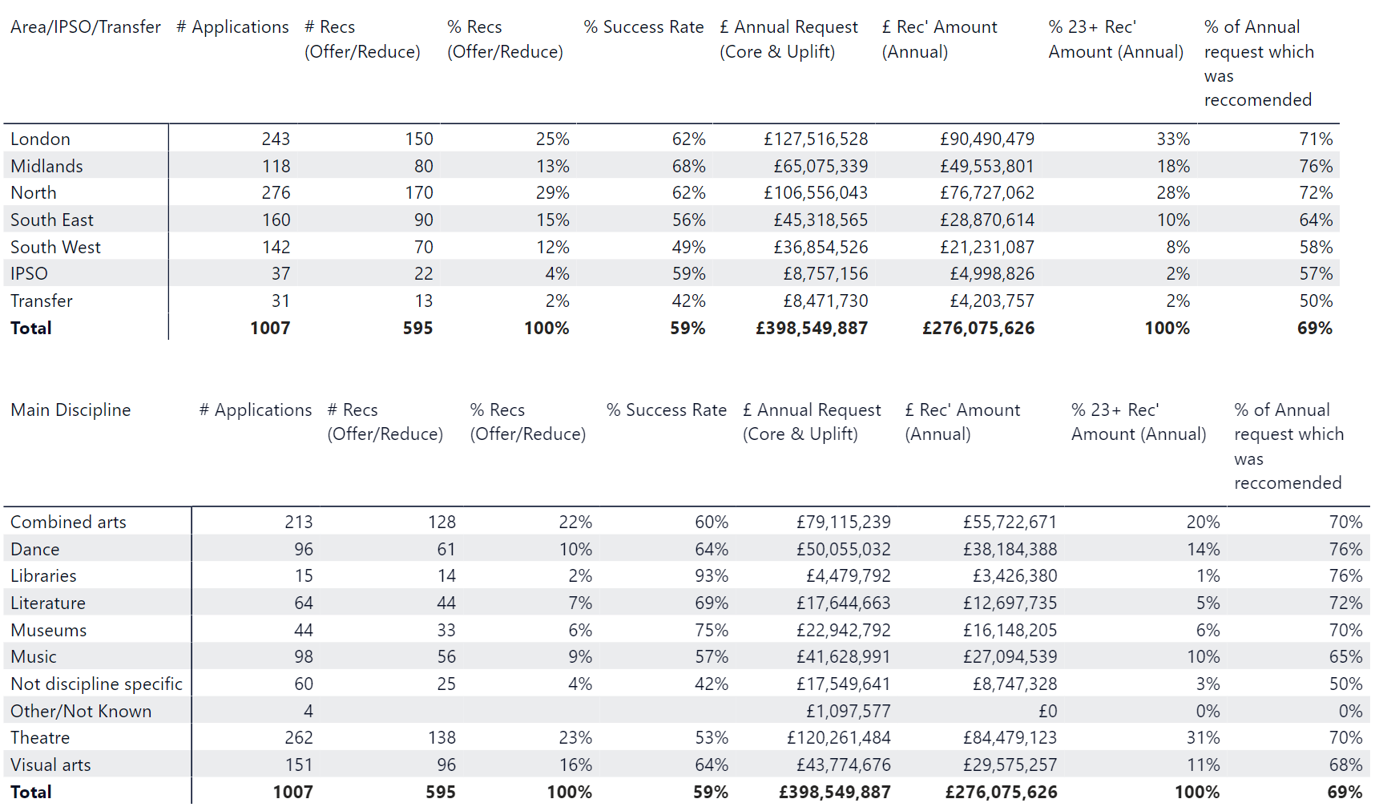

Table 14 Percentage of Investment/Portfolio and Levels of Investment
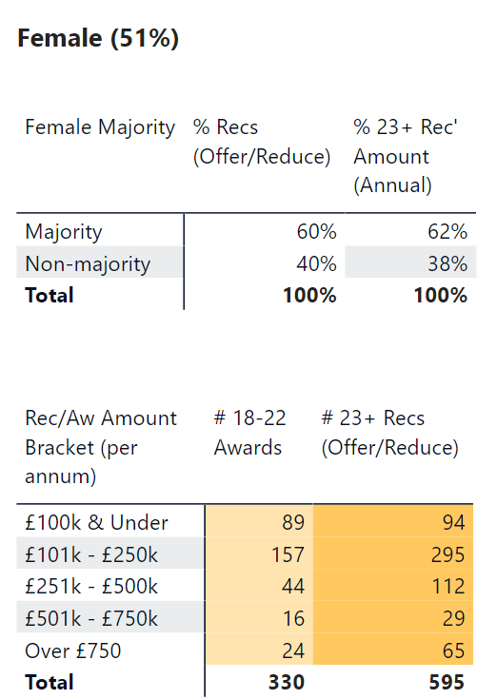
Table 15 New and Current
New
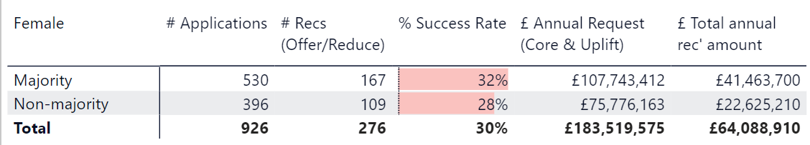
Current
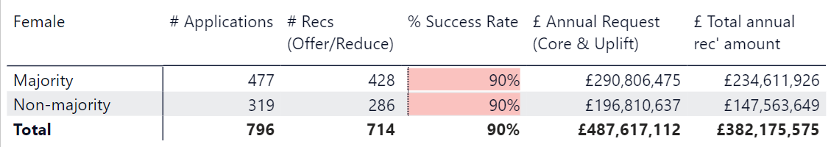

Table 16 Uplifts
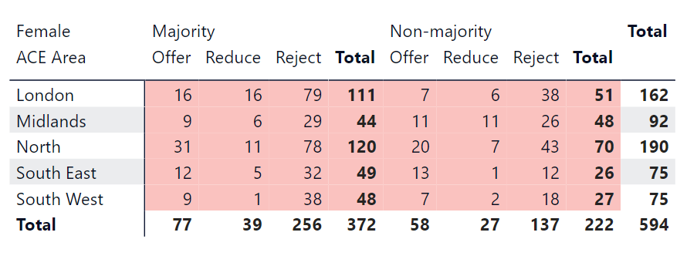

Female Leadership Representation
Table 17 Leadership Positions
Identifies as Female
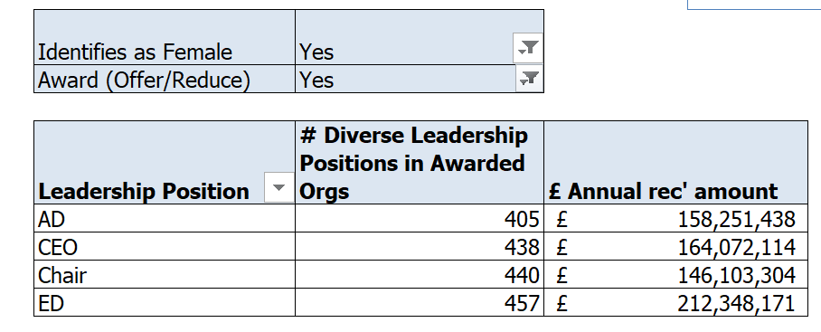

Table 18 Leadership Area Representation
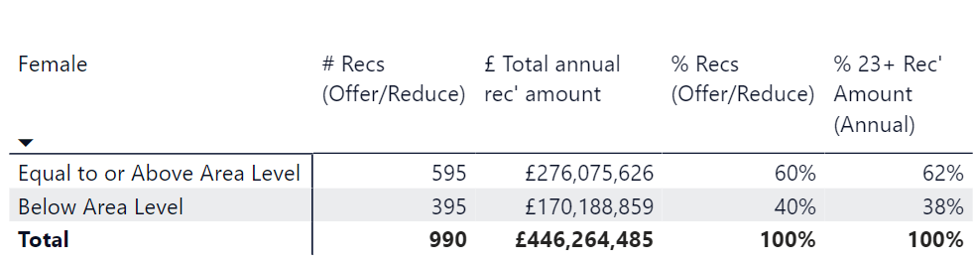

Lower Socio economic Led Organisations (51% definition)
Table 19 Areas and Artform/Discipline
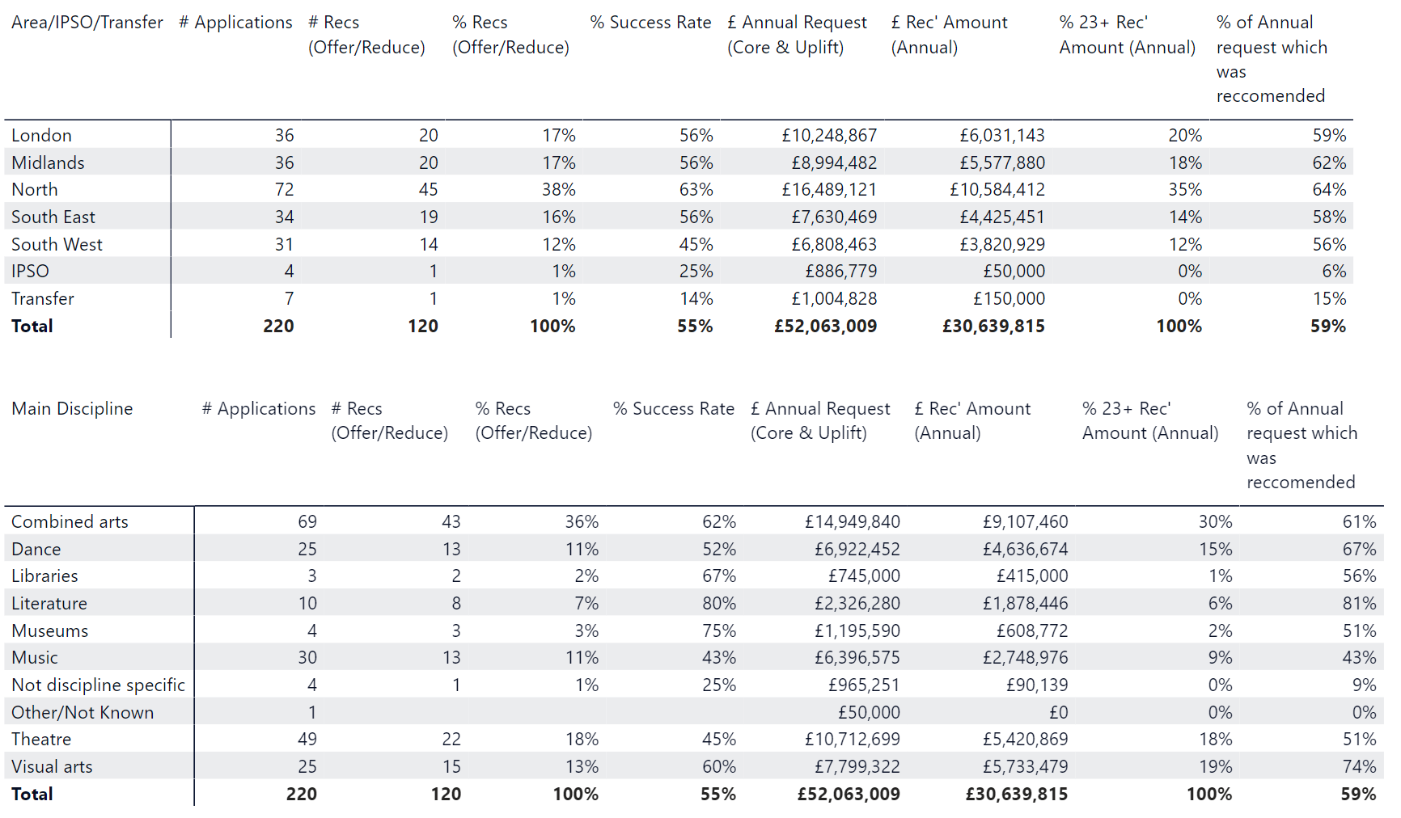

Table 20 Percentage of Investment/Portfolio
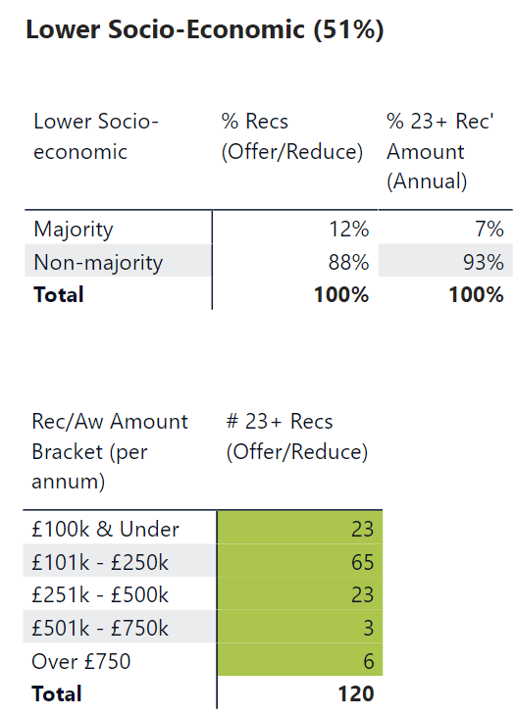
Table 21 New and Current
New
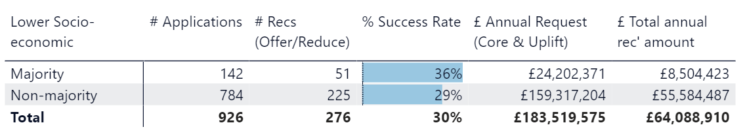
Current
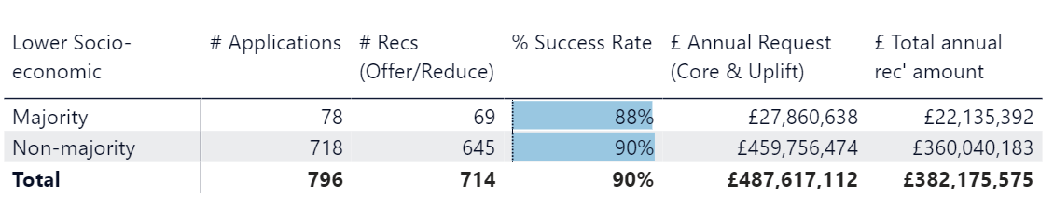

Table 22 Uplifts
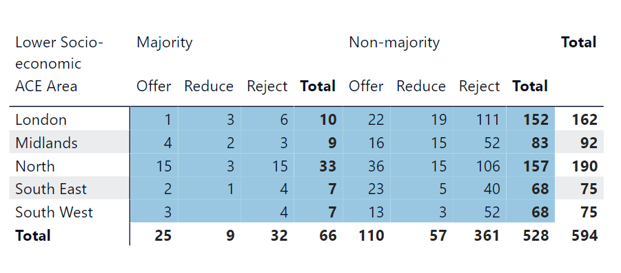

Lower Socio Economic Leadership Representation
Table 23 Leadership Positions
Lower Socio Economic Background
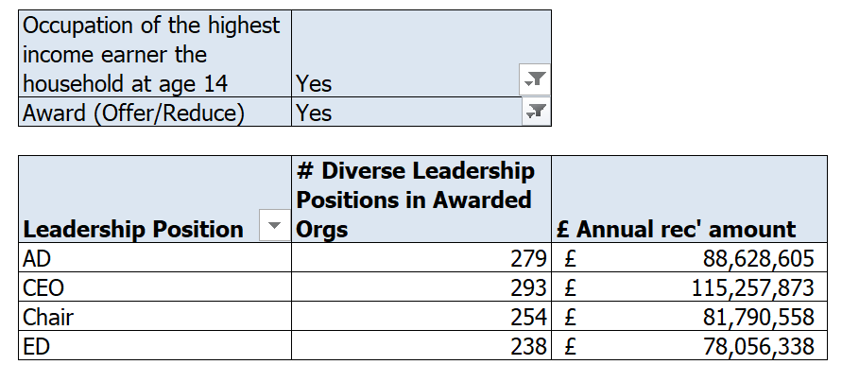

LGBTQ+ Led Organisations (51% definition)
Table 24 Areas and Artform/Discipline
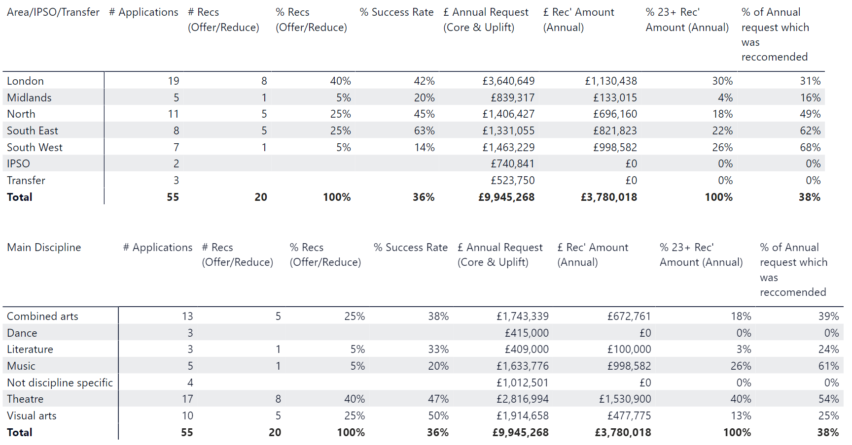

Table 25 Percentage of Investment/Portfolio and Levels of Investment
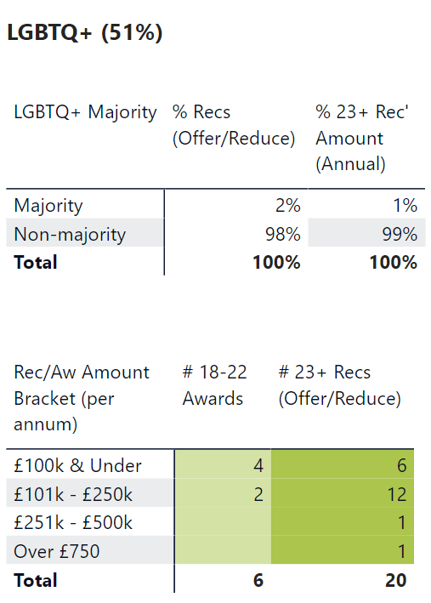

Table 26 New and Current

New
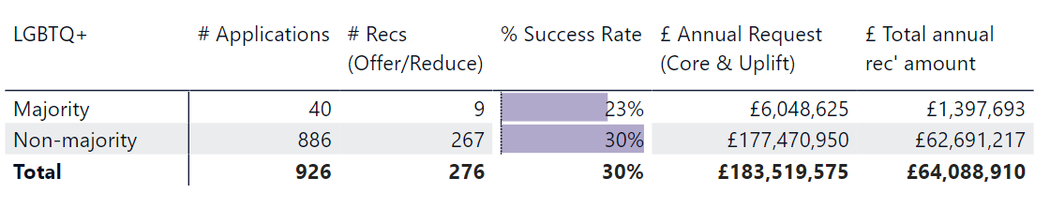
Current
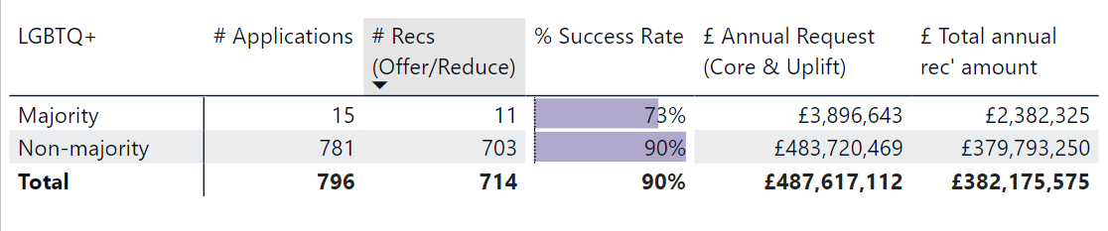

Table 27 Uplifts
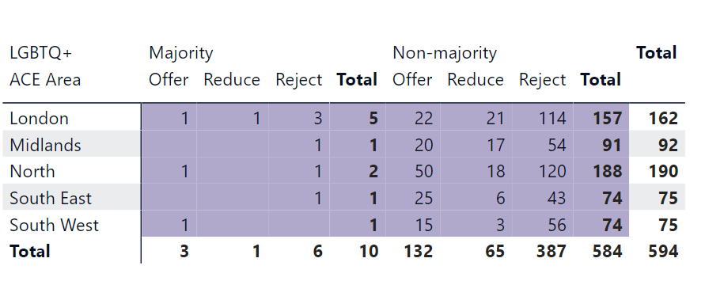

LGBTQ+ Leadership Representation
Table 28 Leadership Positions
Identifies as LGBTQ+
