Introduction

Culture Recovery Fund: Continuity Support
Application Questions

PLEASE READ THIS FIRST
This document gives applicants an indication of the questions they will need to answer to apply for the above fund. Applicants can use this document to help them in drafting their application before the application portal opens.

If you wish to apply, you will need to do this using Arts Council England’s online grant system, Grantium

We will not accept this document as an application form.

This document does not automatically count how many characters or words you have entered. You can use www.charactercountonline.com to check if each of your answers is within the character limit for that question.

As we are still in the process of building and finalising the online application form, it will not look identical to the following document – which will include additional sections (for instance, declarations relating to the HMT conditions for this fund and the Subsidy Control rules).

- The application portal for Culture Recovery Fund: Continuity Support will open at 12pm (noon) on Monday 16 August 2021.

- The deadline for applications in 12pm (noon) on Friday 27 August 2021.

Please do read the Guidance for Applicants and FAQs carefully before beginning to prepare your application.

SECTION: Basic Details

* Tell us about your organisation and its work:
(up to 1,000 characters including spaces, approximately 150 words)

* Are you a commercial or for profit organisation?
Yes/No

Note: the answer will be pre-populated as Yes if your organisation is defined as Commercial on your applicant profile.

If yes, the questions below are visible

Please note: the parent company of any commercial or for profit group must submit the application.

* Are you a supply chain organisation?
Yes/No
By this we mean you do not produce cultural work directly, but your organisation enables and supports the production of culturally significant work

* Are you a parent company applying on behalf of a single or multiple members of a group?
Yes/No

If yes, the question below is visible

* Please provide the names of the organisations within the whole group and specify who will benefit from this funding. You should provide details of any previous Culture Recovery Fund awards to the parent or any individual members of the group, including amounts and project numbers.

(up to 1,500 characters including spaces, approximately 250 words)

* Are you a heritage organisation applying for costs including a museum with either Accredited or Working towards Accreditation status?
Yes/No
Please give us your accreditation number:

Please indicate below the period you are applying for Continuity Support funding to cover.

The activity start date must be no earlier than 1 November 2021 and the activity end date must be no later than 31 January 2022.

* Activity start date:

* Activity end date:

Please tell us about your current, previous and anticipated employment levels

* In a normal year of operating, how many full time equivalents are employed by your organisation in the UK?

* At the time of the application, how many full time equivalents are employed by your organisation in the UK (including furloughed employees)?

* On 1 February 2022, how many full time equivalents do you expect will be employed by your organisation in the UK?

Please tell us about your current, previous and anticipated levels of contractual/ freelance staff

* In a normal year of operating, how many contractual/freelance staff do you employ (on average)?

* At the time of the application, how many contractual/freelance staff do you employ?

* On 1 February 2022, how many contractual/freelance staff do you expect to employ?

SECTION: Financial information

In this section you will tell us the total amount that you are requesting from us, including the amount you are requesting for Sustainability funding (if you are choosing to add this element to your application).

You will also need to tell us about the income that you have received to date, and that you are expecting to receive, until the end of January 2022 from other Government Covid-19 relief schemes:

 | Total received/ awarded before Nov 2021 £0 | Nov  2021 | Dec  2021 | Jan  2022 | Total £0 | Unspent Balance Remaining £0
Coronavirus Job Retention Scheme
Restart Grant Scheme
Recovery Loan Scheme
Additional Restrictions Grant Scheme
Coronavirus Statutory Sick Pay Rebate Scheme
Coronavirus Business Interruption Loan Scheme
Coronavirus Bounce Back Loan Scheme
Retail, Hospitality and Leisure Grant Fund
Small Business Grant Fund
Kickstart Scheme
Other Government Covid-19 relief scheme (please detail):
Other Government Covid-19 relief scheme (please detail):
Other Government Covid-19 relief scheme (please detail):

* Please explain how you have factored these Covid-19 relief funds into your application (including on your financial attachments and why you cannot draw down additional funding via those routes).

(up to 1,500 characters including spaces, approximately 250 words)

* If you have not received income from one or more of the Covid-19 relief funds in the checklist please briefly explain why this scheme/s was not appropriate for your organisation, with specific reference to the financial details provided elsewhere in the application.

(up to 1,500 characters including spaces, approximately 250 words)

In this section of the application form, you will also need to tell us how much you have received from previous rounds of the Culture Recovery Fund – including the Emergency Grassroots Music Venues Fund and Capital Kickstart Fund.

You will also need to tell us:

- Your organisation’s turnover in 2019/20
- Your organisation’s turnover in 2020/21
- Provide further details about your financial position
- Detail whether you are applying to contribute to contingency/reflate your reserves and the number of weeks this equates to

SECTION: Application questions

* Making the case to support your cultural operation

You will need to tell us:

- why you are requesting additional funding and what your financial need is
- whether you have taken advantage of other Government schemes and measures which have been introduced since the pandemic began
- how you have exhausted all other reasonable options to cover your anticipated shortfall for November 2021 – January 2022 including affordable lending, such as use of CBILS; viable alternative options for commercial, contributed and philanthropic income; and using your own resources
- tell us what your reserves position was on 1 April 2020, whether you rebuilt reserves using funding from the Culture Recovery Fund in the first or second rounds, and to what extent you plan to deploy your reserves between 1 November 2021 to 31 March 2022
- how you have managed financial risk in your organisation during this period and, if appropriate, how you have adapted your plans as the public health context has changed
- how you used your previous Culture Recovery Fund grant/s prudently and in line with agreed plans including, if appropriate, how you repurposed it as the public health context has changed
- if you are a for profit parent company applying on behalf of a group, what steps you have taken to provide additional support to the companies within your group
- how you have minimised the gap between your income and expenditure and how your plans represent the most financially prudent way to return to financial viability
- any necessary one-off costs your organisation will incur during this period that are essential to your current plan, including rebuilding reserves to the equivalent of eight weeks’ turnover pre-Covid

(up to 4,000 characters including spaces, approximately 700 words)

* Tell us how you plan to ensure your financial viability and sustainability for the period 1 November 2021 - 31 March 2022

You will need to tell us:

- how you will use this grant to continue supporting your cultural operation between November 2021 – January 2022 in a way that represents value for money. (Please factor in the assumptions about restrictions for November 2021 – January 2022 at the point of application, based on the Culture Recovery Fund: Continuity Support programme specific Government Covid-19 guidance on p.16)
- the current state of your organisation: are you operating, partially operating or have you temporarily closed/ceased trading
- what cultural activities you plan to deliver or support between November 2021 – January 2022, and how that is the most appropriate way for you to transition to a full operation, what conclusions you have drawn about likely consumer behaviour during this period, and its impact on your plans
- how you will adapt your plans in response to potential ongoing changes, including a scenario where consumers are slower to return to cultural venues or cultural activities than you’ve planned for
- what measures you have in place that allow your organisation to react to and mitigate risk, and their effectiveness
- how alternative scenarios can be managed

Using your cashflow and budget template to 30 June 2022, use this question to provide a narrative and tell us:

- after the grant has been spent, what measures you are taking to control expenditure
- how any future income or fundraising plans will contribute, and how realistic these plans are
- whether there are any risks associated with your current plans, and how you intend to mitigate those
- what reserves you expect to have on 1 November 2021
- how any future income or fundraising plans will contribute, and how realistic these plans are

(up to 4,000 characters including spaces, approximately 700 words)

For organisations that answered yes to ‘Do you intend to include a Sustainability bid within your application?’ in the eligibility quiz you will need to answer the following questions as well.

Please note, to be eligible for this element of this fund you must meet the following criteria:
● You must have previously received funding from the Culture Recovery Fund: Grants programme in the first or second rounds to the cumulative value of at least £250,000
● You must have a pre-Covid annual turnover of over £1 million

Arts Council National Portfolio Organisations, Universities and Local Authorities are not eligible to apply to this element of the fund.

SECTION: Sustainability application question

* Making the case for Sustainability funding

You will need to demonstrate:
- strong outputs and outcomes in relation to the Sustainability objectives
- that all other reasonable options, including cost savings measures, have been exhausted or are likely to be insufficient to support your long-term viability
- sufficient evidence of your organisation’s commitment, including relevant skills and experience available at a senior level, to make changes to their operating and business models
- that the identified sustainability activity will improve the financial position of the organisation beyond the initial funding period
- there is sufficient evidence of the board’s ownership/leadership’s commitment to delivering proposed long-term changes to the organisations operating and business models
- that key organisational development milestones have been identified

(up to 4,000 characters including spaces, approximately 700 words)
SECTION: Expenditure

In this section you will fill in a table outlining the cash expenditure for your Continuity Support bid.
The table at the top of the page will be a snapshot of the information you are entering, and will calculate your total expenditure for you as you work. This table is not editable.
The details about each item of expenditure that you add will be shown in the list at the bottom of the page. You should make sure that you show how your figures have been calculated in the 'Description' field. For example, you should show the number of days and the daily rate for any fees shown.
You should solely account for the costs you’re applying for Culture Recovery Fund Grants to cover within this table

Please see an example of what this table will look like within Grantium below.

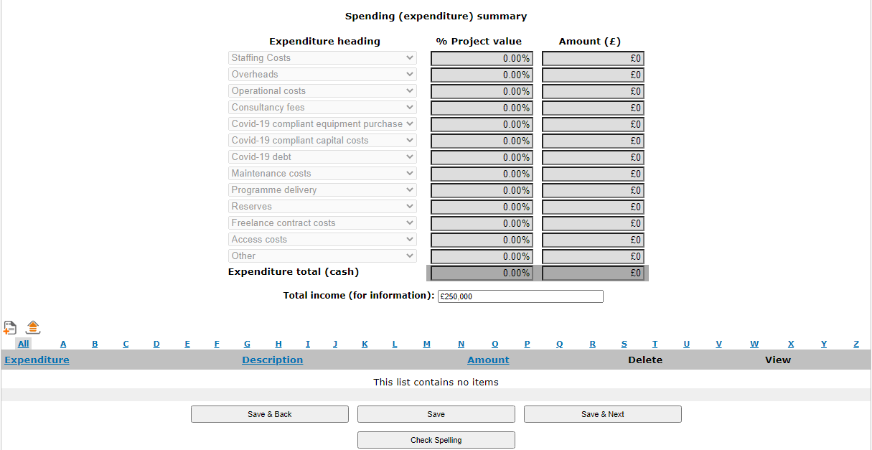

SECTION: Delivery Plan

Delivery Timeline
In this section you will fill in a table to list the main stages and tasks of the delivery of your activity from the start date onwards, and to show who will lead on each part of the delivery.
You will need to enter at least one stage and add each delivery stage in order.

SECTION: Area of Benefit

In this section you will fill in a table entering the location(s) where your activity is happening.

SECTION: Financial attachments

You must provide the mandatory attachments, using the formats specified and templates provided in the guidance for applicants, in support of your application:

- a completed mandatory cashflow template for the period 1 July 2021 – 30 June 2022
- a completed mandatory detailed budget template for the period 1 November 2021 – 1 April 2022
- a balance sheet at 27 August 2021, showing actual levels of restricted and unrestricted reserves
- a balance sheet projection for 31 January 2022, showing projected levels of restricted and unrestricted reserves
- last financial year’s full financial statements (preferably 2019/20 where possible), prepared to the relevant legal standard for an organisation of your size and status

For organisations that answered yes to ‘Do you intend to include a Sustainability bid within your application?’ in the eligibility quiz, you will also need to attach the following mandatory attachments:

- A completed Sustainability funding outline budget for the period 1 November 2021 – 1 April 2022
- A completed organisational outline budget for the period 1 April 2022 – 31 Mar 2023

If your application, which must be completed on Grantium, does not contain the information we need, in the format we ask for it to be in, we might not be able to consider your application.

This should be an average of your organisation’s annual turnover from 2017/18, 2018/19 & 2019/20
By ‘outline’ we mean a budget that gives an overview of the applied for activity, but which is preliminary or draft rather than finalised. We understand that outline budgets may be work in progress and subject to change. The plans and accompanying budgets may be revised in response to feedback from the Arts Council and ongoing work to develop plans, which may be subject to change pending your organisation’s board approval.

