ARTS COUNCIL ENGLAND

Culture Recovery Fund: Repayable Finance Round 2

Easy Read version

We can give loans to help culturally significant organisations transition back to a viable and sustainable operating model during 2020/21

This Easy Read guide can help you think about your activity and our application form

December 2020

Culture Recovery Fund – Repayable Finance

We can give loans to help culturally significant organisations…

…as they move back to a viable and sustainable operating model after the impact of covid-19

This investment is intended to ensure that, by no later than 31 March 2022, successful applicants are operating fully on a viable and sustainable basis

The smallest loan you can apply for is
£1 million

There is no upper limit, but the total available for all the loans we will make is £100 million

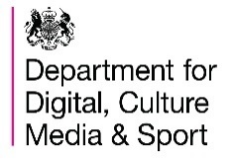
The criteria for this programme are set by the Department of Digital, Culture, Media and Sport (DCMS)

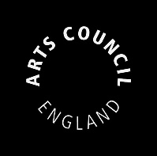
The loans are administered and monitored by Arts Council England on behalf of DCMS

Alongside Recovery Loans, we will also run a Recovery Grants programme

If you plan to apply to another Culture Recovery Fund programme, you cannot make an application to this fund

Find out more about Recovery Grants on our website over the coming days

Who can apply?

The types of organisations that can apply are:

Cultural organisations based in England…

that are properly constituted and registered with at least one of these bodies:

- Companies House,
- Charity Commission
- Financial Conduct Authority (FCA)

This includes:
Organisations in the remit of Arts Council England:

- Dance
- Literature
- Music
- Museums
- Theatre
- Visual Arts
- Combined Arts

Libraries also sit in our remit, but Library services are not eligible to apply to this programme

Local Authorities, Universities and other Public Sector bodies who run or maintain cultural services

Heritage organisations – including built and intangible heritage

Cinemas

See the main guidance [LINK] for more on who can apply to this programme

Who cannot apply?

There are some people or venues we can’t support through this fund. These include:

Individuals – such as individual artists, sole traders, specialists or agents

non-Accredited museums – only museums with full or provisional status can apply

DCMS-sponsored museums and
MOD-sponsored museums

Library services

Consortia – groups of organisations working together

What can I apply for?

You can apply for £1 million and over to pay for:

Costs to support sustainability and/or increase organisational resilience

Operational costs up to 31 March 2022

These can include:

general running costs and overheads like ongoing rent, rates and utilities

staffing and personnel costs

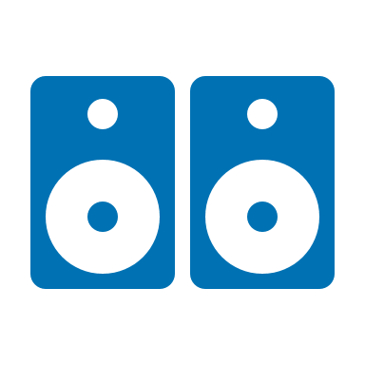
asset purchases – including equipment to support social distancing and other public health requirements
costs for preparing to restart activities that will drive future income. This can include performances, exhibitions and marketing

continued sustainability - for example, ongoing maintenance costs where closure remains necessary

redundancy pay outs where decisions have been made to reduce staff

advice from professionals, for example on risk, safety, how to support staff or on new business models

operating losses incurred as a direct result of the Covid-19 pandemic

maintaining buildings and other assets, including collections, while closed

stabilising collections at immediate risk and temporary storage of collections

security to ensure buildings and sites are secure over any anticipated closure period

costs to prepare for reopening, including hiring staff

risk management reviews

reconfiguring business plans, governance and safeguarding activity

organisational restructures and mergers

costs that may prevent the need for additional, unavoidable, public investment in future

What cannot be funded?

There are some things we can’t pay for through this fund. These include:

Operating costs beyond 31 March 2022

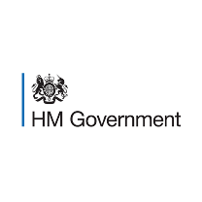
Costs that are eligible to be covered by other strands of Government support, for example, furloughing

Repayment of debt used to finance the business

New projects/activity during a prolonged closure period that do not represent a value for money approach

Increasing reserves beyond the equivalent of up to eight weeks’ turnover

Costs related to the promotion of the beliefs of political or faith organisations

Covering costs/losses already supported through other sources, including any other Arts Council funding

For example, National Portfolio funding, the Arts Council’s Emergency Response Funds and Government schemes

For more details, see the Frequently Asked Questions [LINK] which support this guidance

Applying to this fund

This programme has a two-stage process. Stage one is completing the application form
To apply, start a new application online.
Choose Culture Recovery Fund: Repayable Finance from the list

Set up your online profile as soon as possible. It can take us a few days to confirm it

There will be one round for applications

 | Portal opens | Portal closes
Round One | 15 December 2020  3pm | 7 January 2021  12pm midday

Your application must be submitted by 12pm midday on 7 January 2021

Stage One - The application form

We will first ask for some Basic details - including the amount you want to borrow and some information about your organisation

We will then ask you to answer some written questions and to upload a balance sheet

Over the next few pages, we will give you some detail to help you understand and answer the questions

To help you answer these questions, each question has a list of bullet points

These are outlined in further detail in the main guidance

1 – Cultural Significance

Tell us about your organisation’s work and how it is considered to be culturally significant and/or how it contributes to providing cultural opportunities

Tell us about:

- your national and international significance within the cultural sector

and/or

- your role in providing cultural opportunity in England

You only need to answer one of these options, but you can answer both if you want to
A full list of prompts to help you answer this question can be found in the full guidance

up to 4,000 characters including spaces, about 700 words

2 - Diversity of audiences and workforce

Using the protected characteristics outlined under the Equality Act, tell us how you will improve the diversity of your workforce, governance, audiences, visitors and participants

Tell us:

- what steps you will take to broaden the diversity of your workforce and governance, and the impact of those changes

and

- what steps you will take to broaden the diversity of your audiences, visitor base and participants, and the impact of those changes

You must answer both bullet points for this question

up to 2,000 characters including spaces, about 350 words

You will also be asked to respond to the following questions:

Tell us how Covid-19 has impacted your financial viability, resilience and sustainability

- How has your business model changed, what have you not been able to do?

up to 2,000 characters including spaces, about 350 words

Briefly set out how you would use a loan from this programme, including how this would allow you to achieve financial sustainability and/or increase organisational resilience

- Tell us what you plan to do, and how you plan to safeguard your work and finances
- Include details about what you will do if we are unable to offer you a loan

up to 4,000 characters including spaces, about 700 words

3 – Attachments

You will need to attach:

a balance sheet at 31 March 2020 – this should show levels of restricted and unrestricted reserves

Attachments can be in any of these formats: jpg, xls, xlsx, jpeg, pdf, doc, docx, pptx, and ppt.

The file size limit for all attachments is 10 megabytes.

Stage Two – Additional Information

If your application is successful at Stage One, it will progress to Stage Two. At Stage Two, we will ask you to provide some additional documents

The deadline for Stage Two submissions is 03 February 2021

You may need to prepare these documents before you know the outcome of your Stage One application

Stage two documents:
a recovery plan, see page 19 for more detail on this

your most recent financial statements for the past three financial years

your most recent management accounts for the year ending 31 March 2021

Annual budgets for 2021/22, 2022/23, 2023/24 and 2024/25 - showing how a loan will allow you to achieve financial sustainability by 31 March 2022

Cash flow forecasts for 2021/22, 2022/23, 2023/24 and 2024/25 - showing the impact of the proposed loan

Any assumptions made in your recovery plan should be shown in your financial attachments.
You can use notes to show this

Please provide any cash flows or financial models in Excel format

Recovery Plan
Your recovery plan should be no more than 5000 words long and should tell us:

- how you have managed the impact of Covid-19 so far

- how you have reduced core costs to ensure your organisation is more financially resilient

- how a loan from this programme will enable you to achieve financial viability by 31 March 2022, demonstrating the most value for money route to sustainability

- what activity you anticipate delivering in the period up to a return to financial sustainability, to include any further anticipated closure period

- what assumptions you have made about consumer behaviour in the social distancing scenario we have shared with you

- your plan for identifying, managing and mitigating risk

- your organisational governance and leadership structures, including skills and experience available at a senior level to enable you to adapt and flex your business to the changing external environment

- what financial controls, monitoring and reporting processes you have in place to ensure the effective financial management of your organisation

- key business development milestones

What happens next?

Each section of your application will be assessed by cultural development agencies and specialist financial advisors

It will then be considered by the Culture Recovery Board, who will decide whether to offer the amount you’ve asked to borrow

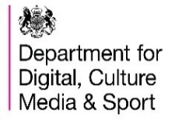
The Culture Recovery Board is a group of experts, selected by the DCMS, who will make decisions on this programme

We will aim to notify you of our Stage One decisions around the end of January 2021.

Stage two assessments will take place throughout February 2021.

If we offer a loan, we will negotiate the terms, and possibly the size, of your loan with you

How do I repay a loan if I am offered one?

Loans terms will typically be:

a fixed yearly repayment over a term of up to 20 years

2%
repayable at an interest rate of 2% per year, applied on a daily basis

See the main guidance for a full Summary of terms for these loan types

Help is at hand

Our friendly Customer Services team can help you with the form or advise on other ways we can help you

For example, if you have any access needs, or use an access support worker

artscouncil.org.uk/contact-us

More details about this fund can be found in the full guidance, which is also available in Large Print

artscouncil.org.uk/CRFrepayablefinance

