Grantium guidance for applicants
How to submit a report

Version 2 – February 2018

As part of our standard conditions for Arts Council National Lottery Project Grants, and for our Strategic Funds, you will be asked to submit an Activity Report form at the end of your project, before you can claim your final payment. If you have been awarded over £15,000 for ACPG, or for some of our Strategic Funds, you will also be asked to submit an interim report form part-way through your project, before you can claim your interim payment. All Activity Reports are completed and submitted using our online system.

This guidance document takes you through the step-by-step process for submitting a report. You should read this alongside the guidance document, How to claim a payment.

How to submit a report

Log into your Grantium account using your username and password.

On the Welcome screen, click on the Submissions link in the grey bar to the left of the screen:
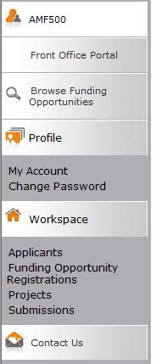

‘Submission’ is the name we use for any online form that you submit. Clicking on this link will take you to a list of every submission linked to your projects. This will include the eligibility questionnaire and application form you submitted, as well as the offer letter acknowledgement you received to notify you of the outcome of your grant.

This list will also show any Activity Reports that are due to be submitted.
Please note: Your Activity Report forms will only appear in your user account four weeks before their due date. This means that if you are completing your interim report, your final activity report form will not be visible in your user account until closer to the time the final payment is due.

To begin working on your Activity Report, click on the Open icon next to the report:

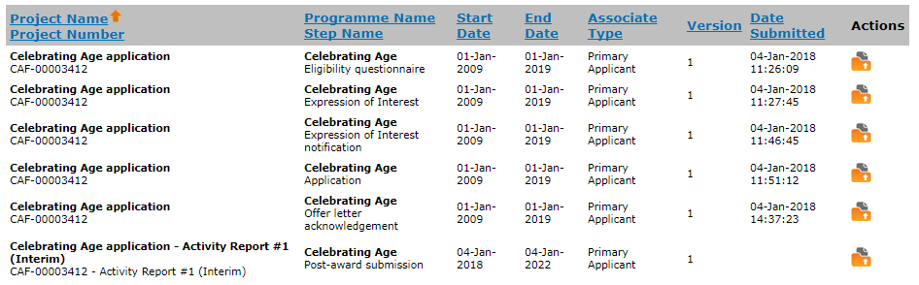

This will take you into the report form workflow. There are a number of screens to work through, which you can see in the navigation bar to the left of the screen. These tasks will be slightly different depending on if you are completing an interim activity report form (for your second payment, for grants of over £15,000) or a final activity report form (for your final payment):

Interim Report Final Report Final Report
(Strategic Funds) (Project Grants)
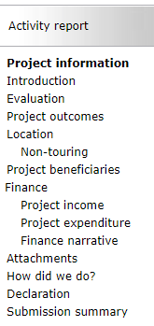
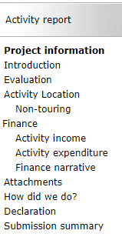
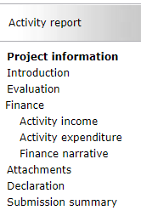

To submit your activity report you will need to work through each of these screens, completing all the information required.

The first screen is the Project information screen. You do not need to enter any information on this screen, however you can view your application form, award schedule, or offer letter by clicking on the links at the top of the screen.

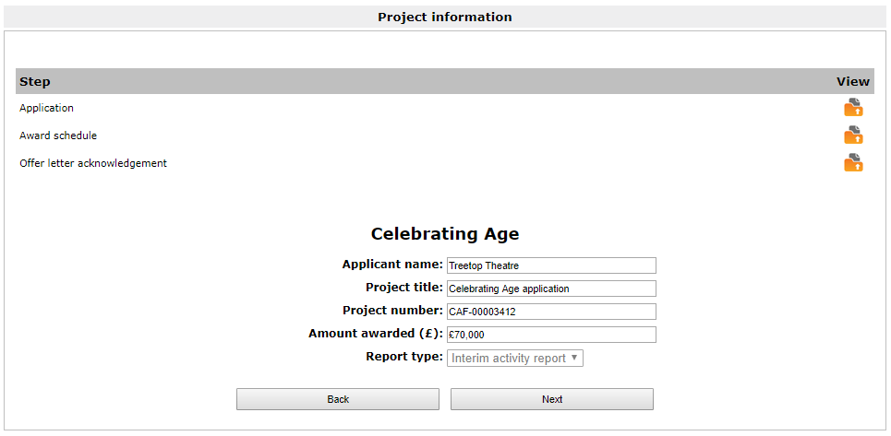

Click Next to proceed.

The next screen is the Introduction screen. This screen provides you with some information about why we are requesting this report from you and what information to include. You do not need to enter any information on this screen.

Click Next to proceed.

The next screen is the Evaluation screen. This screen asks you to evaluate your activity by answering questions about your project and its outcomes. For an interim report, there will be two questions. For a final report, there will be three questions. Fill in the free-text boxes, using up to 3,000 characters per question.

Click Save & Next to move on to the next screen.

The Next screen is Project outcomes (final activity reports only, for Project Grants and Developing Your Creative Practice).

This screen will show you the Project outcomes that you selected in your application form, and ask you whether you achieved these outcomes. Use the text box to tell us more about how you achieved them, or to discuss issues you encountered and what you have learned, using up to 1,500 characters.

Click Save & Next to move on to the following screen.

The next screen is Activity Location (final activity reports only).

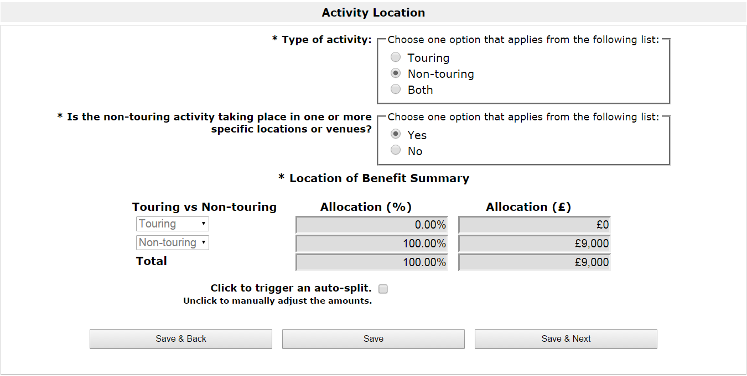

This screen will pull through the information you entered in your original application about the Type of activity, which will have been either Touring, Non-touring, or Both. If there have been any changes to the Type of activity, you can change what is selected.

Click Save & Next to proceed.

The next screen will be either Touring, Non-touring, or you will see both (one after the other) if you selected that your project was both Touring and Non-touring.

If you entered touring venues in your application, the next screen will be the Touring screen with details of your Final tour schedule. You will need to update the tour schedule with details of your project’s time at each of the tour venues.

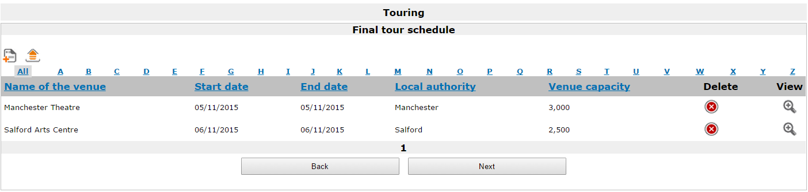

To add another venue to the schedule, click the Add icon . If you did not attend a venue listed here, you can delete it by clicking the Delete icon . To add details to an existing tour date, click the View icon .

Clicking the Add icon or the View icon opens the Touring venue details screen.

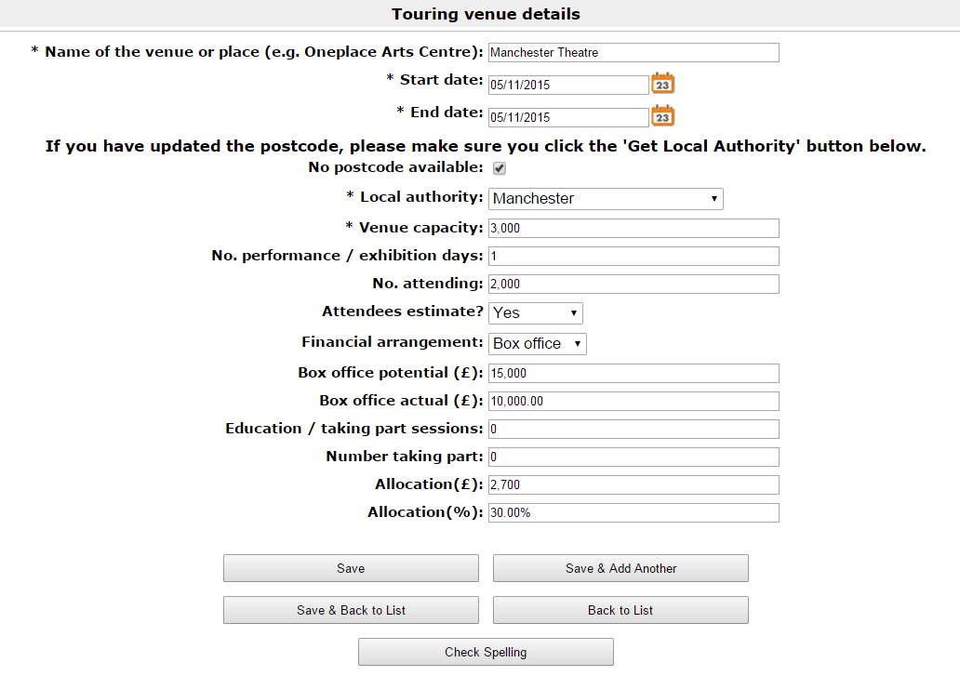

Complete the details as applicable. Click Save & Back to List to return to the Touring screen.

Complete the details for all venues and click Next to continue.

If you identified your project as having a Non-touring element, the next screen will be Non-touring.

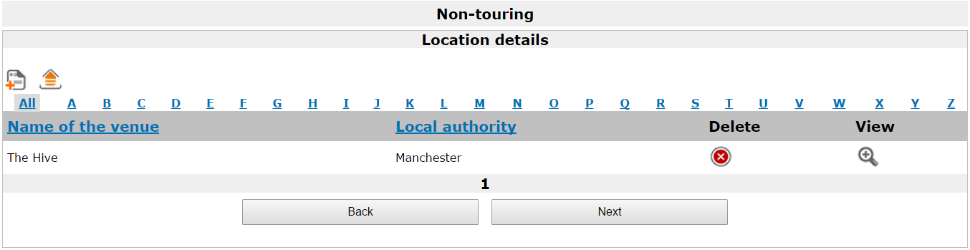

This screen shows details of any non-touring venues that you included in your application. To add another venue to the schedule, click the Add icon . If you did not attend a venue listed here, you can delete it by clicking the Delete icon . To edit any location details of an existing non-touring date, click the View icon .

Clicking the Add icon or the View icon opens the Non-touring venue details screen.
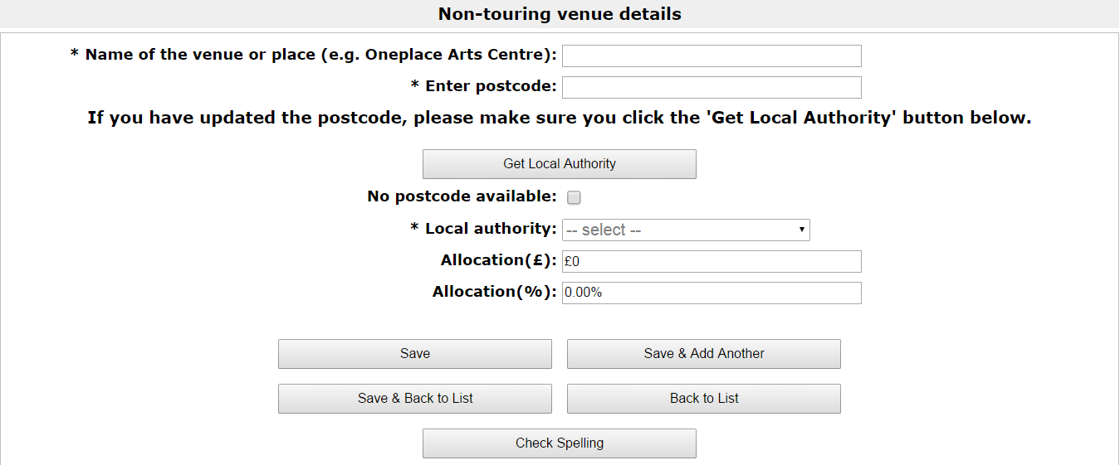

If you are viewing an existing entry, the details on this screen will be filled in already. If you are adding a new entry, complete all details and click Save & Back to List to return to the Non-touring screen.

Click Next to continue.

The next screen is Activity Beneficiaries (final activity reports only).

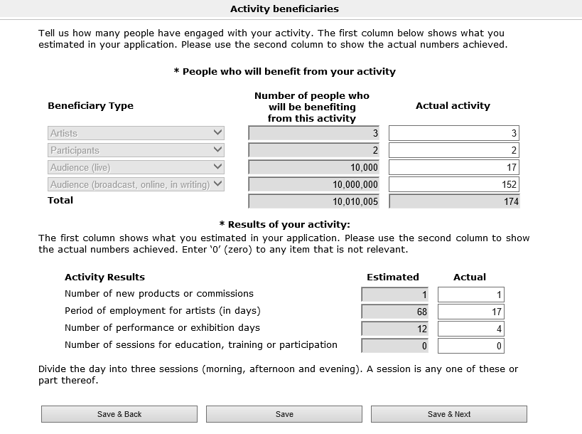

In your original application form, you will have been asked how many people you thought would engage with your project. In your final activity report we ask you to provide more accurate, up to date figures for this. The totals for each section will appear once you click Save. You do not need to work these out yourself.

Click Save & Next to move on to the next screen.

The next screen is the Activity income screen.

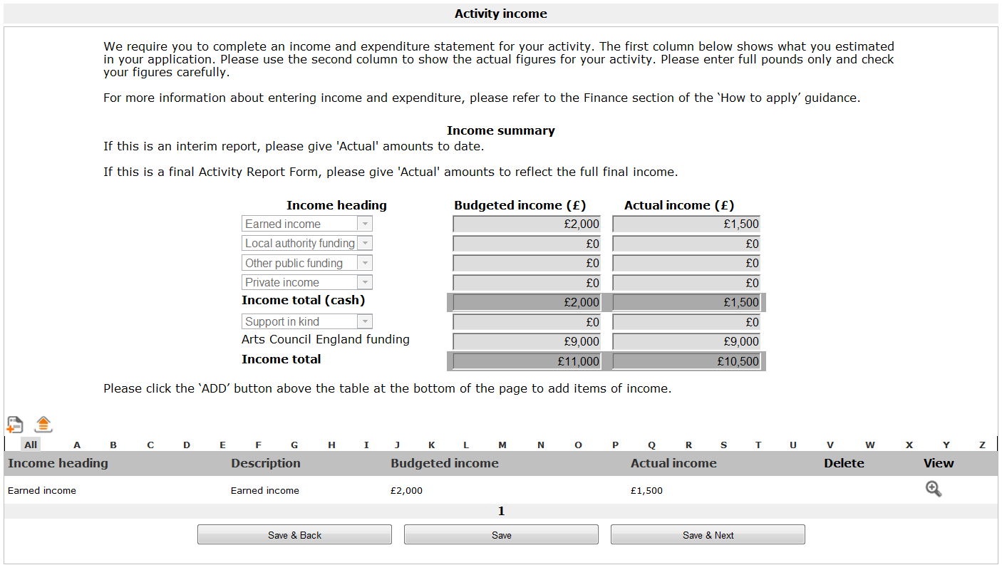

This screen will pull through the budgeted income figures you entered in your original application form. If you are completing this screen as part of an interim report, you will need to add your actual income figures to date. If you are completing it as part of a final activity report, you will need to add your final actual income figures.

To add actual figures for existing income lines, click the View icon . If you want to create a new income line, click the Add icon .

Clicking either one of these icons will open the Income details screen.

Please note, you should only add a new line if you have an entirely new source of income that you did not list on your original application form.

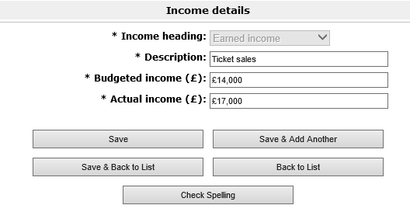

Complete all relevant fields, ensuring you include a figure for Actual income. Once you have done this click Save & Back to List to return to the Activity income screen. Repeat this for any additional income lines you need to update.

On the Activity income screen, click Save & Next once you have updated all of your income lines.

The next screen is Activity expenditure.
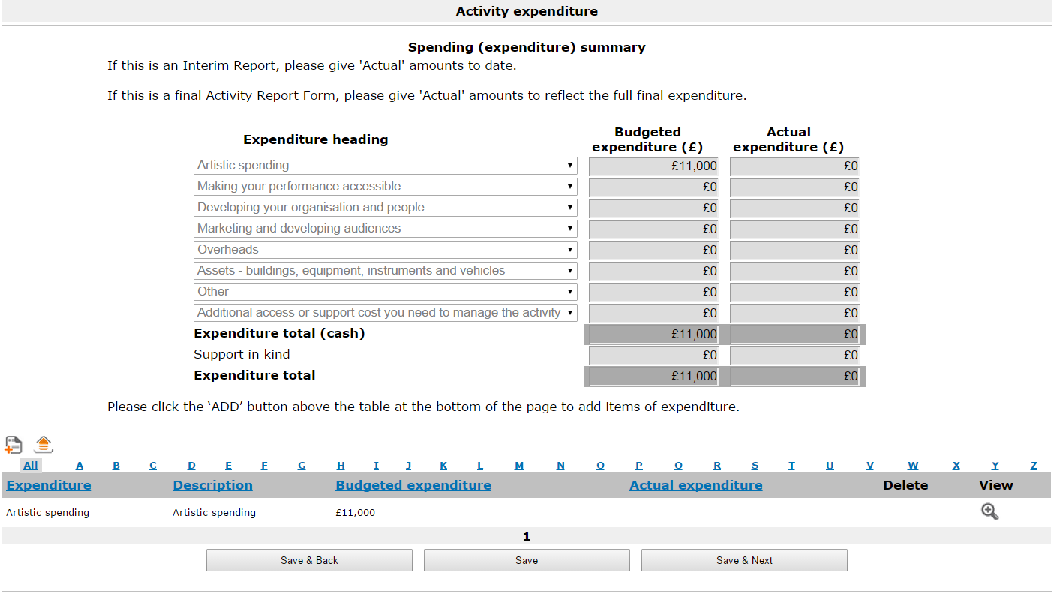

Like the Activity income screen, this screen will pull through the budgeted income figures you entered on your original application form. If you are completing this screen as part of an interim report, you will need to add your actual expenditure figures to date. If you are completing it as part of a final activity report, you will need to add your final actual expenditure figures.

To add actual figures for existing expenditure lines, click the View icon . If you want to create a new expenditure line, click the Add icon .

Clicking either one of these icons will open the Expenditure details screen.

Please note, you should only add a new line if you have an entirely new area of expenditure that you did not list on your original application form.

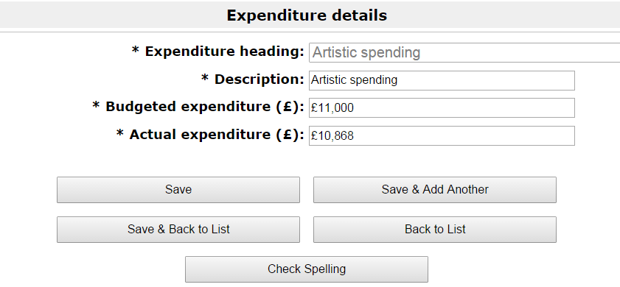

Complete all relevant fields, ensuring you include a figure for Actual expenditure. Once you have done this click Save & Back to List to return to the Activity expenditure screen. Repeat this for any additional expenditure lines you need to update.

On the Activity expenditure screen, click Save & Next once you have updated all of your expenditure lines.

The next screen is the Finance narrative screen.

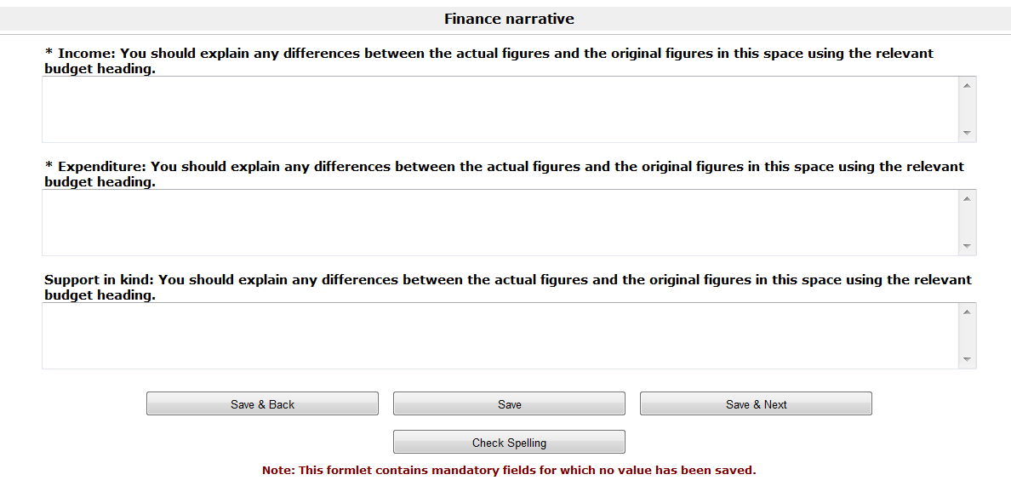

Fill in the free text boxes provided, answering the required questions. If you did not have any support in kind for your project, you can leave this box blank.

Click Save & Next to proceed.

The next screen is the Attachments screen.

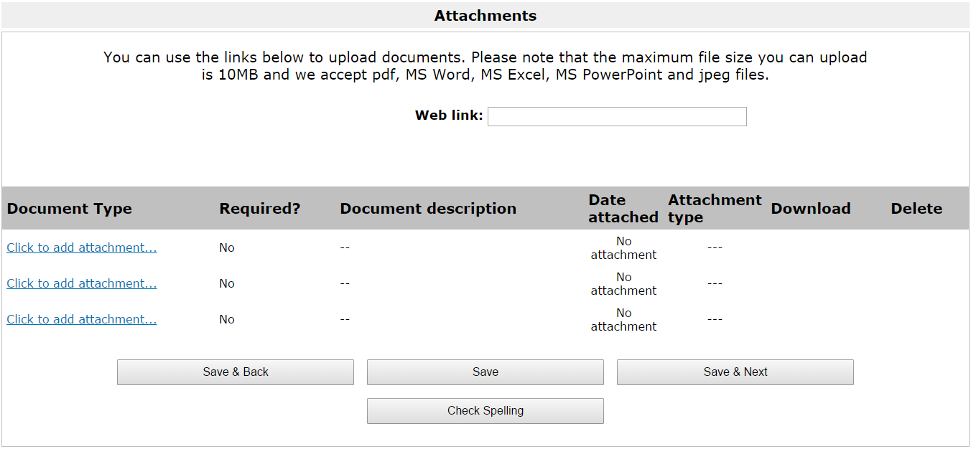

You can use this screen to upload any additional attachments you might like to send to us. Click on the Click to add attachment link to upload your document. File sizes must be a maximum of 10MB and we accept PDF, MS Word, MS Excel, MS PowerPoint and jpeg files. You do not need to upload anything on this screen.

Click Save & Next to proceed.

The next screen is How did we do? (final activity reports only).

This screen asks you how well you think Arts Council England handled your grant. Select your answers from the drop-down lists provided and add any additional comments in the free-text box.

Click Save & Next to proceed.

The next screen is the Declaration screen.

Please read this screen carefully, and work through the Checklist for submitting your activity report form, ticking the appropriate boxes.

Click Save & Next to proceed.

The final screen is the Submission summary screen.

The Submission summary screen provides a recap of the tasks you have just completed. You should have a green tick next to every screen where you have been asked to provide information. If there are any red crosses on this screen, it means that some information hasn’t been entered correctly or has been overlooked. There will be a brief description of the missing information at the bottom of the screen. This is a hyperlink, so you can click on this and it will take you back to the screen in question.

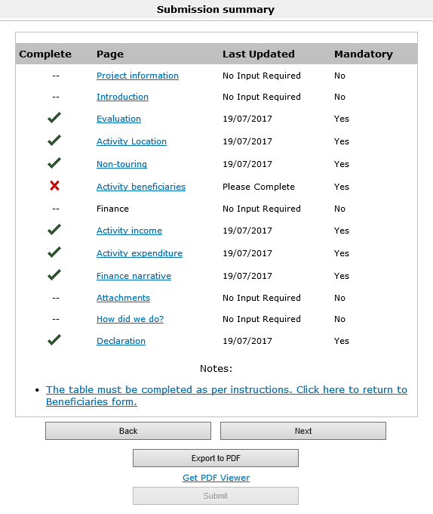

Once you have completed all the information and have green ticks beside every section of the form, you will be able to submit your report.

Click Submit to submit your report. This completes the process.

Further information and support

If you have any questions about the information contained in this document or require some assistance, please contact our Customer Services team on:

Phone: 0845 300 6200, 0161 934 4317
Textphone: 0161 934 4428
Email: enquiries@artscouncil.org.uk
Website: www.artscouncil.org.uk

