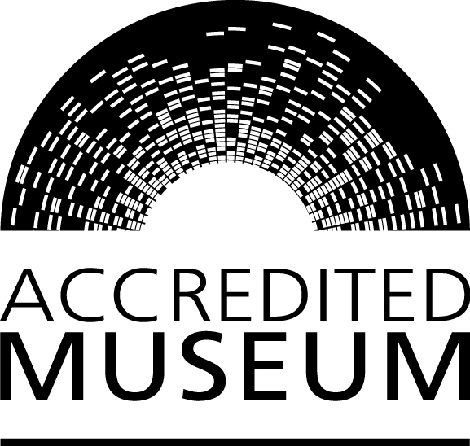

Accreditation
Scheme for museums and galleries in the United Kingdom:
Questions for national & nationally-styled museums

Who is this form for?

This form provides the additional questions that national museums and museums styling themselves as ‘national’ or equivalent should complete. It supplements the full Accreditation Application and Return forms. Full details of the national and nationally styled scales within Accreditation can be found in the ‘Guidance – Introduction’ document published on the Arts Council website: http://www.artscouncil.org.uk/what-we-do/supporting-museums/accreditation-scheme/how-do-i-apply/

If you are using this form to prepare for an application or return submission via our online form, these additional questions will be included in the online form if you indicate that the museum is national or nationally-styled in the section ‘Organisation details’. It is therefore recommended to complete this part of the online form before attempting to complete Sections 1, 2, and 3.

We recommend that you read the guidance documents before you start, as these contain further information on the requirements needed to be awarded Accreditation. They are available from the Arts Council website.

Typographic conventions used in this document

Plain type is used for explanatory text provided throughout the form.

Bold text is used for questions you will be asked in order to assess compliance with the requirements of the 2011 Accreditation Standard.

Italicised text is used for hints that will help you complete the form, such as word limits for free text boxes and markers for conditional questions that are only asked in certain circumstances.

Notes

Please complete all sections as fully as possible as this will support a faster response. Throughout the application form you will be asked to provide evidence. Where this evidence is not in electronic format, please feel free to send us this in the post.

Information regarding all areas of museum management and operations are available through the assessing organisation websites:

- www.artscouncil.org.uk
- www.wales.gov.uk/cymal
- www.museumsgalleriesscotland.org.uk
- www.nimc.co.uk

Technical Accreditation advice and support is available in England through a home-based team. Their contact details are:

Area covered | Name | Contact details
North East | Emma Chaplin | accreditation@emmachaplin.co.uk
North West | Jennie Pitceathly | accreditation@jenniepitceathly.co.uk
Yorkshire | Heather Lomas | accreditation@heatherlomas.co.uk
Midlands | Fiona Mitchell-Innes | accreditation@culturebusiness.co.uk
South East (including East of England) and London | Elaine Sansom | elaineconsult@f2s.com
South West | South West Museum Development | museum.accreditation@bristol.gov.uk

Further information is available from:
- www.collectionslink.org.uk
- www.museumsassociation.org
- www.aim-museums.co.uk

Additional questions for museums with national styling

2.2 Collections Development Policy

The museum must already have a substantial collection in relation to its stated objectives. ‘Substantial collection’ means that the collection is a significant and fully representative collection of national importance and international interest. It should directly reflect the existing status of the museum and provide substantial evidence to support its use of the word ‘national’. The policy and practice of the museum must be to collect a range of objects of national scope and importance and associated information in its particular fields.

Please submit evidence relating to your collection’s national importance and international interest which supports the use of the word ‘national’.

The online form will allow you to provide evidence relating to your collection’s national importance by electronic attachment, or indicate that it will be sent in hard copy to the assessing organisation.

The preferred method is electronic attachment

Please submit a copy of your published catalogue.

The online form will allow you to provide a copy of your published catalogue by electronic attachment, or indicate that it will be sent in hard copy to the assessing organisation.

The preferred method is electronic attachment

Please submit a list of acquisitions in the last 12 months.

The online form will allow you to provide a list of acquisitions by electronic attachment, or indicate that it will be sent in hard copy to the assessing organisation.

The preferred method is electronic attachment

2.4 Care and conservation policy

The museum’s collection must be subject to appropriate standards of care. Evidence must be provided demonstrating adequate resources applied to collections care and conservation.

Please describe the museum’s resources and practices for conserving and preserving the collections. (max. 300 words)

3.2.2 The museum must have adequate facilities to meet the needs of its users

You must provide evidence demonstrating how the quality of facilities reflects the national name, and meets the needs of the visitors the museum is aiming to serve.

Please detail the visitor facilities below. (max. 200 words)

Please describe how you ensure that the quality of the facilities is appropriate. (max. 200 words)

Please describe how you ensure that the facilities are accessible, affordable and appropriate for the needs of visitors the museum is aiming to serve. (max. 200 words)

3.3.1 The museum must exhibit the collections using a variety of interpretative methods

The museum’s display policy must reflect the full range of its collections and justify the use of the word ‘national’. A museum may have substantial collections but insufficient space to represent all its holdings in exhibitions. You must provide evidence of access to collections held in store, for example, visits by appointment.

Please provide a copy of the museum’s display policy.

The online form will allow you to provide the museum’s display policy by electronic attachment, or indicate that it will be sent in hard copy to the assessing organisation.

The preferred method is electronic attachment

Please describe fully how your museum ensures that users can gain access to the full range of collections. (max. 200 words)

3.3.2 The museum provides access to collections/associated information for research and engagement

A museum using the term ‘national’ must recognise its obligation to the museum community as a whole, particularly its role in providing specialist, professional and authoritative expertise and advice to other museums working in the same or similar fields. It must recognise its obligation to national and international scholarship by providing adequate staffing levels and accommodation to deal with such enquiries and by actively publishing scholarly works. Evidence must be provided demonstrating the provision of study and research facilities for academic and public use.

Please describe how your museum’s resources, including staffing levels and accommodation, enable the museum to handle enquiries (max. 200 words)

Please describe how your museum provides specialist advice to other museums. (max. 200 words)

Please attach a list of scholarly works your museum has published in the last three years.

The online form will allow you to provide a list of scholarly works by electronic attachment, or indicate that it will be sent in hard copy to the assessing organisation.

The preferred method is electronic attachment

Please describe the research facilities your museum provides. (max. 200 words)

Please attach a breakdown showing how many people have used the facilities provided in the last 12 months.

The online form will allow you to provide a breakdown of users by electronic attachment, or indicate that it will be sent in hard copy to the assessing organisation.

The preferred method is electronic attachment

