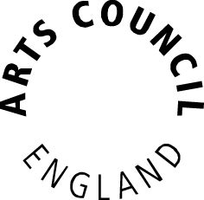
How we’ve balanced our investment

The National Portfolio is just one part of our investment in delivering our strategy – Great Art and Culture for Everyone. For the first time, today’s announcement also covers our overall investment plans for Grants for the Arts and our Strategic funds.

The proposed national portfolio

- The context for this new National Portfolio is declining income. In 2010 we invested £350m of Grant in aid into the portfolio. Today- for 2015/16 we have £270m – a larger figure than it could have been after the Chancellor protected culture with a relatively smaller cut of 5% in the last spending review.

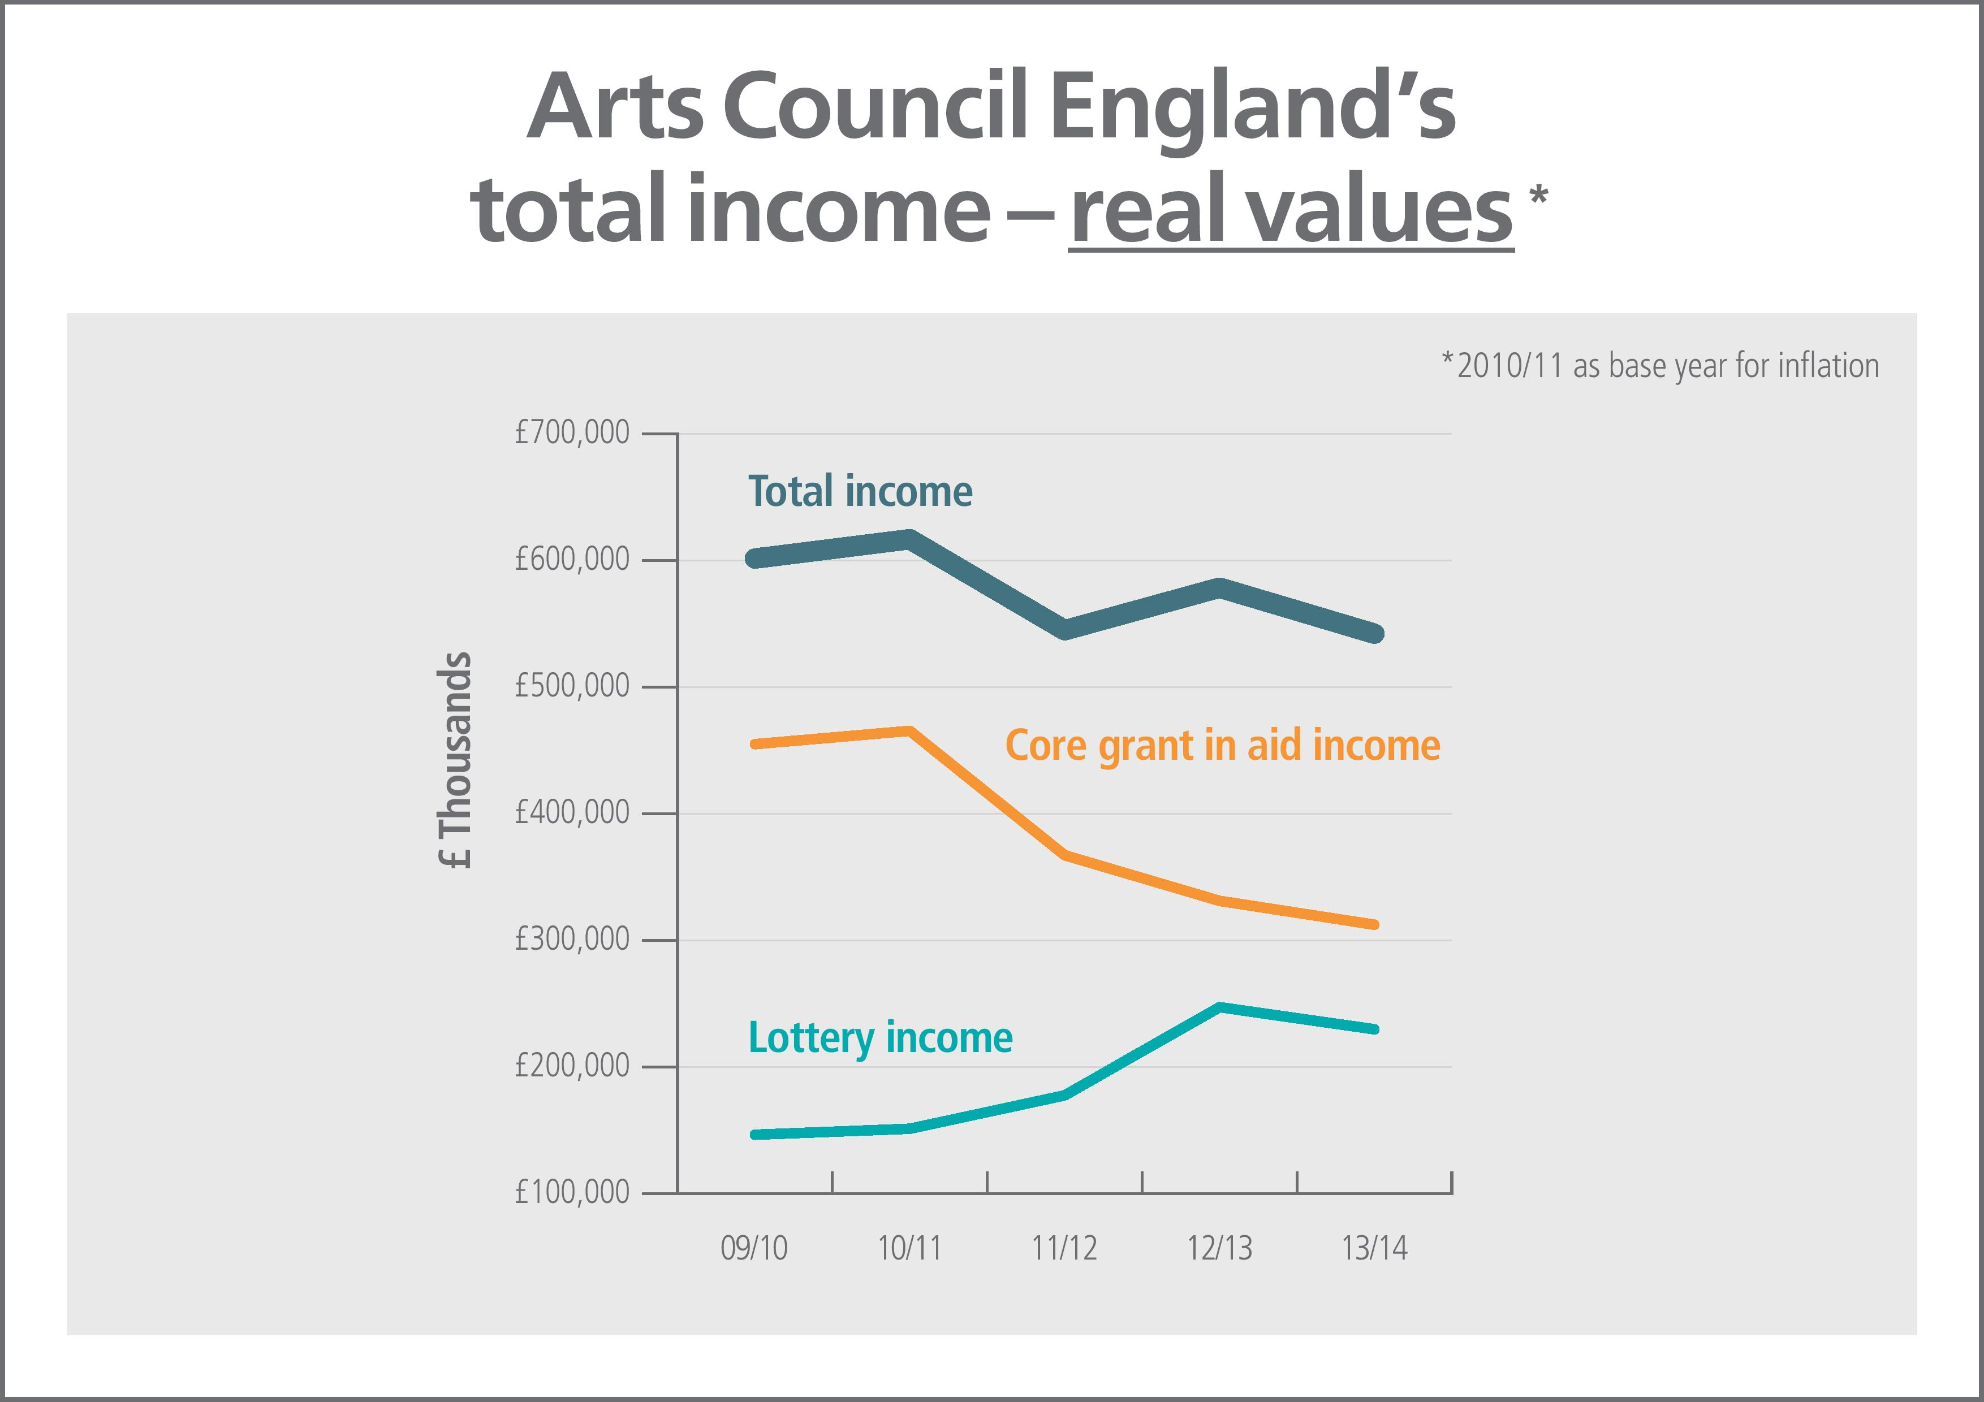

- With this reduction in Grant in aid of 36% since 2010, our investment in 670 National Portfolio organisations and 21 Major Partner Museums consolidates a high performing sector, invests in new talent and provides a strong backbone for our arts and culture.

- Thanks to a sector that has responded with creative boldness in its programming and in driving commercial revenue we can publish today a portfolio we can be proud of.

- The level of funding for National Portfolio organisations and Major Partner Museums assumes standstill funding from Government in 16/17 and 17/18 for later years.

- The following tables give more detail about the profile of the new portfolio including levels of funding for organisations, funding by artform, details on joiners and the museum portfolio.

- 58 organisations will be leaving the portfolio. Undoubtedly this will have an impact on the organisations concerned and we intend to talk to them about next steps before we release any details about them more widely.

National Portfolio

Proposed portfolio for 2015-18
Status | # | £ | % orgs | % £
Uplift to current (based on 14/15 grant) | 87 | 190,717,723 | 9.9% | 18.7%
Reduction to current (based on 14/15 grant) | 37 | 305,972,044 | 4.2% | 30.0%
Joiner | 46 | 22,257,009 | 5.2% | 2.2%
Same Level | 500 | 499,650,698 | 57.0% | 49.1%
Leaver | 58 | - | 6.6% | 0.0%
Unsuccessful applicants | 149 | - | 17.0% | 0.0%
Total | 877 | 1,018,597,474 | 100 | 100

Artform by value of grants
Artform | Current (12/15) £ | Proposed (15/18) £ | £ Change | % Change to Artform £
Combined arts | 176,405,555 | 180,630,569 | 4,225,014 | 2.4%
Dance | 107,901,698 | 118,066,236 | 10,164,538 | 9.4%
Literature | 20,217,935 | 19,940,803 | -277,133 | -1.4%
Music | 289,095,026 | 276,794,897 | -12,300,129 | -4.3%
Not artform specific | 7,988,714 | 8,259,074 | 270,361 | 3.4%
Theatre | 298,226,041 | 296,952,467 | -1,273,574 | -0.4%
Visual Arts | 121,108,604 | 117,953,428 | -3,155,176 | -2.6%
Total | 1,020,943,573 | 1,018,597,474 | -2,346,098 | -0.23%

For more detail on the artforms please go to our website- full narratives have been uploaded today.
NPOs joining the portfolio
Organisation | Area | Recommended 15/16 funding amount
Brownswood Music | London | 89,000
Camden People's Theatre | London | 70,000
Counterpoint Arts Limited | London | 80,000
Create | London | 150,000
Design Museum Ltd | London | 170,000
ILUVLIVE | London | 103,856
Intoart | London | 92,798
Jazz re:freshed Limited | London | 95,795
National Youth Jazz Orchestra | London | 125,000
OTOProjects | London | 74,933
Peckham Space | London | 50,000
Penned in the Margins | London | 45,000
Pop Up Projects CIC | London | 85,203
Sunshine International Arts | London | 75,000
The Koestler Trust | London | 75,000
William Morris Gallery | London | 60,000
Baby People Ltd | Midlands | 48,418
BE FESTIVAL | Midlands | 145,000
East Lindsey District Council | Midlands | 150,000
University of Derby Theatre Ltd | Midlands | 500,000
Abandon Normal Devices Ltd. | North | 135,000
Castlefield Gallery | North | 70,000
Chol Theatre | North | 75,000
Dance United Yorkshire | North | 90,000
Jazz North Limited | North | 190,000
NewcastleGateshead Initiative | North | 100,000
Third Angel | North | 120,000
Tyne & Wear Archives & Museums | North | 500,000
Wired Aerial Theatre | North | 165,000
And Other Stories | South East | 40,000
Corn Exchange (Newbury) Trust | South East | 235,000
Creative Arts East | South East | 150,000
Gulbenkian Theatre | South East | 220,000
New Adventures & Re:Bourne | South East | 1,294,000
Seachange Arts | South East | 300,000
Acta Community Theatre Ltd | South West | 80,000
Black Bird/Red Rose Productions | South West | 200,000
Bournemouth Borough Council | South West | 150,000
Bristol Music Trust | South West | 325,000
Exeter Northcott Theatre Company Ltd | South West | 125,000
Kaleider | South West | 110,000
MAYK Theatre Ltd | South West | 90,000
Situations | South West | 85,000
Tangle | South West | 85,000
The Bike Shed Theatre | South West | 75,000
The Point | South West | 125,000
 | TOTAL | 7,419,003

Major Partner Museums

MPMs joining the portfolio
Organisation | Area | Recommended 15/16 funding amount
Black Country Living Museum | Midlands | 886,000
Derby Museums | Midlands | 854,066
Hull City Council | North | 841,409
Museums Sheffield | North | 600,000
Penlee House Gallery and Museum | South West | 500,000
 | TOTAL | 3,681,475

MPM proposed portfolio 2015-18
Status | # | £ | % orgs | % £
Uplift to current (based on 14/15) | 0 | - | 0% | 0%
Reduction to current (based on 14/15) | 16 | 56,817,480 | 62% | 84%
Joiner | 5 | 11,044,425 | 19% | 16%
Same Level | 0 | - | 0% | 0%
Leaver | 0 | - | 0% | 0%
Unsuccessful applicant | 5 | - | 19% | 0%
Total | 26 | 67,861,905

The reach of our investment

- The companies who will join the portfolio have committed to extend audiences, to educational outreach and to ensure their work and their workforces are diverse.

- This is a commitment by every organisation to everyone in England, whatever their class, colour or background.

- We will hold them to that commitment by monitoring and reporting on their reach.

- There is an overall shift in National portfolio spending. In 2008 this was 51% to London and 49% outside the capital. In 2015/16 this will be 47% in London and 53% outside.

- In terms of our overall investment for the next three years, we want to build on the current trend of 60% of Grant in aid and 70% of National Lottery investment outside London.

- Whilst there is a major challenge to build capacity and investment in certain parts of the country, we do not believe this should be at the expense of London or indeed our significant investments in other major metropolitan centres which are beacons of excellence and attract visitors from home and abroad.

- National Portfolio organisations and Major Partner Museums reach across England and will play a part in the national ecology; extending way beyond their postcode and taking on national responsibilities as part of their funding agreements with us.

- For museums, this includes the For Cornwall Museums Partnership- an example of consortium working, with six leading museums in Cornwall coming together for the first time and in the arts portfolio organisations such as the Royal Shakespeare Company and the National Theatre will continue to roll out national education and outreach programmes across the country.

- Building capacity and production are the biggest challenges in places with low investment in culture. We will weight our strategic funds towards tackling this challenge with a new £15m production fund to ensure that ambition and talent outside London continues to thrive, and further investment in Creative People and Places- a fund to that use radical new approaches to developing excellent, inspiring and sustainable arts experiences for communities not currently engaging with the arts.

- The increase in budget for Grants for the Arts to £70m will broaden the reach of Arts Council funding to support smaller organisations and individual artists across England.

- This represents a vigorous approach to ensuring we can meet the aim in the heart of our strategy of ensuring everyone has an opportunity to be inspired by the arts, museums and libraries.

Grants for the Arts- analysis by area of total awards made in 2012/13 and 2013/14
 | Awards made |  | Awards made
 | Number | % | £’000 | %
London | 1,762 | 28.9% | 36,381 | 27.9%
Midlands | 750 | 12.3% | 17,393 | 13.3%
North | 1,596 | 26.1% | 32,131 | 24.6%
South East | 1,193 | 19.5% | 25,617 | 19.6%
South West | 753 | 12.3% | 17,707 | 13.6%
Outside England | 52 | 0.9% | 1,160 | 0.9%
Total | 6,106 | 100% | 130, 389 | 100%

- The following tables give further details on the distribution of our investment in terms of diversity, across the Arts Councils’ geographic areas and across artform.

Area by value of grants (%)
Area | Current % | Proposed % | Change to Area %
London | 48.8% | 47.3% | -1.5%
South East | 8.5% | 9.0% | 0.5%
South West | 5.6% | 5.9% | 0.3%
Midlands | 16.7% | 17.1% | 0.3%
North | 20.4% | 20.8% | 0.3%
Total | 100% | 100%

National Portfolio- area by value of grants (numbers)
Area | Current (12/15) £ | Proposed (15/18) £ | £ Change | % Change to Area £
London | 498,259,817 | 481,851,502 | -16,408,315 | -3.3%
South East | 86,438,518 | 91,470,157 | 5,031,639 | 5.8%
South West | 56,763,104 | 59,865,339 | 3,102,235 | 5.5%
Midlands | 170,957,444 | 173,946,051 | 2,988,607 | 1.7%
North | 208,524,690 | 211,464,426 | 2,939,736 | 1.4%
Total | 1,020,943,573 | 1,018,597,474 | -2,346,098 | -0.23%

National Portfolio- area by numbers of organisations (numbers)
Area | Current (12/15) | Proposed (15/18) | Change | % Change to Area numbers
London | 256 | 245 | -11 | -4.3%
South East | 68 | 70 | 2 | 2.9%
South West | 80 | 82 | 2 | 2.5%
Midlands | 92 | 87 | -5 | -5.4%
North | 207 | 186 | -21 | -10.1%
Total | 703 | 670 | -33 | -4.69%

MPM Area by numbers of organisations (numbers)
Area |  | Current | Proposed | Change | % Change to Area Numbers
London |  | 2 | 2 | 0 | 0%
South East |  | 4 | 4 | 0 | 0%
South West |  | 2 | 3 | 1 | 50%
Midlands |  | 2 | 4 | 2 | 100%
North |  | 6 | 8 | 2 | 33%
Total |  | 16 | 21 | 5 | 31%
MPM Area by value of grants (numbers)
Area | Current 12 / 15 £ |  | Proposed 15/18 £ | £ Change | % Change to Area £
London | 6,942,558 |  | 6,140,034 | -802,524 | -12%
South East | 15,639,840 |  | 14,440,107 | -1,199,733 | -8%
South West | 8,478,280 |  | 9,324,120 | 845,840 | 10%
Midlands | 7,382,793 |  | 10,451,394 | 3,068,601 | 42%
North | 23,903,888 |  | 27,596,013 | 3,692,125 | 15%
Total | 62,347,358 |  | 67,951,668 | 5,604,310 | 9%

Diversity:
The Arts Council defines a diverse led organisation where that organisation self-defines as such, and where more than 50 per cent of the organisation’s board and senior management are diverse. We are sticking to historic definitions at the moment but this does not capture the growing number of organisations led by diverse cultural leaders. We will work on how to reflect that in the future.

Although it is still important to have art and culture from specific types of organisations, we are shifting away from this approach to one where diversity becomes everyone’s responsibility. The Creative Case looks at diversity and equality within the arts and takes a creative approach to addressing barriers to creativity, participation, learning and involvement around race, disability and gender equality, instead of simply viewing it as a legal requirement. For the first time we will be asking organisations to report back on progress and we will publish updates.
We believe that our national diversity is one of our great resources and we expect the work that we fund will reflect this. The following ratings are provisional and will be revisited when we receive the detailed programme plans that will form part of each NPO funding agreement.
Creative Case Rating of proposed National Portfolio Organisations
Rating | Number | %
Weak | 34 | 5.1%
Met | 103 | 15.4%
Good | 280 | 41.8%
Strong | 253 | 37.8%
Total | 670 | 100%

11% of diverse organisations will receive an uplift in this current portfolio.

Diversity Led by numbers of organisations (numbers)
Diverse Led | Current (14/15) | Proposed (15/16) | Change | Change to Led %
BME Led | 57 | 51 | -6 | -10.5%
Disability Led | 13 | 9 | -4 | -30.8%
Total | 70 | 60 | -10 | -14.3%

Diversity Led by value of grants (numbers)
Diverse Led | Current (12/15) £ | Proposed (15/18) £ | £ Change | % Change to Led £
BME Led | 29,942,145 | 28,250,199 | -1,691,946 | -5.65%
Disability Led | 5,072,530 | 4,315,411 | -757,119 | -14.93%
Total | 35,014,675 | 32,565,610 | -2,449,065 | -6.99%

How we’ve made ends meet

- With some assistance from lottery income and with a better than expected spending review settlement from the Chancellor we have been able to protect our national portfolio with only an 0.23 percent cut overall when comparing 2012-15 to 2015-18

- This is not without significant cost to other parts of our investment. Our strategic funds budget – which we use to invest in opportunities and respond to challenges– is cut significantly from £153m in 2014/15 to £104m in 2015/16

- Because strategic funds are vital to help us with reach we have therefore refocused them to address challenges such as building capacity within the sector around diversity, investing in talent and building production capacity outside London.

- Other strategic funds have taken the weight of cuts including for example our capital pot which is cut by £33m a year and our Catalyst programme where there will no longer be money to match fund endowments for large organisations although work with smaller companies will continue.

- We hope levels of Government support will be maintained. In addition we need Local Authorities to maintain their partnership with us, recognising the vital role culture plays locally in communities and economic regeneration.
Lottery in the National Portfolio
National Lottery money has been used to fund touring and activity with children and young people within the National portfolio since 2012.

Based on this precedent 99 National portfolio organisations will be funded wholly through Lottery in 2015-18; those focusing on touring (more than 50%) or specific types of organisations working with children and young people.

Using National Lottery money will allow an additional number of organisations to join the portfolio. For some organisations this will be the first time that their total grant will be wholly comprised of Lottery funding.

Strategic funds:
A range of strategic funds will support our five goals as described in our 10 year strategic framework, Great art and culture for everyone. Some of the strands of this funding programme include those outlined below.
- Ambition and talent outside London- a £15m project to ensure that organisations can retain talent and build production capacity outside London
- Exceptional awards will continue to run with a proposed budget of £8m to this fund for 2015-18.
- Strategic touring- designed to encourage collaboration between organisations, so that more people across England experience and are inspired by the arts, particularly in places which rely on touring for much of their arts provision. We are proposing to allocate £23m to this fund for 2015-18.
- Creative People and Places- a further £25m to be allocated- maintaining at the current level for the next two years- to target long-term benefits, to currently funded applicants to support their 10 year visions; investment in areas with low engagement and a focus on older people and the arts
- Catalyst and fundraising- future funds will be used to support match fund and capacity building programmes, targeted at small and midscale organisations outside of central London. We are proposing to allocate £26m to this fund for 2015-18.
- Resilience and leadership- we are proposing to allocate £14.4m to resilience and leadership funding in the period 2015-18. This will encompass a number of initiatives, including work with Local Enterprise Partnerships, cultural tourism partners, creative industries and social investment models
- Children and young people will be more of a focus than ever, with more organisations than before we will see a significant increase in the support our ambition to ensure that every child and young person has the opportunity to experience the richness of arts, museums and libraries.
- Diversity- a £6m fund will focus on artistic excellence, increasing resilience and diversifying audiences, the workforce and the leadership of the arts sector to reflect the diversity of contemporary England.

More information on all our Strategic funds is available on our website.

Capital:
Large awards for Round 3 have been successfully applied for by the following organisations. They will now be invited to complete a second stage application
Organisation | Area | Amount
Alternative Theatre Company | London | £2,500,000
Battersea Arts Centre | London | £4,690,000
Design Museum Ltd | London | £3,000,000
Wayne McGregor | Random Dance | London | £988,154
The Theatre Royal and Royal Concert Hall, (Nottingham City Council) | Midlands | £1,608,047
The Drum  (The Newtown Cultural Project Limited) | Midlands | £2,724,335
Royal Shakespeare Company | Midlands | £3,000,000
The University of Warwick | Midlands | £4,000,000
The Lowry Centre Trust | North | £3,000,000
Site Gallery | North | £970,000
Yorkshire Sculpture Park | North | £1,700,000
Theatre Hullabaloo | North | £1,500,000
Cheshire West and Chester Council | North | £3,000,000
Islington Mill | North | £998,000
The Met | North | £3,045,400
Kirkgate Centre Trust | North | £850,000
Contact Theatre | North | £3,851,128
Kettle's Yard Gallery | South East | £3,650,000
Jasmin Vardimon Dance Company | South East | £3,007,742
Modern Art Oxford | South East | £3,500,000
The Hall for Cornwall Trust | South West | £5,000,000
St George's Bristol | South West | £1,950,000
Teignbridge District Council | South West | £750,000

Small awards for Round 2 have been allocated to:
Organisation | Area | Amount
London Sinfonietta | London | £102,004
Discover Children's Story Centre | London | £350,000
Redbridge Drama Centre | London | £192,036
Raw Material Music & Media | London | £197,175
Soho Theatre Company | London | £285,795
Stratford Circus Ltd | London | £321,805
PM Gallery & House | London | £492,457
The Albany | London | £437,175
Siobhan Davies Dance Company | London | £158,308
Camden Arts Centre | London | £149,236
Stoke-On-Trent and North Staffordshire Theatre Trust Limited | Midlands | £495,000
Leicester Print Workshop Studios and Resource | Midlands | £300,000
Dance 4 Limited | Midlands | £499,642
Compton Verney | Midlands | £123,412
Walsall Metropolitan Borough Council | Midlands | £487,500
National Centre For Early Music | North | £133,395
Mind The Gap | North | £120,000
Baltic Centre For Contemporary Arts | North | £179,336
20-21 Visual Arts Centre | North | £489,988
IOU Theatre | North | £184,917
Barnsley Civic Enterprise Ltd | North | £109,164
Stephen Joseph Theatre | North | £275,000
Seven Stories | North | £499,000
Northern Gallery For Contemporary Art | North | £100,000
Northern Print Studio Ltd | North | £147,699
ARC, Stockton Arts Centre | North | £132,987
Slung Low | North | £100,816
Great Georges Community Cultural Project Ltd | North | £450,000
Horse And Bamboo Theatre Company | North | £166,746
Hull Truck Theatre | North | £130,750
Watermill Theatre | South East | £499,996
Oxford Playhouse | South East | £486,284
De La Warr Pavilion | South East | £412,343
Glyndebourne Touring Opera and Glyndebourne Education | South East | £220,000
Canterbury Festival | South East | £255,110
South Hill Park Arts Centre | South East | £379,006
St Edmunds Arts Trust Ltd | South West | £195,000
Acta Community Theatre Ltd | South West | £490,000
Roses Theatre Trust | South West | £250,000
The Point | South West | £367,187
Nuffield Theatre | South West | £180,000
PREMA | South West | £216,146

- Details of the next Capital programme will follow later in the year

