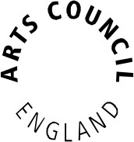

Strategic Touring programme

Guidance for applicants

(for Round 30 onwards)
Contents

Section one – Welcome 2
Section two – Purpose of the Strategic Touring programme 5
Programme aims 5
Programme outcomes 6
Section three – Four steps to applying for funding 9
Section four – Eligibility 12
Consortia and partnership agreements 14
Applications from National Portfolio Organisations (NPOs) 15
Commercial profit-making organisations 15
Section five – What type of activity can you apply for? 17
Section six – When to apply 19
Section seven – Using our online system: before you apply 20
Using our online system – your applicant profile 22
Using our online system – the eligibility questionnaire 24
Section eight – The application form 26
Your proposal 50
Section nine – What happens to your application 60
1 Eligibility check 60
2 Assessment 60
3 Decision-making 62
If your application is successful 62
If your application is unsuccessful 63
Section ten – Further information 63
Section eleven – Key definitions 67
Section twelve – Additional resources 71
Appendix 1 – Touring out of England – the 15 per cent rule 75

Section one – Welcome

Thank you for your interest in the Strategic Touring programme.

This guidance gives you information on how to apply for funding to the programme.

One of the ways in which we will address our national approach to touring is the Strategic Touring programme. The focus of the programme is for people across England to have improved access to great art that visits their local area, particularly in places that rely on touring for much of their arts provision.

We want to see stronger, more dynamic relationships forged between all of those involved in touring work, with collaboration and audiences at the heart of projects.

We want to support a wider range of high-quality and diverse work on tour including, in particular, to people with the least engagement, and more work that reflects the diversity of local communities and/or contemporary England.

We want to see more work that reflects the current priorities of inbound international work and an increase in mid-scale theatre.

About Arts Council England
Arts Council England champions, develops and invests in artistic and cultural experiences that enrich people’s lives. We support a range of activities across the arts, museums and libraries – from theatre to digital art, reading to dance, music to literature, and crafts to collections.

Great art and culture inspires us, brings us together and teaches us about ourselves and the world around us. In short, it makes life better. Between 2015 and 2018, we plan to invest £1.1 billion of public money from government and an estimated £700 million from the National Lottery to help create these experiences for as many people as possible across the country.

From 1 October 2011, we added museums and libraries to our remit. As with the arts, this sees us championing, developing and investing in museums and libraries. In April 2012, we announced a new network of Music Education Hubs, working with funding from the Department for Education.

Our strategic framework document Great Art and Culture for Everyone sets out our ambitions for arts and culture in England. We believe that increasing the number of people who experience and contribute to the arts, to museums and to libraries is good for society. We acknowledge that despite public investment, there remain significant disparities in the level of arts and cultural opportunities across the country.

We believe that our national diversity is one of our great resources and we expect the work that we fund will reflect this and will be alive to the opportunities that diversity offers. Arts Council England observes the public sector Equality Duty 2011 and the protected characteristics as defined in the Equality Act 2010. We are also committed to promoting equality across differing socio-economic groups.

The Creative Case for Diversity is an exciting and significant repositioning of Arts Council England’s approach to diversity. It is intended to bring about fundamental change. The Creative Case for Diversity is based upon the principle that diversity, in the broadest sense, is an integral part of the artistic process. It is an important element in the dynamic that drives art forward, creating opportunities for artistic collaboration, innovation and risk-taking through embracing a wide range of influences and practices.

For us to attract the next generation to the arts and culture sector, we need the work we do to engage with, and reflect, the diversity of all our communities, and we expect the organisations and individuals we fund to lead the way.

For more information about Arts Council England, visit www.artscouncil.org.uk.

About Arts Council England’s strategic funds 2015–18
Our strategic funds help us to target particular challenges, opportunities or gaps, creating an environment where further development can take place in the arts and culture sector. Ultimately, they help us meet the goals set out in our strategy, Great Art and Culture for Everyone. Our goals, for reference, are:
Goal 1: Excellence is thriving and celebrated in the arts, museums and libraries
Goal 2: Everyone has the opportunity to experience and be inspired by the arts, museums and libraries
Goal 3: The arts, museums and libraries are resilient and environmentally sustainable
Goal 4: The leadership and workforce in the arts, museums and libraries are diverse and appropriately skilled
Goal 5: Every child and young person has the opportunity to experience the richness of the arts, museums and libraries
Section two – Purpose of the Strategic Touring programme

Programme aims
Through the range of applications we will support through the Strategic Touring programme, we aim to ensure that:

- A wider range of people engage with the arts:
- Extending the reach of high-quality touring work by widening audience access
- Better access to high-quality work for people in places in England which rely on touring for much of their arts provision
- More high-quality work reaching people and places with the least engagement
- A wider range of venues and partners are involved in the development of arts touring:
- Stronger relationships are forged between those involved in artistic, audience, producers, venues and promoters
- The development of formal or informal touring networks
- Empowering audiences and venues to have a greater impact on touring product
- Broadening the range of venues presenting work
- A wider range of high-quality work is toured:
- To people and places with the least engagement in the arts

- Reflecting the diversity of local communities and/or contemporary England and increased work that supports the Creative Case for Diversity
- Our current priorities are:
- Incoming international work
- Mid-scale theatre

We encourage applicants to consider how their project can make the best possible contribution to the aims, but each application does not have to address every aim.

These aims relate to our success measures for goal 2 of our strategic framework:
- engagement levels have increased among those currently least engaged in arts and culture
- more people have the opportunity to experience and participate in great art, museums and libraries
- the number and range of people experiencing great art, museums and libraries has increased
- there is a demonstrable increase in the depth and quality of people’s cultural experiences

Programme outcomes
The outcomes we hope to achieve through the Strategic Touring programme are:
- successful applicants play an active role in ensuring that high-quality art and culture reaches more people and places across England
- a positive change in collaborative behaviour between those involved in creating and programming work which tours
- more effective touring, programming and audience development of high-quality work on tour, including more projects on tour that reflect the current priorities of international inbound work and mid-scale theatre
- increased Creative Case for Diversity work that reflects the diversity of local communities and/or contemporary England
- presenters, promoters and the communities they serve are given opportunities to influence the kinds of art created to tour
- more promoters are improving their knowledge and skills in creative commissioning, programming, audience development and international work
- audiences and venues are placed at the heart of decisions made by those creating and managing work on tour
- more people are involved in creating and managing work on tour, improving their knowledge and skills in touring and audience development
- more people are improving their knowledge and skills in programming and developing audiences for international work
- collaboration between international promoters in England and venues around the country is encouraged
- artistic contact between local and international artists is fostered
- evaluation and key learning is disseminated within the sector to support the development of good practice

How much funding is available?
Between 2015 and 2018, £35 million is available for Strategic Touring. This includes £2.25 million from the Olympic Lottery Distribution Fund to support inbound international touring.

Strategic Touring or Grants for the Arts?
Touring plays an important part in our 10-year strategy, Great Art and Culture for Everyone. In addition to the Strategic Touring programme, we also fund touring projects through Grants for the Arts.

Many touring projects will be potentially eligible for either fund, but individual projects will normally be a much stronger fit against one programme or the other. Consider these programme characteristics to help you decide:

Strategic Touring | Grants for the Arts
Specifically created to fund touring work | Funds a range of activity, including touring
Strategic/proactive – projects must deliver on the strategic aims of the fund | Reactive programme that allows us to respond to the sector’s good ideas
Lower limit £15,000, no upper limit | Grants of £1,000–£100,000
National Portfolio Organisations (NPOs) eligible | NPOs not eligible
Normally six deadlines for applications in year | Rolling programme with no deadlines
Emphasis on:  - areas of low engagement with the arts and those areas that rely on touring for much of their arts provision  - developing networks and partnership working  - legacy and sustainability  - best practice around data capture and sharing | More scope for considering touring projects that are not focused on the specific aims of the Strategic Touring programme, and projects where touring is part of a multi-strand activity.  NB: You can apply to Grants for Arts to develop partnerships and pilot approaches to test new work or ways of working prior to applying to the Strategic Touring programme

If you are in any doubt about which fund you should apply for, please call our Customer Services team to discuss your project further.

Section three – Four steps to applying for funding

- Read this guidance carefully

This guidance explains the eligibility requirements for the Strategic Touring programme and how to complete your application form, so please read it carefully before you begin.

We are committed to being open and accessible, and want to make sure our services are available to everyone. If you experience or anticipate any barriers within the application process or require help to make an application or to access services and information, please contact us for details about the type of support that we can provide.

How to contact us

Phone: 0845 300 6200, 0161 934 4317
Textphone: 0161 934 4428
Email: enquiries@artscouncil.org.uk
Website: www.artscouncil.org.uk
Post: Arts Council England – Grant Management,
The Hive, 49 Lever Street, Manchester, M1 1FN

- Log in to our online application system (Grantium)

Applications to the Strategic Touring programme are made via our online application system, accessed through our website. There are full instructions for making an application using our online system in the Application form section of this guidance.

Arts Council England introduced a new grant management system, Grantium, in January 2016. The new system allows applicants to manage all of their projects online. All applications, along with decision letters, payment requests and any communication regarding your application, are managed through the online system.

Please visit our Grantium pages for a suite of guidance documents on how to use the system.

To make an application on our online system, you must have a validated applicant profile.

It takes up to five working days from submission for us to validate a new applicant profile so, if you do not already have a validated profile, you must submit your applicant profile to us for validation at least five working days before the deadline for the round of the Strategic Touring programme to which you intend to apply. We cannot guarantee that we will be able to validate your applicant profile in time for you to complete and submit your application by the application deadline if you leave fewer than five working days. Please note, you will not be able to start your application until your applicant profile has been validated. You are, therefore, strongly advised to submit an applicant profile for validation as soon as you can.
Please see the Applicant profile section of this guidance and our guidance sheet on ‘How to create and manage your user account and applicant profile’ for more information about applicant profiles.
If you need additional support using the online application system, please contact us on 0845 300 6200.

- Talk to us about your application (the ‘mandatory conversation’)
Once you have read the guidance and started to think about your application, you must speak with a designated Relationship Manager in one of our area offices in more detail about your proposal. We use the term ‘mandatory conversation’ to describe this scheduled, structured conversation, which often takes place by telephone. You must have this mandatory conversation before submitting your application to the Strategic Touring programme. Please contact our Customer Services team on 0845 300 6200 to find out more about this.
We will arrange a time to speak with you. As a general guide, we would aim to broadly cover the assessment prompts under the headings of your proposed activity, audience development, finance and management. See the Your proposal section for more details.
Once you have had this conversation with the designated member of staff, we will send you an email to confirm that the mandatory conversation has been completed. You can then submit your application at any time, uploading a copy of the email we send you as supporting information (see the Attachments section on our website for instructions on where to do this).
It is your responsibility to develop and write the application, including what you feel to be all the relevant information. We will talk with all potential applicants but cannot guarantee success for any applicant.
We will not be able to read or provide written comment on draft applications.

- Fill in the online application form

In addition to information about your activity, the application form also asks for information that we may use to report to government or to monitor the different backgrounds of people who receive funding. We will not use this type of information when we consider your application.

Applicants must ensure they attach a copy of the email we send confirming that the mandatory conversation (see above) has taken place, together with any other mandatory or optional supporting documents (see the Attachments section for instructions on where to do this). We will not consider any additional information you send after you have submitted your application.

Once you have started your application, you can save the form and come back to it at any time, up to the deadline for that round, to complete it. If you choose to delay your application until the next funding round, the form that you have started, and all the information that you have entered, will remain available for you to continue to develop.

We will use the information you give us in your application form to help us decide whether we will offer you a grant. If your application does not contain the information we need in the format we ask for it to be in, we might not be able to consider your application. After you have read this guidance, if you have any further questions, please contact us. Be ready to clearly describe your activity to us, as this will help us give you good advice and will save time.

Our Customer Services team can offer advice around eligibility but please note that we can only make a definitive decision about whether an application is eligible once we have received your full application.

Section four – Eligibility

Please read the eligibility requirements for the fund carefully. If you do not meet any of these requirements, we will be unable to consider your application for funding.

Who can apply? | - organisations including National Portfolio Organisations (NPOs), Major Partner Museums, Music Education Hubs, libraries, Bridge Organisations and non-arts organisations including museums  - individuals  - consortia, partnerships, networks and groups, including Creative People and Places (one organisation must take the lead on the application and finances for non-constituted groups)  - commercial profit-making organisations (applying for a self-contained, financially ring-fenced arts project with a clear benefit to the public)
Who cannot apply? | - applicants who have not had a mandatory conversation with a Relationship Manager  - applicants resubmitting a previous application who have not received detailed feedback or had a further mandatory conversation with a Relationship Manager  - applicants who are applying for funding for the same project from other Arts Council England programmes  - applicants who have overdue payment conditions on previous Strategic Touring grants made to them
What activity can be supported? | - touring of any artform work to two or more venues, including new work or existing work, revivals and remounts  - inbound international touring – our cross-border touring agreement with the other UK Arts Councils remains in place for this programme and can be found on our website  - National Portfolio Organisations and Major Partner Museums activity can apply but organisations must demonstrate how the proposed activity they will deliver or benefit from is additional to their regularly funded activity  - National Portfolio Organisations and Major Partner Museums may be involved in applications as contributors without receiving any direct financial or other benefit from the activity, for example, by providing mentoring support, advice and rehearsal or office space  - National Portfolio Organisations and Major Partner Museums can also be named in applications as venues on a provisional tour schedule. This will not normally count as additional activity  See Key definitions for more information on what we mean by a tour, venue, promoter, and people and places with the least engagement in the arts
What activity cannot be funded? | - activities that are not related to the arts  - activities that do not benefit or engage people in England (in the short or long term) or that do not help artists and arts organisations in England to carry out their work  - touring activity that does not mainly take place in England, in line with the restrictions outlined in the ‘15 per cent rule and touring outside England’ appendix to this guidance  - touring of historic art and historic collections that does not include some element of contemporary artistic activity  - activities (including buying goods or services) that have started or been bought, ordered or contracted before we make a decision about your application. This is because we cannot fund activity retrospectively  - costs that are already paid for by other income, including your own funds or any other funding  - extensions of currently funded existing or planned tours by National Portfolio Organisations
How much can be applied for per application? | A minimum of £15,000
How much match funding from sources other than ACE is required? | We expect a minimum of 10 per cent of the total cost (cash and in kind) of the activity to come from sources other than Arts Council England. This match funding can be made up of cash and/or in-kind support
Delivery timetable | Activities must be time-limited and take place over a maximum of three years (start date to end date)

Consortia and partnership agreements
We will accept applications for funding from organisations working as a consortium, partnership, network or group. For non-constituted consortia or groups, one organisation must act as the lead organisation and submit the application. If the application goes on to be successful, this organisation would then be accountable for the grant.

Groups can include promoters, producers, curators, artists, agencies, companies, marketing or audience development specialists, local authority representatives or any other kind of organisation or individual. They must:
  - include at least one promoter or equivalent from the above
  - have one individual or organisation that will have the main responsibility for managing the application and any grant
  - include individuals or organisations that will act as the main lead for audience development activity on behalf of the group, or else explain how they would address this deficit within the project

All partners within the consortium must show a firm commitment to joint working, including capturing and sharing data in line with best practice.

Your application must show the benefits and rationale of working as a consortium. If we decide to fund your project, we will enter into a legally binding grant agreement with the lead organisation. This organisation must accept our terms and conditions for grants and will be solely accountable to us for all monitoring information, how all the money is spent, and for the full and successful delivery of the project.

One of our standard terms and conditions for grants is that the organisation we enter into a grant agreement with cannot subcontract any of the project to other organisations without our prior agreement in writing. If we award a grant, before the project can start we must approve a partnership agreement between the lead organisation and the other partners involved in the project.

There is further guidance about Partnership agreements on our website.

Applications from National Portfolio Organisations (NPOs)
NPOs that apply to the fund (including those who are listed as partners) must be able to demonstrate how their proposed activity is additional to that included in their funding agreement. For example, an organisation already funded to tour will not be eligible to apply for additional dates to extend an existing project. Activity which, for example, demonstrates a change in scale or tours to a different geographic area from that specified in the funding agreement may be considered. However you will need to make a clear case within your application as to how this is additional to your NPO-funded work. Please talk to us about this if you are unsure about whether your activity is eligible.

Applications can be made to remount, re-produce or re-tour a previous project, providing it can show how it will meet the aims of the Strategic Touring programme.

Commercial profit-making organisations
Commercial profit-making organisations are eligible to apply to the Strategic Touring programme. However, we cannot give grants to organisations that share out profits to members or shareholders unless the activity applied for is a self-contained, financially ring-fenced arts project with a clear benefit to the public. Applicants should ensure they comply with current regulations on state aid. We suggest that any commercial organisation gets in touch with us at an early stage to discuss their application.

Section five – What type of activity can you apply for?

We welcome applications that will make a contribution to achieving the programme’s aims and outcomes outlined in Section two.

While we are not prescriptive about the types of touring activities we would like to fund in order to meet the aims of this fund, we anticipate that the types of touring projects we will fund could include elements such as:
  - artistic activity, for example: the creation of new work to be toured; commissioning, remounting, re-production or re-touring of work that has already been presented to the public, or supporting the costs of touring existing work, including incoming international work
  - audience development activity, for example: research; work to address access issues; marketing materials, and educational support materials
  - skills development activity, for example: training; mentoring; networking, and opportunities to go and see artistic work or spend time with people in different organisations
  - pilot projects, for example: exploring new ways of working and new partnerships, and supporting or testing new touring models
  - proportionate management and administrative costs, for example: those related to capacity-building, access support for those involved in delivering the activity, and the evaluation and dissemination of learning
  - in exceptional circumstances, applicants can include some expenditure on equipment if directly related to the activity
  - work produced overseas that will enrich the experience of audiences in England

Other income for your activity
We want to make our funding go further, and we expect you to make the most of any other sources of income available to you. We expect at least 10 per cent or more of the total cost of your activity to come from other sources of income. Partnership funding is an opportunity for you to demonstrate the extent and breadth of the partnerships that underpin your project and its legacy.

This can include:
- income earned from your activity
- funding from public organisations such as local authorities
- grants from trusts and foundations, sponsorship, private giving
- support in kind
- a contribution from you or your organisation

In very special circumstances, we can provide a grant for the total cost of your activity. These circumstances could include situations where there is little chance of raising money from other sources. If you apply to us for the total cost of your activity, your proposal must tell us what your special circumstances are, and what you have done to try to raise money from other sources, otherwise your application may not be eligible to be assessed.

Section six – When to apply

The Strategic Touring programme has usually has six rounds each year (although there are five rounds in 2016/17), and you can submit your application at any time once you have had your mandatory conversation with us.

Please see the Strategic Touring page on our website for the latest information about deadlines.

To be considered for a particular funding round, applications must be submitted by 5pm on the deadline day for that round.
We aim to notify applicants of our decision no later than 12 weeks after the deadline date for that round.
Any decision to offer funding will be subject to finalising an offer letter and any special conditions for grants.
Section seven – Using our online system: before you apply

All applications to the Strategic Touring programme are made using our online application system, accessed through our website.

When making an application, you will use three different areas of the online system:

- the applicant profile
- the eligibility questionnaire
- the application form

This section guides you through the applicant profile and the eligibility questionnaire.

System notes
When using the online system, please note that:

- Throughout the application system, any items marked with an asterisk (*) must be completed.

- Please navigate using the onscreen buttons only (such as the ‘Save and next’ button within the system). You are unable to use the navigation buttons at the top of your browser window (such as the browser ‘Back’ button). Always use the ‘Back’ or ‘Save and back’ buttons within the system.

- Any ‘free text’ boxes in the application form have a strict character limit stated above them. Please stick to this limit as any text you add beyond this will be automatically deleted when you save your answers.

- Remember to save your work regularly as you go along – the system times out after 15 minutes of inactivity.

- The submission summary displays a list of all the steps you’ve worked through. It is the final screen in each section of the process, but you can refer to it at any time. If you have completed a step successfully, there will be a green tick beside it. If a step is incomplete or has not been completed successfully, this will be indicated by a red cross. A hyperlinked statement at the bottom of the page will tell you which part of each step needs attention. Click on this hyperlinked statement to go back to the step and make your amendments.

- It is your responsibility to keep the information in your applicant profile up to date. Before you start an application for any new project, please go through your applicant profile, ensure your information is correct, and update it if necessary.

- If at any time you would like to contact us, click Contact us in the left-hand menu bar for contact information.

For more detailed guidance on using our online system, please see our information sheet ‘How to create and manage your user account and applicant profile’.

Using our online system – your applicant profile

Before you make an application, you will need to create an applicant profile. The ‘applicant’ is the entity (individual or organisation) we will make a grant to if your application is successful, and an applicant profile is where all their contact information is held on our system.

Validation of your applicant profile
If you have applied to our Grants for the Arts programme since 27 January 2016 (when we began using our new online system), you will already have created an applicant profile that will have been validated. If you have not, or if you are registering a new applicant, we will have to validate your applicant profile before you can start an application. Validation allows us to make sure that there is only one applicant profile per applicant on the system, and to check some basic contact information, where relevant.

It is important that you factor in enough time to allow us to do this when you plan to make an application because you will not be able to start your application until your applicant profile has been approved. You are, therefore, strongly advised to submit an applicant profile for validation as soon as you can.

It takes up to five working days from submission of a new applicant profile for us to validate it. If you do not already have a validated profile, you must submit your profile to us for validation at least five working days before the deadline for the round of the Strategic Touring programme that you intend to apply to. We cannot guarantee that we will be able to validate your applicant profile in time for you to complete and submit your application for funding by the deadline if you leave fewer than five working days.
Please see our guidance sheet ‘How to create and manage your user account and applicant profile’ for more information about applicant profiles.
If you need additional support using the online application system, please contact us on 0845 300 6200.
While you wait for your applicant profile to be validated, you cannot access your application form on the system, but should use this time to read this guidance thoroughly and begin to plan your application. You can also use this time to contact us with any queries.

You will receive an email notification when your profile has been approved. This will include instructions on how to access the eligibility questionnaire and application form.

The 12 weeks we need to reach a decision on your application is in addition to the time we need to approve your applicant profile. The 12-week decision period begins on the date of the application deadline for this round.

How to create your applicant profile
If you do not already have an applicant profile, you need to create one. Please follow the instructions in our guidance sheet ‘How to create and manage your user account and applicant profile’.

If your applicant profile has already been validated or your existing profile is up to date, please go straight to the Eligibility questionnaire section of this guidance.

You will receive an email notification when your profile has been approved. This will include instructions on how to access the eligibility questionnaire and application form.

If we are unable to validate your applicant profile
Sometimes we may not be able to validate your profile within our stated processing time; for example, if you submit a profile for an individual or organisation that is already registered on our system or if any of the information we need is missing or unclear. In these cases, we will write to you and explain what you need to do next. Please remember that you cannot begin an application until your applicant profile has been validated.

Using our online system – the eligibility questionnaire

Once your applicant profile has been validated (or if you already have an existing and up-to-date applicant profile), you can complete the eligibility questionnaire for the Strategic Touring programme.

If your profile is newly validated and you have received an email notification with instructions for accessing the eligibility questionnaire, please follow the instructions given in that email.

If your profile has already been validated, please log in to the system. Once logged in:
- click Browse programmes in the left-hand menu bar
- click View on the far right of the screen next to Strategic Touring (this will take you to the Apply for funding screen)
- click Apply Now at the bottom of the screen
- select your applicant profile from the dropdown menu at the top of the screen (do not use the dropdown menu on the bottom half of the screen)
- click Save & Next. This will take you to your applicant profile
- click Return to Registration Wizard at the bottom of the grey navigation bar on the left of the screen
- three options will appear – ‘Cancel’, ‘View’ or ‘Next’. Click Next
- enter your project name and click Save & Next. This will take you to the eligibility questionnaire

The eligibility questionnaire
Before you begin completing an application form, we want to ensure that your proposed project meets some of our basic eligibility criteria.

The screens in the eligibility questionnaire will take you through some basic points of eligibility, but this questionnaire is not a full eligibility check. (We will complete a full eligibility check within 10 working days of the deadline for the round to which you apply.) You should read the Eligibility section of this guidance carefully before applying.

Work through the eligibility questionnaire screen by screen. As you work through, if any of your answers indicate that your project does not appear to be eligible, you will be taken to a screen that explains why.

- Submission summary
The submission summary displays a list of all the screens in the eligibility questionnaire that you’ve worked through. If you have completed a screen successfully, there will be a green tick beside it. If a screen is incomplete or has not been completed successfully, this will be indicated by a red cross. A hyperlinked statement will tell you which part of each screen needs attention. Click on this hyperlinked statement to take you to the screen and make your amendments.

(If the answers you have given indicate that your activity is not eligible, you will not be able to continue on to the application form.)

When you have completed your eligibility questionnaire, click Submit.

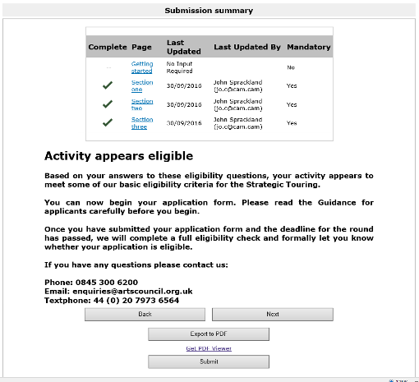


Section eight – The application form

When you have completed the eligibility questionnaire successfully, you can start your application to the Strategic Touring programme.

This section of the guidance provides detailed instructions on how to complete the application form. It follows the structure of each of the screens you will see as you work through the application form online. You should read it thoroughly before you begin, and follow the instructions carefully when you complete the form.

Using this section of the guidance

- Each screen that you will see as you work through the application form is titled in ► bold with an arrow in this guidance with explanatory text for that screen underneath.

- The questions the form asks in the application form are marked with ‘Question’ and are shown in bold and italics.

- Any clickable onscreen links are shown underlined in this guidance.

- Guidance on how to use the online system is shown outlined in red with the header System note.

Finding your application form

The Submissions screen
Once you have submitted the eligibility questionnaire and we have told you your activity appears eligible, you will be taken to the Submissions screen (a ‘submission’ is anything that you submit to us using the online system, such as an eligibility questionnaire or an application form):

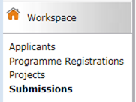

Listed on the Submissions screen are all the submissions that you have made or that are ready for you to complete. If something is ready to start or in progress, the Date submitted column will be blank. If something has already been submitted, the date and time it was submitted will appear here.

The column called Programme Name/Step Name will show you which submission is your application form:
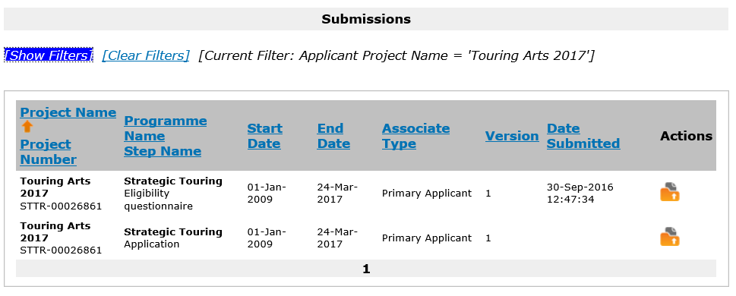

If you have made other applications to us using our Grantium online system, you will also be able to see the submissions relating to them on this screen. You can use the dropdown filters at the top of the screen to choose the name of the project you are working on:

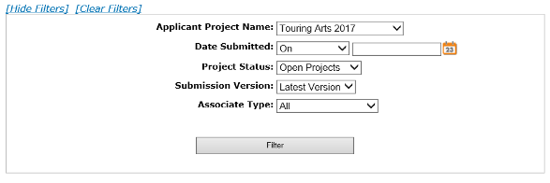

Starting the application form
To open and begin the application form, click the ‘Open’ icon next to your project’s application in the list:
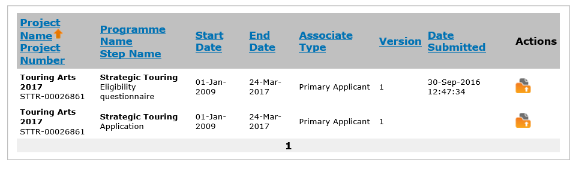

If you don’t complete your application form in one sitting, you can always access your in-progress form through this Submissions screen. To continue working on a particular submission, click the open icon on the right-hand side of the screen.

About the application form
The application form takes you through a number of sections. These are listed in the navigation bar on the left of the screen:
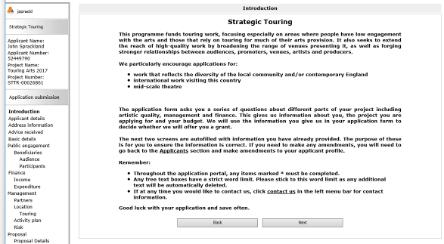

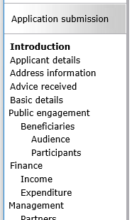

The application form asks you a series of structured questions about different parts of your activity, including:
- Public engagement – who your activity will engage
- Finance – your budget for the activity
- Management – partners, locations, activity plans etc

The latter part of the application form then asks you to complete a proposal for your activity, against the headings ‘Your proposed activity’, ‘Audience development’, ‘Finance’ and ‘Managing the activity’.

Applicant details and basic details

- Applicant details
At this stage, the Applicant details screen reappears to allow you to ensure that all your information is correct. If you have multiple applicant profiles linked to your user account, it is also an opportunity for you to ensure that you have selected the correct applicant.

If any of the details are incorrect, you will need to exit the application form and go back into your applicant profile to make your amendments. Please see our information sheet ‘How to create and manage your user account and applicant profile’ for guidance on how to do this.

- Address information
As with the previous screen, the Address information screen reappears to allow you to ensure that all your information is correct.

- Contact information
As with the previous screen, the Contact information screen reappears to allow you to ensure that all your information is correct.

- Advice received
If you have received any advice, please tell us about it here (please tick all options that apply).

- Basic details

Project information

Question:
Please give a concise description of the activity you are asking us to support
This description gives us a brief summary of the key aspects of your activity, so please describe your activity simply and clearly. If your activity includes incoming international touring work, please state this clearly in the project description.

Question:
Are you applying as part of a partnership, network or consortium?
If you answer ‘yes’ to this question, you will be asked to attach a document in the Other attachments section outlining the group’s aims and structure. Read the Consortia and partnership agreements section of the guidance for more information on consortia.

Question:
Please tell us what the main artform is for your activity
Use the dropdown menu to select the artform description that best describes the main artform of your activity (‘All artforms’ or ‘No specific artform’ are included in the options).

Amount requested

Question:
Please tell us the total amount you are requesting from us, including any personal access costs
Here we want you to tell us the amount you will be requesting from us, including any access costs. The figure you give should be the same as the figure you entered on the eligibility questionnaire.

Access costs are any extra costs relating to your own access needs (if you are deaf or disabled or experience learning difficulties, for example), or those of the delivery team, that you will need to pay to help manage your project. For example, payment for a sign language interpreter to help you manage your project is an access cost.

If your application includes personal access costs and you have any queries, please contact us on 0845 300 6200 or enquiries@artscouncil.org.uk.
Question:
Do you, or does your organisation object to receiving National Lottery funding for religious reasons?
If you answer ‘yes’ to this question, you will need to upload a letter explaining why you or your organisation object to receiving National Lottery funding on the Letter attachments screen.

Activity dates

Question:
Please enter the start and end date of your project
You must allow enough time for us to process your application. We cannot fund any goods or services that you have bought, ordered or contracted before we can make a decision on your application, so your start date must be after the decision date for the round you are applying to; this is generally 12 weeks after the application deadline. Strategic Touring projects can be delivered over a maximum of three years.

If you are applying for £100,000 or less:
You should also allow sufficient time between receiving notification of our decision and the start of your activity to adequately develop your audience development plan, which is a mandatory payment condition for all grants for £100,000 and under. If you do not factor in enough time to do this, any first payment may be delayed.

Please give a start date for your activity that:
- includes all the stages of the activity that you are asking for support towards, not just your tour dates (including, for example, development time)
- meets the restrictions for project length
- allows you enough time to develop your audience development plan, where relevant

Consortium partners
Please note that this section is only for partners that are part of any consortium or network making the application. Additional project partners should be added in the partners section of the Management screen later in the form.

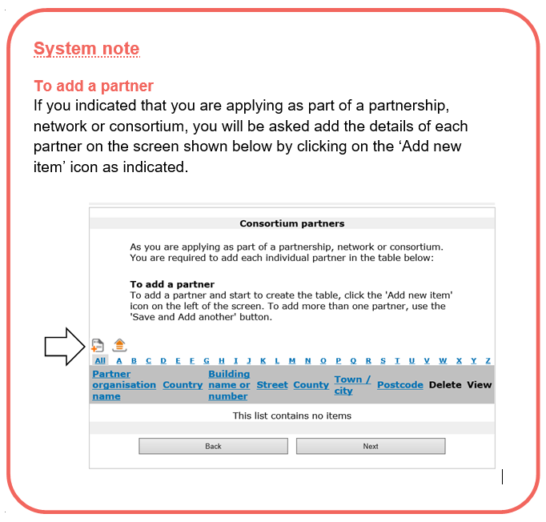
- Public engagement
In this section of the application form, we want you to tell us about who will engage with your activity. We ask you to estimate the numbers engaging with your activity based on what you think you will achieve. There is then a screen for you to tell us more about the audiences and/or participants for your touring activity, who they are and how you will reach them.

- Beneficiaries
People who will benefit from your activity
Use this screen to tell us how many people will engage with the activity you are applying for, and also how many people have engaged with your wider activities over the last 12 months.

Results of your activity
In the section at the bottom of this screen, please estimate the outcomes of your activity in the categories given. Enter ‘0’ (zero) for any item that is not relevant.

- Audience
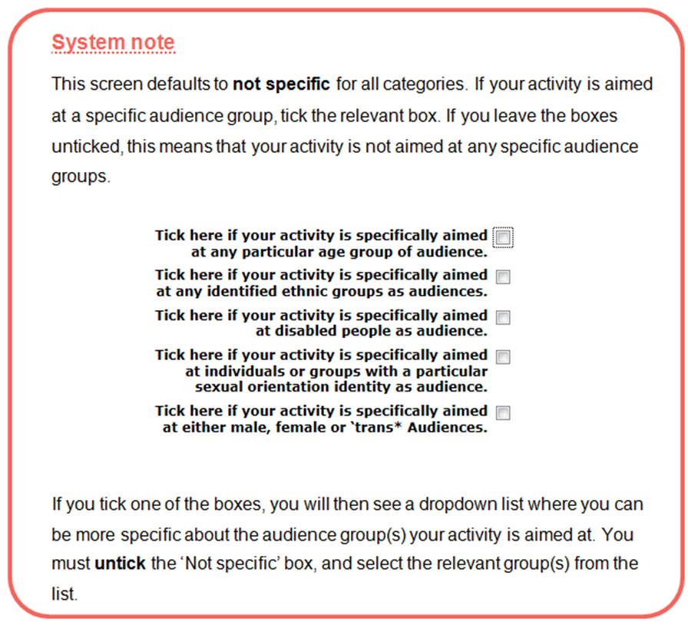

- Participants
On this screen, we ask you to give us some more details about the participants your activity is aimed at, if any. (For example, if your touring activity has participatory elements.)

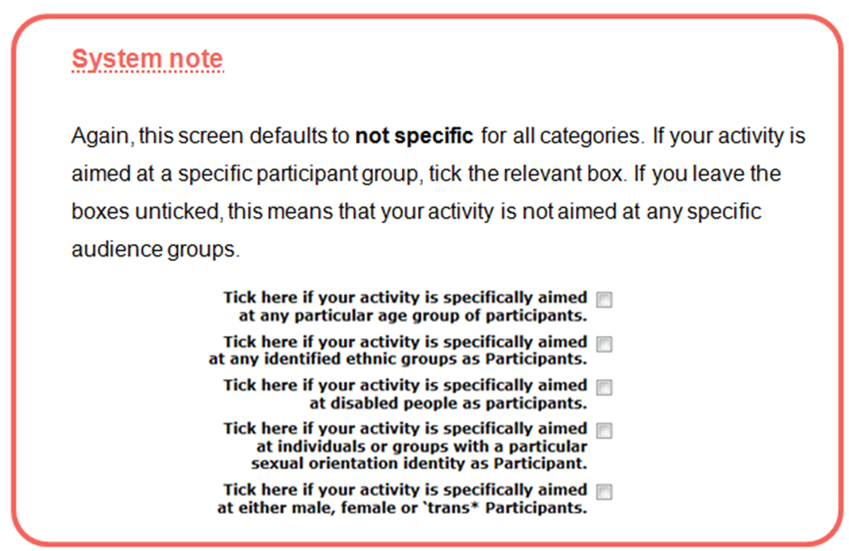
- Finance
The Finance section asks you to complete a budget for your project and is divided into two screens: Income and Expenditure. This guide will tell you how to complete each screen. There is also a Finance section to complete in your proposal, which is where you provide further detail about the finances for your activity and your approach to managing the budget.

Key things to remember about budgets:

- Your budget has to balance
Your income needs to be the same as your expenditure.

- We expect you to find at least 10 per cent of the total cost of your project from other sources
Financial income from other sources helps to demonstrate partnership support for the activity, and shows that the activity is making the most of our investment.

- We need to be able to see how you have worked your figures out
Please break them down clearly under the headings provided in the budget table.

- Your budget should be for the total cost of the project you are applying to do
We view your request to Strategic Touring funding as a contribution towards the overall cost of the project, and we do not generally allocate our funding to specific items of expenditure.

- Income
On this page, you should enter all the cash and in-kind income for your project.

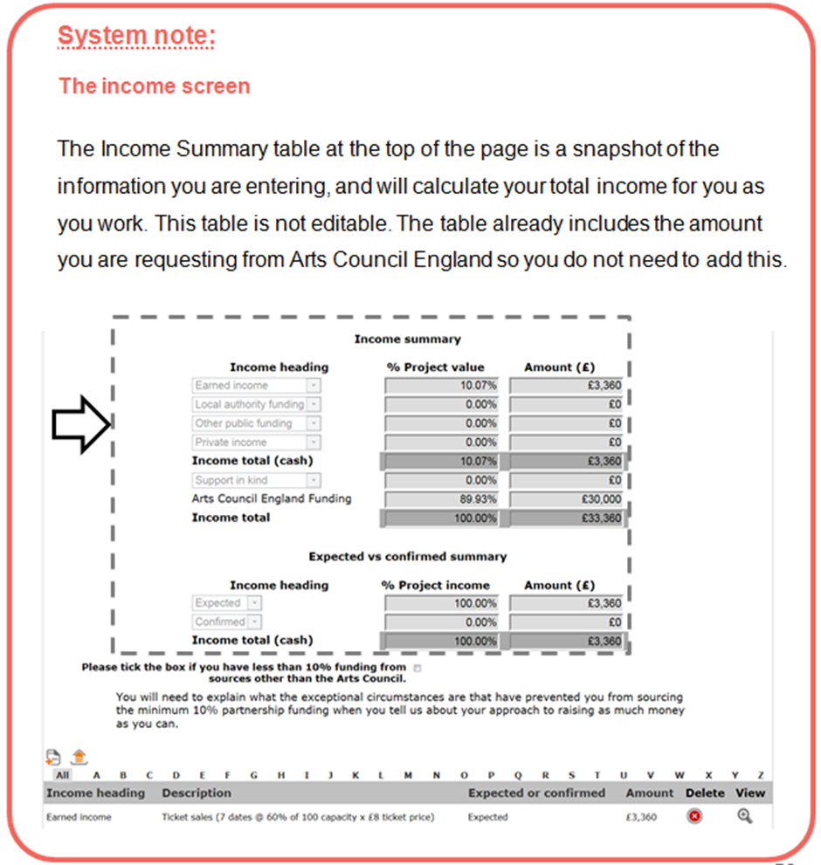

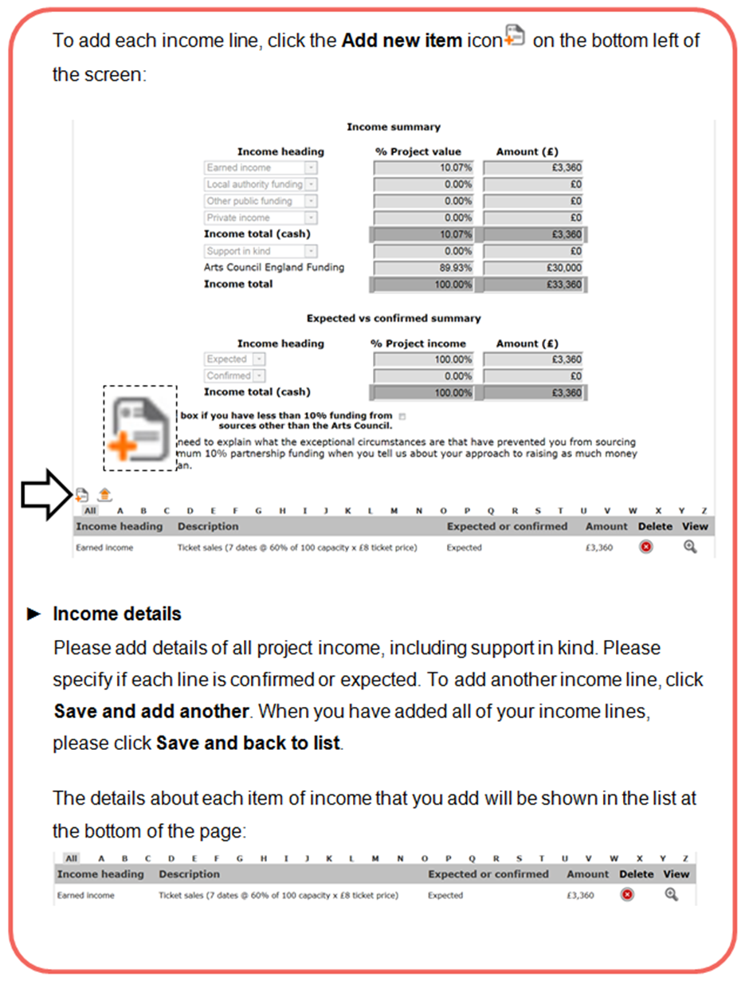

Requesting more than 90 per cent of the cost of your activity from us
In exceptional circumstances, we may be able to provide up to 100 per cent of the cost of the activity.

If you tick this box, you will need to explain why you are requesting more than 90 per cent of your project from us in the Finance section of your proposal.

How to present your income lines

- You should make sure that you show how your figures have been calculated in the Description field; for example:

Ticket sales (7 dates @ 60% of 100 capacity x £8 ticket price) £3,360

- You should enter all the cash income specific to this project on this page (excluding the amount you are applying to us for), as well as any support in kind you will receive.

- You should include any other income that is either confirmed or expected towards the project, including any applications to other funding bodies or trusts or foundations, under the appropriate budget headings. We take this into account when we are completing our assessment, and we generally consider confirmed income to reduce financial risk. (We may ask you to provide evidence of income you have shown as confirmed as a condition against your first payment if your application is successful.)

- Please use full pounds only and no pence (for example, £1,167 not £1,167.21).

- Expenditure
On this page, you should enter all the cash expenditure for your project.

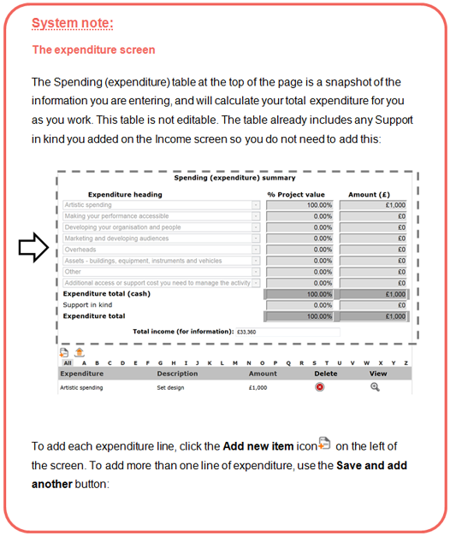

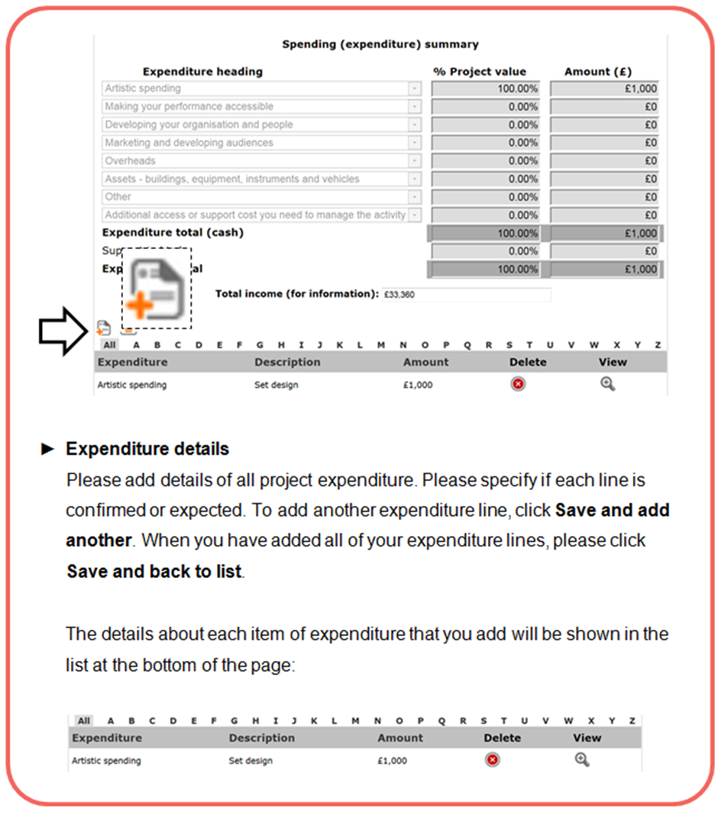

How to present your expenditure lines

- You should make sure that you show how all your figures have been calculated in the Description field. For example, you should show the number of days and the daily rate for any fees included:

Specialist marketing consultancy, 2 days @ £200 per day = £400

- If you are registered for VAT, your expenditure figures should not include VAT that you can claim back. If you are not registered for VAT, your costs should include VAT.

- You should get financial advice from your own accountant or the relevant tax office. For information about VAT and other taxes, contact HM Revenue & Customs (HMRC) through their website (www.hmrc.gov.uk).

- Management
In this section of the application form, we want you to tell us how you will manage your project. We will ask you to tell us about any other partners involved in the project, where it will be taking place and how you will manage and evaluate the project. We will ask you to complete a timeline of the key stages of your project.

- Partners
Question:
Please list any activity partners using the tool on this page

Please note that this section is for additional project partners that are not part of any consortium or network making the application. Please return to the Consortium partners screen to add any partners that are part of the network, consortium or group for the activity.

Here we ask you to tell us about any other partners involved in the project, their role in the project and the status of their involvement. They could be an individual or an organisation, and will be working to support a specific aspect of the activity.

We understand that not all types of touring activity will involve any additional partners. If this is the case for your activity, please leave this screen blank.

A partner could be a person or organisation:
- providing business support
- providing specialist sector support
- helping you to reach participants or audiences (community groups, local authorities, housing associations, arts venues)
- supporting the activity in kind (providing free use of space, marketing support, staff time etc)
- making a financial contribution to the activity

We ask you to include contact details for each of your project partners. As part of our assessment we may contact some of your listed partners to confirm their involvement.

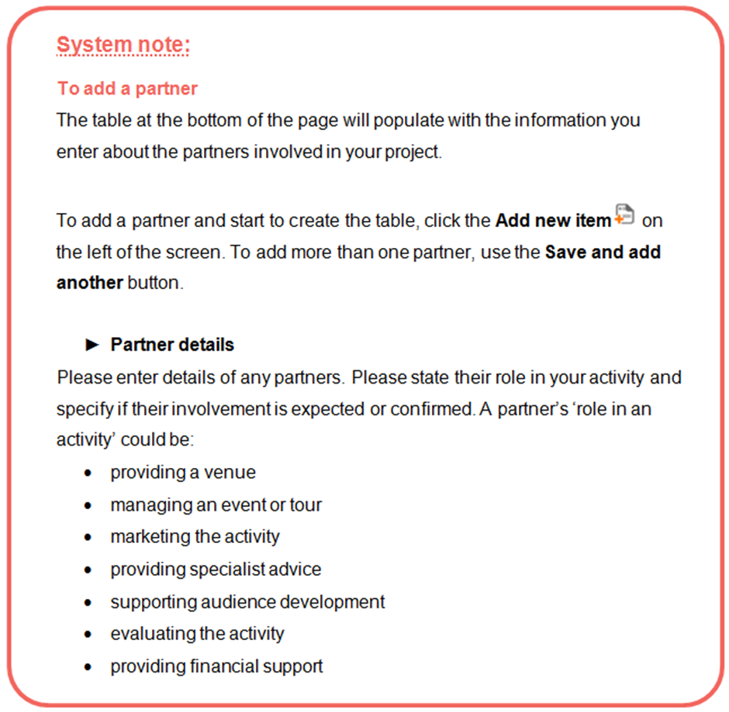

- Location
For the Strategic Touring programme, Type of activity is set at ‘Touring’.

Touring
In this section we ask you to give us information on where your activity takes place.

Preliminary tour schedule
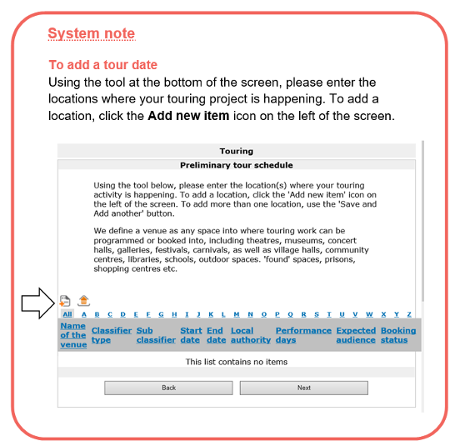

Touring venue details
On this screen, enter all known venue details.

There needs to be a minimum of two venues included in any tour, one of which can be where the activity has been created/initiated.

You should tell us whether each tour booking is:

• Confirmed – the booking dates and contractual arrangements are confirmed, subject to Strategic Touring programme funding, and probably won’t change
• Pencilled – there has been a detailed discussion between you and the venue. The venue has an understanding of the likely contractual arrangements and has agreed to pencil a date
• Discussed – you are currently in active discussion with a venue about your project but have not agreed a date or terms
• Not discussed – you have identified suitable venues but have not yet discussed the project with them

We do not expect you to have fully confirmed your tour by the time you apply. We will consider your tour based on the number of ‘confirmed’, ‘pencilled’, ‘discussed’ and ‘not discussed’ bookings, your track record and the relationship you have with the venues. We may also contact a selection of listed venues on your tour schedule to discuss with them your proposed tour and its relevance to their venue.

An unconfirmed tour schedule does not automatically mean that we will consider your tour schedule to be risky or unrealistic. However, where a large proportion of tour dates are unconfirmed, you must explain within the application how realistic the proposed tour schedule is. If you have a strong track record of securing tours and have strong partnerships with the proposed venues, producers and so on, tell us so we can have confidence that the proposed tour is achievable.

Normally, if your application contains only ‘not discussed’ dates or little evidence of relationships with the venues, we would consider your application to be underdeveloped and may not be able to progress it to the assessment stage.

To add more venues, use the Save and add another button.

- Activity plan
To give us a clear understanding of how your project will be managed, we would like to know about your planning and preparation to date and to see an outline project plan for your proposed activity.

Question:
Please briefly identify the main stages of any planning and preparation activity completed to date
We want to know what planning you have done to date so that we can understand if your activity is well considered and realistic. Please list the preparation you have done for this activity. For example:
- research
- developing partnerships
- scoping work (for example, audiences, building)
- considering potential risks
- planning the delivery of the activity (for example, producing a timeline)
- securing commitment from partners subject to funding

Please note that any costs associated with this preparatory work should not be included in your budget, as we cannot fund any part of an activity that has already taken place.

Activity timeline

Question:
Please use the table on this screen to identify the main stages of the activity from the start date onwards, and to show who will lead on each element of the activity

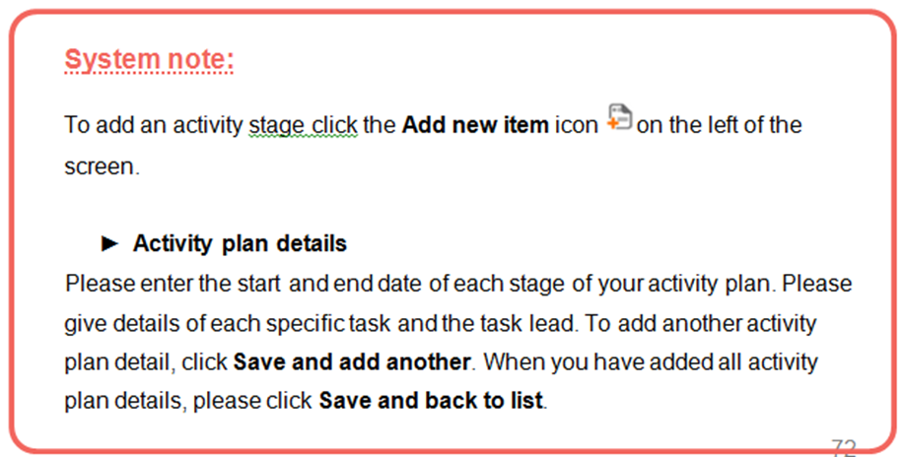

You can add as many lines as you need to this table to identify the main stages of the activity, for example: planning, partnership development, research, delivery (any performances/shows/exhibitions/workshops/events), evaluation, and so on. Touring activity (performance/exhibition dates etc) should be clearly identified using the timeline alongside the other stages of the activity. This allows us to get an overview of your activity.

Please add the stages of the activity to the table in chronological order. Dates for the different stages of your activity can overlap (for example, if you will be marketing the activity at the same time as completing other stages). In the final column, ‘Task lead’, please tell us who will be managing each stage of the activity. This could be you, or one of your partners.

Example activity plan:

Start date | End date | Activity or task | Task lead
1/8/2016 | 15/8/2016 | Conclusion of project planning including confirmation of workshop schedule | John Smith  (project manager)
8/8/2016 | 22/8/2016 | Marketing | Community partners
19/8/2016 | 30/8/2016 | Workshop planning by artists | Lead artists
4/9/2016 | 4/9/2016 | Introductory workshop session at Newtown Community Centre | John Smith (project manager) with Newtown Community Centre
10/9/2016 | 10/9/2016 | Workshop session with lead artist 1 | Kate Jones (lead artist 1)
17/9/2016 | 17/9/2016 | Workshop session with lead artist 2 | Adil Gupta (lead artist 2)
11/10/2016 | 11/10/2016 | Final show of work at Newtown Community Centre | John Smith  (project manager)
15/10/2016 | 15/10/2016 | Feedback session with participants | John Smith  (project manager)
15/10/2016 | 31/10/2016 | Evaluation period | John Smith (project manager) and lead artists

- Risk
If your application is for over £50,000, we will ask you to identify the main risks that could affect the successful delivery of your activity.

Please use the tool to identify the main risks to the activity (up to a maximum of 10 risks). Identify the actions you will take to mitigate these risks.

The types of risks you identify will be different depending on the nature of your touring activity, but you should think about:

- risks to the activity’s financial viability (for example, not securing expected partnership funding)
- risks to the stability and capacity of the delivery team (for example, partners changing, stability of the consortium or group, capacity and workforce issues, etc)
- risks to achieving public engagement (for example, not securing your tour schedule successfully)
- risks to the successful management of the activity (for example, practical concerns such as not securing any appropriate permissions, etc)
- risks to achieving high-quality outcomes (for example, not securing the artists/artistic team you want to work with)

We ask you to give each risk a rating of ‘Major’, ‘Moderate’ or ‘Minor’. This rating should relate to the impact of each risk on the activity if it were to occur.

We use your analysis of risks to the activity to help us with our assessment of your application. We want you to show that you have considered risk thoroughly, and
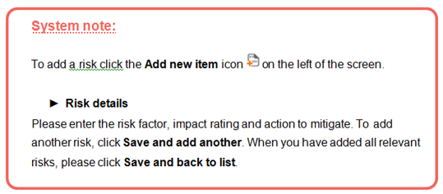
have thought about how you will mitigate risk.

Your proposal

We ask you to include a proposal about the touring activity that you want us to support. This is a very important part of the application process, as it gives applicants the chance to provide in-depth information about their activity and to show how it would align with the aims of the programme.

The proposal is divided into four ‘free text’ sections of up to 13,000 characters each: ‘Your proposed activity’, ‘Audience development’, ‘Finance’ and ‘Managing the activity’.

Your proposal should address the areas broken down by heading below, and throughout should show how the project will deliver against the aims and desired outcomes of the programme as set out in Section two.

If you plan to tour your activity across a large number of smaller venues then you can talk about your approach across a ‘circuit’ rather than each individual venue. In these cases, we would expect there to be a clear unifying factor across the venues, for example, overall management by one promoter (such as a rural touring circuit or a group of schools within a particular local authority).

- Proposal details

Your proposed activity (up to 13,000 characters)
This section of your proposal must:

- Provide an outline of the artistic activity and how it will strengthen and develop the touring infrastructure in relation to the aims and outcomes of the Strategic Touring programme.

- Provide details of the names, skills and experience of the artists and other main people involved.

- Explain why the work is going to be presented at the venues you have listed in your tour schedule. Describe your relationship with the promoters/artists/organisations/venues/presenters in each of the locations and how they have been involved in the development of the project. If you have listed any venues as ‘not discussed’, please explain why.

- Provide detail of the demand for the activity from venues and audiences.

- Explain what you are adding to the existing ‘artistic offer’ in each venue/place you are touring to and how it is providing access to artistic activity not normally programmed by those venues/promoters or ordinarily available in those places.

- Explain how the work reflects the diversity of local communities and/or contemporary England and increases work that supports the Creative Case for Diversity.

- Provide details of how you plan to evaluate the activity, including why this is appropriate for the size and scale of the project.

- Provide details of how you will disseminate key learnings from the programme with the sector to support the development of good practice.

- Explain your legacy plans for this activity. How will relationships be sustained and developed through and, if appropriate, beyond the life of the project? This could include artists, promoters, venues and audiences.

- (If you are reapplying for the development of a previous Strategic Touring-funded project) describe how this project will build on the learning and evaluation from the previous one.

- (If you are resubmitting a previously unsuccessful application) clearly summarise how you have changed the application in response to the feedback received.

- (If you are applying as an NPO or have NPO partners within the application, either as producers or host venues) summarise how the proposed activity is clearly additional to yours and/or your partner organisations’ NPO-funded work.

- (If your application is to support the creation of new work rather than touring an existing project) provide a clear case as to why investing in new work is the best approach.

- (If your activity will tour to venues outside England) show clearly that the performances/exhibition days/event days outside England represent no more than 15 per cent of the total number of performances/exhibition days/event days. For more information, see the ‘Touring out of England – the 15 per cent rule’ appendix at the end of this guidance document.
- (If your application is to support incoming international touring work and/or mid-scale theatre) describe how the project will develop skills and confidence in programming, touring and build audiences in these priority areas.

Audience development (up to 13,000 characters)
Any information you provide in your proposal should not be duplicated in your audience development plan (this is a mandatory attachment if you are applying for over £100,000). This proposal section in your application form explains who your audience is (and other aspects of your audience development work as outlined below), and the audience development plan explains how you intend to reach and engage them.

If you are applying for over £100,000, you will need to provide further details in your mandatory audience development plan at the point you submit your application.

If you are applying for £100,000 or less, we will ask for an audience development and marketing plan as a first payment condition if your application is successful. (You should allow sufficient time between receiving notification of our decision and the start of your activity to adequately develop your audience development plan. If you do not factor in enough time to do this, any first payment may be delayed.)

This section of your proposal must:

- Provide detail about the people the activity will reach, including estimated attendance and participation numbers for each venue.
- Be realistic with live audience projections and show how you have arrived at those figures, for example, by using attendance figures from previous visits to a venue.
- Describe what the online audience figures are based on and, if possible, break down digital engagement into active participants and casual browsers.

- Provide details of how you are using any research you have undertaken on your potential audiences, including new audiences, or whether you are drawing on published research such as arts-based segmentation research and/or Audience Spectrum.

- Provide details of how you and your partners are collecting audience and participation data, how this will be analysed to inform your future work, and how this data will be collected and shared in line with best practice.

- Provide details of how you have involved audiences in developing your activity and how you will make the most of those partnerships to extend the reach of the activity.

- Provide details of your marketing activity and how this is suited to your target audience.

- Provide details of how you plan to continue to develop and sustain relationships with your audiences beyond the life of the project. What measures will be put into place for the retention of those new audiences beyond the initial events and audience engagement activity?

- Provide details of how you will monitor and evaluate the longer term impact and legacy of the activity on the audience and delivery partners.

- Explain how access will be addressed through and, if appropriate, beyond the life of the activity.

- Provide details of who is leading the audience development part of the activity and how this will be managed across the partnership, network or consortium.

Finance (up to 13,000 characters)
The budget section of the application form gives us some of the information we need to carry out our financial assessment, but this section of your proposal gives us more detail and must address:

- How you have worked out the figures in your budget.

- Your approach to raising as much money as you can from other sources, what other sources of funding you have applied for, and the progress of any other applications you have made for funding.

- The proposed deals from each of the venues to be visited in the tour, with expected income broken down in the budget by each venue.

- How you will manage the budget and your cash flow and what financial controls are in place.

- How the partnership, network or consortium has agreed for the budget to be managed and what reporting structures will be put in place.

- How financial risk will be shared appropriately across all of those involved, including Arts Council England.

- How you have worked out the figures in your budget, for example, fees, rates and purchases.

- Any effect the activity will have on your long-term financial sustainability; if appropriate, this may include evidence of declining dependency for second or third applications, or reducing Arts Council England subsidy for return visits to venues.

- How you have ensured provision for access in terms of making the performances accessible, for example, for audiences, participants and performers.

- Details of any proposed equipment or asset purchases for this activity, and why this is essential to the effective delivery of the project. Please reference quotes from suppliers within your application. For further information, please refer to the Grants for the Arts information sheet on making asset purchases.

- What your special circumstances are if you are applying to us for the total cost of your activity.

Managing the project (up to 13,000 characters)
This section of your proposal must include the following:

- The planning and organisational requirements of the project, including how you will manage the main stages of your activity and what each stage contains. You may also wish to provide a detailed project plan as an additional attachment at the end of the form.

- Details of the lead manager for the activity and their past experience of successfully managing a similar activity.

- Evidence that you and the proposed partnership have the capacity and capability to deliver the programme and are able to demonstrate commitment from partners to the outline activity, budget and overall plan.

- Any identified risks to successfully completing the project, and how you will manage them.

- The long-term impact and legacy of the activity on you/your organisation and the delivery partners in terms of capacity, programme, audience development work and business plan.

- If you are applying as an organisation, details of how your management committee or board are involved in the activity at an appropriate level.

- If you are an NPO, details of how this activity may affect your current risk rating.

- If you are making an asset or equipment purchase, details of how this will be managed/utilised beyond the life of this project.

- Details of how environmental sustainability will be addressed through and, if appropriate, beyond the life of the project.

- If relevant, details of how conservation standards and security of any artworks will be maintained while on tour.

- Evidence that you have considered the protected characteristics, including socio-economic status, to identify and address barriers to attending or participating in your activity.

- Attachments

Each attachment you upload can be a maximum of 10MB in size.

- Financial attachments
You must upload the following mandatory attachment on the ‘Financial Attachments’ screen:
- most recent management accounts if lead applicant is not an NPO and is applying for over £100,000

The following additional financial information is optional for applicants:
- a more detailed budget, if you choose to use the application budget as a summary

- Letter attachments
You must upload on the ‘Letter Attachments’ screen:
- the email we sent confirming that you had a mandatory conversation with an Arts Council England Relationship Manager

If you indicated on the ‘Basic details’ screen that you had an objection to receiving money from the National Lottery on religious grounds, you should also attach your letter stating your objection here.

- Other attachments
You must upload the following mandatory attachments on the ‘Other Attachments’ screen:
- for applications over £100,000, a detailed audience development and marketing plan, spanning the life of the project
- all partnerships, networks and consortia applying to the programme should attach a document listing members of the group and their common aims and basic governance, and formally constituted groups can attach their constitution
The following additional information is optional and can be attached on the ‘Other attachments’ screen:
- one concise and relevant document of supporting information from partner venues, organisations or promoters who are planning to book the applicant’s work
- a more detailed project plan

No other supporting information should be attached or linked to, and, if it is, it will not inform the assessment. You must ensure that any key information within the attached additional information is clearly referenced within your proposal, with an explanation of which attachment you are referring to. Only one web link can be included as part of the application or attachments.

We will use the information you give us in your application form and relevant attachments to help us decide whether we will offer you a grant. If your application does not contain the information we need in the format we ask for it to be in, we may not be able to consider your application.

Monitoring information, the declaration and submitting your form

- Monitoring information
This screen shows the information you entered in your applicant profile. Please review the information to ensure that it is correct. This is particularly important if you haven’t made an application to us using that profile for some time.

We may use this information to report to the government or to monitor the different backgrounds of people who receive grants. We will not use this information to assess your application. If you do not know some of the information or you would prefer not to provide it, you can tick the ‘Prefer not to say’ box in your applicant profile.

- Declaration
This screen contains a tick box asking you to confirm that the information provided is correct and that you are authorised to submit it on behalf of the applicant. It also includes a number of important questions about you and your application. Please read the declarations carefully before you respond to them.

- Submission summary
The submission summary displays a list of all the steps you have worked through. If you have completed a step successfully, there will be a green tick beside it. If a step is incomplete or has not been completed successfully, this will be indicated by a red cross. A hyperlinked statement will tell you which part of each step needs attention. Click on this hyperlinked statement to take you to the step and make your amendments.

By clicking Submit, you are submitting your application for our consideration.

The system will return you to the Submissions screen, where you will see a submission time and date next to the Application form submission for your project.

After you submit your application

In the list of your applications in the ‘Submissions’ area of the portal you will see a date and time stamp next to your Strategic Touring application. This means it has been successfully submitted and received by us.

Contacting us after you have submitted your application

We consider your application to be complete when you send it to us and we will only contact you if we need to clarify any part of your application.

Section nine – What happens to your application

1 Eligibility check
When we get your application, we first check whether it is eligible against most of our straightforward eligibility criteria. More information on eligibility can be found in the Eligibility section of this guidance.

If your application is not eligible at this stage, this means that we cannot process it any further and it will not be considered for funding. We will notify you via the online system and will explain our decision.

If your application is eligible at this stage, we will send you a confirmation email. The email will include your project number, which we will use whenever we contact you about your application. Please quote your project number if you need to contact us.

We will complete our basic eligibility check within 10 working days of receiving your application. If you have not heard from us within this time, you can contact us at enquiries@artscouncil.org.uk or on 0845 300 6200.

2 Assessment
After we have established that your application is eligible against our criteria, it will go forward to a pre-assessment check. This is a step where we will check your application against some of our more qualitative eligibility criteria. Your application may still be made ineligible at this stage – if this is the case, we will notify you via the online system and will explain our decision.

If your application is eligible after our qualitative checks, it moves on to full assessment. This involves a consideration of your application in terms of risk, an assessment against criteria with scoring, and a score against our overview criteria.

We will make our assessment based on the information you provide in your application, any further information that we request and, where relevant, data and information from the Charity Commission and Companies House websites relating to your constitution and audited accounts from the past two years. If your organisation (or any of the activity partners) is a National Portfolio Organisation, we may also take its current risk rating into account.

We will involve specialist staff across the country to inform our assessment of applications.

Assessment criteria
We assess your application against the four criteria (‘Your proposed activity’, ‘Audience development’, ‘Finance’ and ‘Managing the project’) using a set of prompts. These prompts are questions that we will ask about your application that help us decide what score to award.

We will assess your application using the information in your application form and any supporting information.

The scores we use are:
- met (outstanding)
the application meets the criteria and shows outstanding qualities
Score = 4
- met (strong)
the application meets the criteria and shows strong qualities
Score = 3
- met
the application meets the criteria
Score = 2
- potential
the application does not meet the criteria but shows potential to do so
Score = 1
- not met
the application does not meet the criteria
Score = 0

Any application that is scored as met, met (strong) or met (outstanding) against all the assessment criteria will be recommended for funding.

If your application is scored as having potential or as not meeting one or more of the four assessment criteria, it will not be recommended for funding.

Overview areas
As well as the four assessment criteria, we look at three other areas to help us decide whether or not to offer funding. These areas help us to take an overview of our investment through this programme.

Overview 1: to what extent will this activity contribute to strengthening relationships and collaborative working in touring?

Overview 2: to what extent will the activity contribute to giving people across England improved access to great art visiting their local area?

Overview 3: to what extent will this activity contribute to increasing the amount of high-quality work on tour for a wider range of people?

Your application will get a score for each of the overview areas as follows:
- 3 if the activity will make an exceptional contribution
- 2 if the activity will make a considerable contribution
- 1 if the activity will make a partial contribution
- 0 if the activity will make no contribution

3 Decision-making
Once we have scored your application and a recommendation has been made whether to fund it, we will make our decision. To do this, we will consider how strongly your activity scored against our criteria, the risks we have noted and the overview scores, and we will also consider your activity alongside other applications to the fund.

We expect to receive more applications than we can fund, and therefore not all projects that successfully meet the aims and criteria for the programme will be funded.

When we will reach a decision
We aim to reach a decision on all eligible applications within 12 weeks from the date you submitted your application. If we are not able to meet our published turnaround times, we will let you know by email as soon as we can.

Once a decision is made
Once we have made a decision, we will advise you by email to log in and check the outcome of your application via the online system.

If your application is successful
If you are awarded funding, your online account will show an offer letter and additional information that will allow you to accept the grant via the online system.

If you applied for £100,000 or less, we will ask for a detailed audience development and marketing plan as a condition of your first payment. In this plan, you should include details on how you intend to reach and engage your target audience. You may wish to consider researching your audience in each location, tailoring your plans to the needs of individual partners and venues. For further information on this, please refer to the Additional resources section.

For all grants, we might also list some additional information you will need to provide us with before we will release your first payment (we call these additional pieces of information ‘payment conditions’). For example, we might ask for confirmation that the other income for the activity is in place.

If you have overdue payment conditions for ongoing Arts Council England awards across any other programmes, we will ask for these to be submitted or for you to reschedule your payments and conditions for that award before we release your first payment. Your previous offer letter would have listed the conditions you needed to meet and when we expected to receive your monitoring information. A condition is considered overdue once the date for submitting the information on the payment schedule for your grant has passed.

At the end of your project, we will ask for a short standardised case study to help support development of good practice, which may be shared on Culture Hive or the Arts Council England website. We will provide a template for supplying this case study to us.

Accepting your offer
We will ask you to acknowledge and accept your offer letter and our terms and conditions via the online system using the ‘Acknowledge offer letter’ submission.

Everyone who receives a grant must accept our standard conditions. These conditions are attached to any offer and are also available on our website. Alternatively, you can contact us for a copy (enquiries@artscouncil.org.uk, 0845 300 6200).

You will also need to print out and complete the bank details form, and send this back to us as a hard copy (this is for security reasons).

Requesting your first payment from us
For each payment of your grant, there will be a submission called ‘Payment request’ in the Submissions area of the online system that you must complete before we can release any payments. This submission also allows you to upload any information needed to meet the payment conditions we have set.

Please see our Grantium guidance sheet for step-by-step instructions on accepting a grant and requesting a payment.

If your application is unsuccessful
If we decide not to fund your activity, your online account will show a letter explaining our decision and outlining your next steps. You will also receive the full assessment report.

In 2016/17, there are five rounds of the Strategic Touring programme and you can reapply if you wish. However, please note that any new application for the same activity must sufficiently address the reasons why the original application was not successful. We will not be able to consider any reapplications that have not done this. If you would like to reapply to a later round, we strongly recommend that you seek feedback from your assessor. You will need to begin a new application form using the online system. You will also need to have another mandatory conversation with a Relationship Manager in your area.
Section ten – Further information

Complaints procedure
If you are not happy with the way we dealt with your application, please contact us and we will discuss this with you. If you are still unhappy, you can ask us for a copy of our complaints procedure. Details are in ‘Making a complaint’ on our website at www.artscouncil.org.uk, or you can email enquiries@artscouncil.org.uk or phone 0845 300 6200.

Please note that you can only complain if you believe we have not followed our published procedures when processing your application. You cannot appeal against the decision.

What to do if you cannot accept National Lottery funding for religious reasons
The funding we can provide from other sources is very limited, but we can arrange other funding if you cannot accept National Lottery funding for religious reasons. You should apply using our standard application materials and tick the box in the ‘Basic details’ section to state that you cannot accept National Lottery funding. We will process your application in the same way that we process all applications. If we decide to offer you a grant, it will not come from our budget from the National Lottery.

Making records of your activity available to us for audit
Applicants should be aware that Arts Council England conducts checks on a sample of applications every year to ensure that our funding is being used appropriately. We reserve the right to ask successful applicants for access to all or part of their documentation relating to their activity, and therefore grantholders must keep clear records of project management and financial records (including all invoices) for us to access when required.

Freedom of Information Act
Arts Council England is committed to being as open as possible. We believe that the public has a right to know how we spend public funds and how we make our funding decisions.

We are also listed as a public authority under the Freedom of Information Act 2000. By law, we may have to provide your application documents and information about how we have reached our decision to any member of the public who asks for them under the Freedom of Information Act 2000.

We may not release those parts of the documents which are covered by one or more of the exemptions under the Act. Please see the Freedom of Information website at https://ico.org.uk for information about freedom of information generally and the exemptions.

We will not release any information about applications while we are making a decision, as this may interfere with the decision-making process.

You can find out more about the Freedom of Information Act on our website.

Public sector equality duty
Your application form gives us information that we may use to report to government or to monitor the different backgrounds of people who receive grants.

Under the public sector equality duty, we must research and monitor the different backgrounds of people who receive our grants.

Section eleven – Key definitions

These are the key terms that we use throughout the guidance and in the application form for the programme. These terms are applicable to any kind of touring activity across any artform.

Touring
Our definition of touring activity refers to the same artistic programme or event taking place in two or more venues. This covers all artforms, scales of work and kinds of places, from outdoors to indoors, local to national. The artistic programme or event may involve live performances, digital exhibition and/or exhibition artworks; it should be fundamentally the same event offered to all, but may involve some adaptation to suit the different spaces and contexts in which it is being presented.

Touring activity relates to artistic programmes or events which take place at a geographic location, with some live element in terms of being close to performers or artworks and/or experiencing something with a group of people. We recognise the growing inter-relationships between touring and digital distribution, and anticipate that this may be reflected within some applications to the programme.

Venue
We define a venue as any space into which toured work can be programmed or booked, including, but not limited to, theatres, museums, concert halls, galleries, festivals, carnivals, village halls, community centres, libraries, schools, outdoor spaces, ‘found’ spaces, prisons and shopping centres.

Promoter
We define the promoter as the individual responsible for booking or programming work into a venue or circuit of venues. This can be, for example, the director, artistic director, curator, programmer, manager, circuit co-ordinator or local authority employee. In most cases, this would be the person who takes financial responsibility for booking or programming the event on behalf of an organisation.

Diversity and the Creative Case for Diversity
Our definition of diversity encompasses responding to issues around race, ethnicity, faith, disability, age, gender, sexuality, class and economic disadvantage, and any social and institutional barriers that prevent people from participating in and enjoying the arts.

The Creative Case for Diversity is an exciting and significant repositioning of Arts Council England’s approach to diversity and sits within goal 1 of Arts Council England’s strategic framework. It is intended to bring about fundamental change. The Creative Case for Diversity is based upon the principle that diversity, in the broadest sense, is an integral part of the artistic process. It is an important element in the dynamic that drives art forward; creating opportunities for artistic collaboration, innovation and risk-taking through embracing a wide range of influences and practices.

For us to attract the next generation to the arts and culture sector, we need the work we do to engage with, and reflect, the diversity of all our communities, and we expect our funded organisations to lead the way.

You can find more information about Arts Council England’s priorities around diversity and the Creative Case for Diversity on our website.

Places with the least engagement in the arts
Where you live is likely to have a profound impact on the likelihood of you attending and participating in the arts. There are considerable differences in engagement levels for regions, local authority areas and neighbourhoods across England, and these differences go beyond merely people’s choices about whether they attend and/or participate in the arts. Having considered options to help us prioritise where we target strategic funds, we believe that the Active People Survey currently offers the best proxy by which to understand engagement levels at local authority level in each area of England. (This survey is currently being updated as the Active Lives Survey, with new data available from 2017.)

We are interested in encouraging more engagement with arts activity in the local authority areas with relatively low levels of attendance and participation. These are the bottom third for levels of arts engagement in England, according to a two-year average from the Active People Survey. You can find a copy of the local authority data from the Active People Survey here.

The Active People Survey – and the updated ongoing Active Lives Survey – explores participation in leisure and recreational activities, including sport, physical activity and culture. The survey is led by Sport England in partnership with Arts Council England, Public Health England and the Department for Transport.

The new Active Lives Survey has been conducted by Ipsos MORI since November 2015 and will run for five years. It replaces Sport England’s Active People Survey, which ran, largely unchanged, from 2005/06. Between 2008 and 2010, the Active People Survey measured artistic attendance and participation, museums and gallery attendance, and use of public libraries. Between August and October 2015, Sport England consulted stakeholders on the methodology of measuring sports participation; the consultation resulting in the new Active Lives Survey.

Data from the Active Lives Survey about arts and cultural engagement between November 2015 and November 2016 will be published by Arts Council England in February 2017. The release will include local authority level data.

People who are least engaged in the arts
We want people to engage in the arts whatever their social or economic background. Evidence suggests that by understanding what makes people engage in the arts and addressing the barriers that stop them, we can open up the arts to many more people. We have undertaken some arts-based segmentation research to help organisations better understand how different kinds of people engage in the arts.

We are interested in reaching more people in both the ‘some engagement’ and ‘not currently engaged’ segments. You can find more about segmentation and the Audience Spectrum arts-based segmentation model through The Audience Agency.

We are particularly interested in work that tours to areas of low engagement or low provision. Low engagement may refer to geographical areas or to communities which are least engaged. Low provision may refer to overall cultural provision or individual artform provision.

Mid-scale theatre
There is currently a gap between demand and supply of quality theatre touring to venues of between 400 and 800 seats. We are interested in activity that addresses this alongside the wider aims of the Strategic Touring programme.

International work
We are interested in supporting incoming international work touring in England. For these purposes, international means work from outside the UK. If your activity involves touring work from the UK to venue(s) outside England, those dates cannot represent more than 15 per cent of the total number of tour dates funded through this application. You can find out more about the 15 per cent rule and international work in the appendix to this guidance.

Section twelve – Additional resources

You can find more about segmentation and Audience Spectrum, the arts-based segmentation model, through The Audience Agency. The Audience Agency has also undertaken work on digital and online engagement figures which may be able to help in breaking down digital engagement into active participants and casual browsers.

If you have previously received any funding from Arts Council England, you are also eligible for a free advice surgery with The Audience Agency.

You might also find it helpful to look at the resources on the Culture Hive website, www.culturehive.co.uk, which includes useful archive publications from Arts Council England such as:

- Greater than the sum of its parts: a joined up guide to working in groups
- Relationships between subsidised and commercial theatre
- A practical guide to marketing an event on tour
- Call it a tenner: the role of pricing in the arts

There are also a range of Grants for the Arts information sheets on our website which may be helpful to your application, including:

- Touring information sheet
- Audience development and marketing
- How to pay artists
- Asset purchase

Evaluation is a structured way of thinking about what has happened. See our Self-evaluation information sheet for a basic introduction to evaluating arts projects. You can download this from our website at www.artscouncil.org.uk.

Other Arts Council England programmes

We encourage applicants to acknowledge and, where relevant, connect with the existing arts infrastructure in the places to which they are touring. There are a number of Arts Council England programmes including Creative People and Places, Music Education Hubs and Bridge Organisations located throughout the country which can offer useful connections to the local infrastructure – particularly in support of reaching least engaged audiences. The following links will tell you more about these particular programmes. If you do propose to work in partnership with these programmes, you should ensure that the relevant organisations have been consulted and engaged in the planning and development of the project, as well as evidencing their support within the application.

Music Education Hubs are groups of organisations – such as local authorities, schools, other hubs, arts organisations, community or voluntary organisations – working together to create joined-up music education provision, respond to local need and fulfil the objectives of the hub as set out in the national plan for music education.
http://www.musiceducationuk.com/music-hubs-in-england/
Arts Council England funds a network of Bridge Organisations to connect the cultural sector and the education sector so that children and young people can have access to great arts and cultural opportunities. They work with local schools, art organisations, museums, libraries, Music Education Hubs, local authorities, Further Education and Higher Education institutions, and many other partners to develop a network of cultural provision.
http://www.artscouncil.org.uk/children-and-young-people/bridge-organisations

The Creative People and Places fund focuses on parts of the country where involvement in the arts is significantly below the national average. This may be due to lack of opportunities to attend and participate, lack of traditional arts infrastructure, or because of socio-economic factors, issues with physical accessibility or a limited offer of activities. Creative People and Places collaborations allow local people to shape the art they want to see in their area. People involved in Creative People and Places projects are empowered to experiment with new and different approaches to develop inspiring, sustainable art programmes that will engage audiences in those communities. If you are planning to work in a Creative People and Places area, please think about how you can create meaningful relationships with people and partners in this place, and how your work will reflect what local people in this area would like to see in their communities. For further information, please speak to the lead Relationship Manager for the project with which you wish to work.

http://www.creativepeopleplaces.org.uk/

Digital
Digital technology is transforming the way we make, exhibit, distribute, receive and exchange art. Arts Council England is committed to supporting digital change and innovation, and creative media, across the arts and culture sector. By ‘creative media’, we mean artistic and cultural works and content created for digital platforms, or distributed digitally to reach the public. The relationship between live and digital distribution can be effective in supporting reach and engagement across all artforms.

Support for this work is available from The Audience Agency. They can provide a range of digital services to help organisations reach and grow their online audiences, develop or refine digital strategies, understand how to better engage audiences and learn how to measure the value of online activity. They also provide a wide range of training on topics such as Improving Social Media Effectiveness, Understanding Google Analytics and Facebook & Twitter Advertising, which can be delivered in person or, in some cases, via an online webinar.
For further information, visit https://www.theaudienceagency.org/services/digital
Arts Council England programmes supporting digital engagement

Canvas: multi-channel network
Canvas is a new showcase channel for the great video content being produced by artists and organisations working in England today. Launched in 2015, the platform already includes a growing number of touring venues and producers. Canvas aims to be ‘the home of the UK arts scene on YouTube’ and will continue to aggregate existing online content and give arts organisations the necessary skills to reach and engage with YouTube’s audiences.

Random Acts
During 2015–18, Arts Council England will be supporting talented young artists from across England to make short films for Channel 4’s acclaimed short film strand, Random Acts. The films will be showcased on TV and online to increase access to the arts among Channel 4’s young core demographic. The programme is being delivered by ‘network hubs’ in different areas to work with a range of partner organisations to support young artists as part of the film-making process.

The Space
The Space develops and commissions great art digitally. This partnership with the BBC and BBC Academy helps organisations and artists capture their best live arts events so that they can be enjoyed digitally, and it creates new interactive digital art projects to be experienced online. The Space will commission projects that use digital to capture, extend and create artworks, increase the availability of the arts on BBC platforms and build digital capacity for arts organisations, with a focus on content production.

For more information on these programmes, visit: http://www.artscouncil.org.uk/how-we-make-impact/creative-media
Appendix 1 – Touring out of England – the 15 per cent rule

Although we mainly fund touring activity that takes place in England, up to 15 per cent of any touring activity presented to us may take place outside England: either in other part(s) of the UK (Scotland, Wales and/or Northern Ireland) or internationally outside the UK (or a combination of both).

We calculate the percentage of an activity happening outside England based on the number of performances or exhibition/event days in each location shown in the preliminary tour schedule in the application form.

Normally, we would only fund activity taking place at the Edinburgh International or Fringe Festivals if it is part of a wider tour of Scotland and the total activity in Scotland does not make up more than 15 per cent of the touring activity.

Example A
An 18-date tour has 16 performances in England, one in Wales, and one in France. Two of the 18 performances are outside England, therefore 11 per cent of the touring activity is outside England. On the basis of this tour schedule, the activity would be considered eligible for Strategic Touring.

Example B
An 18-date tour had 14 performances in England, two in Wales and two in France. Four of the 18 performances are outside England, therefore 22 per cent of the touring activity is outside England. On the basis of this tour schedule, the activity may not be considered eligible for Strategic Touring.

Including activity outside England in your application
Generally, a maximum of 15 per cent of the total number of performances or exhibitions/event days included in a Strategic Touring tour schedule can be outside England.

Sometimes, however, a tour will include more than 15 per cent of performance or exhibition/event days outside England and there may be a case for presenting the full tour schedule to us (for example, if your international dates are part of a wider programme of artistic or organisational development that you want to show).

If your tour schedule includes more than 15 per cent of performances or exhibition/event days outside England, there are two possible approaches to presenting this in your Strategic Touring application:

- Apply for support towards part of your tour
Apply to us for a project that makes up part of your overall tour, and which includes 15 per cent or less of touring activity outside England (you can tell us about the wider tour in your narrative but don’t include the dates outside England in your tour schedule); or

- Show how activity outside England is paid for by other funds
Include your full tour schedule that includes more than 15 per cent touring performance or event days outside England, but show and clearly articulate that any performance or event days taking the proportion over the 15 per cent threshold are fully covered by clearly allocated confirmed funding from other sources (this can be shown in your detailed budget attachment).

Example C
A 10-date tour might have six performance days in England and four in Wales. If this was presented without any other confirmed income, it would be considered ineligible for Strategic Touring funding because 40 per cent of the performance days are outside England. However, if this project had funding confirmed from Arts Council Wales (or another funder) that was directly allocated to covering at least three of those performance days in Wales, we could view this as eligible for Strategic Touring because we would only be contributing to the performance days in England and one of the dates in Wales (10 per cent outside England).

In exceptional circumstances, we may be able to take expected income from venues into account along with, or instead of, confirmed income from another funder. We would only be able to take this kind of funding into account where an applicant has explicitly demonstrated a very strong track record of securing box-office income with that venue previously. Whether we accept expected box-office income in this way to offset performance or event days outside England is entirely at our discretion.

If an applicant chooses to present their full tour schedule in their application, they should be aware that we do not take the amount of confirmed income allocated to covering international dates into account when we calculate the project’s partnership (‘match’) funding. This means that the budget would need to show at least the minimum 10 per cent match-funding in addition to the amount of confirmed funding that will cover international performance or event days. (This is because we use that amount of confirmed funding to offset the ineligible international activity, so it cannot also be taken into account when we calculate the match-funding for the eligible part of the activity.)

Incoming tours
Applicants based outside England but within the EU can apply to tour their work into England.

Arts Council England

Phone: 0845 300 6200, 0161 934 4317
Textphone: 0161 934 4428
Email: enquiries@artscouncil.org.uk
Website: www.artscouncil.org.uk
Post: Arts Council England – Grant Management,
The Hive, 49 Lever Street, Manchester, M1 1FN

Charity registration no 1036733

© Arts Council England October 2016

Our definition of diversity encompasses responding to issues around race, ethnicity, faith, disability, age, gender, sexuality, class and economic disadvantage, and any social and institutional barriers that prevent people from creating, participating or enjoying the arts.
By mid-scale theatre, we mean drama going to venues with 400-800 seats
www.artscouncil.org.uk
http://www.artscouncil.org.uk/sites/default/files/download-file/ACE_Partnership_Agreements_Guidance_August_2014.pdf
www.artscouncil.org.uk/what-we-do/our-priorities-2011-15/diversity-and-creative-case
http://www.artscouncil.org.uk/participating-and-attending/active-lives-survey
www.theaudienceagency.org/audience-research-and-insight/audience-spectrum
www.theaudienceagency.org/audience-research-and-insight/audience-spectrum
www.artscouncil.org.uk/funding/grants-arts/information-sheets

