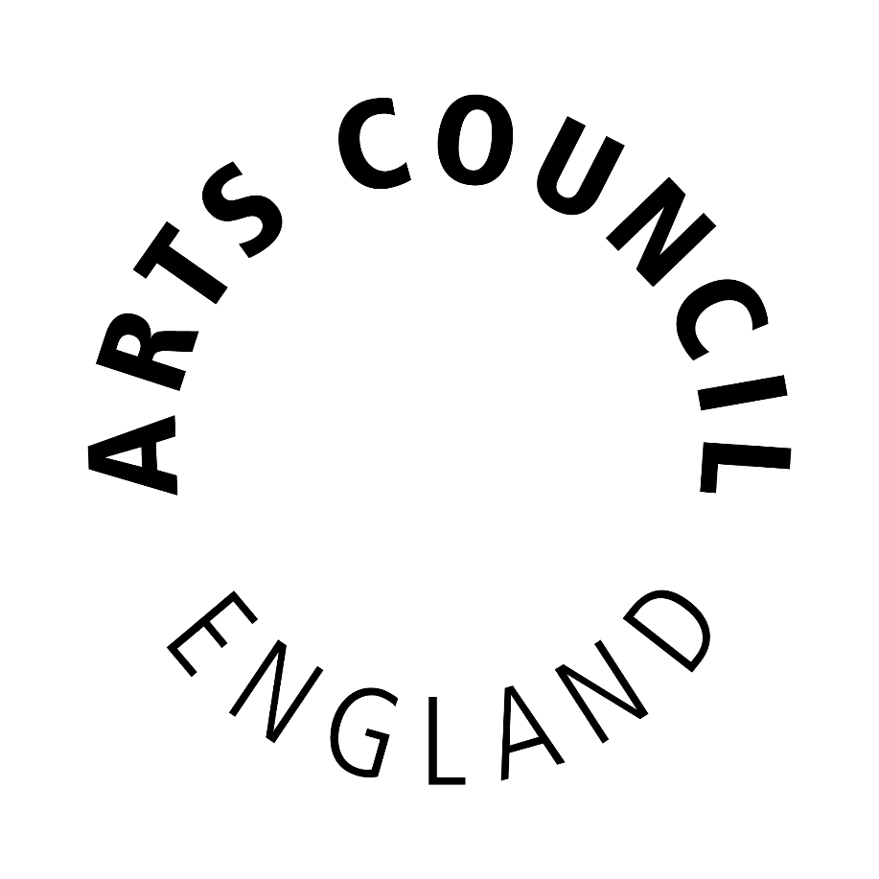

Publication scheme

October 2016

The Freedom of Information Act requires all public authorities to have a Publication
Scheme.

The Publication Scheme is a document that describes the types of information that we routinely publish, where you can find the information and whether we charge for supplying it. It is not a list of our publications nor is it a list of every document that we hold.

The Arts Council is committed to routinely publishing a significant amount of information and, where possible, providing quick and easy access to material without any need for a formal written request. We do this by publishing as much information as we can through our website, which is designed to function as the key source of our Publication Scheme.

This scheme lists the different types of information that we routinely make available. The scheme is divided into seven categories which describe the general headings under which information is published; each category is further divided into sub-categories for ease of access.

Charging for Information
We make no charge for information available on our website or for providing paper copies of documents requested through the Freedom of Information Act. However, please note if you request multiple copies of the same document, or different documents, a charge may be made.

Freedom of Information Requests
The Publication Scheme is not a list of all the documents that we hold. If you are unable to find the information that you are looking for by following the links below or on our website, please contact us and we will do our best to help you find the information that you are looking for. Please contact:

Senior Officer, Information
Arts Council England
The Hive
49 Lever Street
Manchester M1 1FN foi@artscouncil.org.uk
WHO WE ARE AND WHAT WE DO

Find out about how we are governed, our investment in the arts museums and libraries, our areas and how to contact us:
http://www.artscouncil.org.uk/about-us/

Find out about our organisation structure:
http://www.artscouncil.org.uk/working-us/organisational-structure

Find out about what we do:
http://www.artscouncil.org.uk/about-us/supporting-arts-and-culture

Find out about some of our projects and our work:
http://www.artscouncil.org.uk/about-us-0

http://www.artscouncil.org.uk/arts-council-england-corporate-plan-2015-18

Find out about research and data reports recently published and those scheduled to be published in the future:
http://www.artscouncil.org.uk/publications-schedule

WHAT WE SPEND AND HOW WE SPEND IT

Find out about how and where we invest public money:
http://www.artscouncil.org.uk/about-us/how-and-where-we-invest-public-money

Find out about Arts Council’s funding and which individuals and organisations’ have benefited from our investment:
http://www.artscouncil.org.uk/funding/

Find details of all awards offered through Grants for the Arts here:
http://www.artscouncil.org.uk/grants-arts-0

See our current and previous year’s Annual Review (which includes our Accounts):
http://www.artscouncil.org.uk/who-we-are/annual-review/

See the expenses for our National Council and our Executive Board: http://www.artscouncil.org.uk/who-we-are/transparency/national-council-expenses/

http://www.artscouncil.org.uk/our-executive-board/executive-board-expenses

Browse lists of items of payments of over £5,000 until April 2015, and payments of over £25,000 since that date:
http://www.artscouncil.org.uk/items-spend?sort=field_publishing_date&order=desc

Find out about our procured goods, services and works by either issuing competitive tenders or invitations to quote in line with UK government policy and all relevant legal requirements:
http://www.artscouncil.org.uk/supply-us

WHAT ARE OUR PRIORITIES AND HOW ARE WE DOING

Find out about our mission, ten year strategy and our Corporate Plan:
http://www.artscouncil.org.uk/about-us/our-mission-and-strategy

See our current Annual Reviews (which includes our Accounts):
http://www.artscouncil.org.uk/publication/arts-council-england-grant-aid-and-lottery-distribution-annual-report-and-accounts
HOW WE MAKE DECISIONS

Take a look at our timeline for the 2018-22 National Portfolio, then find out more about our decision making process:
http://www.artscouncil.org.uk/national-portfolio-2018-22/our-timeline-and-decision-making

Find out about our Governance and the terms of reference of our National Council and Committees:
http://www.artscouncil.org.uk/our-organisation/

Take a look at the minutes of our National Council meetings: http://www.artscouncil.org.uk/who-we-are/how-we-are-run/national-

Find out about how we make investment or grant decisions
http://www.artscouncil.org.uk/national-portfolio-organisations/how-were-decisions-made

Our Executive Director for Arts and Culture, blogs about what really goes on in our Grants for the Arts decision meetings:
http://www.artscouncil.org.uk/blog/getting-heart-grants-arts

OUR WRITTEN POLICIES AND PROCEDURES

For guidance on how to apply for Arts Council Funding:
http://www.artscouncil.org.uk/funding/funding-finder

Download our Grants for the Arts guidance: http://www.artscouncil.org.uk/funding/apply-funding/apply-for-funding/grants-for-the-arts/guidance-and-information-sheets/

THE SERVICES WE OFFER

Find out about our funding programmes that we offer and the different art forms we support:
http://www.artscouncil.org.uk/artforms/

Find out about our news and press services: http://www.artscouncil.org.uk/news/

Find out about conferences and events:
http://www.artscouncil.org.uk/jobs-and-conferences/conferences/

Find out about our complaint procedures for dealing with complaints and the sorts of things people can make a formal complaint about:
http://www.artscouncil.org.uk/advice-and-guidance-library/making-complaint

Browse our news and our publications:
http://www.artscouncil.org.uk/news/

