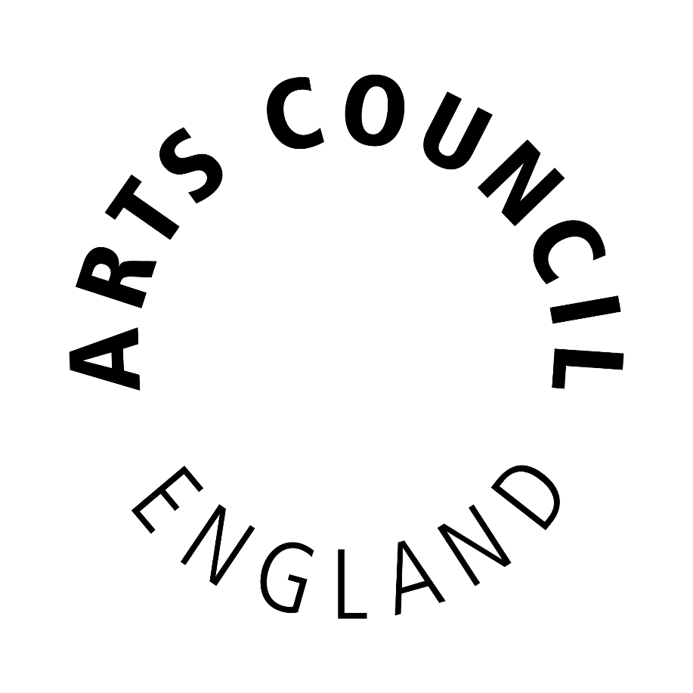

Publication scheme

July 2016

The Freedom of Information Act requires all public authorities to have a Publication
Scheme.

The Publication Scheme is a document that describes the types of information that we routinely publish, where you can find the information and whether we charge
for supplying it. It is not a list of our publications nor is it a list of every document that we hold.

The Arts Council is committed to routinely publishing a significant amount of information and, where possible, providing quick and easy access to material without any need for a formal written request. We do this by publishing as much information as we can through our website, which is designed to function as the key source of our Publication Scheme.

This scheme lists the different types of information that we routinely make
available. The scheme is divided into seven categories which describe the general headings under which information is published; each category is further divided
into sub-categories for ease of access.

Charging for Information
We make no charge for information available on our website or for providing paper copies of documents requested through freedom of information. However, please note if you request multiple copies of the same document, or different documents, a charge may be made.

Freedom of Information Requests
The Publication Scheme is not a list of all the documents that we hold. If you are unable to find the information that you are looking for by following the links below or on our website, please contact us and we will do our best to help you find the information that you are looking for. Please contact:

Senior Officer, Information
Arts Council England
The Hive
49 Lever Street
Manchester M1 1FN foi@artscouncil.org.uk

WHO WE ARE AND WHAT WE DO

Find out about how we are governed, our investment in the arts, our areas and how to contact us:
http://www.artscouncil.org.uk/about-us/

Find out about the art forms that we support, our policies and other related publications:
http://www.artscouncil.org.uk/artforms/

Find out about some of our projects and our work:
http://www.artscouncil.org.uk/arts-council-england-corporate-plan-2015-18

WHAT WE SPEND AND HOW WE SPEND IT

Find out about Arts Council’s funding and which individuals and organisations have benefited from our investment:
http://www.artscouncil.org.uk/funding/

See our current and previous year’s Annual Review (which includes our Accounts):
http://www.artscouncil.org.uk/who-we-are/annual-review/

See the expenses for our National Council and our Executive Board: http://www.artscouncil.org.uk/who-we-are/transparency/national-council-expenses/

http://www.artscouncil.org.uk/who-we-are/transparency/executive-board-expenses/

WHAT ARE OUR PRIORITIES AND HOW ARE WE DOING

Find out about our Corporate and Strategic Plans:
http://www.artscouncil.org.uk/what-we-do/mission/our-plan-2011-15/

http://www.artscouncil.org.uk/great-art-and-culture-everyone

Take a look at the minutes of our National Council meetings: http://www.artscouncil.org.uk/who-we-are/how-we-are-run/national-
council/members-of-the-council/

Find information regarding our Executive Board
http://www.artscouncil.org.uk/who-we-are/how-we-are-run/executive-board/

FUNDING PROGRAMMES

Find out about our funding programmes that we offer and the different art forms we support:
http://www.artscouncil.org.uk/artforms/

Download our Grants for the Arts guidance: http://www.artscouncil.org.uk/funding/apply-funding/apply-for-funding/grants-for-
the-arts/guidance-and-information-sheets/

THE SERVICES WE OFFER

Find out about our news and press services: http://www.artscouncil.org.uk/news/

Find out about conferences and events:
http://www.artscouncil.org.uk/jobs-and-conferences/conferences/

Browse our news and our publications: http://www.artscouncil.org.uk/news/

