Grantium Guidance for Applicants:
How to create and manage your user account and applicant profile

Version 2 – July 2017

Contents
1. Introduction 4
2. What is a user? What is an applicant? 5
2.1 User 5
2.2 Applicant 5
2.3 Validation of applicant profiles 5
3. Creating a user account 7
4. Starting to create an applicant 10
5. How do I know whether to create an individual or organisation applicant? 12
6. Accounts and applicant profiles 14
6.1 Individuals 14
6.2 Organisations 18
6. 3 Universities and local authorities 21
6.4 When a person works for more than one applicant 23
7. Step by step: Creating an applicant profile (individual) 26
8. Step by step: Creating an applicant (organisation) 30
9. Navigating your user account 38
10. How to manage your contact details 44
11. How to link or unlink a user to an applicant 48
11.1 How to link a user to an applicant 49
11.2 How to unlink a user from an applicant 53
11.3 Amending user rights 55
12. FAQs 57
13. Further information and support 57

1. Introduction

As part of the cost saving requirements set by the government in our 2011–15 settlement, Arts Council England has introduced a new grant management system: Grantium. This move allows us to combine the features of an online application portal and an internal grant administration system into one.

This system allows applicants to manage all of their projects with Arts Council England online. All applications, along with decision letters, payment requests and any communication regarding your application, are managed through the online system. This change does not mean applicants and awardees lose someone to speak to, rather it allows us to be more efficient in the way we use our resources. It also allows applicants to have greater control over the information they provide us with.

This document gives you the key information you need in order to create and manage your user account and applicant profile(s) on Grantium.

2. What is a user? What is an applicant?

To make an application on the system, you are required to create a user account and then an applicant; this section will explain what both these terms mean.

2.1 User

You create a user account in order to gain access to Grantium. A user account is unique to you and you should not share your log on details with anyone.

You only need to create a user account once, and should use these details each time you want to log in to the system. Guidance on how to do this can be found in the Creating a user account section of this guidance.

2.2 Applicant

Once you have created your user account and logged in to the system, you must create an applicant profile. The applicant is the entity (either an individual or an organisation) who can make an application and who can enter into a grant agreement if the application is successful. The applicant profile includes all contact information for the applicant.

You might have more than one applicant linked to your user account. For example, you might have an applicant profile for yourself as an individual, and also be linked to an organisation that you work for and make grant applications for.

Applicants can be linked to several different users; for example, an organisation’s applicant profile should be linked to user accounts of the person who writes and submits grant applications, and to the person who has authority to accept an offer of a grant.

Over the next few pages, we will show you examples of how a user account and an applicant profile would look for:

- an individual
- an organisation
- universities and local authorities

2.3 Validation of applicant profiles
Please note that when you create an applicant profile for the first time, you will not be able to access an application form until we have validated your profile. We do this to ensure no duplicate profiles are created on the system. This validation process will usually take up to five working days. Please bear this is mind when you are planning your application.

3. Creating a user account

You create a user account in order to gain access to Grantium. A user account is unique to you and you should not share your log on details with anyone.

You only need to create a user account once, and should use these details each time you want to log in to the system.

Every person who uses our online system for any purpose (for example to make applications, accept grant offers, or submit reports and payment conditions) must first set up a user account to give them access to the system.

This is the first screen you will see when you access the new online system:

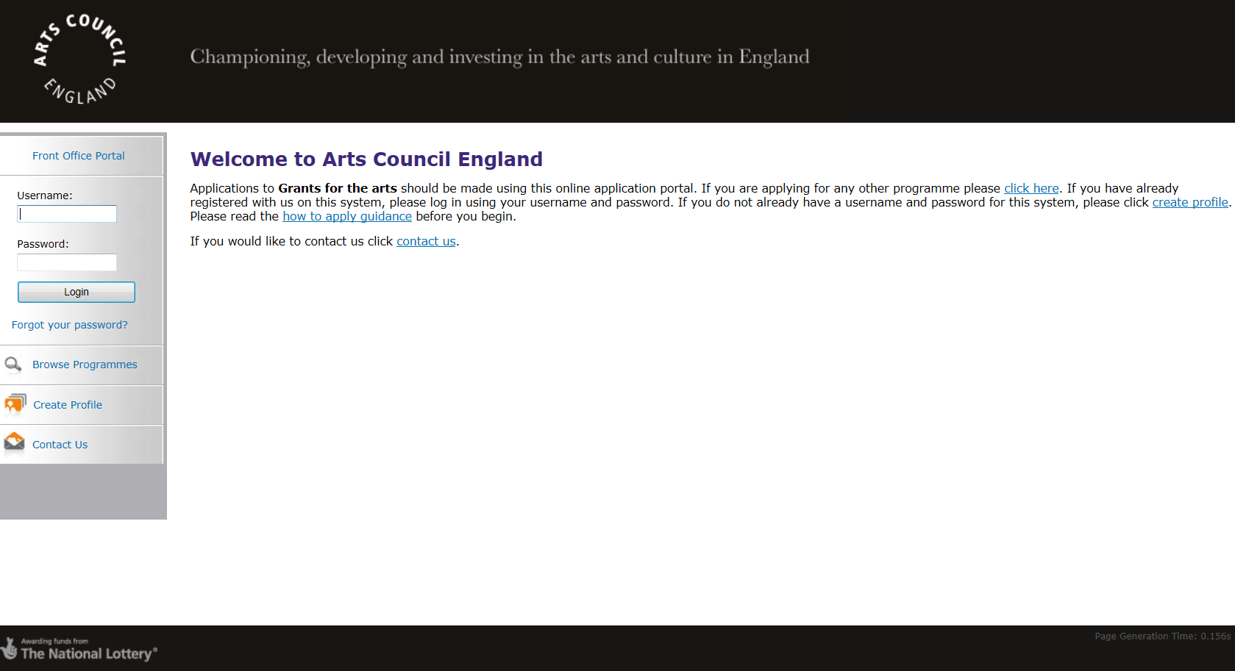
To create an account, click Create Profile in the navigation bar on the left of the screen.

This opens up the User Account screen:

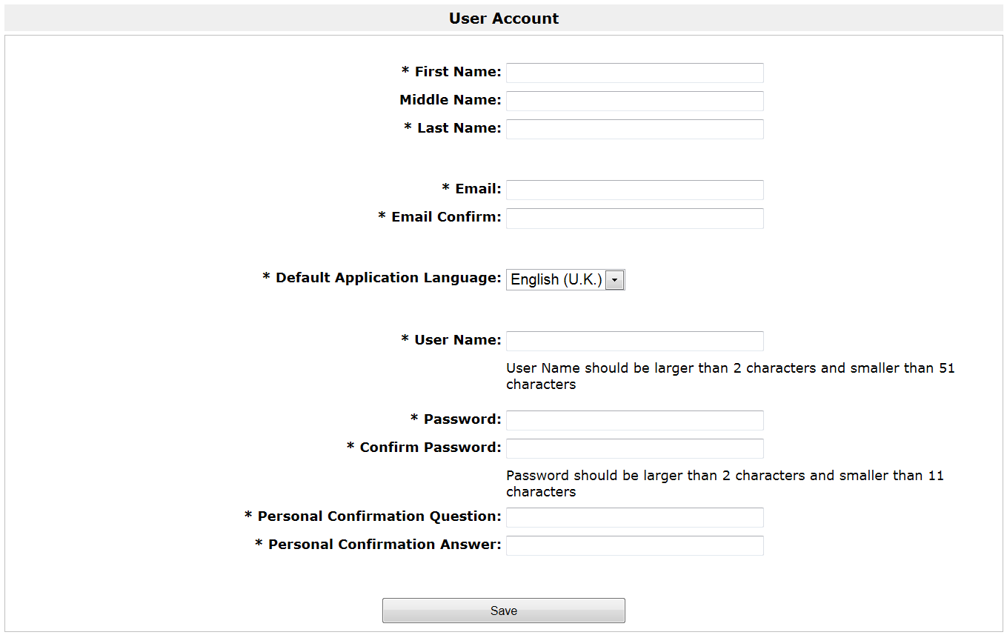

Please complete the details, making sure you fill in every field marked with an asterisk (*).

Please note:

You must enter your real first and last names in the first fields (you can choose your own User Name lower down this screen).

The email address you enter here is the address to which we will send all notifications for any projects you are involved in. Please enter it carefully, and make sure it is up to date.

Your chosen user name has to be unique on our system. The system will let you know if the name you have chosen is already taken. You may need to use numbers to ensure your user name is unique.

The personal confirmation question will act as a security question in case you forget your password. Please choose a question and answer that will be memorable to you.

Click Save to complete.

This creates your user account. You will only ever need one account. It can be linked to more than one applicant profile if, for example, you want to make applications in your own name, but also for an organisation you work on behalf of. For guidance on how that works, please read section 11.1 How to link a user to an applicant.

For an organisation, we would recommend that two members of staff have user accounts linked to the organisation profile. One should be the person who writes applications and manages grants. One should be the person with the authority to accept a grant offer, normally a chief executive or equivalent.

4. Starting to create an applicant

Once you have a user account, you will need to create an applicant profile. Clicking Save at the end of the user account screen takes you to this page:
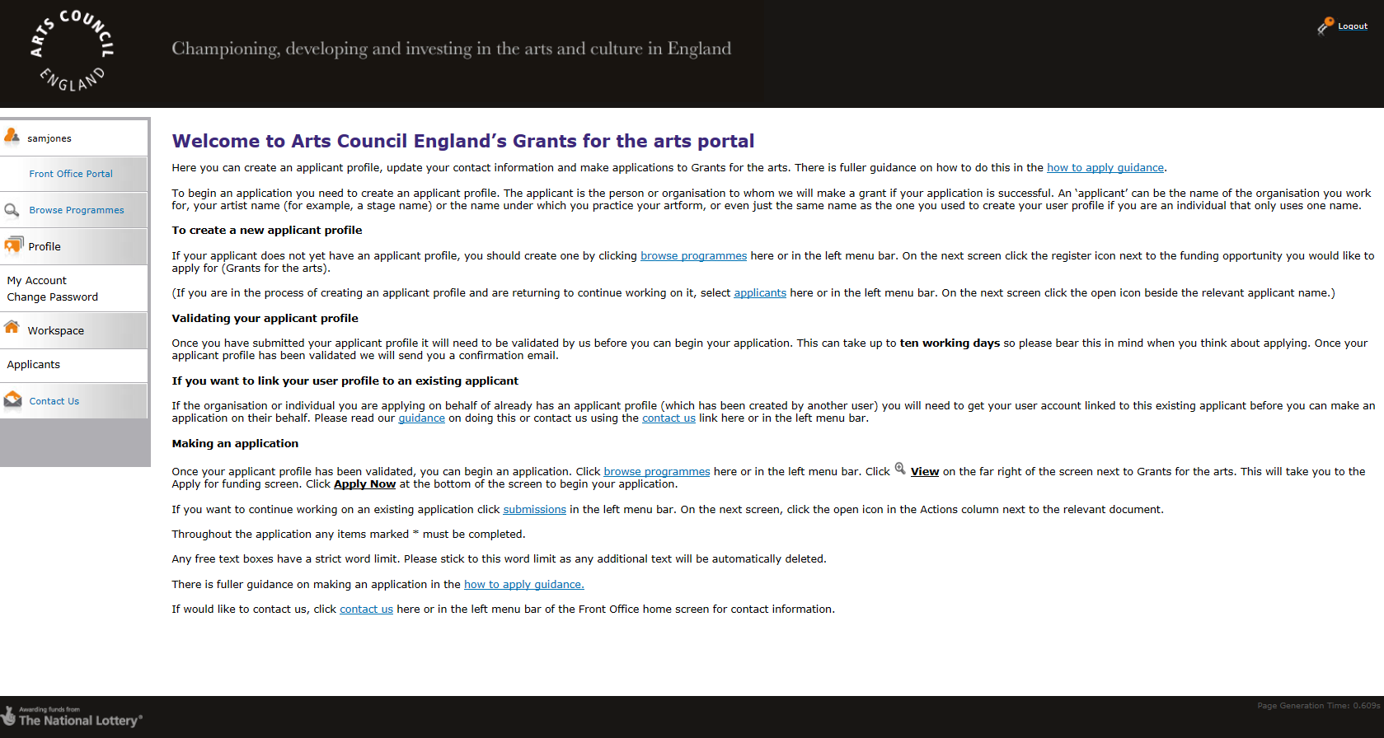
This is the same screen you will see every time you log in with your user name, which is displayed at the top of the navigation bar on the left hand side of the screen.

To create an applicant, click Browse Programmes in the left menu bar.

This screen will then appear:
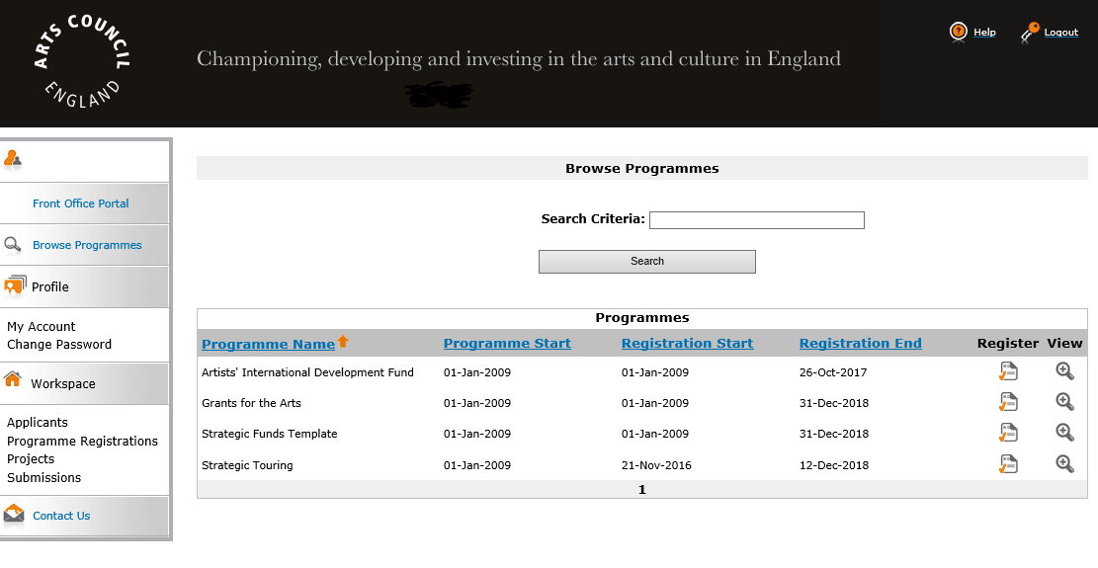
Click the Register icon on this screen.

The next screen you will see is the Applicant Details screen:
Select your Applicant Type (either organisation or individual) from the dropdown.

(For more information on deciding whether your applicant is an individual or an organisation please see section 5 of this guidance)

Enter the name of your applicant when the field appears:

The applicant name should be the legal name of the individual artist or organisation:

- If you are creating a profile for yourself as an individual, the applicant name should be your own real name

- If you are creating a profile for an organisation that you represent, the applicant name should be the legal name of the organisation

The applicant name must also correspond to a bank account in the same name. For more information please read our bank details guidance.

Click Save & Next to proceed.

5. How do I know whether to create an individual or organisation applicant?

Individuals:
Individual applicants might be:
- artists, musicians, writers, performers
- promoters, producers
- curators, directors
- groups of people who are not part of an organisation (one person will need to take the lead and have the main responsibility for managing the application and any grant)
- sole traders, whose business bank account names must include their business names (eg ‘Arts Club’, or ‘John Smith T/A [trading as] Arts Club’)

These applicants should create an individual applicant.

Organisations:
Types of organisations might be:
- arts organisations
- local authority and other public organisations such as library services and museum services
- regional and national organisations
- organisations whose normal activity is not related to the arts, including voluntary and community groups, sole traders (whose business bank account names must include their business names, eg ‘Arts Club’, or ‘John Smith T/A [trading as] Arts Club’)
By ‘organisation’ we mean a single group of people working towards a shared or common goal, with a governing document in place to support its work. Organisations can take many forms, for example a limited company, a charity or an unincorporated group.
If you create an organisation applicant, you must have:
- a bank account in the organisation’s exact name with two signatories (unless you operate a business as a sole trader and then we can sometimes accept an account with a single signatory). You can find out more about our bank details requirements in the bank details guidance, on our website.
- a governing document, which we will request when you submit your applicant profile to us. Please read our information sheet on Governing documents for more information.
Applicants who meet these requirements should create an organisational applicant.

6. Accounts and applicant profiles

6.1 Individuals
There is one key rule to remember when creating an individual applicant profile:

Your individual applicant profile should always be in the same name as your user account.

When we receive a new individual applicant profile to validate, we check that the name on your applicant profile is the same as the name you used to set up your user account. We are generally not able to validate applicant profiles for individuals where the user account and the applicant profile are under different names.

This is because we would not expect individuals to make applications on behalf of another individual, and because the signatory accepting any individual grant must match the name of the individual we are making a grant to.

Example – an individual profile

Simon Dale is an individual artist who would like to make a grant application. He has not applied using Grantium before.
He creates a user account in his own name (green circle in the diagram below) which gives him access to the system.
He then creates an applicant profile in the name of Simon Dale (yellow square). He submits his profile for validation.

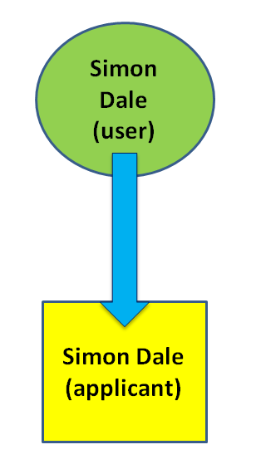
After the applicant profile is validated by the Arts Council, Simon can make applications and, if successful, manage any grants via the system. If he changes his address or any contact details, he can amend these in his applicant profile.

Sometimes, individual applicants may want other users to work jointly with them on writing an application; for example, a producer or consultant may work with the individual on their application. The following example shows how this should be done.

Example – an individual who wants to allow another user to jointly work on an application

Simon Dale is an individual artist who would like to make a grant application with the assistance of producer Emma Roberts.

Simon would need to go through the process in the example above to create his user account and an applicant profile in his own name.
Once Simon has had his applicant profile validated, he can give Emma access to his applicant profile. She can then help fill in the application form.
Simon should submit the application form so the name on the form will match the name on the profile.
Please seesection 11 of this guidance on how to link or unlink another user from an applicant profile for more information.

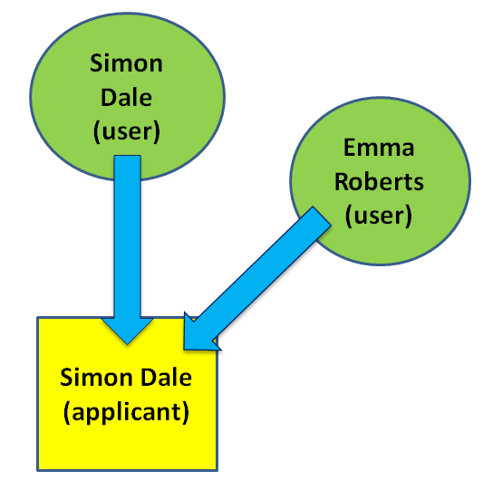
It is important to note that when Simon gives Emma access to his applicant profile, she will have access to all information he has stored there. This includes his contact details, any previous applications and any previous submitted conditions.

After Emma has helped complete the application form, Simon can remove her access from his profile (see 11.2 How to unlink a user).

We generally cannot validate applicant profiles where the applicant name is different to the name of the user who submitted the profile. This is because we would not expect individuals to make applications on behalf of another individual.

Example – an individual applicant profile we wouldn’t be able to validate

Emma Roberts wants to create a profile for Simon Dale, who is an individual.

Emma Roberts has created a user account in her own name (green circle in the diagram below).
She then created an applicant profile in the name of Simon Dale, who she is working with (yellow square).
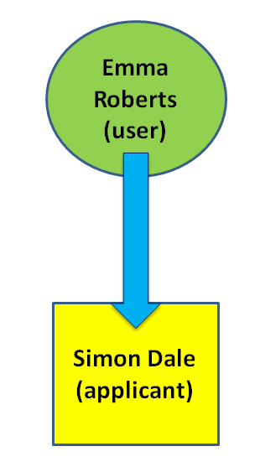
We would not validate this profile as Simon would need to create his own applicant profile – Emma does not have authority to create his applicant profile the only time this would be allowed was if Emma has Power of Attorney from Simon).

Please see section 7, Step by step: Creating an applicant profile (individual), for more detail on creating an applicant profile.

6.2 Organisations
This is an example of how an organisation would set their applicant profile up on Grantium. If you are a university or local authority, please refer to the next section.

Example – an organisation profile

Amy Shah is the Chief Executive of the National Puppet Theatre Company. She wants to set up the organisation’s applicant profile.

Amy creates a user account in her own name which gives her access to the system (represented by green circle in the diagram below).
She then creates an applicant called National Puppet Theatre Company (yellow square).
Amy must ensure she has the delegated authority within the organisation to create an applicant profile on behalf of that organisation.

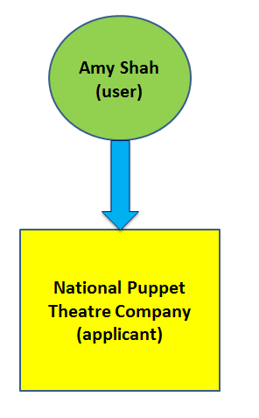

After the applicant profile is validated by the Arts Council, Amy can make applications on behalf of National Puppet Theatre Company and if successful, manage their grants via the system. If the organisation changes address or any contact details, she can amend these in the applicant profile.

Organisations may wish to have more than one user connected to their applicant profile; if only one user account is linked to your organisation’s applicant profile this may cause problems accessing your profile at a later date if they are not available or leave the organisation. We would recommend that only two members of staff have user accounts at any one time. One should be the person who writes applications and manages the administration of the grants. The other should be the person who has the authority to accept a grant offer, normally a chief executive or equivalent.

Example – adding a second user to an organisation applicant profile

With the above in mind, Amy asks her General Manager, Richard, to work on an application with her in Grantium.

For Richard to have access to the National Puppet Theatre Company applicant profile, he must set up his own user account to gain access to the system.

Once his has done this, he must let Amy know his user name and email address.

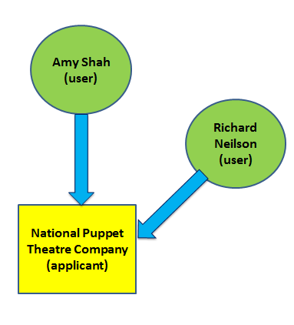
With this information she can link him as a user to the organisation’s applicant profile, as shown in the diagram below. Please see the section of this guidance on how to add and remove another user from an applicant profile for more information.

Both Amy and Richard now have access to all the information stored within the National Puppet Theatre Company’s applicant profile – this would include any previous applications made by the applicant as well as any monitoring information submitted to meet any payments.

Please see section 8, Step by step: Creating an applicant profile (organisation), for more detail on creating an applicant profile.

6. 3 Universities and
Organisations such as universities and local authorities contain many departments where their work may not necessarily cross over. In many cases departments are also often split across different sites and therefore may not be aware of other departments making applications to us.

We recommend that departments of universities and local authorities set up their own separate applicant profiles.

Example

Birchester City Council has three departments who are going to make applications to Arts Council England: the Museums department, the Culture department and the Music Services department.

Each of the heads of those departments must set up their own user accounts, and create an applicant profile for their own department.

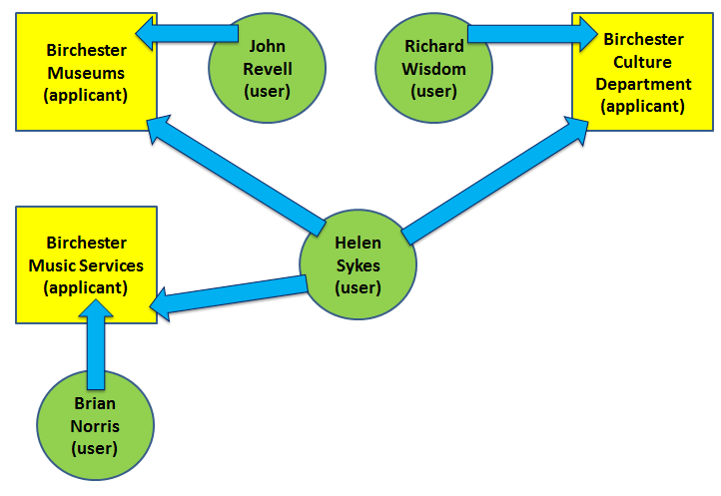

Brian Norris, Head of Music Services, sets himself up as a user. He is then prompted to create an organisational applicant profile, which he calls Birchester Music Services. After the applicant profile is validated by the Arts Council, Brian can make applications and if successful, manage grants via the system.

The heads of the Museums department and the Culture department go through the same process of setting up their own a user accounts, and then their department’s organisational applicant profile (see diagram).

As a local authority is defined as a type of organisation, only the staff member with the correct delegated authority can accept a grant on behalf of that organisation. Therefore, in this example, the Chief Finance Officer (Helen Sykes) must also set herself up as a user.

Once she has done this, she must let each of the Heads of Departments know her user name and email address. With this information, they can then link her as a user to each of their departments, as shown in the diagram opposite. Step by step guidance on how to link and unlink a user can be found in section 11 of this guidance.

Please see section 8, Step by step: Creating an applicant profile (organisation), for more detail on creating an applicant profile.

6.4 When a person works for more than one applicant

Many people in the arts and cultural sector will work for more than one applicant. This example will illustrate a person who is both an individual artist and someone that works for an organisation.

Example

Elaine Fernandez has two jobs. She works both as an independent musician as well as an Artistic Director for a classical music organisation. She applies to Arts Council England for grants as both an individual artists as well as on behalf of the music organisation she works for.

Elaine’s own applicant profile
She creates her user account (green circle in the diagram below) which gives her access to the system.

She then creates an applicant called Elaine Fernandez (yellow square).

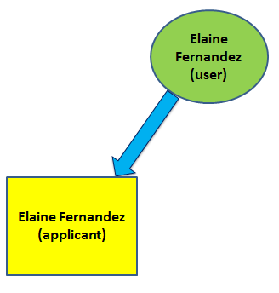

After the applicant profile is validated, Elaine can make applications as an individual and if successful, manage any grants via the system. If she changes her address or any contact details, she can amend these in her applicant profile.

A profile for the organisation Elaine works for
She also creates an organisation applicant profile for the organisation she works for: Treble Clef Company (as shown in the diagram below). She does not need to create another user account, only a new applicant profile.

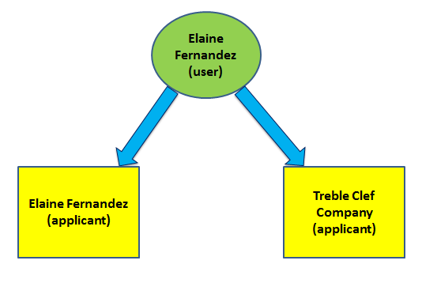
After the applicant profile for the organisation is validated, Elaine can make applications on behalf of that organisation and, if successful, manage any grants via the system. If she changes address or any of the contact details of the organisation, she can amend these in the organisation’s applicant profile.

Adding another user for Treble Clef Company
Elaine would also like her colleague at the Treble Clef Company to submit and manage grant applications. She asks her colleague, Thomas, to create a user account (the green circle).

Once he has done this, he must let Elaine know his user name and email address. With this information she can link him as a user to the Treble Clef Company applicant profile, as shown in the diagram below (step by step guidance on how to link and unlink a user can be found in section 11 of this guidance).

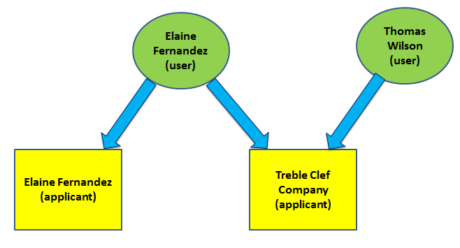

Therefore in this example, Elaine has both access to Elaine Fernandez (the individual applicant) and Treble Clef Company (the organisation applicant). Thomas only has access to the Treble Clef Company applicant.

Please see section 7 Step by step: Creating an applicant profile (individual) and section 8 Step by step: Creating an applicant profile (organisation) for more detail on creating an applicant profile.

7. Step by step: Creating an applicant profile (individual)

[For guidance on creating an applicant profile for an organisation, please see section 8 Step by step: Creating an applicant profile (organisation)]

In creating an applicant profile for yourself as an individual, you will be guided through the following screens:

- Applicant Details
- Address information
- Monitoring information
- Declaration
- Submission Summary

Any question marked with an asterisk (*) is a mandatory field. If at any point you need assistance, please don’t hesitate to contact our Customer services team. Click Contact Us in the navigation bar on the left of the screen to see contact details.

- Applicant details

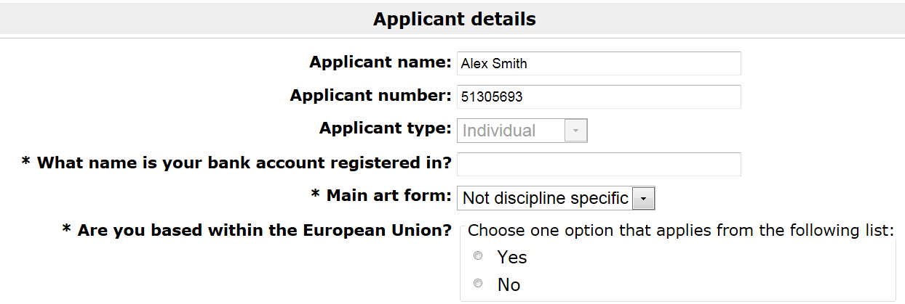

On this screen you need to tell us what name your bank account is registered in (this will usually be simply the same name as your applicant name for individuals, for example Alex Smith), the main artform you work in, and whether you are based in the EU.

(Please note, having your applicant profile validated does not mean that we accept your bank account name as a valid one for any grant you might receive in the future. Approval of bank details will only take place when a bank details form is submitted as condition of first payment on any grant.)
- Address information

This screen asks for basic contact information. Select the tick box and use the postcode search to find your address.

Fill in all the other fields marked with an asterisk and any other relevant fields.

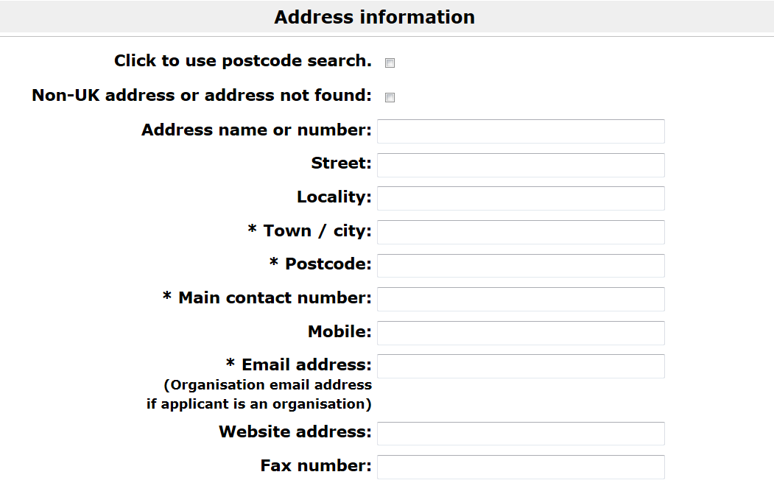

- Monitoring information

We may use this information to report to the Government or to monitor the different backgrounds of people who receive grants. We will not use this information to assess any applications you make. If you do not know some of the information or you would prefer not to provide it, you can fill in the ‘Not known/Prefer not to answer’ boxes.

- Declaration

Tick the box to confirm that you are the person whose applicant profile is being submitted (or in certain circumstances, their support worker – please see our information sheet Making Grants for the Arts accessible to all applicants for more information).

- Submission summary

The submission summary displays a list of all the steps you’ve worked through. If you have completed a step successfully, there will be a green tick beside it. If a step is incomplete or has not been completed successfully, this will be indicated by a red tick. A hyperlinked statement will tell you what part of each step needs attention. Click on this hyperlinked statement to take you to the step and make your amendments.

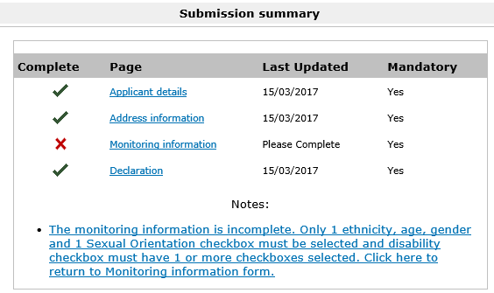

This example shows an applicant profile where the tickbox on the monitoring information screen hasn’t been selected, and so the user can’t proceed. The user can click on either the note itself or the monitoring information link, and can go back and correct this. They can then return to the submission summary screen and there will be a green tick beside monitoring information.

- Clicking Complete

By clicking Complete on the Submission Summary screen, you are submitting your applicant profile to us for validation.

We will aim to approve your profile within five working days. You will receive an email notification when this has been done.

Please note, you will not be able to start your application until your applicant profile has been validated.

8. Step by step: Creating an applicant (organisation)

In creating an applicant profile for which is an organisation, you will be guided through the following screens:

- Applicant details
- Address information
- Your contact information
  - Contact details
- Financial background
- Governance document attachments
  - Attachment details
- Monitoring information
- Declaration
- Submission summary

Any question marked with an asterisk is a mandatory field. If at any point you need assistance, please don’t hesitate to contact our Customer services team. Click Contact Us in the navigation bar on the left of the screen to see contact details.

- Applicant details

Complete all the fields marked with an asterisk, and all other relevant fields.

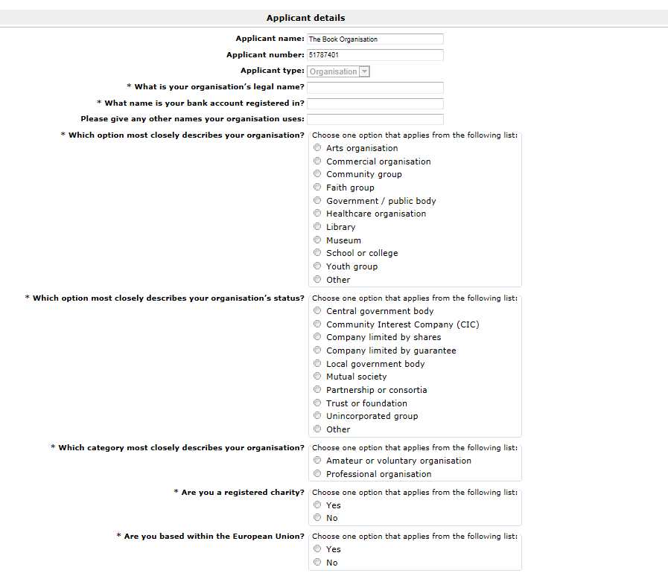

An important note on bank accounts:
If creating an applicant profile for an organisation, that organisation must have a bank account that:
- is in the exact name of your organisation
- has two signatories
This is usually a business bank account. We cannot make payments for a grant made to an organisation into an individual’s bank account.

If you apply as a group of people or as a group of organisations, we will only make payments to the named person or organisation taking the lead in making the application. The person or organisation who is taking the lead will be responsible for the grant.

(Please note, having your applicant profile validated does not mean that we accept your bank account name as a valid one for any grant you might receive in the future. Approval of bank details will only take place when a bank details form is submitted as condition of first payment on any grant.)

You can find out more about our requirements for bank details in the bank details guidance information sheet, available on our website.

- Address information

This screen asks for basic contact information.

Fill in all the other fields marked with an asterisk and any other relevant fields.

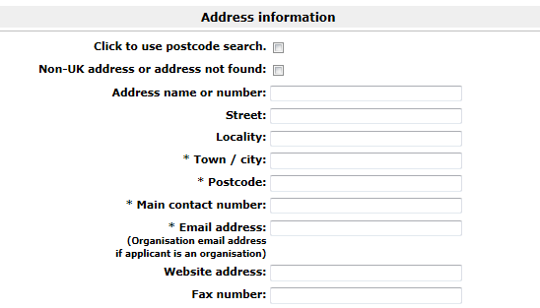

- Your contact information

You should enter the names and contact details of any key members of the organisation’s staff here. Please note: these contact details are for your organisation in general and are not specific to a single project.

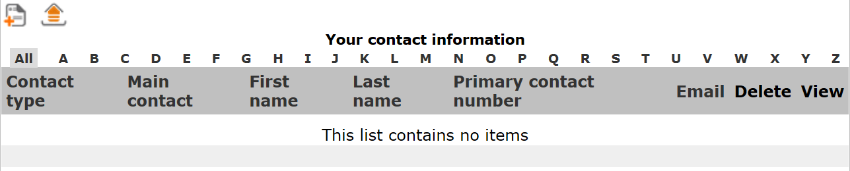
To add a contact, click the add icon . This opens up the contact details screen.

- Contact details

This screen allows you to add the details of any key members of staff at your organisation (such as Chief Executives, Finance Officers, Administrators, etc). You can add as many contacts as you think relevant.

One contact needs to have the checkbox ticked to signify that they are the main contact for this organisation.

An important note on the main contact:
In order to receive any notifications about applications and projects made using this applicant profile, the main contact also needs to have a user account. Their account must then be linked to this applicant. For guidance on how to do this, please read section 11.1 How to link a user to an applicant.

Please also note that any other contacts you list here will only receive notifications about the applicant’s projects if they have their own user accounts and have been linked to the applicant.
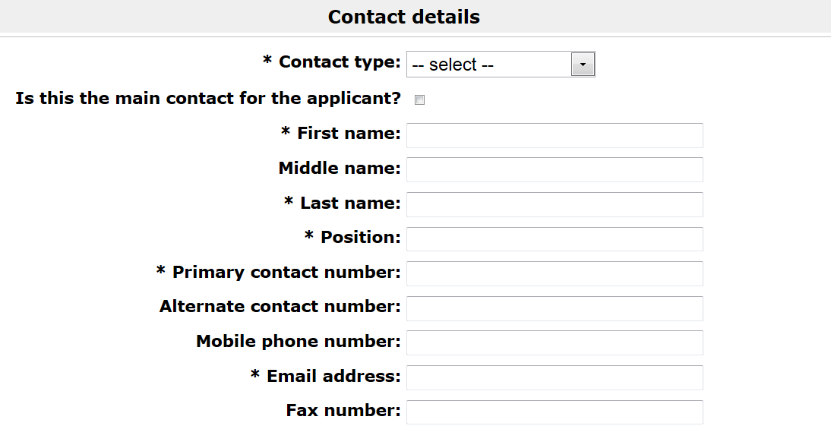

Complete the fields marked with an asterisk, and any other relevant fields.

- Financial background

Please make sure to enter your company number if you have told us that your organisation has a status where this is relevant. We may not be able to validate your profile within our published turnaround times if you do not provide this information accurately.

- Governance document attachments

On this screen, you need to attach a Governing document. All organisations making an application to us (including unincorporated groups) must have a written governing document in place (for example a constitution, set of rules or trust deed). Please read the information sheet Governing documents for more information about what we need to see.

To add your governing document, click on Click to add governance document and upload the file.

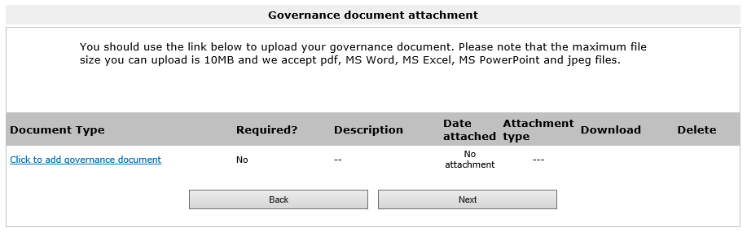

- Monitoring information

This screen asks you to enter a figure for the number of members in your senior management team and on your management committee, board, governing body or council. It then asks you to enter a figure for the number of members who make up each of our monitoring sections.

We may use this information to report to the Government or to monitor the different backgrounds of people who receive grants. We will not use this information to assess your application. If you do not know some of the information or you would prefer not to provide it, you can fill in the ‘Not known/Prefer not to answer’ box.

- Declaration

Please tick the box to confirm that you are authorised by the organisation named on the applicant profile to submit the information on its behalf and to create its applicant profile.
- Submission summary

The submission summary displays a list of all the steps you’ve worked through. If you have completed a step successfully, there will be a green tick beside it. If a step is incomplete or has not been completed successfully, this will be indicated by a red tick. A hyperlinked statement will tell you what part of each step needs attention. Click on this hyperlinked statement to take you to the step and make your amendments.

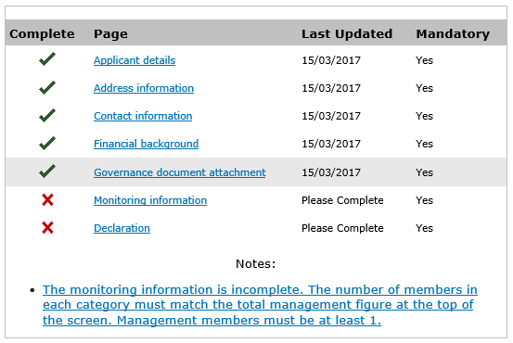

This example shows an applicant profile where there is missing information in several sections, and so the user can’t proceed. They can click on either the note itself or the section names, and can go back and correct this.

- Clicking Complete

By clicking Complete on the Submission Summary screen, you are submitting your applicant profile to us for validation.

We will aim to approve your profile within five working days. You will receive an email notification when this has been done.

Please note, you will not be able to start your application until your applicant profile has been validated.

9. Navigating your user account

Once you have an account in Grantium, you can manage all the applications you have made with Arts Council England from that account since 27 January 2016. If you do not yet have an account, please see section 3 Creating a user account.

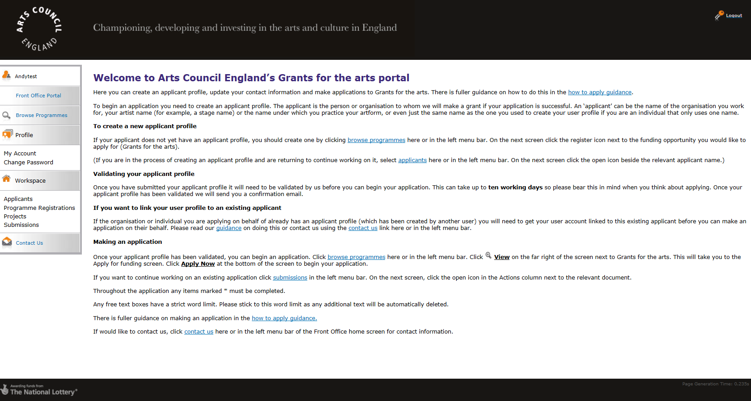
When you log in with your account details, you will see a screen that looks like this:

This is the landing page for your account.

As well as providing you with some information, there is a navigation pane on the left of the screen. You will navigate your account via this navigation pane. This is what it looks like up close:

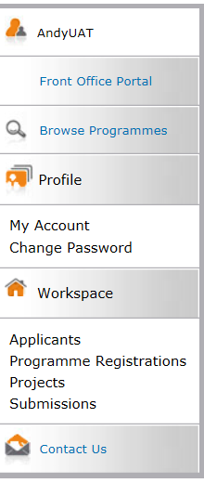
Your username

Lists all programmes currently open for applications

Change the password for your account
Your account details

The various headings found in the Workspace section will be explored in the guidance below

Opens up a new window containing all Arts Council England’s contact details

The Workspace section

The headings in the Workspace section are how you will manage any projects or grants you have with Arts Council England. The headings are:

Applicants
Programme registrations
Projects
Submissions

Applicants

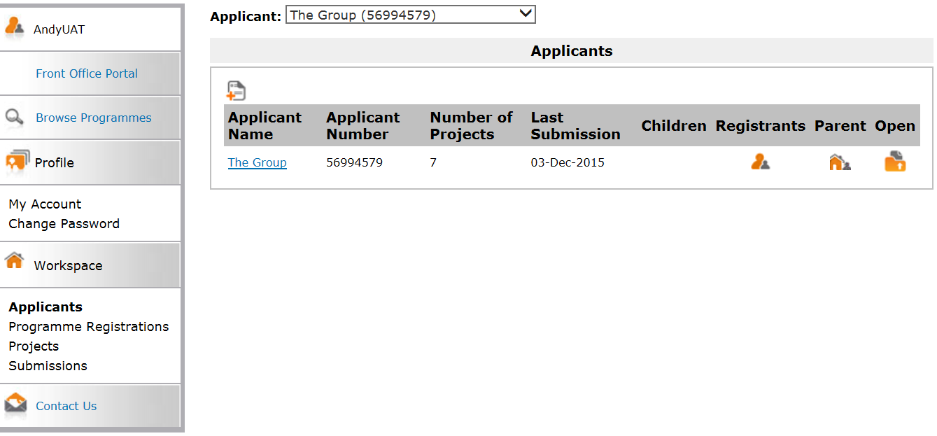
Applicants shows all the applicants you are linked to.
The screen will only show one applicant at a time. If you are linked to multiple applicants, you can select the one you want to view from the dropdown at the top of the screen.

For help in creating an applicant, please read section 4 Starting to create an applicant.

To view a list of the other users who are linked to this applicant, click the Registrants icon . If you want to link another user to this applicant, please read the How to link a user to an applicant section of this guidance.

The Parent icon will show you a list of other applicants which are linked with your applicant. This is an internal function for Arts Council England and is only really relevant to universities and local authorities.

To view the contact details of the applicant, click the Open icon . If you want to amend any of the contact details within, please read section 10 How to manage your contact details of this guidance.

Programme Registrations

Programme Registrations lists all the funding opportunities that are open for applications.
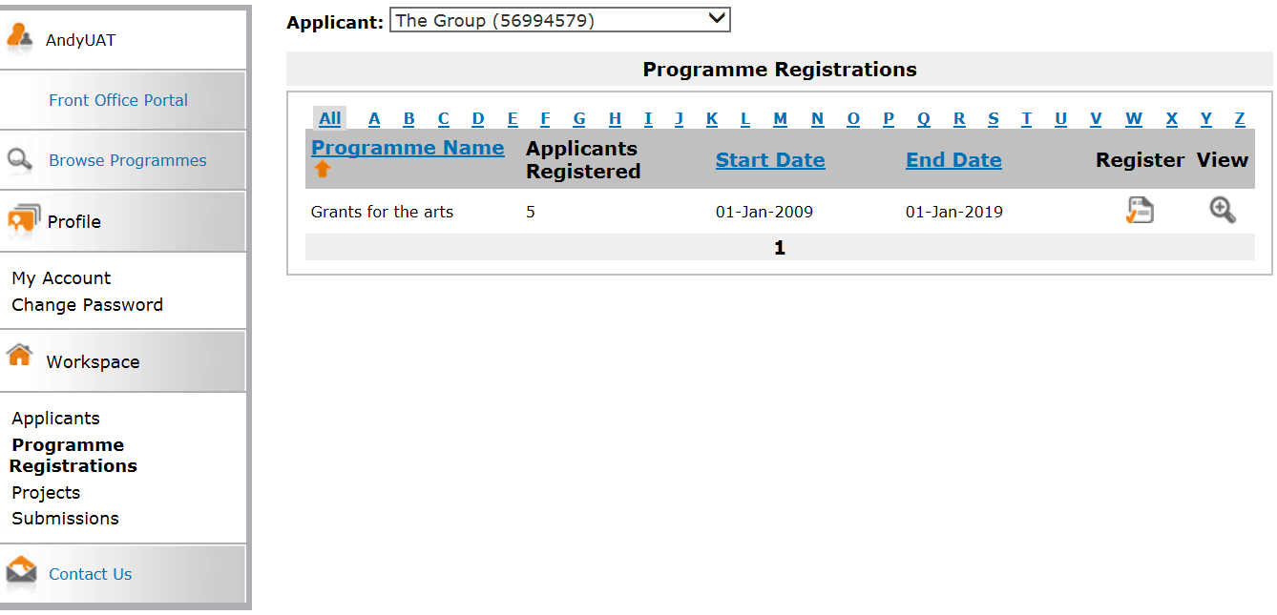
Again, this screen will only show details for one applicant at a time. If you are linked to multiple applicants, you can select the one you want to view from the dropdown at the top of the screen.

To register an applicant for a funding programme, first ensure you have the correct applicant selected, then click the Register icon . This will take you to a notification page which will let you know you have now registered your applicant for that funding programme. This means that you will be able to access the eligibility questionnaire and application form for that programme.

To find out more information about a funding programme, click the View icon on the relevant line. This will take you to a landing page with information about the selected funding programme. From this page, you can begin an application by clicking Apply Now.

Projects

Projects lists all the projects you have ever created on the system.
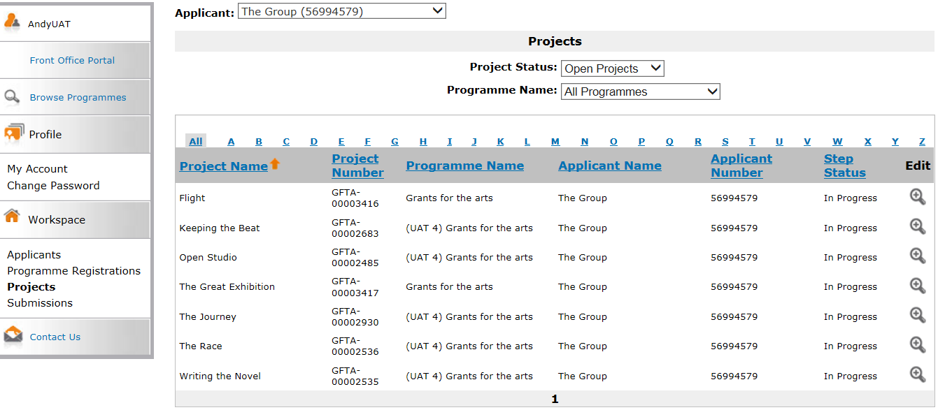
Again, this screen will only show details for one applicant at a time. If you are linked to multiple applicants, you can select the one you want to view from the dropdown at the top of the screen.

Use the filters to filter by open or closed projects, or by different programmes.

A note on naming your projects

The Projects screen can start to look confusing if you have a number of projects with similar names. If you request funding for an annual event which always has the same name, or if you have to resubmit an application for a project, please make sure the projects are named in a clear way that allows you to see the project you want to work on.

Submissions

Submissions lists everything you have submitted to us for each of your projects. This includes eligibility questionnaires, application forms, offer acceptances, payment requests and reports.
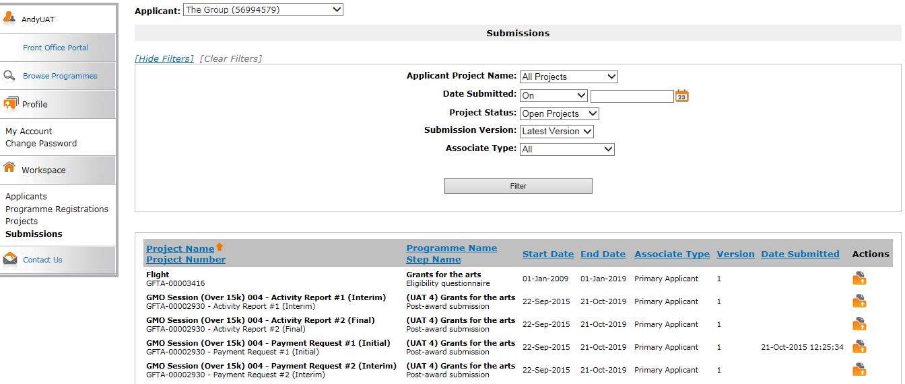
Again, this screen will only show details for one applicant at a time. If you are linked to multiple applicants, you can select the one you want to view from the dropdown at the top of the screen.

If you have a number of projects, it might be useful to use the filters to show the submissions relating to one specific project. To do this, select the relevant project from the dropdown and click Filter.

The Start Date and End Date shown on this screen relate to the programme itself and are not specific to your project so you can ignore these.

The Date Submitted shows you when a particular submission was completed and submitted to Arts Council England. If there is no date shown in this column, this means the submission still needs to be worked on and submitted.

To continue working on a submission, click the Open icon . This will take you directly into the submission where you can continue to work on it.

To view a submission that has already been completed, click the Open icon . This will take you directly into the submission. You will not be able to amend anything, but you will be able to click through it and review everything within it.

10. How to manage your contact details

By using the system to make an applicant profile and/or make an application, you are agreeing to keep your own contact details up to date by maintaining your Applicant profile. What you enter into the system is Arts Council England’s only record of your contact details so you need to update any changes yourself.

To make changes, log in to the system. Click Applicants in the navigation bar on the left side of the screen.

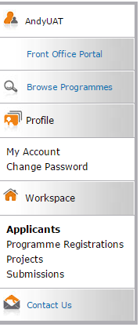

On the next screen, select the relevant applicant from the dropdown at the top of the screen:

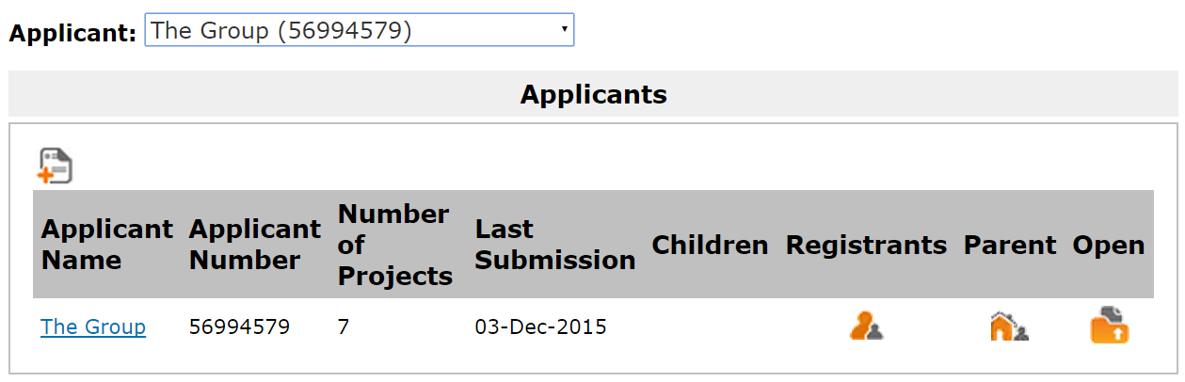

Next, click the Open icon .

The next screen is titled Applicant Details and is the first screen of your applicant profile. To make changes, you will first need to go to the Submission summary by clicking the link in the navigation bar on the left of the screen.

Please note, the sections listed in the navigation bar for organisation applicants will be different to the list for individual applicants, as shown below:

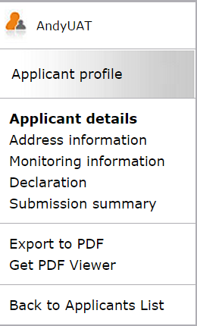
Organisation Individual
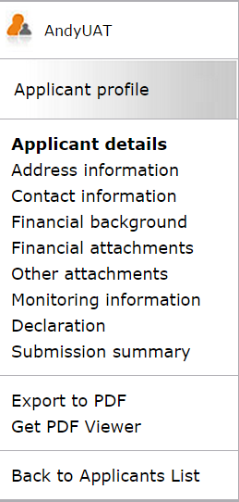
On the Submission summary screen, click Edit. This opens up all the sections of the applicant profile for editing:

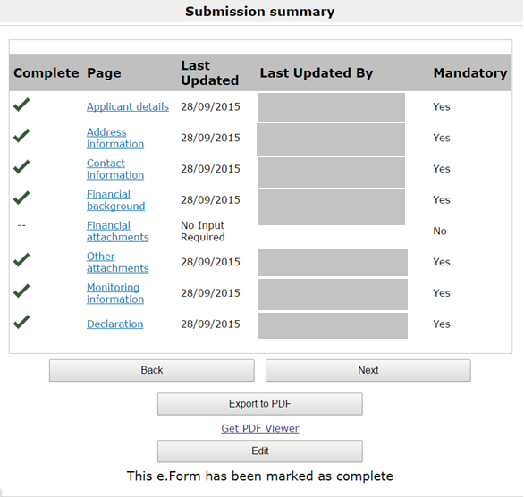

You will now be able to go into each section of the Applicant profile and make any changes you need to.

When you have finished making changes, return to the Submission summary:

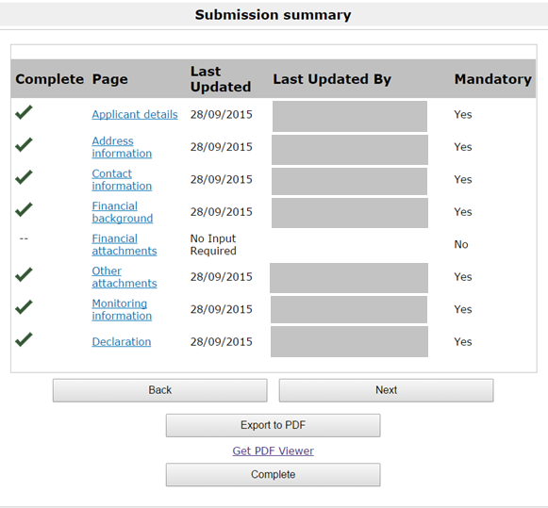

This time, click Complete to close off all sections of the form again and save any changes you have made.

This completes the process.

11. How to link or unlink a user to an applicant

Once you have created an applicant profile, you may want other users to have access to that applicant. There are a number of reasons why you would want to do this:

- you work on behalf of an organisation and there are several people within your organisation who want to be able to submit applications on its behalf

- you work at an organisation and are not authorised to accept grant offers. As such, your chief executive officer (or equivalent) would need an account and to be linked to the organisation profile

- you are working with a support worker and want the support worker to be able to work on your applications

- you are working with a consultant and want the consultant to be able to work on applications and to see all the information relating to your applicant

Each of these people would need to create an account for themselves. As the person who created the applicant in the first place, you would then have to find these users on Grantium and create a link between them and the applicant.

Example
Alex Smith
User
Sam Jones

The Book Organisation
Applicant

In this example Alex Smith creates an account. Alex then creates an applicant, The Book Organisation. Sam Jones is the CEO of The Book Organisation. Alex asks Sam to create an account. Once this is done, Alex finds Sam on the system and links Sam to The Book Organisation.

For an organisation, we would recommend that two members of staff have user accounts. One should be the person who writes applications and manages grants. The other should be the person with the authority to accept a grant offer, normally a chief executive or equivalent.

11.1 How to link a user to an applicant

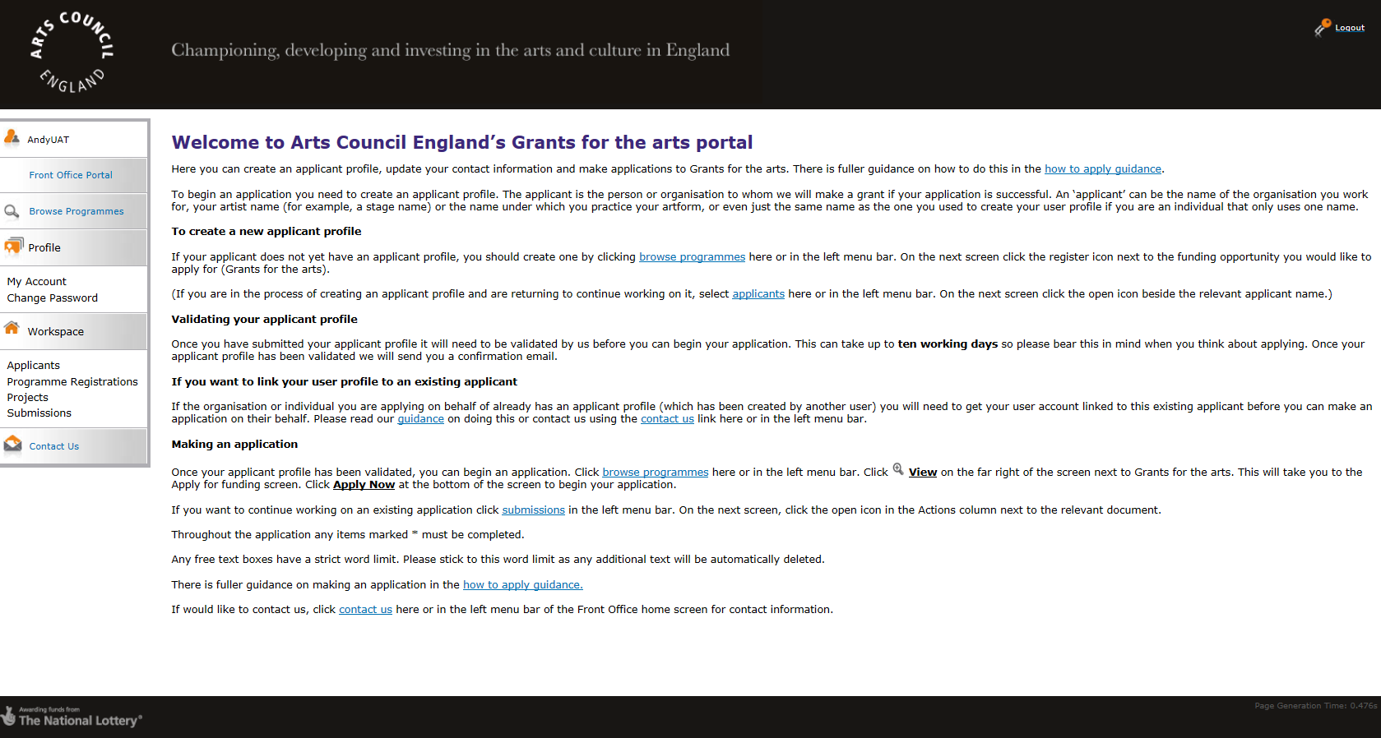
Log in with your account details. You will land here:
Click Applicants in the left menu bar. This screen will then appear:
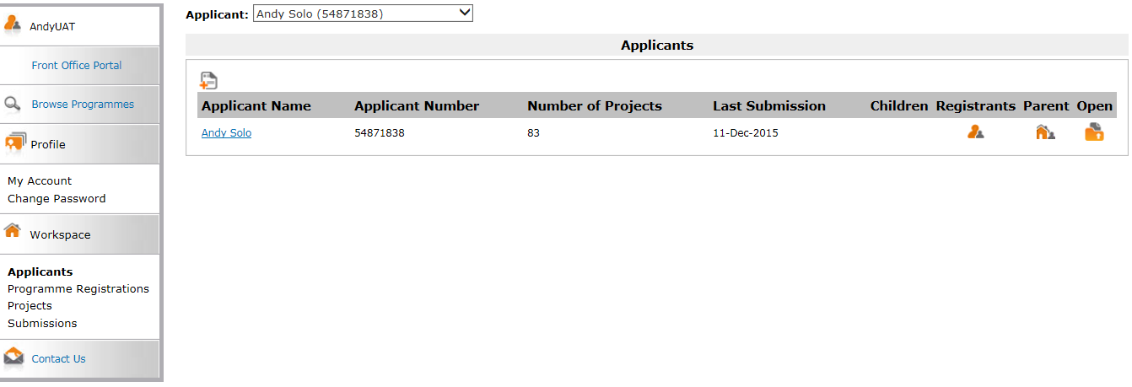
If your user account is already linked to a number of different applicants, you will need to select the right one from the dropdown at the top of the screen. If you only have one applicant so far, it will automatically be shown.

Click the Registrants icon .

(A registrant is a name for users who have access to an applicant.)

The next screen to appear is this Applicant Details screen:
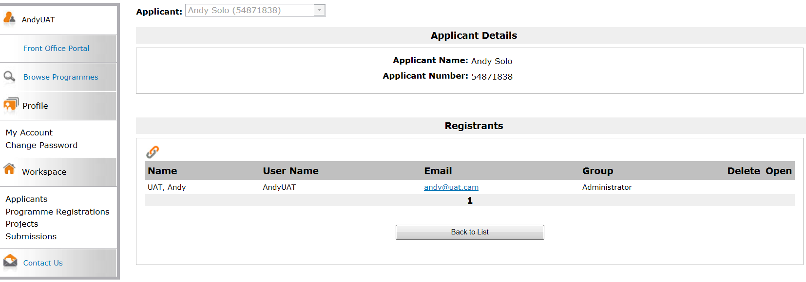
This screen shows you all the users who are linked the applicant, listed in a section called Registrants. At first, you should be the only one. To link another user, click the Link icon .

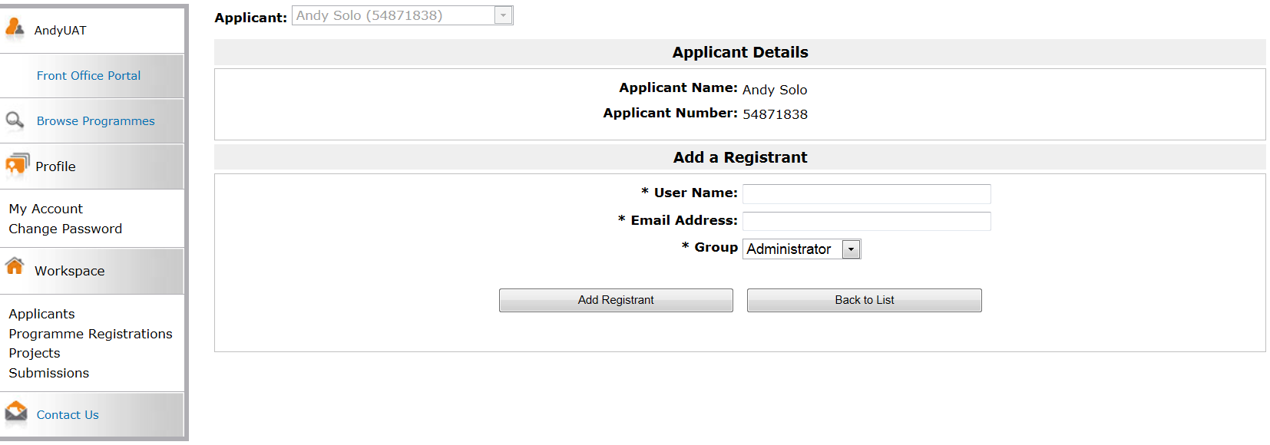
This opens a search function. Enter the user name and email address of the user you want to add. Under Group, you have two options available from the dropdown: Administrator and Standard User.

The functions of the two roles are the same except that an Administrator can link and unlink other users to an applicant and a Standard User cannot.

You should decide which role to give any registrants. These can be amended at any time. Guidance for this can be found in section 11.3 Amending user rights.

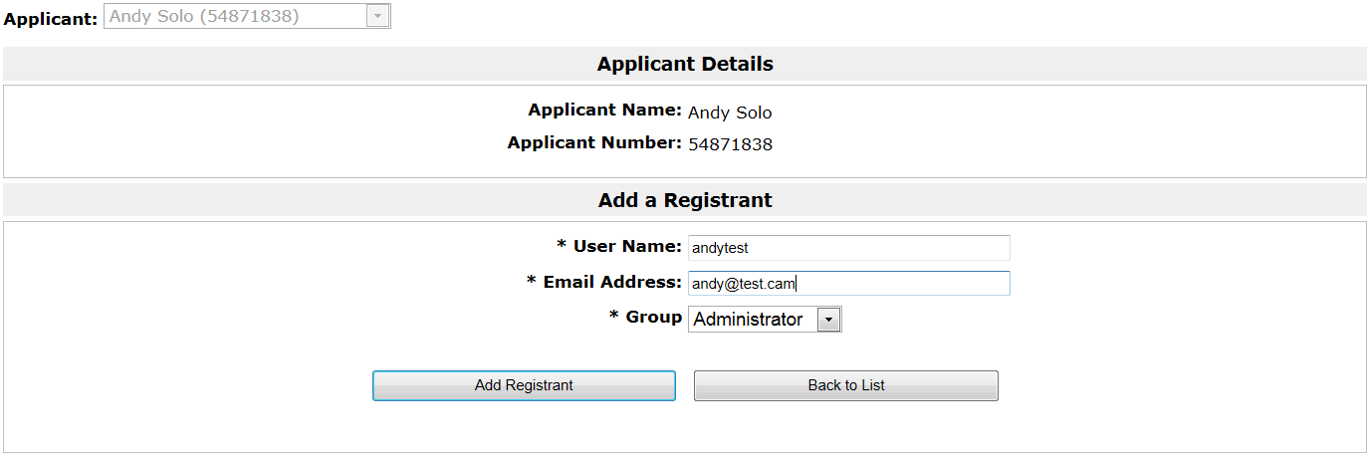
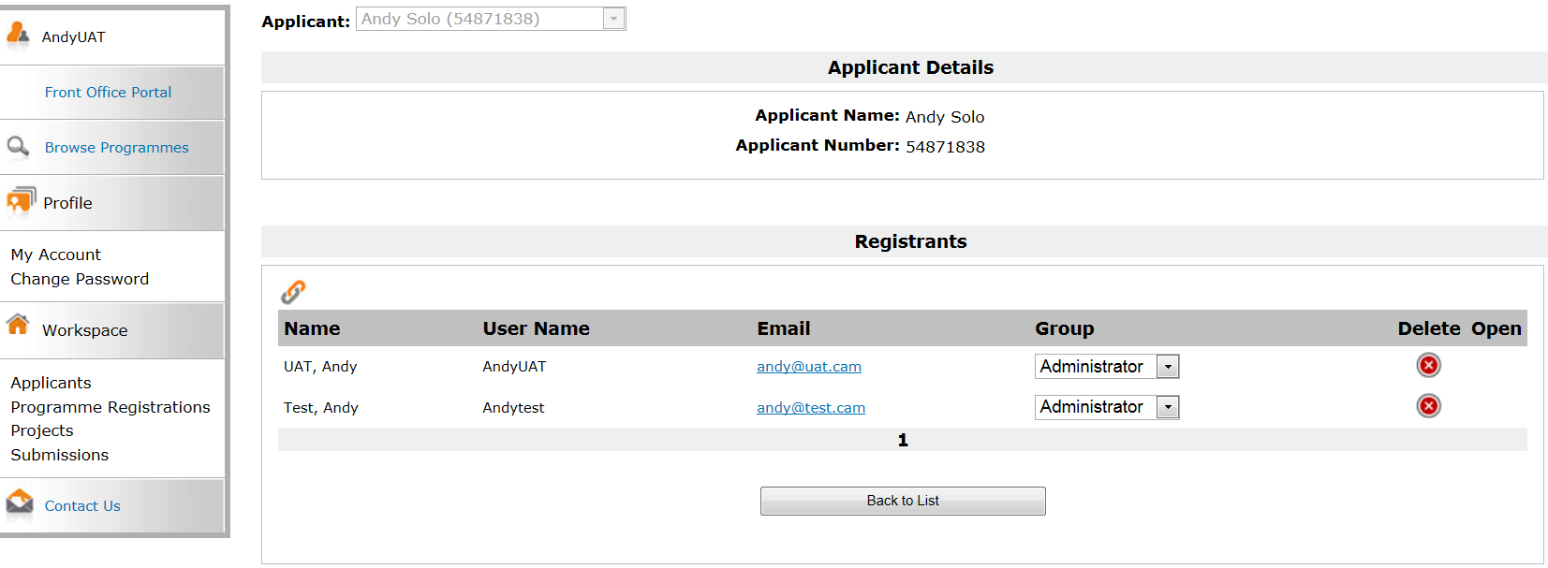
When you have entered the details of the user you want to add (who must have their own user account), click Add Registrant.

On the Applicant Details screen, you will now see the person you have just added listed as a registrant alongside yourself.

This completes the process.

11.2 How to unlink a user from an applicant

Log in with your account details. You will see this screen:
Click Applicants in the left menu bar. This screen will then appear:

If your user account is already linked to a number of different applicants, you will need to select the right one from the dropdown at the top of the screen. If you only have one applicant so far, it will automatically be shown.

Click the Registrants icon .

On the Applicant Details screen, you will now see all the users linked as registrants. To remove one, click the Delete icon .

A question box will come up.

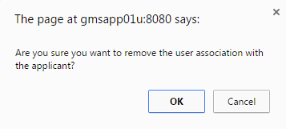

Click OK.

This completes the process.

11.3 Amending user rights

Log in with your user account details. You will land here:

Click Applicants in the left menu bar. This screen will then appear:

Click the Registrants icon .

The next screen to appear is this Applicant Details screen:

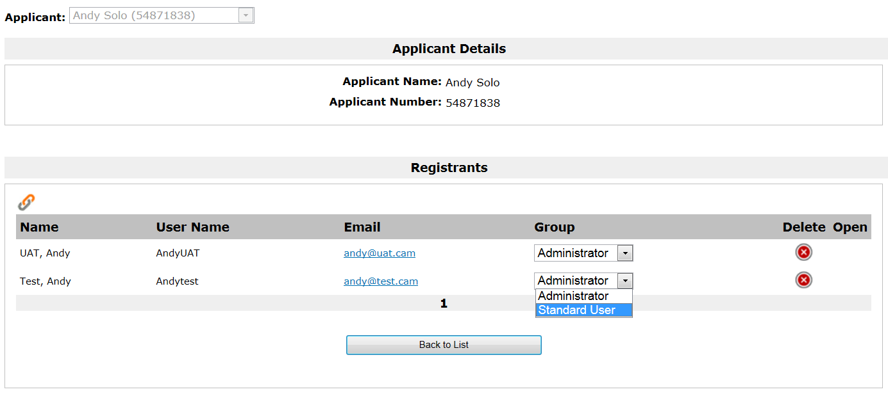
In the Group column, choose the relevant role from the dropdown, beside the relevant user.

A question box will come up.

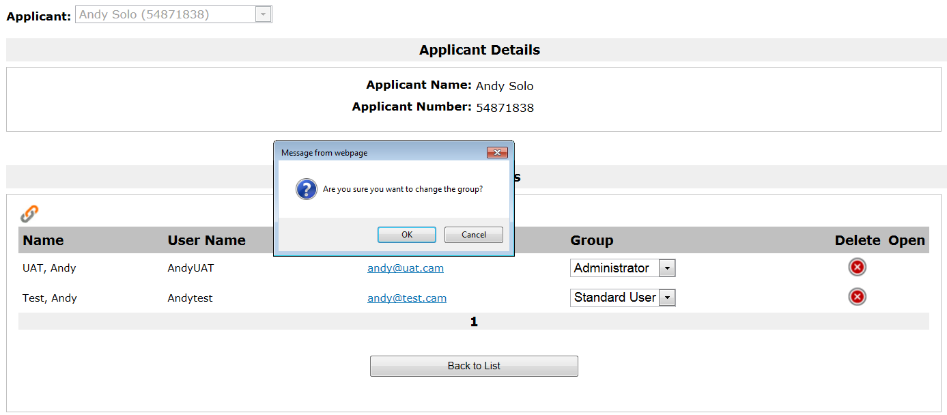
Click OK.

This completes the process.

12. FAQs

I forgot my user name – what can I do to get it? | Please contact Customer Services (details below)
I forgot my password – what can I do to get it? | Click on ‘Forgot your password?’ on the log on screen. You will be prompted to enter your email address. Details will be emailed to you about how to access your account.
What are the implications of giving another user access to my applicant profile? | Any user given access to an applicant profile will have access to all information stored there. This includes contact details, any previous applications and any previously submitted conditions. They will also be able to write and submit applications, and request payments and submit conditions due on any open grant (though we may not be able to accept these submissions if the user is not authorised to submit them). For more information please see our webpage Before you begin.

13. Further information and support

If you have any questions about the information contained in this document or require some assistance, please contact our Customer Services team on:

Phone: 0845 300 6200, 0161 934 4317
Textphone: 020 7973 6564
Email: enquiries@artscouncil.org.uk
Website: www.artscouncil.org.uk

