

**Grantium guidance for applicants**

*How to acknowledge a decision*

*Version 1 – January 2016*

When a decision has been reached about your application, you will receive an email notification. This will be delivered to the email address you entered when you created your account and will appear like this:

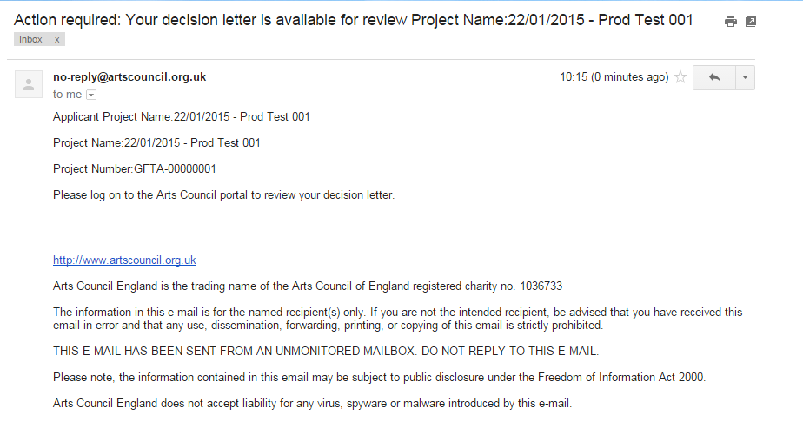

Once you have received your notification, you need to log into the system using your account details.

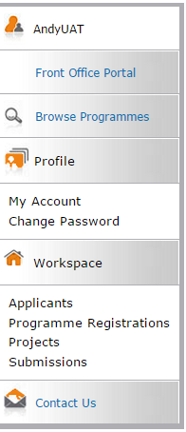

Once you have logged in, click **Submissions** in the navigation bar on the left of the screen.

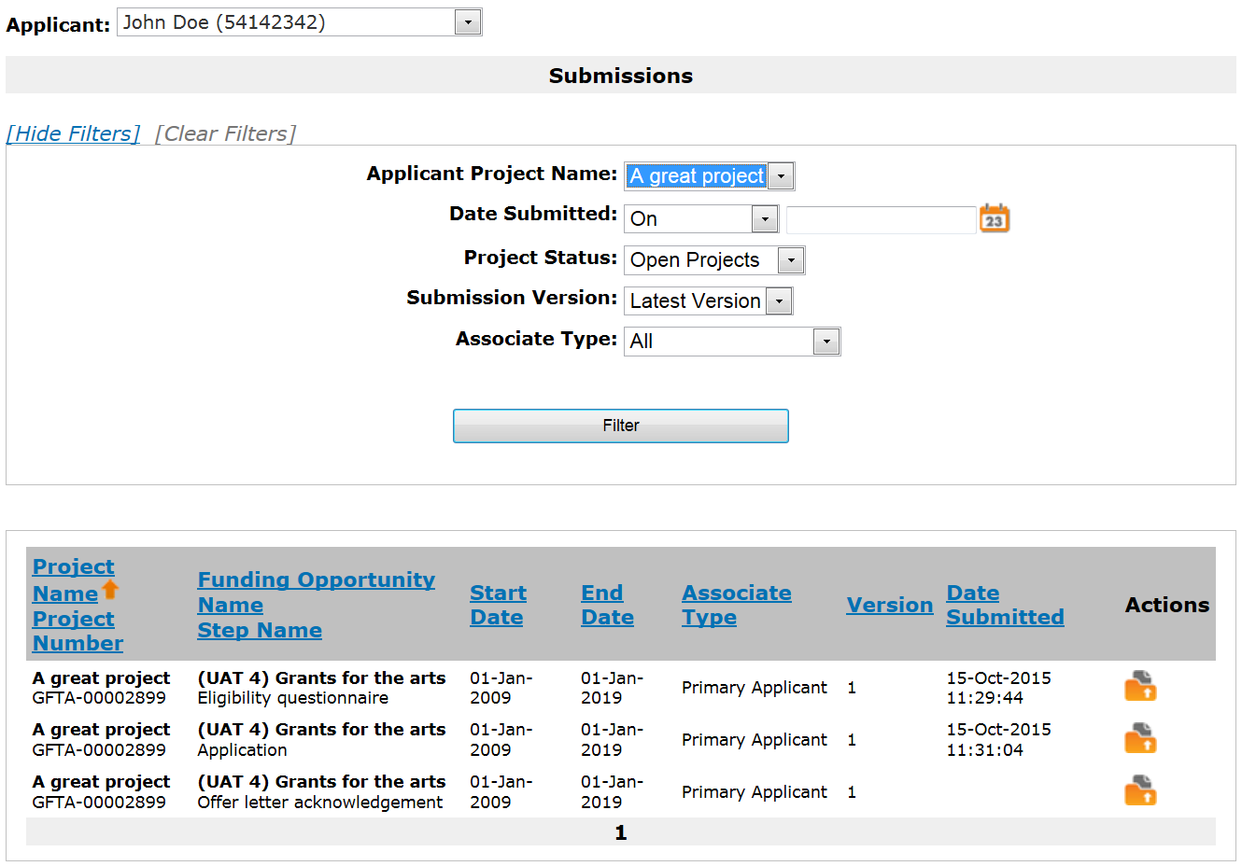Select the relevant applicant from the dropdown at the top of the **Submissions** screen and use the filters to select the relevant project.





Listed here, you will see the **Eligibility questionnaire** and **Application** that you submitted. You will also see a new item which will either be titled **Offer letter acknowledgement** or **Decision letter**, depending on the decision made on your application.

Click the **open** icon  to view the letter.

**If your application was successful**

If your application was successful, you will see an **Offer letter acknowledgement**.

Click the **open** icon  to view the letter.

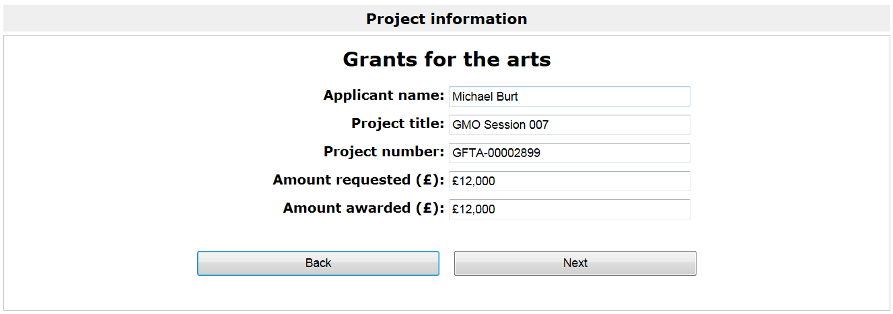The first screen is the **Project information** screen. This gives some basic details about the project. There is nothing on this screen that requires action.



Click **Next** to proceed.

If your application was for more than £15,000, your application will have been appraised and the next screen will be the **Appraisal** screen. If you applied for less than £15,000, your application will have gone through the risk check process and the next screen you will see is the **Offer Letter** screen. Please turn to page 7 for guidance on this screen.

On the **Appraisal** screen you will see how your application was scored and the comments the appraiser made.

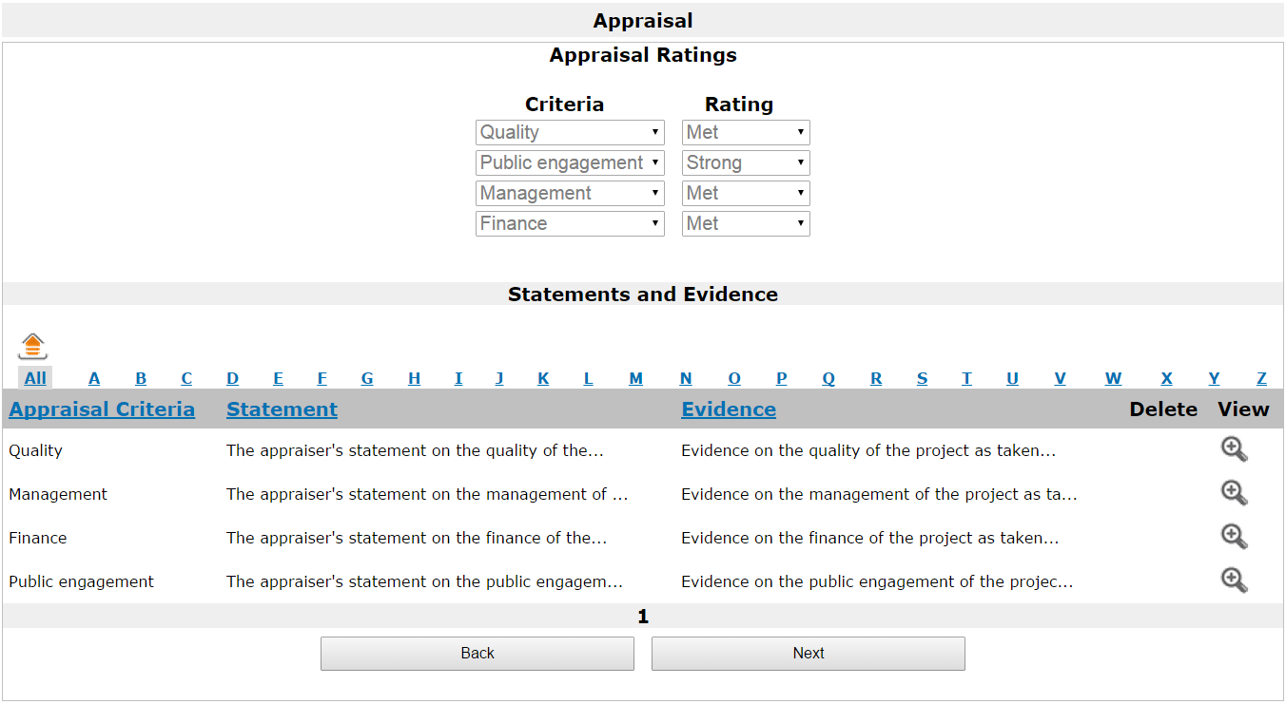

At the top of this screen, the **Appraisal Ratings** section shows the rating against each of the criteria: Quality, Public engagement, Management and Finance. The ratings can be Outstanding, Strong, Met, Potential or Not met.

In the **Statements and Evidence** section, you can see the appraiser’s statements against each of the appraisal criteria and the evidence this statement is based on. To read these in full, click the **View** icon on the relevant line.

This opens up the **Statements** screen where you can read the statements in full.

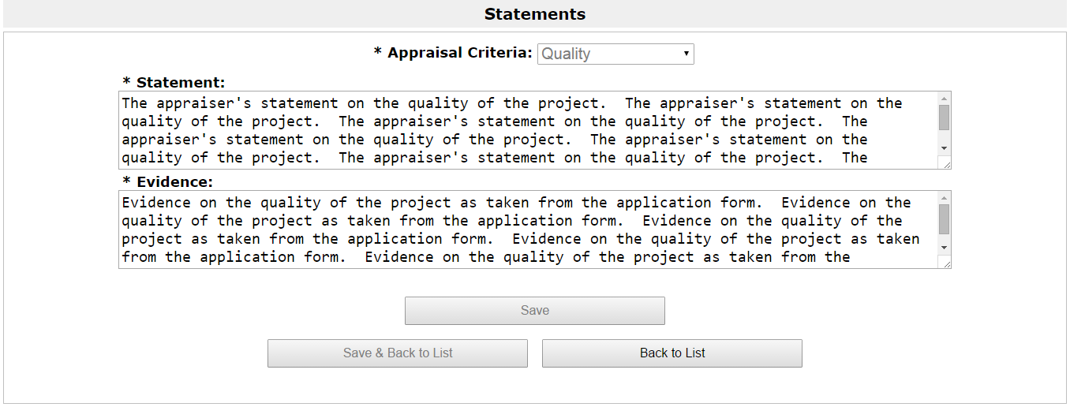

To return to the **Appraisal screen**, click **Back to List**.

For more information about the appraisal process, please see our information sheet ‘[Appraisal process for Grants for the arts’](http://www.artscouncil.org.uk/funding/grants-arts/2016/information-sheets).

When you are ready to move on from the **Appraisal** screen, click **Next**.

The next screen is the **Offer letter** itself. The offer letter contains details of your project including payment dates and conditions.

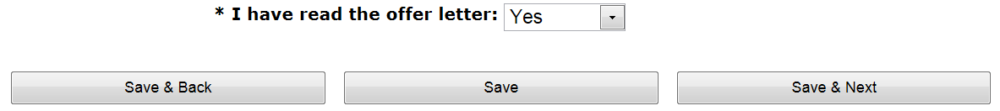

Once you have read the letter, confirm that you have done so by selecting **Yes** from the dropdown at the bottom of the screen.

Click **Save & Next** to proceed.

The next screen is the **Attachments** screen. From this screen you can download our **Bank details** form and our standard **Terms and conditions** for grants.

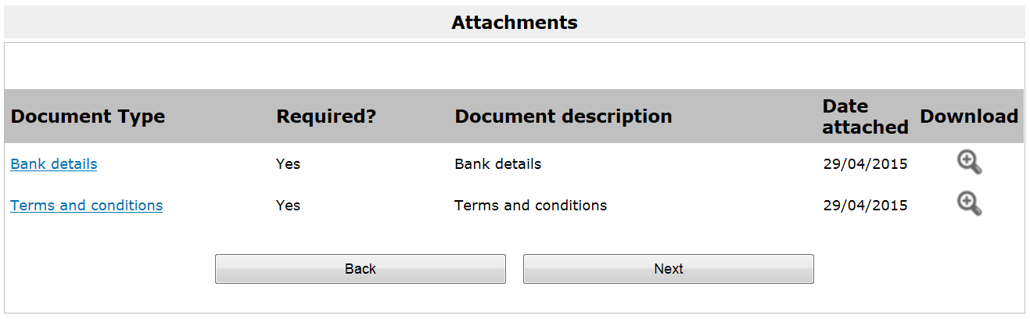

Please read the **Terms and** conditions.

The **Bank details** form should be printed and completed in hardcopy and returned to:

Grant Management  
Arts Council England  
The Hive  
49 Lever Street  
Manchester  
M1 1FN

Click **Next** to continue.

The next screen is the **Acknowledgement** screen on which you confirm acceptance of the offered grant and grant conditions. This screen will look different depending on whether you are an **individual** or an **organisation**.

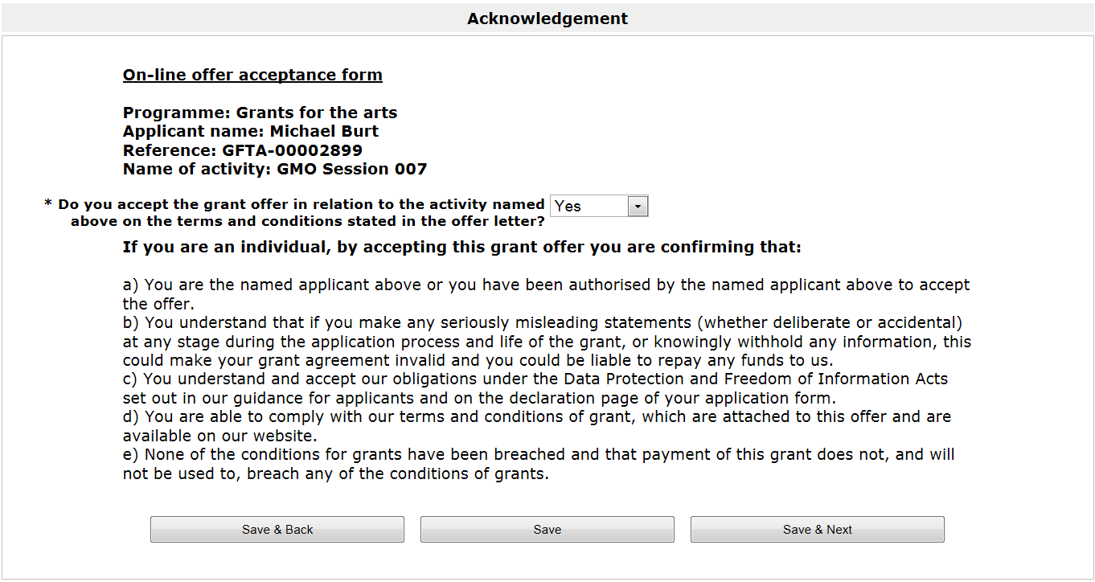**As an individual**, the **Acknowledgement** screen will look like this:

Select **Yes** from the dropdown and click **Save & Next** to proceed.

**As an organisation**, the **Acknowledgement** screen will look like this:

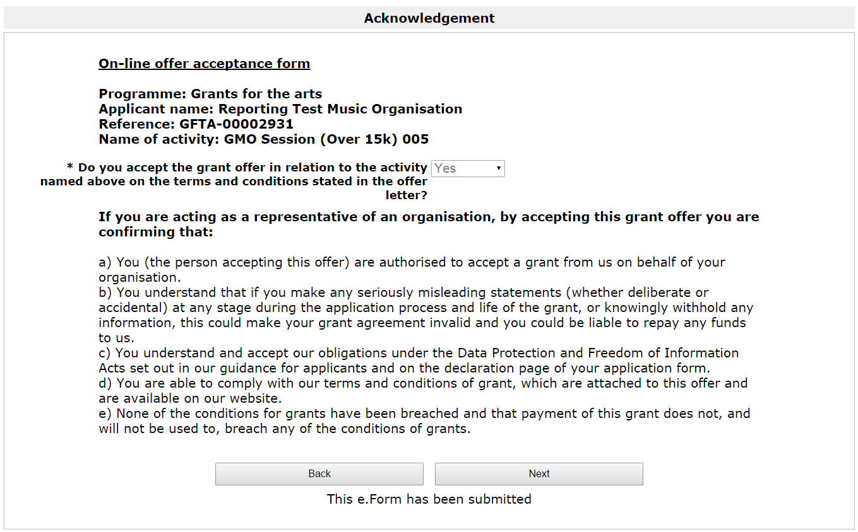

Select **Yes** from the dropdown and click **Save & Next** to proceed.

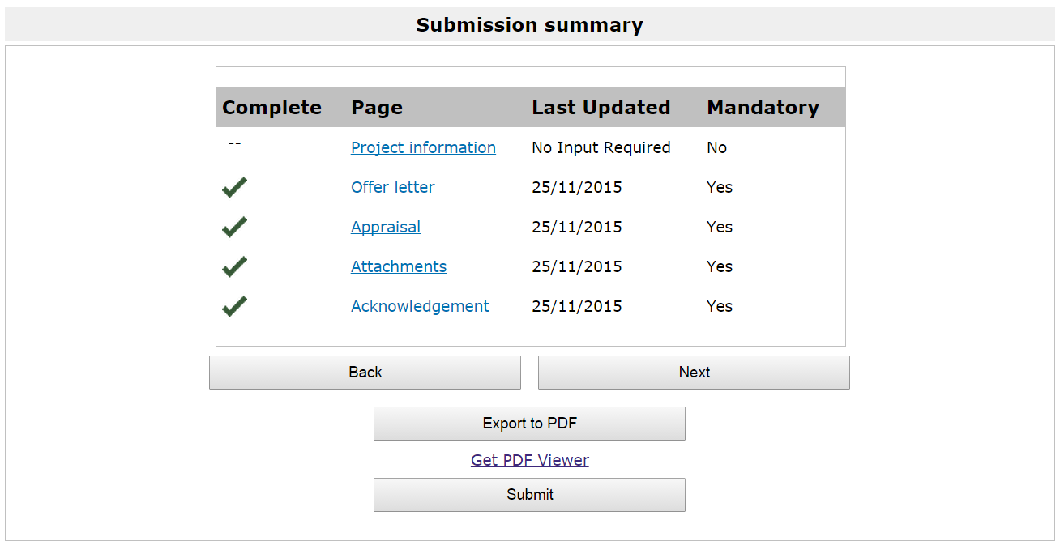

On the **Submission summary** screen, click **Submit** to complete the process.

Claiming your first grant payment from us involves an additional process. Please refer to our guidance sheet ‘[How to claim a payment](http://www.artscouncil.org.uk/funding/our-application-portal/post-decision-support)’ for guidance on doing this.

**If your application was not successful**

If your application was not successful, you will see a **Decision letter**.

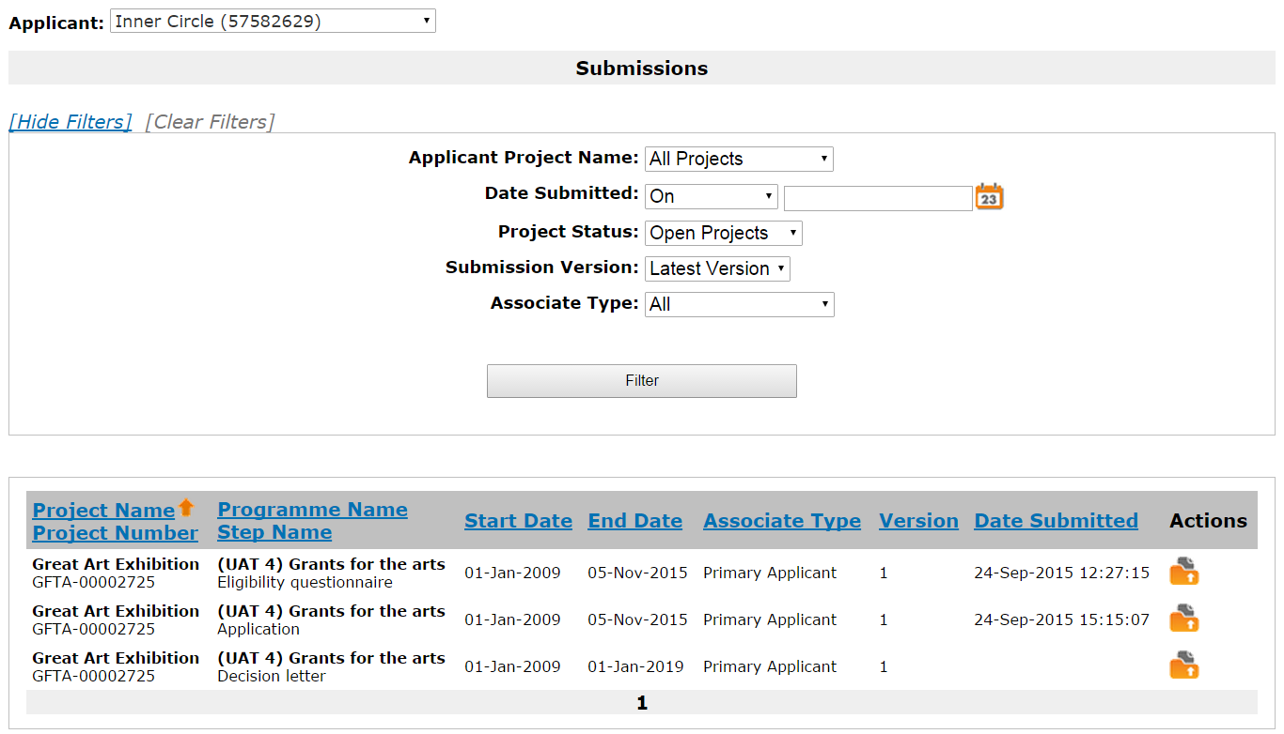



Click the **open** icon  to view the letter.

The first screen is the **Project information** screen. This gives some basic details of the project. There is nothing on this screen that requires action.

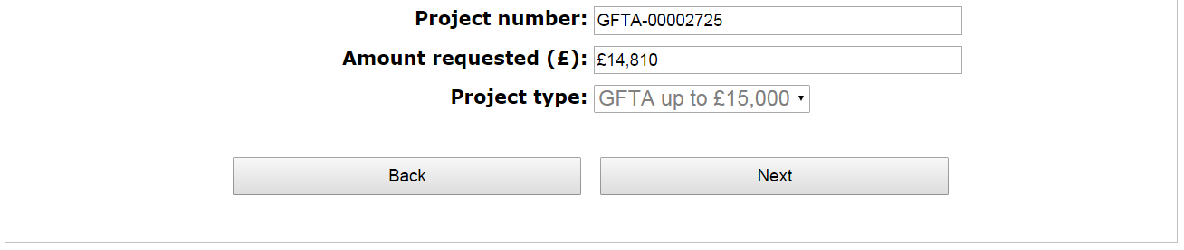



Click **Next** to proceed.

If your application was for more than £15,000, your application will have been appraised and the next screen will be the **Appraisal** screen. If you applied for less than £15,000, your application will have gone through the risk check process and the next screen you will see is the **Decision Letter** screen. Please turn to page 13 for guidance on this screen.

On the **Appraisal** screen you will see how your application was scored and any comments the appraiser made.



At the top of this screen, the **Appraisal Ratings** section shows the ratings against each of the criteria: Quality, Public engagement, Management and Finance. The ratings can be Outstanding, Strong, Met, Potential or Not met.

In the **Statements and Evidence** section, you can see the appraiser’s statement against each of the appraisal criteria and the evidence this statement is based on. To read these in full, click the **View** icon on the relevant line.

This opens up the **Statements** screen where you can read the statements in full.



To return to the **Appraisal screen**, click **Back to List**.

For more information about the appraisal process, please see our information sheet ‘[Appraisal process for Grants for the arts’](http://www.artscouncil.org.uk/funding/grants-arts/2016/information-sheets).

When you are ready to move on from the **Appraisal** screen, click **Next**.

The next screen is your **Decision letter** itself. An extract is shown below.

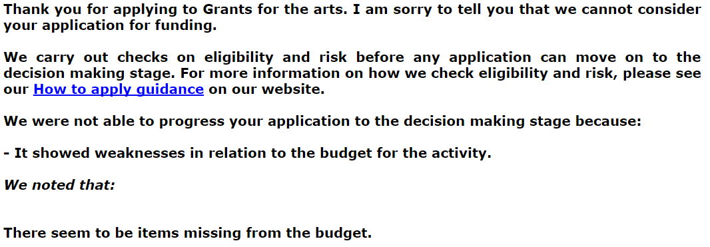

The letter will explain the reason we came to our decision.

Click **Next** to proceed.

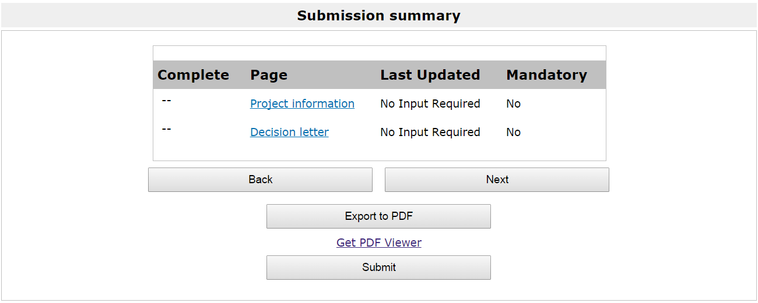

On the **Submission summary** screen, click **Submit** to complete the process.

## Further information and support

If you have any questions about the information contained in this document or require some assistance, please contact our Customer Services team on:

**Phone:** 0845 300 6200, 0161 934 4317

**Textphone:** 0161 934 4428

**Email:** [enquiries@artscouncil.org.uk](mailto:enquiries@artscouncil.org.uk)

**Website:** [www.artscouncil.org.uk](http://www.artscouncil.org.uk)