

**Grants for the Arts**

**How to apply**

**£15,000 and under**



# Contents

**Welcome 4**

**Eligibility 8**

**Using our online system – an introduction 17**

**Using our online system – applicant profiles 19**

Your applicant profile 19

Validation of your applicant profile 19

How to create your applicant profile 20

If we are unable to validate your applicant profile 21

Further guidance on applicant profiles 21

**Using our online system – the eligibility quiz 22**

Using the Registration Wizard to apply to Grants for the Arts 23

The eligibility questionnaire 26

Finding your eligibility quiz if you don’t complete it immediately 31

**The application form – what we need to know… 32**

**…and using the online system to apply 32**

Finding your application form 33

Starting the application form 34

About the application form 34

Things to remember: 36

**Applicant details and basic details 37**

**Artistic quality 37**

**Public engagement 37**

**Finance 37**

**Management 37**

**Attachments/ links 37**

**Monitoring, the declaration and submitting your form 37**

**What happens to your application 37**

**Further information 37**



# Welcome

Thank you for your interest in Grants for the Arts, our funding programme for arts activities that engage people in England and help artists and arts organisations to carry out their work. We are able to make grants between £1,000 and £100,000 and Grants for the Arts is a continuous programme, so you can apply at any time.

The awards we make through Grants for the Arts help us to achieve our mission of ‘Great art and culture for everyone’. Grants for the Arts is funded by the National Lottery.

If you experience or anticipate any barriers within the application process or require help to make an application or accessing services and information, please contact us for information on the type of support that we can provide. Our information sheet ‘Access needs and Grants for the Arts’ explains some of the ways we can help. Download it from our [Grants for the Arts information sheets](http://www.artscouncil.org.uk/funding/grants-arts/2016/information-sheets) page, or contact us for a copy.

**How to contact us**

**Phone:** 0845 300 6200, 0161 934 4317

**Textphone:** 020 7973 6564

**Email:** [enquiries@artscouncil.org.uk](mailto:enquiries@artscouncil.org.uk)

**Website:** [www.artscouncil.org.uk](http://www.artscouncil.org.uk)

**Post:** Arts Council England, Grants for the Arts

PO Box 4353, Manchester, M61 0DQ

Using this guidance

This guidance document leads you through the process of applying to Grants for the Arts, step by step. The colours of the headings tell you what type of information is in each section.

**Green text**

* Information about the programme (for example eligibility criteria, permissions needed, timescales and so on)
* Things you need to think about when planning your project and putting together your application
* What we expect to see in your answers to the questions we ask in the application form

**Red text**

* Explains how to use our online application system to make your application to Grants for the Arts
* Our online application system has changed in January 2016, so even if you have applied to us before you will need to make sure you read these sections carefully.
* Key guidance on using the system is highlighted under the title **System note**

Four steps to apply to Grants for the Arts

You’ve got a great idea. What next?

1 Read this guidance carefully

This guidance explains the eligibility requirements for Grants for the Arts and how to complete your application form, so please read it carefully before you begin.

This guidance is for applications for £15,000 or under. If you are applying for over £15,000 you will need to read the [How to apply guidance for Grants for the Arts – over £15,000](http://www.artscouncil.org.uk/funding/grants-arts/2016/how-to-apply) instead.

2 Is your activity right for Grants for the Arts?

Please check if your activity is eligible for funding through Grants for the Arts. The list in the Eligibility section of this guidance gives more information on what we can and cannot fund.

After you have read this guidance, if you have any further questions please contact us. Be ready to clearly describe your activity to us, as this will help us give you good advice and will save time.

Grants for the Arts is a competitive programme. Please consider what you would do if we cannot fund your activity. You can find some useful information on other sources of funding on our website ([www.artscouncil.org.uk](http://www.artscouncil.org.uk)).

3 Log in to our online application system (Grantium)

Applications to Grants for the Arts are made via our online application system. You must have a validated applicant profile before you can begin your eligibility questionnaire or application. It can take up to five working days for us to validate a profile, so you need to take this time into account when you are thinking about when to apply to us.

More information about using our online application system can be found in the Applicant profiles and Application form – what we need to know and using the system to apply sections of this guidance.

4 Fill in the application form.

The application form asks you a series of questions about different parts of your activity including: artistic quality, public engagement, management and finance.

This gives us information about you, the activity you are applying for and your budget. We will use the information you give us in your application form to decide whether we will offer you a grant. If your application does not contain the information we need in the format we ask for it to be in, we might not be able to consider your application.

Our Customer Services team can offer advice around eligibility but please note that we can only make a definitive decision about whether an application is eligible for Grants for the Arts once we have received your full application.

We wish you success with your application.



# Eligibility

Who can apply

Grants for the Arts are for individuals, organisations involved in arts related activity and other people who use the arts in their work.

Individual applicants to Grants for the Arts might be:

* artists, musicians, writers, performers
* promoters, producers
* curators, directors
* groups of people (one will need to take the lead and have the main responsibility for managing the application and any grant)

Types of organisations we can make grants to include:

* arts organisations
* local authority and other public organisations such as library services and museum services
* regional and national organisations
* organisations whose normal activity is not related to the arts, including voluntary and community groups
* groups of organisations (one will need to take the lead and have the main responsibility for managing the application and any grant)

By ‘organisation’ we mean a single group of people working towards a shared or common goal. This can take many forms (for example a limited company, a charity or an unincorporated group).

If you are applying as an organisation, you should have an organisational bank account with two people who can sign in the organisation’s name and we will ask you to upload a copy of your **governing document** when you submit your applicant profile to us. Please read our information sheet ‘[Governing Documents and Grants for the Arts’](http://www.artscouncil.org.uk/funding/grants-arts/2016/information-sheets) for more information.

We can only make grants to individuals and organisations based within the European Union. If you are an individual based within the EU (but outside England), you will need to have a bank account in the UK. If you are an organisation based within the EU (but outside England) you will need to have a registered office in the UK and a bank account in the UK.

Individuals resident in and organisations registered in England will also need to have a bank account in the UK.

You can find out more about our bank details requirements in the information sheet ‘[Bank details and Grants for the Arts’](http://www.artscouncil.org.uk/funding/grants-arts/2016/information-sheets), on our website.

Who cannot apply

The following individuals or organisations cannot apply to Grants for the Arts. If you fall into one of these categories, your application will not be eligible.

* organisations that receive regular funding from us through the National portfolio organisation programme
* people who have not submitted any overdue payment conditions on any previous grant from us (there is further information on this below)
* organisations that share out profits to members or shareholders, unless the activity you are applying for is a self-contained arts project that does not result in any profit making activity and has a clear benefit to the public
* students, for activities directly linked to their formal course of study, activities which contribute towards their course assessment, their tuition fees or living costs. By ‘student’ we mean a person following a course of study in a school, a college or a university. We cannot fund students directly or indirectly for these costs
* individual educational establishments (eg one school or college) where the activity does not provide benefits to the wider community or artists. This also applies to third party applications from individuals or organisations for delivering activity in a single school or college
* individuals or organisations based (living) outside of the European Union
* members of Arts Council England’s national council

What you can apply for

Grants for the Arts is the Arts Council’s open access funding programme, and is designed to allow us to support a wide variety of arts-related activities.

Activities we support must be clearly related to the arts and must be project-based, up to a maximum of three years in length. This means that an activity must happen for a defined period of time, with a start and end date and its own objectives to be achieved in that time. This is to distinguish project funding from regular or ongoing funding, which we do not provide through Grants for the Arts.

You can apply for:

* festivals and carnivals
* events, productions and exhibitions
* artistic research and development
* making work
* residencies
* commissions
* participatory projects, workshops
* audience development
* marketing activities
* professional development and training
* organisational and business development
* other arts-related projects

If you are applying for certain types of activity we recommend that you also read any relevant information sheets, as there are additional things you might need to consider before making an application. Find a full list of these sheets on our website <http://www.artscouncil.org.uk/information-sheets>.

These activities include:

* touring work
* library-led activity
* international work
* capital (building) applications
* purchasing equipment (including instruments and vehicles)
* education-related activity
* some artform-specific types of application

Applying for more than one type of activity

Your application can cover more than one type of activity. For example, you could apply for touring costs and professional development work in one application. We can advise you on how to do this and whether this is appropriate for you.

What you cannot apply for

You cannot apply for the following activities:

* projects that are not related to the arts
* projects that do not benefit or engage people in England (in the short or long term) or that do not help artists and arts organisations in England to carry out their work
* self-promotional projects which do not provide public benefit, either immediately or in the long term, or where the applicant does not have an artistic track record. This would include buying equipment and instruments which would not be used for the benefit of the public
* projects (including buying goods or services) that have started, been bought, ordered or contracted before we make a decision about your application. This is because we cannot fund activity retrospectively
* general running costs and ongoing overheads. These include those relating to salaries, equipment or buildings (such as rent, insurance and maintenance costs). You can apply for some time limited overheads that are directly related to delivering your project (such as costs for additional staff time, venue hire or utilities). You can find out more about overheads in the information sheet ‘[Repeat activities, ongoing overheads and salaries’](http://www.artscouncil.org.uk/funding/grants-arts/2016/information-sheets), on our website
* costs that are already paid for by other income including your own funds or any other funding
* projects in a formal educational setting for educational purposes necessary by law
* activities that are intended to make a profit within the project period (by this we mean that activities that are expected to make more money or income than it costs to deliver the activity)
* fundraising activities, such as charity galas, that do not benefit the arts
* activities that involve an applicant making grants to third parties using funding they have received from us (involving the grantholder acting as a decision maker on who the end recipients of our funds will be)

There are some types of activity where eligibility is more complicated:

* we cannot support projects relating to film and video (such as film or video production and cinema exhibition) unless it is in support of artists’ work in the moving image. Please read our information sheet ‘[Artists’ film and the moving image, and Grants for the Arts](http://www.artscouncil.org.uk/funding/grants-arts/2016/information-sheets)’ for more detail about what we do and do not fund relating to film, video and the moving image
* we cannot support activities or events that mainly take place outside England unless they clearly benefit individuals and artists living in, and organisations based in, England. Please read our ‘[International activity, and Grants for the Arts](http://www.artscouncil.org.uk/funding/grants-arts/2016/information-sheets)’ information sheet for more information
* we cannot support touring activity where more than 15% of performance or event days take place outside England. Up to 15 per cent of any touring activity presented to us may take place outside England: either in other part(s) of the UK (Scotland, Wales and/or Northern Ireland), or internationally outside the UK (or a combination of both). We calculate the percentage of an activity happening outside England based on the number of performance or event days in each location shown in the preliminary tour schedule in the application form. Please read our ‘[Touring and Grants for the Arts](http://www.artscouncil.org.uk/funding/grants-arts/2016/information-sheets)’ information sheet for more information
* we cannot support the purchase of second-hand equipment apart from certain musical instruments and some specialist equipment. Please read our ‘[Asset purchase and Grants for the Arts](http://www.artscouncil.org.uk/funding/grants-arts/2016/information-sheets)’ information sheet for more information
* we normally require a minimum of 10 per cent funding from sources other than the Arts Council. In exceptional circumstances we may be able to provide up to 100 per cent of the cost of the activity. If you are asking us for more than 90 per cent of the total cost of your activity, you must tell us why you have been unable to secure any other funding. Using the information you give us we will decide whether we can accept your application. If we cannot, it will not be eligible and we will not be able to process it.

There may be other types of activity we are not able to support for technical reasons relating to our Charter or restrictions on the type of funds that we distribute. If one of these reasons applies to your activity, we will write to you and let you know why it is ineligible.

Overdue conditions on previous grants

If you are currently in receipt of a Grants for the Arts award, you cannot make another application unless you are up to date with submitting the conditions for your earlier grant.

You must submit any overdue conditions before you apply again. Your previous offer letter would list what conditions you needed to meet, and when we expected to receive your monitoring information.

A condition is considered overdue once the date for submitting the information on the payment schedule for your grant has passed. If you have a query about conditions for a previous grant please contact us ([enquiries@artscouncil.org.uk](mailto:enquiries@artscouncil.org.uk), 0845 300 6200).

Underdeveloped applications

If your application does not contain the information we need to be able to come to a decision on your application, in the format we ask for it to be in, it will not be eligible. If your application is not eligible, this means that we cannot process it any further and it will not be considered for funding. If your application is not eligible we will write to you to let you know, and will explain our decision.

When you must ask us for permission to apply

There are some types of activity where you must ask us for permission to apply. These include:

Making an additional application  
Only in exceptional circumstances would we accept a second application from someone while they are still waiting for a decision from us on a first application. If you want to make a second application you must contact us ([enquiries@artscouncil.org.uk](mailto:enquiries@artscouncil.org.uk), 0845 300 6200) to request permission to apply. We will confirm in writing whether you can apply and you must attach this letter with your second application.

Applying for over £100,000  
In special circumstances we can accept applications for grants over £100,000. If you plan to apply for over £100,000 you must contact us ([enquiries@artscouncil.org.uk](mailto:enquiries@artscouncil.org.uk), 0845 300 6200) to request permission to apply. We will confirm in writing whether you can apply and you must attach this letter with your application.

Capital (building) applications for more than £15,000  
If you plan to apply for activity relating to building work (refurbishing arts buildings, improving access, buying property or leasing a building, for example), you will need to contact us for permission ([enquiries@artscouncil.org.uk](mailto:enquiries@artscouncil.org.uk), 0845 300 6200). You can find out more about capital (building) projects in the information sheet ‘[Capital (Buildings) and Grants for the Arts](http://www.artscouncil.org.uk/funding/grants-arts/2016/information-sheets)’, on our website.

Applications relating to Music education hubs activity  
A Music education hub is a collection of organisations working in a local area to create joined up music education provision for children and young people, both in and out of school. If you are a music education hub, one of their partners or an organisation working with a music education hub who wishes to apply for support for a related activity, you will need to contact us for permission to apply. Please read our information sheet ‘[Music Education Hubs and Grants for the Arts](http://www.artscouncil.org.uk/funding/grants-arts/2016/information-sheets)’ for more detail about what types of activity we can and cannot fund, and the process for getting permission to apply.

**Activities requiring a decision from us earlier than our standard decision time of six weeks**

We need six working weeks (not including the time we need to validate an applicant profile for a new applicant) to process applications for £15,000 or under. However, there are some circumstances – strictly by exception – where we may be able to come to a decision more quickly than this due to the time sensitive nature of the activity being proposed. This is called **‘time sensitive permission’**, and is only available in very specific circumstances. We will decide whether your request meets the criteria for making a time sensitive application, and whether we have the capacity to process your application more quickly than our standard decision times. Our decision is final and entirely at our discretion. It should be noted that we do not grant time sensitive permission very often. Please read our information sheet ‘[Time sensitive applications and Grants for the Arts](http://www.artscouncil.org.uk/funding/grants-arts/2016/information-sheets)’ for more detail about the process for getting permission to apply.

Our other funding programmes

Grants for the Arts is the Arts Council’s open access funding programme, and is designed to accommodate a wide variety of types of activity. Some of our other funding programmes focus on specific types of activity, such as touring, capital (building) projects or to support individuals to work internationally. If you are applying for support towards these types of activity you may wish to look at the application materials for some of our other programmes to make sure that Grants for the Arts is the most appropriate programme for your project.

For more information about our other funding programmes, please visit our website.



# Using our online system – an introduction

All applications to Grants for the Arts are made using our online application system, accessed through our website.

When making an application you will use three different areas of the online system:

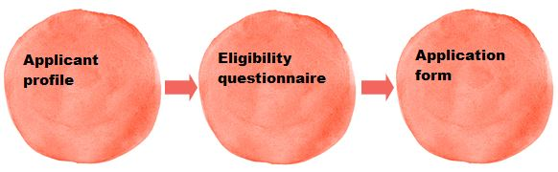

When using the online system, please note that:

* Throughout the application system, any items marked with **an asterisk (*)** must be completed
* Please navigate using the **onscreen buttons only** (such as the ‘Save and next’ button within the system).You are unable to use the navigation buttons at the top of your browser window (such as the browser ‘Back’ button). Always use the ‘Back’ or ‘Save and back’ buttons within the system
* Any free text boxes in the application form have a **strict character limit** stated above them. Please stick to this limit as any text you add beyond this will be automatically deleted when you save your answers
* Remember to **save your work regularly** as you go along – the system times out after 15 minutes of inactivity
* The **submission summary** displays a list of all the steps you’ve worked through. It is the final screen in each section of the process, but you can refer to it at any time. If you have completed a step successfully, there will be a green tick beside it. If a step is incomplete or has not been completed successfully, this will be indicated by a red cross. A hyperlinked statement at the bottom of the page will tell you what part of each step needs attention. Click on this hyperlinked statement to go back to the step and make your amendments
* It is your responsibility to keep the information in your applicant profile **up to date**. Before you start an application for any new project, please go through your applicant profile, ensure your information is correct, and update it if necessary
* If at any time you would like to contact us, click **Contact us** in the left menu bar for contact information

For more detailed guidance on using our online system, please read our information sheet ‘[How to create and manage your user account and applicant profile](http://www.artscouncil.org.uk/funding/our-application-portal/pre-application-support)’.



# Using our online system – applicant profiles

## Your applicant profile

Before you make an application, you will need an applicant profile. The ‘applicant’ is the person or organisation we will make a grant to if your application is successful, and an applicant profile is where all their contact information is held on the system.

If you:

* have never made an application to Grants for the Arts before, or
* have not applied to us since 27 January 2016, or
* are registering a new applicant

we have to ‘validate’ your applicant profile before you can start an application.

Validation allows us to make sure that there is only one applicant profile per applicant on the system, and to check some basic contact and organisational information where relevant.

## Validation of your applicant profile

It is important that you factor in enough time to allow us to do this when you plan to make an application because **you will not be able to start your application until your applicant profile has been approved**.

Your applicant profile will be submitted to us when you have completed it, and we will aim to approve it **within five working days**. In the meantime, you cannot begin work on your application but should use this time to read this guidance thoroughly and begin to plan your application. You can also use this time to contact us with any queries.

The six weeks we need to reach a decision on your application is **in addition** to this time for approving your profile. The six week decision period begins when you press ‘Submit’ on your application form.

The table below shows when you need to have your applicant profile validated by us:

|  |  |
| --- | --- |
| Scenario | Time needed to validate profile |
| You have never made an application to Grants for the Arts before | Five working days |
| You have not applied to us since 27 January 2016 | Five working days |
| You have already applied to us since 27 January 2016, and are applying using an applicant that is already linked to your user account and has been validated previously | Validation not needed – check your existing profile and make any changes needed |
| You have applied to us since 27 January 2016, but you are registering a new applicant that is not already linked to your user account | Five working days |

You will receive an email notification when your profile has been approved. This will include instructions on how to access the eligibility quiz and application form.

## How to create your applicant profile

If you do not already have an applicant profile you need to create one. Please follow the instructions in our guidance sheet ‘[How to create and manage your user account and applicant profile](http://www.artscouncil.org.uk/funding/our-application-portal/pre-application-support)’.

If your applicant profile has already been validated or your existing profile is up to date, please go straight to the Eligibility quiz section of this guidance.

## If we are unable to validate your applicant profile

Sometimes we may not be able to able to validate your profile within our standard processing time of five working days, for example, if you submit a profile for an individual or organisation that is already registered on our system or if any of the information we need is missing or unclear. In these cases we will write to you and explain what you need to do next. Please remember that you cannot begin an application until your applicant profile has been validated.

## Further guidance on applicant profiles

There is full guidance on [creating and submitting an applicant profile](http://www.artscouncil.org.uk/funding/our-application-portal/pre-application-support) on our website.



# Using our online system – the eligibility quiz

This section of the guidance provides detailed, step-by-step instructions on how to complete the eligibility questionnaire. You should read it thoroughly before you begin, and follow the instructions carefully when you complete the questionnaire.

When your applicant profile has been validated (or if your existing applicant profile is up to date), you can complete the eligibility questionnaire for Grants for the Arts. You will receive an email notification when your profile has been approved. This will include instructions on how to access the eligibility quiz and application form.

* Each screen that you will see as you work through the eligibility questionnaire is titled in **► bold with an arrow** in this guidance, with explanatory text for that screen underneath
* Any clickable onscreen links are shown underlined in this guidance

## Using the Registration Wizard to apply to Grants for the Arts

The Registration Wizard guides you through registering to apply, choosing the applicant you want to apply under, and setting up your project on the system.

To access the Registration Wizard:

* **Browse programmes**

To begin, click Browse programmesin the Workspace section of the left menu bar:

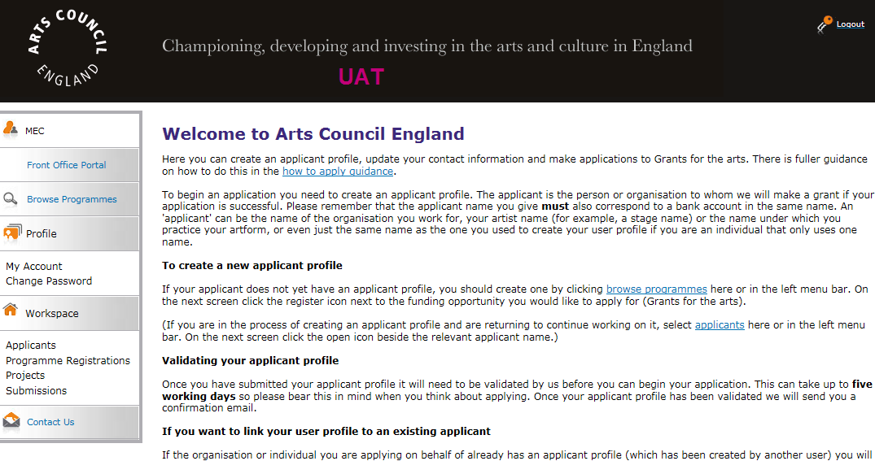

Click View View on the far right of the screen next to Grants for the Arts:

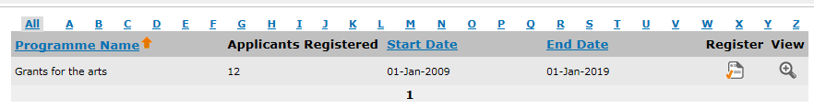

This will take you to the Apply for funding screen. Click Apply Now at the bottom of the screen to begin your application.

* **Applicant details**

Select your applicant from the dropdown in the **top half** of the screen.

Use only the top section of this screen.

Do not use the bottom half of the screen called ‘Applicant type’. This is only used when a user is creating a new applicant through this screen, and if used it will generate a new applicant. You should always be using a validated applicant at this stage, and should be able to select it from the dropdown at the **top** of the screen:

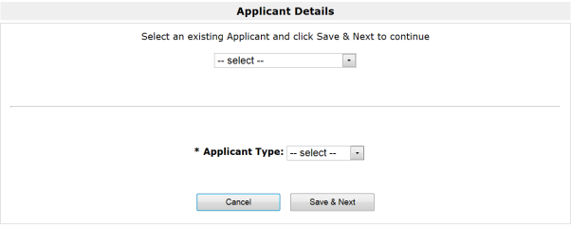

SELECT YOUR APPLICANT HERE

**DO NOT USE THIS SECTION**

Click Save & Next to continue.

* **Applicant details (2)**

The next screens show the information you entered in your applicant profile. Please review each screen to ensure that your contact information is correct. This is particularly important if you haven’t made an application to us using that profile for some time.

The contact details shown at this stage will be the details that pull through onto your application form. Making sure they are correct at this stage is important, because any changes that are made to your contact details after you have created a new project will not be changed in your application form.

To move through the screens click Save & Next.

It is your responsibility to keep the information in your applicant profile up to date. If you notice that you need to change any details, you should go to the Submission summary at the end of this section, click the Edit button and go to the appropriate screen to make your changes.

Once all your details are correct, to proceed with your application please click Return to Registration Wizard in the left menu bar:



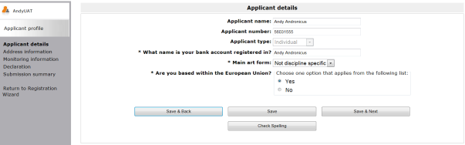

For more guidance on how to make changes to your details, please refer to the ‘Managing your contact details’ section of our guidance document, ‘[How to create and manage your user account and applicant profile](http://www.artscouncil.org.uk/funding/our-application-portal/pre-application-support)’.

* **Complete applicant profile**



Click **Next** to proceed with your application.

* **Create a project**

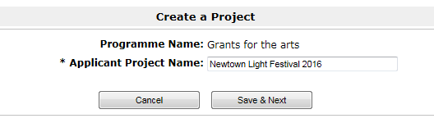

Please add the name of your project. This will be the project name that we use throughout the process (and if your application is successful we will use it to label all of your reports and payment requests) so please make sure it is correct and refers clearly to your project, for example ‘**Newtown Light Festival 2016**’.

Click **Save & Next**.

## The eligibility questionnaire

Once you have given your project a name, you will be taken to an eligibility questionnaire. Before you begin completing an application form, we want to ensure that your proposed project meets some of our basic eligibility criteria.

The screens in the eligibility questionnaire will take you through some basic points of eligibility, but this questionnaire is not a full eligibility check. (When we receive any application we conduct a full eligibility check within 10 working days.)

You should read the Eligibility section of this guidance carefully before applying.

As you work through the eligibility questionnaire, if any of your answers indicate that your project does not appear to be eligible you will be taken to a screen that explains why.

* **Eligibility questions – section one**

The questions on this screen allow us to check your application against some basic criteria and establish how much you are requesting from us.

Personal access costs

If you are deaf or disabled or experience learning difficulties there may be extra costs relating to your own access needs, and/or any access needs of the artists you’re working with, that you will need to pay to help you deliver your Grants for the Arts project and manage your grant online. For example, payment for a sign language interpreter to help you manage your activity.

Only include post-application costs for personal access costs in your expenditure table. Do not include costs relating to preparing, planning and submitting your application.

We want to know your personal access costs so we can deduct them from the total project costs when we decide how long it will take use to make a decision. This is particularly important if you are requesting close to £15,000 from us. For example, if you are applying for £15,350 but £650 of this relates to your personal access costs, we would still view this as the same as an application for under £15,000 and would make a decision on your application within six weeks. You should use the guidance notes for applications for £15,000 and under to complete your application form.

To find out more about personal access costs please read our information sheet ‘[Access needs and Grants for the Arts](http://www.artscouncil.org.uk/funding/grants-arts/2016/information-sheets)’.

Total request

Enter the total amount you are requesting from us, including any personal access costs. Please enter this figure accurately as it will determine some of the questions we will ask.

* **Eligibility questions – section two**

If you answer **yes** to either of the questions on this screen, please read the relevant [information sheets](http://www.artscouncil.org.uk/funding/grants-arts/2016/information-sheets) for further information about:

* - funding for projects involving film or video
* - funding for purchasing second hand equipment

If you are satisfied that your project is eligible, please tick the tick box and continue with the eligibility questions.

* **Eligibility questions – section three**

Only in exceptional circumstances would we accept a second application from someone while they are still waiting for a decision from us on a first application. Please see 'When you must ask us for permission to apply' in the Eligibility section of this guidance for more information.

If you answer **yes** to the question regarding permission to apply, please be aware that you will need to upload a copy of the permission letter from us in the **Letter attachments** section of the eligibility questionnaire.

* **Eligibility questions – section four**

If you are the lead organisation of a music education hub, or are working with a Music education hub(s) as part of your activity, you will need to have obtained permission to apply for Grants for the Arts and will need to upload evidence of permission in the **Letter attachments** section of the eligibility questionnaire. Please see 'When you must ask us for permission to apply' in the Eligibility section of this guidance for more information.

* **Letter attachments – for applicants requiring permission to apply**

Please attach a copy of all relevant permission to apply letter(s) that we have sent you. If these letter(s) are not uploaded, we will not be able to process your application.

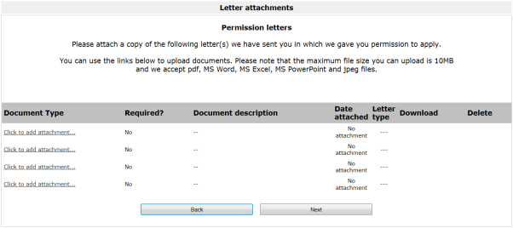

To attach a letter, click the hyperlink labelled ‘Click to add attachment’.

* **Attachment details**

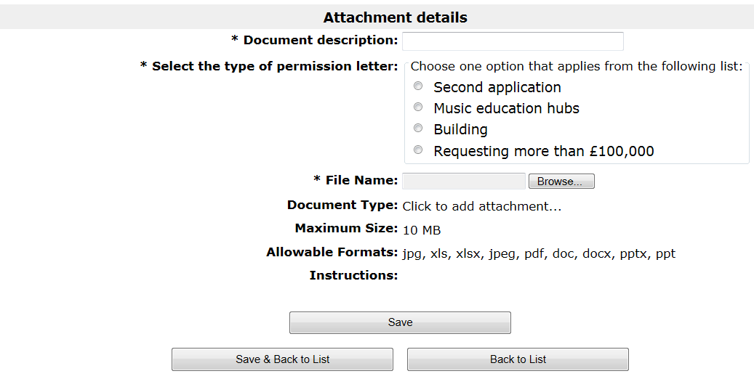

On this screen, please locate and upload the required document. Please ensure all documents are clearly labelled in the **Document description** field.

* **Submission summary**

The submission summary displays a list of all the steps you’ve worked through.

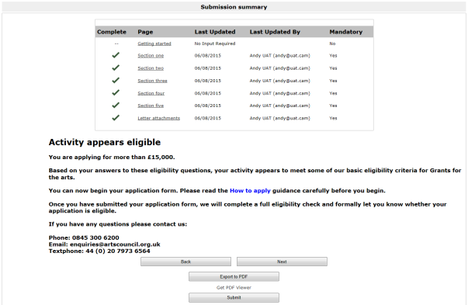



If you have completed a step successfully, there will be a green tick beside it. If a step is incomplete or has not been completed successfully, this will be indicated by a red cross. A hyperlinked statement will tell you what part of each step needs attention. Click on this hyperlinked statement to take you to the step and make your amendments.

(If the answers you have given indicate that your activity is not eligible or you do not have the required permission letter(s)] you will not be able to continue on to the application form.)

When you have completed your eligibility questionnaire, click Submit.

## Finding your eligibility quiz if you don’t complete it immediately

* **The Submissions screen**

If you don’t complete your Eligibility questionnaire immediately or you are logged out by the system at any point, you can always access it through the **Submissions** screen. (A ‘submission’ is anything that you submit to us using the online system, such as an eligibility questionnaire or an application form):

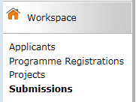

Listed on the **Submissions** screen are all the submissions that you have made or that are ready for you to complete. If something is ready to start or in progress, the **Date submitted** column will be blank. If something has already been submitted, the date and time it was submitted will appear here.

The column called **Programme Name / Step Name** will show you which submission is your eligibility questionnaire:

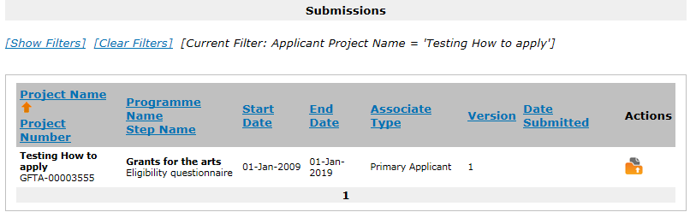

Click the ‘Open’ icon  next to your eligibility quiz.



# The application form – what we need to know…



# …and using the online system to apply

When your applicant profile has been validated (or if your existing applicant profile is up to date) and you have completed the eligibility quiz successfully, you can start your application to Grants for the Arts.

This section of the guidance provides detailed, step-by-step instructions on how to complete the application form. It follows the structure of each of the screens you will see as you work through the application form. You should read it thoroughly before you begin, and follow the instructions carefully when you complete the form.

* Each screen that you will see as you work through the application form is titled in ► **bold with an arrow** in this guidancewith explanatory text for that screen underneath
* The questions we ask in the application form are marked with ‘**Question**’ and are shown in ***bold and italics***
* Any clickable onscreen links are shown underlined in this guidance
* Guidance on how to use the online system is shown outlined in red with the header **System note**

## Finding your application form

* **The Submissions screen**

Once you have submitted the eligibility questionnaire and we have told you your activity appears eligible, you will be taken to the **Submissions** screen. (A ‘submission’ is anything that you submit to us using the online system, such as an eligibility questionnaire or an application form):



Listed on the **Submissions** screen are all the submissions that you have made or that are ready for you to complete. If something is ready to start or in progress, the **Date submitted** column will be blank. If something has already been submitted, the date and time it was submitted will appear here.

The column called **Programme Name / Step Name** will show you which submission is your application form:

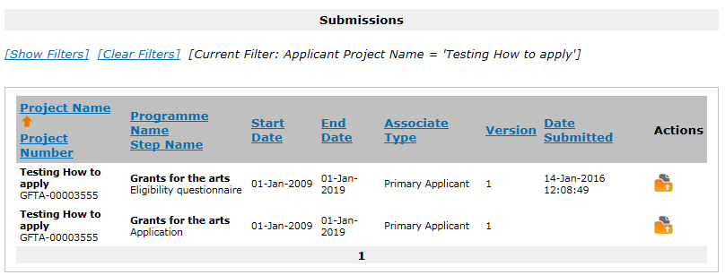

If you have made other Grants for the Arts applications to us since 27 January 2016 you will also be able to see the submissions relating to them on this screen. You can use the dropdown filters at the top of the screen to choose the name of the project you are working on:

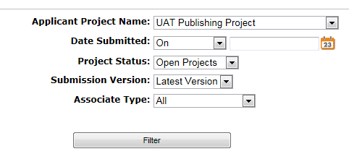

## Starting the application form

To open and begin the application form, click the ‘Open’ icon  next to your project’s Application in the list:

Screenshot of system

If you don’t complete your application form in one sitting, you can always access your in-progress form through this Submissions screen. To continue working on a particular submission, click the open icon  on the right side of the screen.

## About the application form

The application form takes you through a number of sections. These are listed in the navigation bar on the left of the screen:

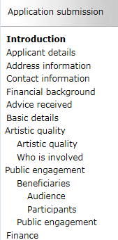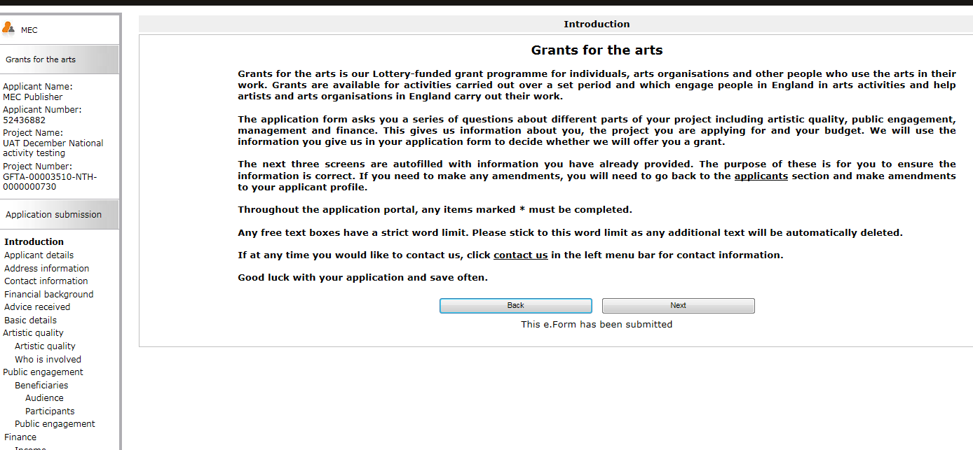

Some of the sections ask for basic information about your activity, and others ask for more detailed information. Please read this guidance carefully, and use it to help you complete each section of the application form.

The application form asks you a series of questions about different parts of your activity including:

* its artistic quality
* how it will engage the public
* how it will be managed
* the budget for your activity

We will use the information you give us in your application form to decide whether we will offer you a grant.

## Things to remember:

* Throughout the application screens, **any items marked * onscreen** must be completed
* Any free text boxes have **a strict word limit**, shown next to each question. Please stick to this word limit as any text you add beyond this will be automatically deleted when you save your answers
* Remember to **save your work regularly** as you go along – the system times out after 15 minutes of inactivity

**If at any time you would like to contact us, return to the Submissions screen and click Contact us in the navigation bar on the left of the screen.**



# Applicant details and basic details

* **Applicant details**

At this stage, the **Applicant details** screen reappears to allow you to ensure that all your information is correct. If you have multiple applicant profiles linked to your user account, it is also an opportunity for you to ensure you have selected the correct applicant.

If any of the details are incorrect, you will need to exit the application form and go back into your applicant profile to make your amendments. Please see our information sheet ‘[How to create and manage your user account and applicant profile’](http://www.artscouncil.org.uk/funding/our-application-portal/pre-application-support) for guidance on how to do this.

* **Address information**

As with the previous screen, the **Address information** screen reappears to allow you to ensure that all your information is correct.

* **Contact information (organisations only)**

As with the previous two screens, the **Contact information** screen reappears to allow you to ensure that all your information is correct.

* **Financial background (organisations only)**

The year your organisation was formed and your organisation’s company number (if entered) pull through into this screen. Please enter your organisation’s actual income figure for the last financial year in the box. If you are a new organisation, please provide an estimated income figure for your first year. Tell us your turnover, rather than your gross / net income or profit.

* **Advice received**

If you have received any advice, please tell us about it here (please tick all options that apply).

* **Basic details**

Project information

**Question:**

***Please give a concise description of the activity you are asking us to support.***

(No more than 600 characters, approximately 100 words)

This description gives us a brief summary of the key aspects of your activity, so please describe your activity simply and clearly.

You should include the main details about the nature of your activity, what will happen and who it is aimed at. For example, a completed activity description could look like this:

*Our project involves working with groups of young people aged 12-15 to support them to produce their own creative written work. Four groups of young people from four different schools will take part in workshops with a professional poet to develop their own work, which they will perform at a showcase event at the end of the project. We will also produce a video of their performances that will be hosted on the project website.*

Amount requested

**Question:**

Please tell us the total amount you are requesting from us, including any personal access costs.

Here we want you to tell us the amount you will be requesting from us, including any personal access costs. The figure you entered on the eligibility quiz will ‘pull through’ into this box. You can edit the amount you are applying for, but if you are changing the amount to above or below the £15,000 threshold you may need to start a new eligibility questionnaire. Contact us for more details.

***Please tell us how much of these are personal access costs.***

These are the costs relating to your own access needs, and/or any access needs of the artists you’re working with, that you will need to pay to help you deliver your Grants for the Arts project and manage your grant online. For example, payment for a sign language interpreter to help you manage your activity.

Only include post-application costs for personal access costs in your expenditure table. Do not include costs relating to preparing, planning and submitting your application.

You will have told us about the expected costs of your personal access costs, as part of the eligibility questionnaire. The figure you provided will ‘pull through’ onto the online application form, and ‘pre-populate’ the basic details section and the expenditure table. If you need to change the amount you will need to edit the figure in this box, and the budget line for personal access costs in your expenditure table will automatically update.

To find out more about personal access costs please read our information sheet ‘[Access needs and Grants for the Arts](http://www.artscouncil.org.uk/funding/grants-arts/2016/information-sheets)’.

Activity dates

**Question:**

***Please enter the start and end date of your project.***

Your start date must allow enough time for us to come to a decision on your application, and should include sufficient time to complete all the stages of your project.

*The time we need to make a decision*

We need at least six weeks to come to a decision on applications for £15,000 and under.

We cannot fund any goods or services that you have bought, ordered or contracted before we make a decision on your application.

If your start date is exactly six weeks from the day you will be submitting your application, the system will allow you to submit the application but we would not view this as good practice and this is likely to be highlighted in our risk check.

Please also be aware that once we have made a decision, if your application is successful we need an additional period of time to make a payment to you. During this time we notify you of your offer and wait for you to accept it, authorise your bank details, consider any material to meet payment conditions we have set, and go through the financial checks we carry out before releasing any payment. This can take around two weeks, and can sometimes take longer depending on the circumstances.

We recommend that you allow enough time for this process when choosing your project start date.

*Deciding on a start date and end date*

Please give a start date and end date for your project that will give you enough time to complete all the main stages of the project that you are asking us to support. For example, if your activity is a short festival but you are asking us to support the development and marketing of that festival as well as the delivery, you should give start and dates that include the development and marketing period as well as the festival itself.

*Time sensitive applications*

Our standard decision time is six weeks. However, there are some circumstances – strictly by exception – where we may be able to come to a decision more quickly than this due to the time sensitive nature of the activity being proposed. This is called ‘time sensitive permission’, and is only available in very specific circumstances as outlined in our guidance sheet, ‘[Time sensitive applications and Grants for the Arts’](http://www.artscouncil.org.uk/funding/grants-arts/2016/information-sheets). We will only accept applications with tighter deadlines if permission has been granted by us in advance. Wewill confirm in writing whether you can apply and you must attach this letter with your application in the ‘Letter Attachments’ section.



# Artistic quality

* **Artistic quality**

In this section we want you to tell us about you and your artistic work, some more detail about the project you would like to do, and how this project will help you or your organisation develop. We also ask about any other artists you may be working with, what their role is, and why you have chosen to work with them.

**Question:**

**Please provide a brief summary of you or your organisation’s recent relevant artistic work, experience and achievements.**

(No more than 1500 characters, approximately 250 words)

If you are applying as an individual:

We ask you to provide this summary instead of a detailed artistic CV. This paragraph will tell us about your artistic track record and your career to date, so you should aim to present a clear, concise summary of your work.

If you are applying as an organisation:

This paragraph will function as a statement about the artistic work of your organisation. If you are applying as an organisation whose work is not mainly in the arts, you should tell us briefly about the area of your main activities and your previous experience using the arts in your work where appropriate.

All applicants:

The type of information you give us will depend on what kind of work you do, but you should tell us about:

* your key artistic achievements to date – for example exhibitions, productions, publications, etc
* any key commissions you’ve received
* key pieces of work you’ve completed
* if you’ve worked with any established artistic partners
* any other information relevant to your artistic track record

**Question:**

**What is your proposed artistic activity, and what do you want to achieve by doing it?**

(No more than 1500 characters, approximately 250 words)

This is your opportunity to tell us more about your activity and why you want to do it. You should tell us about:

* what your artistic activity is
* the artistic idea behind the activity
* what you want to achieve by doing the activity

**Question:**

**Why is this activity important for your artistic development?**

(No more than 1500 characters, approximately 250 words)

This is a question about how the activity will develop your practice, skills, or organisation and how it fits with your wider artistic career or programme. Arts Council England is the arts development agency for England and we want to fund activities that move artistic practice forward.

You should think about how doing this activity will affect your work, both immediately and/or in the longer term. Does your activity allow you to:

* work in new ways, new contexts or with new people
* reach new or different audiences
* to try out new approaches
* achieve other types of development (for example, organisational, business or professional development)

Some activities might involve contributing to the artistic development of others. If this applies to your activity (for example, an activity involving working with emerging artists to support their professional development) you can tell us about this here too.

* **Who is involved**

We want to know about the other artists who are part of your activity. By ‘artist involved in the activity’ we mean artists (or arts organisations) who:

* are part of your activity’s artistic programme; or
* are directly involved in shaping the activity artistically

For example, this could be:

* programmed artists (as part of a tour, exhibition, publishing programme or a festival)
* other artists working in collaboration with you to produce work
* an artistic mentor
* other people taking on key artistic roles in the activity – director, curator, composer, programmer, etc

**Question:**

***Please list the main additional artists involved in your activity using the table, up to a maximum of 10 artists***.

Do not include yourself if you are the main artist. If you are working with any individuals or organisations who are helping to deliver or manage your activity, please tell us about them in the Management section of the application form.

We understand that not all types of activity will involve other artists. If you are the sole artist involved in your activity please leave this screen blank.

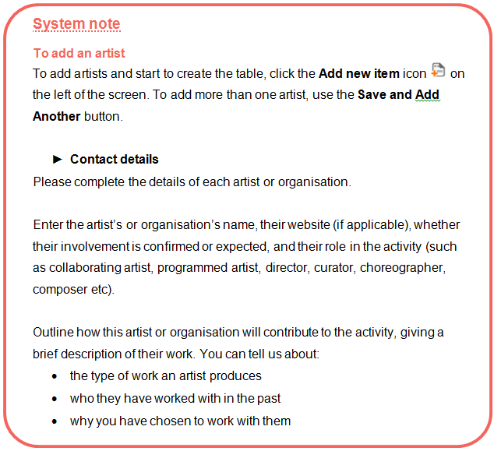



# Public engagement

* **Public engagement**

In this section of the application form we want you to tell us about who will engage with your activity. We want to know more about the audiences and/or participants for your activity, who they are, and how you will reach them. We ask you to estimate the numbers engaging with your activity based on what you think you will achieve.

You can find out more about developing audiences in the information sheet ‘[Audience development and marketing, and Grants for the Arts’](http://www.artscouncil.org.uk/funding/grants-arts/2016/information-sheets), on our website.

* **Beneficiaries**

People who will benefit from your activity

Use this screen to tell us how many people will engage with the activity you are applying for, and also how many people have engaged with your wider activities over the last 12 months.

Results of your activity

At the bottom of this screen, please also estimate the outcomes of your activity providing *number of new products or commissions*, *period of employment for artists (in days)*, *number of performance of exhibition days* and *number of sessions for education, training or participation*. Enter ‘0’ (zero) for any item that is not relevant.

When providing a figure for the number of sessions for education, training or participation, divide the day into three sessions (morning, afternoon and evening). A session is any one of these.

* **Audience**

On this screen we ask you to give us some more details about the audience(s) your activity is aimed at.

By 'audience' we mean people who are going to experience your activity as viewers, listeners or readers but are not actively involved in the activity**.**

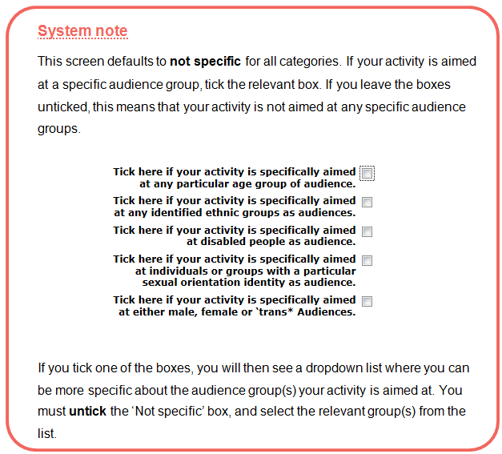

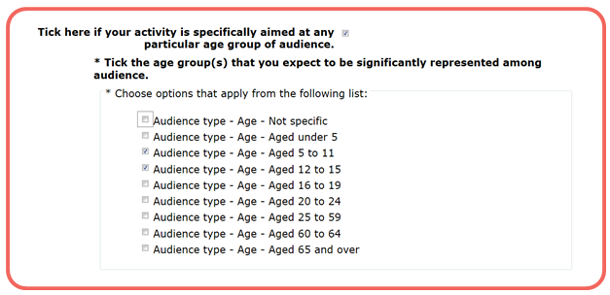

* **Participants**

On this screen we ask you to give us some more details about the participants your activity is aimed at, if any.

By 'participants' we mean people who are actively involved in your activity (other than the artists or others leading the activity) by devising, creating, making, presenting or performing.

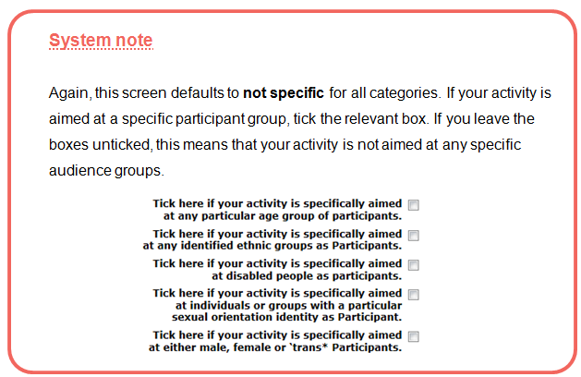

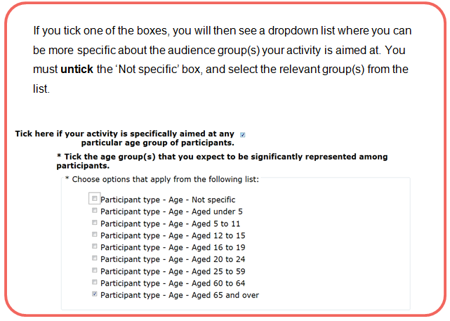

* **Public engagement**

**Question:**

***Who will engage with this activity?***

(No more than 1500 characters, approximately 250 words)

On the previous screens you have told us about the audience and participant groups your activity is aimed at. Here, we want to know more detail about who is going to engage with your activity and in what ways. We understand that target audiences will be different for different types of activity.

For example, an activity might target:

* a very specific group of people (young people aged 12-15 in Birmingham) or
* a wider audience group (theatre audiences in the Midlands)

We are interested in the relevance of the activity to audiences/participants. Please tell us about why the activity will be appropriate for the groups you identify, and think about how you know there is (or will be) demand for your activity from those groups.

If your activity will engage people who do not usually engage with the arts you should tell us here.

*Types of engagement*

There are different ways that people can engage with an activity. They might include:

* as active participants (for example, in a workshop)
* as audience members
* as readers (for example, of a publication)
* as participants in research or public consultation (such as helping to plan an activity)

Please also tell us:

* how you will ensure that audiences/participants have a high quality artistic experience
* how the activity could have a lasting impact on participants

*Research and Development (R&D)*

Some types of activity might not involve engaging people immediately, for example some research and development (R&D) work. If you are applying for R&D activity, you should tell us about the target audiences for your work now or in the future, and how they will engage with your work.

You can find out more about research and development activities in the information sheet ‘[Research and development (R&D) activities, and Grants for the Arts’](http://www.artscouncil.org.uk/funding/grants-arts/2016/information-sheets), on our website.

**Question:**

***Please describe how you will reach your target audience or participants, in the short or long term, and give details of your proposed marketing activities where appropriate.***

(No more than 1500 characters, approximately 250 words)

We want to understand how you are going to reach the people that will experience or take part in your activity. We want to see that you have plans in place that will ensure people know about your activity and will want to take part in or attend your activity.

Please tell us how you plan to:

* identify potential audiences/participants
* recruit any participants for the activity
* promote your activity (for example, to gain media coverage)

You can find out more about marketing your activity in the information sheet ‘[Audience development and marketing, and Grants for the Arts’](http://www.artscouncil.org.uk/funding/grants-arts/2016/information-sheets), on our website.

*Research and Development (R&D)*

If you are applying for R&D activity, please tell us how you plan to ensure your work reaches your identified target audiences in the short or long term. You should tell us what steps you will take to ensure people experience your work.

For example, this might be how you plan to get a gallery, theatre or festival to show your work, or a publisher to publish it.

You can find out more about research and development activities in the information sheet ‘[Research and development (R&D) activities, and Grants for the Arts’](http://www.artscouncil.org.uk/funding/grants-arts/2016/information-sheets), on our website.



# Finance

* **Finance**

The Finance section asks you to complete a budget for your project and to answer some questions about how you will manage your budget.

The Finance section is divided into three screens: Income, Expenditure and Finance questions. This guide will tell you how to complete each screen, step by step.

*Key things to remember about budgets:*

**Your budget has to balance**

Your income needs to be the same as your expenditure.

**We expect you to find at least 10% of the total cost of your project from other sources**

Financial income from other sources helps to demonstrate partnership support for the activity, and shows that the activity is making the most of our investment. On average, those who were successful in getting funding from us received about 51 per cent of their income from other sources.

**We need to be able to see how you have worked your figures out**

Please break them down clearly under the headings provided in the budget table.

**Your budget should be for the total cost of the project you are applying to do**

We view your request to Grants for the Arts as a contribution towards the overall cost of the project, and we do not generally allocate our funding to specific items of expenditure

Please check your figures carefully. If you do not fill in this section correctly, we cannot process your application.

Income

* **Income**

On this page you should enter all the cash and in kind income for your project.

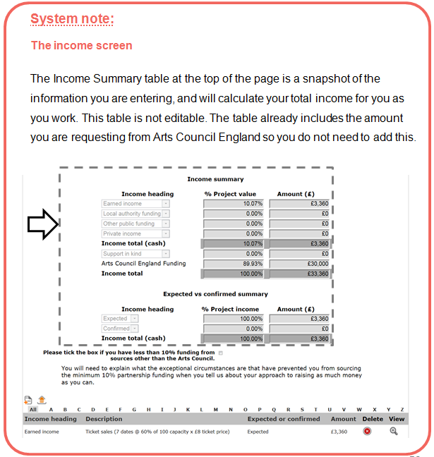

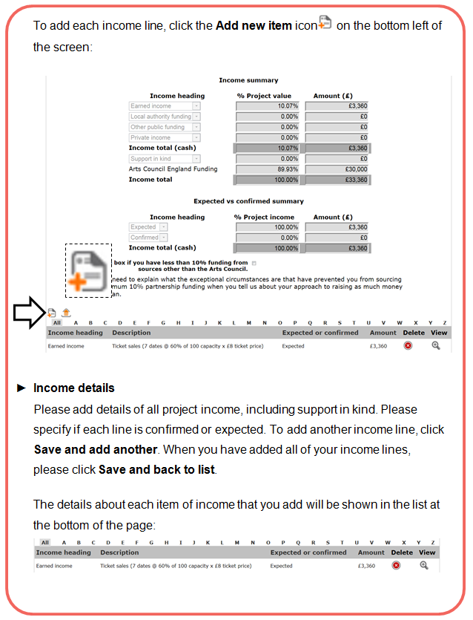

*Requesting more than 90 per cent of the cost of your activity from us*

In exceptional circumstances we may be able to provide up to 100 per cent of the cost of the activity.

If you tick this box you will need to explain why you are requesting more than 90 per cent of your project from us on the following screen when you tell us about your approach to raising as much money as you can.

*How to present your income lines*

* You should make sure that you show how your figures have been calculated in the 'Description' field, for example:

Ticket sales (7 dates @ 60% of 100 capacity x £8 ticket price) £3,360

* You should enter all the cash income specific to this project on this page (excluding the amount you are applying to us for), as well as any Support in kind you will receive
* You should include any other income that is either confirmed or expected towards the project, including any applications to other funding bodies or trusts or foundations, under the appropriate budget headings. We take this into account when we are completing the risk check, and we generally consider confirmed income to reduce financial risk. (We may ask you to provide evidence of income you have shown as confirmed as a condition against your first payment if your application is successful.)
* Please use full pounds only and no pence (for example, **£1,167** not **£1,167.21**)

*The budget headings (income)*

Earned income

Include any income you will earn from this activity (for example, from ticket sales, workshop fees or selling work or publications). You should be realistic about the level of income you are likely to earn for your activity. For touring activities, please provide details of your confirmed income from guaranteed fees from venues, your estimated income, or both. Please provide a clear breakdown for each entry to show us how you have reached your figures.

**Example: Earned income**

|  |  |  |  |
| --- | --- | --- | --- |
|  | Expected | Confirmed | Income |
| Four performances at a venue with 600 seats and a 70 per cent full audience (420 people) is 4 x 420 tickets at £6 = £10,080 | x |  | £10,080 |

If VAT is charged on ticket sales or admission prices, do not include it in your earned income figures. For information about VAT and other taxes, contact HM Revenue & Customs (HMRC) through their website ([www.hmrc.gov.uk](http://www.hmrc.gov.uk)).

Local authority funding

Include any funding you have received or applied for from local authorities for this activity. Please give us the name of each local authority and the amount.

Other public funding

Include any funding you have received or applied for from any other public organisation (for example, the British Council). Please give us the name of each organisation and the amount.

Private income

Include any income from private sources, for example from you or your organisation, donations or grants from trusts and foundations, or from crowdfunding. This should include funding you have already confirmed and funding you expect to receive (for example, applications you have made but have not received a decision on yet, or applications that you intend to make during the project). If you are an individual and you are providing some cash income towards the activity, please include it in this section. Please give us the details and the amounts.

Support in kind

Support in kind can be a valuable part of your activity.

Support in kind is used to describe any materials or services that you would otherwise have to pay for but that are being provided free of charge or at a reduced rate. The value of support in kind contributes towards the proportion of funding we require you to have from other sources.

Support in kind might include:

* equipment being provided free of charge that you would otherwise have to buy or hire
* the use of rehearsal or performance space that you would otherwise have to pay for
* volunteers who are giving their time for free
* a discount given from the full price of goods or services (for example, printing costs). You should show the discount amount as support in kind, and show the reduced cost you will pay for the goods or services in the expenditure section of the budget

Please include details of who is giving the support in kind, what it is and an estimate of its value.

You can find out more about how to work out the in kind support for your activity in the information sheet ‘[Support in kind, and Grants for the Arts’](http://www.artscouncil.org.uk/funding/grants-arts/2016/information-sheets), on our website.

Expenditure

* **Expenditure**

On this page you should enter all the cash expenditure for your project.

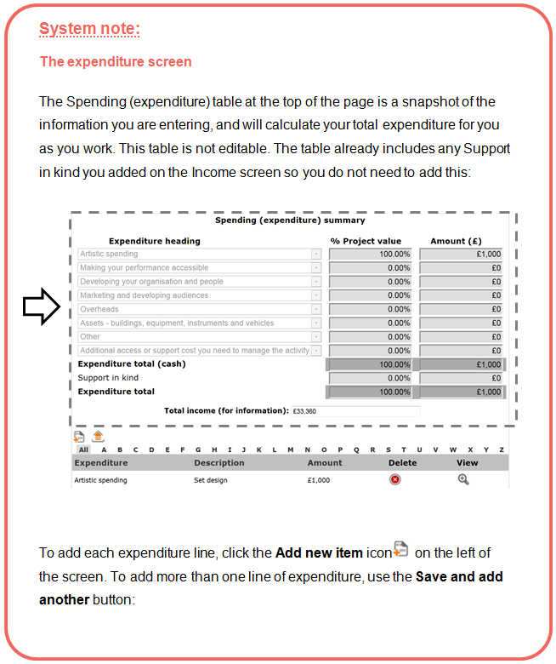

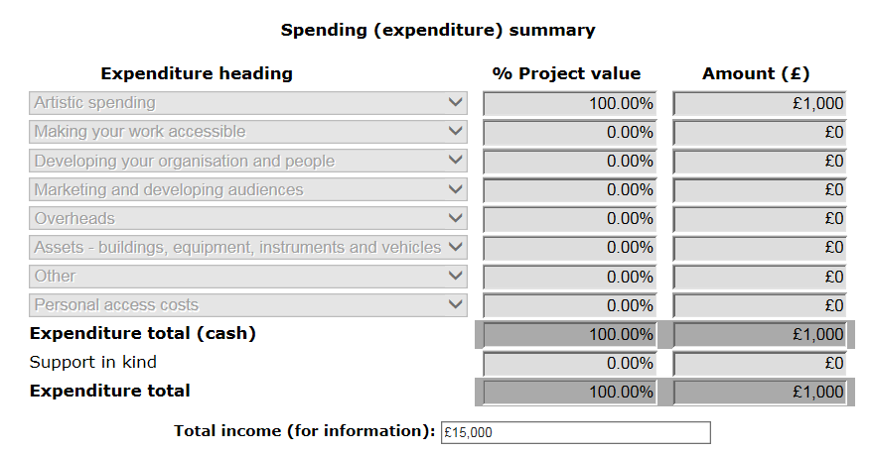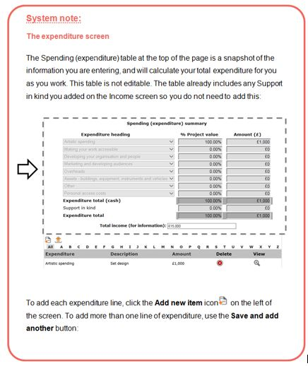





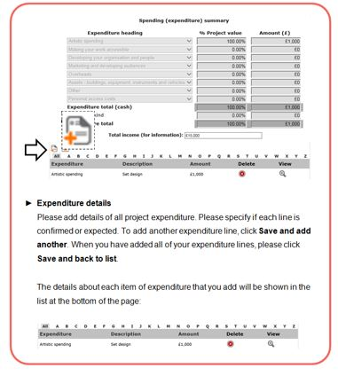



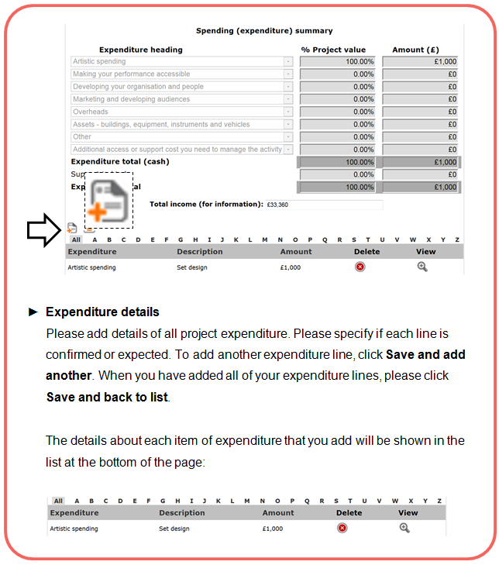



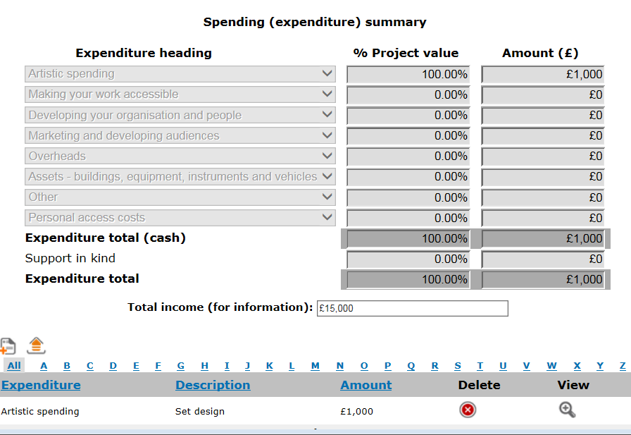

*How to present your expenditure lines*

* You should make sure that you show how all your figures have been calculated in the **description** field. For example, you should show the number of days and the daily rate for any fees shown:

Specialist marketing consultancy, 2 days @ £200 per day = £400

* If you are registered for VAT, your expenditure figures should not include VAT that you can claim back. If you are not registered for VAT, your costs should include VAT
* You should get financial advice from your own accountant or the relevant tax office. For information about VAT and other taxes, contact HM Revenue & Customs (HMRC) through their website ([www.hmrc.gov.uk](http://www.hmrc.gov.uk))

*The budget headings (expenditure)*

Artistic spending

In this section, please include any of the artistic costs you need to pay for. Please show how you have reached your figures.

You need to show:

* The fees and wages of artists involved in the activity

For example, actors, musicians, dancers, visual artists, stage designers, directors, producers, composers, writers, choreographers, stage managers, lighting designers, curators, workshop leaders and other artistic roles

We are committed to making sure that artists are paid appropriately for activities we support. The amount is likely to depend on a number of things, including the experience and skills of the artist, the type of work and the length of the contract. If you are involved in the activity as an artist, you can include your own artistic fees here

There are recognised codes of practice set by relevant lead organisations. You can find out more about fees for artists in the information sheet ‘[Paying artists, and Grants for the Arts’](http://www.artscouncil.org.uk/funding/grants-arts/2016/information-sheets), on our website. AN: The Artists Information Company also provides useful information on paying visual artists (visit [www.a-n.co.uk](http://www.a-n.co.uk))

If you are employing people to take part in your activity, you may need to budget for paying an employer’s National Insurance contribution for each person. You may also have to provide paid holiday leave and pension contributions

You should seek appropriate advice on your statutory obligations around employing people. For information contact HM Revenue & Customs (HMRC) through their website ([www.hmrc.gov.uk](http://www.hmrc.gov.uk))

* the other arts related costs of delivering the activity

Such as, the costs of events, commissions, research and development, preparation, productions and residencies, including any materials or equipment you hire to carry out these things. For touring activities, please include costs for creating and preparing the tour, and costs that are the direct result of touring (for example, travel, transport and accommodation)

Making your work accessible

We are committed to making sure that everyone has access to the work we fund. As a result, we encourage you to include the costs of making your activity accessible to participants and audiences.

In this section please include any costs that you will need to pay to make your activity accessible to a wide range of people. Access costs might include costs of signed performances and materials in other formats such as in Braille or on CD, for example.

Use the budget ‘personal access costs’ to tell us about costs relating to your own access needs, and/or any access needs of the artists you’re working with, that you will need to pay to help you deliver your Grants for the Arts project and manage your grant online.

Developing your organisation and people

Include the costs of any activity aimed at developing your organisation. This could include things like business planning, support from consultants, staff training and professional development costs, and feasibility studies (studies to test the potential of a business plan).

Marketing and developing audiences

Include all marketing and audience development costs that relate directly to the activity you are applying for.

For example, design and print costs, direct mailing, website design, photography, research, and fees to any people who are delivering press, audience development and marketing activity for you.

Overheads

There are some overheads or running costs that we do not fund. We have listed ‘What you cannot apply for’ in the Eligibility section of this guidance.

You can apply for extra time-limited overhead costs that are directly related to the activity you are asking us to support – for example, payments to staff, phone bills, postage and insurance. You can apply for a contribution to your ongoing overheads if these are not covered by other funding. The amount you apply for must relate directly to the amount of time spent on the activity you are asking us to support, so please explain how you have worked this out.

Assets – buildings, equipment, instruments and vehicles

Include any costs relating to refurbishing arts buildings, improving access, buying property and leasing a building. In general we would not expect to fund feasibility studies (studies to test the potential of a building plan) or early development of designs. Please see our information sheet ‘Capital applications – building projects and equipment purchases’ for more information.

Include the costs of buying assets including equipment, instruments and vehicles. You should get competitive quotes from more than one business or supplier. While we do not ask you to send quotes with your application, we do ask you to tell us about them in the question below this section of the budget. As part of our eligibility and risk checks we will look at whether any proposed asset purchases are justified and appropriate to the project. You may be asked to submit invoices for any purchases as a payment condition if your application is successful. You can find out more about purchasing equipment, instruments and vehicles in the information sheet ‘[Asset purchase and Grants for the Arts’](http://www.artscouncil.org.uk/funding/grants-arts/2016/information-sheets), on our website.

Other spending

Include any other spending for your activity that is not included elsewhere. This can include an amount for unexpected costs (contingency spending).

Personal access costs

Costs relating to your own access needs, and/or any access needs of the artists you’re working with, that you will need to pay to help you deliver your Grants for the Arts project and manage your grant online. For example, payment for a sign language interpreter to help you manage your activity.

Only include post-application costs for personal access costs in your expenditure table. Do not include costs relating to preparing, planning and submitting your application.

You will have told us about the expected costs of your personal access costs, as part of the eligibility questionnaire. The figure you provided will ‘pull through’ onto the online application form, and ‘pre-populate’ the basic details section and the expenditure table. If you need to change the amount you will need to edit the figure on the basic details page, and the budget line for personal access costs in your expenditure table will automatically update. You cannot edit the budget line for personal access costs from the expenditure table page.

To find out more about personal access costs please read our information sheet ‘[Access needs and Grants for the Arts](http://www.artscouncil.org.uk/funding/grants-arts/2016/information-sheets)’.

Finance questions

* **Finance questions**

**Question**

**Please describe your approach to raising as much money as you can from other sources. Identify which other sources of funding you have applied to, and the progress of any other applications you have made (including the date you will know the outcome)**

(No more than 1500 characters, approximately 250 words)

We want to make sure that the funds we award go as far as possible. Please tell us:

* how you plan to raise the funds from other sources shown in the income section for this specific project (if you have a fundraising plan, you can refer to it here)
* about any specific sources of funding you have applied to for this project, including when you expect to know if you have been successful (if you tell us about any applications you currently have under consideration with other funders here, you must include an appropriate figure in the income section of your budget otherwise we may treat your budget as unbalanced)
* if you have made (or intend to make) several applications for a total amount greater than what is required, on the basis that some of them will be unsuccessful, please tell us here about your approach here. Please indicate the applications you think are most likely to be successful and become partnership funds for this project. The budget you present must balance, and should be for the most likely scenario. We reserve the right to come to a judgement on whether your budget is balanced when read alongside your explanation.
* if your budget includes earned income, tell us more about how you have worked this out (how you decided on ticket prices, for example)

If you have requested more than 90 per cent of the cost of your activity from us

You must tell us in this box why you have been unable to secure the minimum 10 per cent funding from other sources. Using the information you give us we will decide whether we can accept your application. If we cannot, it will be made ineligible and we will not be able to process it.

**Question:**

Briefly tell us about your experience in managing budgets, and describe how you will manage the budget.

In this section we want you to list any relevant experience you have had managing budgets of a similar size. This information helps us to understand whether the budget is likely to be realistic and well managed. You can also tell us about any financial controls that are in place, such as:

* contingency (an amount in your budget for unexpected costs)
* who is responsible for authorising and making purchases
* your banking arrangements (for example, will you have a separate account for your activity to manage spending?)

**Question:**

Please describe how any fees, rates and purchases have been calculated

We want to know that the costs in your budget are reasonable and realistic. Please tell us how you have worked out the cost of:

Fees for artists and other people (such as project managers, consultants etc)

Remember, we are committed to making sure that artists are paid appropriately for activities we support.

Their fees will depend on a number of things, including their experience and skills, the type of work and the length of the contract.

Your answer to this question might include reference to industry standard guidelines. There are recognised codes of practice set by relevant lead organisations.

You can find out more about fees for artists in the information sheet ‘[Paying artists, and Grants for the Arts](http://www.artscouncil.org.uk/funding/grants-arts/2016/information-sheets), on our website. AN: The Artists Information Company also provides useful information on paying visual artists (visit [www.a-n.co.uk](http://www.a-n.co.uk)).

Fees or rates for services

If your application involves paying for services (for example website design, venue hire, PR support or other services) you should tell us how you have calculated your costs.

Asset purchases (purchasing equipment)

If your application involves buying equipment, instruments and vehicles, you should get quotes from more than one business or supplier. You do not have to send quotes with your application, but you should reference these quotes in your answer and we may ask for them at a later stage.

Here you must tell us briefly:

* how the equipment, instrument or vehicle is appropriate for your needs
* why purchasing the equipment is necessary (ie rather than hiring it)
* how your future running costs for any maintenance, insurance and replacement will be met

You can find out more about Asset purchases in the information sheets ‘[Asset purchase and Grants for the Arts’](http://www.artscouncil.org.uk/funding/grants-arts/2016/information-sheets) and ‘[Capital (Buildings) and Grants for the Arts’](http://www.artscouncil.org.uk/funding/grants-arts/2016/information-sheets), on our website.



# Management

* **Management**

In this section of the application form we want you to tell us how you will manage your project. We will ask you to tell us about any other partners involved in the project, where it will be taking place and how you will manage and evaluate the project. We will ask you to complete a timeline of the key stages of your project.

* **Partners**

**Question:**

Please list any project partners using the tool on this page

Here we ask you to tell us about any other partners involved in the project, their role in the project and the status of their involvement.

We want to know about who will be supporting the management and delivery of your activity. They could be an individual or an organisation, and will be working to support a specific aspect of the activity.

Please note that this question requires different information than the earlier question about artists involved in the activity. These partners might be completely separate to the artists who are involved in the activity, or they might be the same people or organisations performing different roles in your activity. (An artist you are working with might also be a partner. In the ‘Who’s involved’ section of the application form you will have told us about their artistic track record. In this section you should tell us about their management skills.)

We understand that not all types of activity will involve partners. If this is the case for your activity please leave this screen blank.

A partner could be a person or organisation:

* helping to manage the activity
* (for example a project manager)
* providing business support
* (such as a consultant or accountant)
* providing specialist sector support
* (such as publishers, curators, producers)
* helping you to reach participants or audiences
* (community groups, local authorities, housing associations, arts venues)
* supporting the activity in kind
* (providing free use of venue, marketing support, staff time etc)
* making a financial contribution to the activity

Types of partners could include:

* arts organisations, libraries or museums
* local authorities, community organisations and other non-arts organisations (such as housing associations, health authorities, schools, etc)
* venues
* audience development organisations
* individuals (such as tour manager, marketing manager, accountant etc)

We ask you to include contact details for each of your project partners. As part of our risk check we may contact some of your listed partners to confirm their involvement.

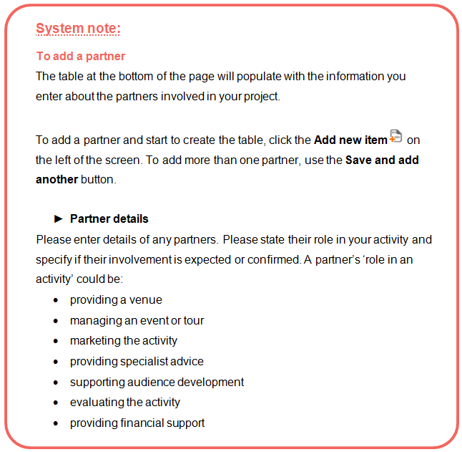

**Question:**

**Please provide a brief summary of your and your partners' recent experience in managing similar types of activity**

(No more than 1500 characters, approximately 250 words)

Please use this section to briefly outline your experience managing similar types of activity. Also, please tell us about any activity partners’ experience and expertise, showing why they are appropriate to support the management and delivery of the activity.

For example, if you have told us an organisation is providing audience development support for your activity, please briefly tell us about that organisation’s experience in that type of work.

* **Location**

**Question:**

**Tell us if your activity is touring, non-touring or both**

We report to local and national government on where funded projects take place. To help us to do this we ask you to give us information on where your project will take place. You will be asked to complete a tour schedule and / or tell us where the non-touring activity will take place.

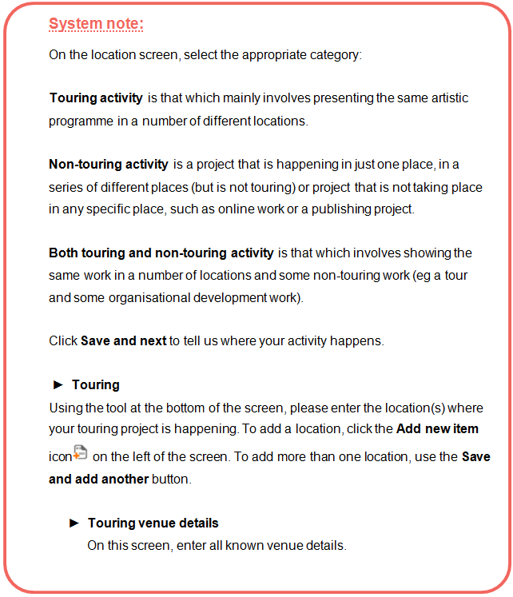

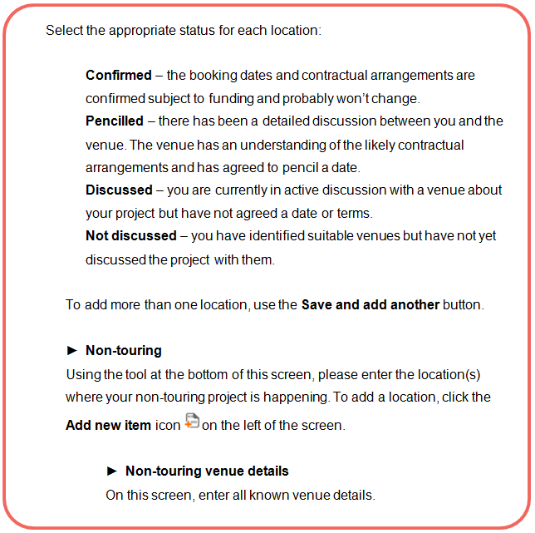

Activity timeline

* **Activity plan**

To give us a clear understanding of how your project will be managed, we would like to know about your planning and preparation to date and to see an outline project plan for your proposed activity.

**Question:**

**Please briefly identify the main stages of any planning and preparation activity completed to date.**

(No more than 1500 characters, approximately 250 words)

We want to know what planning you have done to date so that we can understand if your activity is well considered and realistic. Please list the preparation you have done for this activity. For example:

* research
* developing partnerships
* scoping work (eg audiences, building)
* considering potential risks
* planning the delivery of the activity (eg producing a timeline)
* securing commitment from partners subject to funding

Please note this work should not be included in your budget, as we cannot fund any part of an activity that has already taken place.

If we have agreed to process your application time sensitively, you **must** tell us here how you plan to manage the short timescale of your activity. If you do not do this, we may decide that your activity has a major risk and will be unable to consider it.

**Question:**

**Complete the table, identifying date, end date, activity or task and task lead**

Identify the main stages of the activity from the start date onwards, and to show who will lead on each element of the activity.

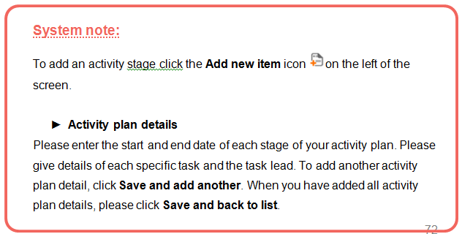

You can add as many lines as you need to this table to identify the main stages of the activity, for example: planning, partnership development, research, delivery (any performances/shows/exhibitions/workshops/ events), evaluation, and so on. Where an activity includes public performances or events (for example a tour or a festival) that happen during the activity period, these should be clearly identified using the timeline. This allows us to get an overview of the different stages of your activity.

Please add the stages of the activity to the table in chronological order.

Dates for the different stages of your activity can overlap (for example, if you will be marketing the activity at the same time as completing other stages). In the final column ‘task lead’ please tell us who will be managing each stage of the activity. This could be you, or one of your partners.

There is an example activity plan on the next page.

**Example activity plan:**

|  |  |  |  |
| --- | --- | --- | --- |
| **Start date** | **End Date** | **Activity or task** | **Task Lead** |
| 1/8/2016 | 15/8/2016 | Conclusion of project planning including confirmation of workshop schedule | John Smith  (project manager) |
| 8/8/2016 | 22/8/2016 | Marketing | Community partners |
| 19/8/2016 | 30/8/2016 | Workshop planning by artists | Lead artists |
| 4/9/2016 | 4/9/2016 | Introductory workshop session at Newtown Community Centre | John Smith (project manager) with Newtown Community Centre |
| 10/9/2016 | 10/9/2016 | Workshop session with Lead Artist 1 | Kate Jones (Lead artist 1) |
| 17/9/2016 | 17/9/2016 | Workshop session with Lead Artist 2 | Adil Gupta (Lead artist 2) |
| 24/9/2016 | 24/9/2016 | Workshop session with Lead Artist 3 | Jack Shaw (Lead artist 3) |
| 1/10/2016 | 1/10/2016 | Workshop session with Lead Artist 4 | April Johnson (Lead artist 4) |
| 11/10/2016 | 11/10/2016 | Final show of work at Newtown Community Centre | John Smith  (project manager) |
| 15/10/2016 | 15/10/2016 | Feedback session with participants | John Smith  (project manager) |
| 15/10/2016 | 31/10/2016 | Evaluation period | John Smith (project manager) and lead artists |

Evaluation

* **Evaluation**

**Question:**

**Please briefly tell us how you plan to monitor the progress of your activity and to evaluate your achievements throughout the activity.**

(No more than 1500 characters, approximately 250 words)

If we give you a grant, we will ask you to evaluate your work and fill in an activity report form at the end of your activity.

Evaluation is a structured way of thinking about what has happened. Evaluation can help you to:

* make decisions during your activity
* shape future activities
* improve your work
* show what happened as a result of your activity

You can find a basic introduction to evaluating arts activities in the information sheet ‘[Self evaluation and Grants for the Arts’](http://www.artscouncil.org.uk/funding/grants-arts/2016/information-sheets), on our website.



# Attachments/ links

* **Letter attachments**

This screen will only be visible if you have told us in the eligibility questionnaire or on the Basic details screen that your activity requires permission to apply.

Please upload a copy of any correspondence we have sent you in which we gave you permission to apply under certain circumstances:

* If your application is for more than £100,000
* If your application is for a Capital project over £15,000
* If you are making an additional application while you are still awaiting a decision from us on a first application
* If your application relates to Music education hubs activity
* If your application is to be processed time sensitively

If you do not attach the appropriate letter(s) here, we will be unable to process your application.

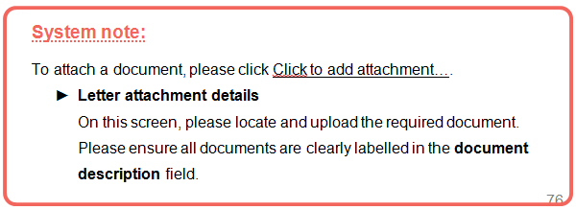

* **Other attachments (under £15,000)**

Where appropriate, you can upload one supporting document as an attachment or one web link to illustrate the quality of your work.

This attachment or web link should only be used to give us a sense of your work. It should not be used to provide further information about your activity.

* we can only accept one document or web link
* the document can be a maximum of five pages
* the maximum file size you can upload is 10MB
* we can accept the following formats:
  + pdf
  + jpeg (image file)
  + Microsoft Word
  + Microsoft PowerPoint
  + web link (please note we will only view a single website page)

Please do not upload links to folders or sites containing lots of documents — we will not be able to take these into account.

If you are applying as an organisation, your **governing document** will pull through from your applicant profile to this screen. You do not need to upload it again.

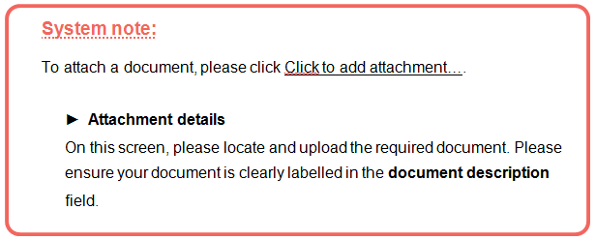



# Monitoring, the declaration and submitting your form

* **Monitoring information**

This screens show the information you entered in your applicant profile. Please review the information to ensure that it is correct. This is particularly important if you haven’t made an application to us using that profile for some time.

We may use this information to report to the government or to monitor the different backgrounds of people who receive grants. We will **not** use this information to appraise your application. If you do not know some of the information or you would prefer not to provide it, you can fill in the ‘Prefer not to say' box.

For organisations: We define an organisation as being 'Black and minority ethnic led' if at least 51% of the senior managers, management committee, board, governing body or council identify as Black or minority ethnic. Please give the number of senior managers and members on your management committee, board, governing body or council who identify as being from the listed groups.

* **Declaration**

This screen contains a tick box asking you to confirm that the information provided is correct and that you are authorised to submit it on behalf of the applicant. It also includes a number of important questions about you and your application. **Please read the declarations carefully before you respond to them.**

* **Submission summary**

The submission summary displays a list of all the steps you’ve worked through. If you have completed a step successfully, there will be a green tick beside it. If a step is incomplete or has not been completed successfully, this will be indicated by a red cross. A hyperlinked statement will tell you what part of each step needs attention. Click on this hyperlinked statement to take you to the step and make your amendments.

Submitting your application

By clicking **Submit**, you are submitting your application for our consideration.

The system will return you to the Submissions screen, where you will see a submission time and date next to the Application form submission for your project.

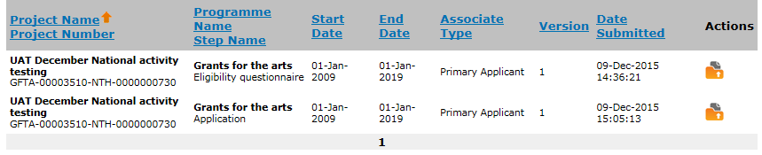



# What happens to your application

You’ve submitted your application. What happens next?

1 Eligibility check

When we get your application we first check whether it is eligible. More information on eligibility can be found in the Eligibility section of this guidance.

If your application is not eligible, this means that we cannot process it any further and it will not be considered for funding. If your application is not eligible we will notify you via the online system, and will explain our decision.

If your application is eligible, we will send you a confirmation email. The email will include your project number, which we will use whenever we contact you about your application. Please quote your project number if you need to contact us.

We will complete our eligibility check within 10 working days of receiving your application. If you have not heard from us within this time you can contact us at [enquiries@artscouncil.org.uk](mailto:enquiries@artscouncil.org.uk), or on 0845 300 6200.

2 Risk check

If your application is eligible, we will carry out a risk check. This check looks at how realistic and achievable your management plans and budget are.

The things we look at as part of the risk check include (but are not limited to):

* timeline  
  For example: Is the timeline achievable and detailed enough?
* partnerships  
  For example: Are appropriate partnerships in place to support the activity, and are they confirmed?
* planning  
  For example: Is the activity sufficiently well planned?
* tour schedule  
  For example: Is any tour schedule at an appropriate stage of confirmation?
* evaluation  
  For example: Are plans to evaluate the activity appropriate?
* budget  
  For example: Is the budget reasonable and appropriate for the activity you’ve proposed?
* partnership funding  
  For example: Is there an appropriate level of partnership funding, and is any expected funding likely to be secured?
* financial management  
  For example: Are there appropriate measures in place to manage the budget?
* asset purchase  
  For example: Are any asset purchases justified clearly, and are the costings based on quotes?
* previous grants from us  
  For example: How has any previous funding you have had from us been managed?
* governance (organisations)

For example: We will check your Companies House/Charity Commission registrations where appropriate, and may check that your governing document allows you to deliver the activity you are proposing.

How we look at risk

We can give any of these factors a risk rating of major, moderate or minor.

Major risk means that a particular issue gives us concern that the activity is not likely to be managed successfully and/or there are serious concerns about your budget.

If we consider any aspects of your activity’s management or finances to be major risk, we cannot process it any further and it will not be funded. If your application is unsuccessful at the risk check stage, we will notify you via the online system, and will explain our decision.

Moderate risk means that although a particular issue represents some risk to the successful delivery of the activity, we have decided that this can be addressed.

If you are awarded funding, we will ask you to send us additional information before we will release your first payment. We call these additional pieces of information ‘payment conditions’. For example, we might ask for a confirmed tour schedule or confirmation that the other income for the activity is in place.

Minor risk means that although we have noted a particular issue we do not think it represents risk to the successful delivery of the activity, and we will take no action.

3 Decision making

After completing the risk check, we will consider the strength of the artistic and public engagement aspects of your activity. We want to fund activities that are of high quality and engage people strongly.

We will consider your activity alongside other applications and will look at the range of projects we support. We want the projects we fund to cover a broad range of activity types, artforms and geographical areas. We also review a range of reports on our spending so far and future demand, and refer to our [Corporate Plan](http://www.artscouncil.org.uk/what-we-do/mission/our-plan-2015-18/). This influences the choice we make.

We will also review our investment in activities in areas of least engagement with the arts. These are the areas that have been identified as being in the bottom 33 per cent of areas in England for engagement with the arts by the [Active People Survey](http://www.artscouncil.org.uk/what-we-do/research-and-data/arts-audiences/active-people-survey/). For more information visit our website.

When we will reach a decision

We will aim to reach a decision on all eligible applications for £15,000 or under within six weeks from the date you submitted.

If we are not able to meet our published turnaround times we will let you know by email as soon as we can.

Once a decision is made

Once we have made a decision, we will advise you by email to log in and check the outcome of your application via the online system.

If your application is successful

If you are awarded funding, your online account will show an offer letter and additional information that will allow you to accept the grant via the online system.

We might also list some additional information you will need to provide us with before we will release your first payment (we call these additional pieces of information ‘payment conditions’). For example, we might ask for a confirmed tour schedule or confirmation that the other income for the activity is in place.

Accepting your offer

We will ask you to acknowledge and accept your offer letter and our terms and conditions via the system using the ‘Acknowledge offer letter’ submission.

Everyone who receives a grant must accept our standard conditions. These conditions are attached to any offer, and are also available on our website or you can contact us for a copy ([enquiries@artscouncil.org.uk](mailto:enquiries@artscouncil.org.uk), 0845 300 6200).

You will also need to print out and complete the bank details form, and send this back to us in **hardcopy** (this is for security reasons).

Requesting your first payment from us

For each payment of your grant, there will be a submission called ‘Payment request’ in the Submissions area of the online system that you must complete before we can release any payments. This submission also allows you to upload any information needed to meet the payment conditions we have set.

Please see our [guidance sheet](http://www.artscouncil.org.uk/funding/our-application-portal/post-decision-support) for step by step instructions on accepting a grant and requesting a payment.

If your application is unsuccessful

If we decide not to fund your activity, your online account will show a letter explaining our decision and outlining your next steps. This contains the full level of feedback that we are able to provide.

Grants for the Arts is a rolling programme and you can reapply. However, please note that any new application for the same activity must sufficiently address the reasons that the original application was not considered for funding. We will not be able to consider any reapplications that have not done this. If you would like to reapply you will need to begin a new application form using the online system.



# Further information

Complaints procedure

If you are not happy with the way we dealt with your application, please contact us and we will discuss this with you. If you are still unhappy, you can ask us for a copy of our complaints procedure. Details are in Making a complaint, which is available on our website, [www.artscouncil.org.uk](http://www.artscouncil.org.uk) or by contacting us by email to [enquiries@artscouncil.org.uk](mailto:enquiries@artscouncil.org.uk) or by phoning 0845 300 6200.

Please note that you can only complain if you believe we have not followed our published procedures when processing your application. You cannot appeal against the decision.

What to do if you cannot accept National Lottery funding for religious reasons

The funding we can provide from other sources is very limited, but we can arrange other funding if you cannot accept National Lottery funding for religious reasons. You should apply using our normal application materials and tick the box in the Basic details section to state that you cannot accept National Lottery funding. We will process your application in the same way that we process all applications. If we decide to offer you a grant, it will not come from our budget from the National Lottery.

Making records of your activity available to us for audit

Applicants should be aware that Arts Council England conducts checks on a sample of applications every year to ensure that our funding is being used appropriately. We reserve the right to ask successful applicants for access to all or part of their documentation relating to their activity, and therefore grantholders must keep clear records of project management and financial records (including all invoices) for us to access when required.

Freedom of Information Act

The Arts Council is committed to being as open as possible. We believe that the public has a right to know how we spend public funds and how we make our funding decisions.

We are also listed as a public authority under the Freedom of Information Act 2000. By law, we may have to provide your application documents and information about how we have reached our decision to any member of the public who asks for them under the Freedom of Information Act 2000.

We may not release those parts of the documents which are covered by one or more of the exemptions under the Act. Please see the Freedom of Information website at [www.ico.gov.uk](http://www.ico.gov.uk) for information about freedom of information generally and the exemptions.

We will not release any information about applications whilst we are making a decision, as this may interfere with the decision-making process.

You can find out more about the Freedom of Information Act in the information sheet ‘How we treat your application under the Freedom of Information Act’, on our website.

Public Sector Equalities Duty

Your application form gives us information we may use to report to the Government or to monitor the different backgrounds of people who receive grants.

Under the Public Sector Equalities Duty we must research and monitor the different backgrounds of people who receive our grants.

Solicited applications

We may occasionally ask for specific applications to help us achieve our mission and priorities. This may be different from area to area depending on the local priorities. For more details about our mission and priorities, please see our website [www.artscouncil.org.uk](http://www.artscouncil.org.uk).

**Arts Council England**

**Phone:** 0845 300 6200, 0161 934 4317

**Textphone:** 0161 934 4428

**Email:** [enquiries@artscouncil.org.uk](mailto:enquiries@artscouncil.org.uk)

**Website:** [www.artscouncil.org.uk](http://www.artscouncil.org.uk)

**Post:** Arts Council England - Grants for the Arts,

The Hive, 49 Lever Street, Manchester, M1 1FN

Charity registration no. 1036733

© Arts Council England September 2016