ACE-logo

**Budgets for Grants for the Arts activities**

# 

Contents

**1 Grants for the Arts 2**

**2 Example budgets for Grants for the Arts activities 2**

**3 Key things to remember 2**

**4 Completing the budget table 3**

4.1 Income 3

4.2 Support in kind 5

4.3 Expenditure 5

**5 Example Budgets 9**

5.1 Example blank budget – Income section 10

5.2 Example budget for an individual artist 12

5.3 Example budget for an individual with personal access costs 14

**6 Contact us 15**

# 1 Grants for the Arts

Grants for the Arts (GFTA) is our Lottery-funded grant programme for individuals, arts organisations and other people who use the arts in their work. Grants are available for activities carried out over a set period and which engage people in England in arts activities and help artists and arts organisations in England carry out their work.

Activities we support must be clearly related to the arts and must be project-based, up to a maximum of three years in length. Grants normally range from £1,000 to £100,000 and we can fund up to 90 per cent of the cost of an activity.

All applicants must also read the ‘[How to apply guidance](http://www.artscouncil.org.uk/funding/grants-arts/2016/how-to-apply)’, download it from our website or contact us for a copy.

# 2 Example budgets for Grants for the Arts activities

As part of your Grants for the Arts application form, you must provide a budget for your activity. The budget section of the application form gives us the information we need to be able to consider the financial viability of your activity.

The total income and total spending (expenditure) must be the same. If they are not, we will not be able to process your application. This guidance will help you to present a balanced budget.

# 3 Key things to remember

**Your budget has to balance**

Your income needs to be the same as your expenditure

**We expect you to find at least 10 per cent of the total cost of your activity from other sources**

Financial income from other sources helps to demonstrate partnership support for the activity, and shows that the activity is making the most of our investment

**We need to be able to see how you have worked your figures out**

Please break them down clearly under the headings provided in the budget table

**The budget should be for the total cost of the project**

You should include all the income you hope to receive, and all the money you think you will need to spend to deliver your activity. If the money you request from Arts Council England will be spent on a specific part of the activity, please let us know in the written section of your budget.

**Please use full pounds only and no pence**

For example, £1,167 not £1,167.21

**Please check your figures carefully**

If you do not fill in your budget correctly, we cannot process your application

# 4 Completing the budget table

## 4.1 Income

In this section of the application form we ask you to tell us about any other cash income for your activity, as well as any Support in kind you will receive.

We expect at least 10 per cent of the total cost of the activity to come from other sources. Financial income from other sources helps to demonstrate partnership support for the activity, and shows that the activity is making the most of our investment.

You should break down the income for your activity under the headings provided in the budget table. You need to show whether you are expecting each item of income or whether it has been confirmed. We take this into account when we are completing the risk check, and we generally consider confirmed income to reduce financial risk.

For each entry you will need to select the appropriate income heading, give a brief description (ticket sales, private donation, crowd funding etc), tick to show if this income is Expected or Confirmed and enter the amount.

You can add additional budget lines under each Income heading, so you do not need to include all Earned income in one budget line. Adding more budget lines breaks down the budget, giving us more detail about your income.

**Earned income**

Include any income you will earn from this activity (for example, from ticket sales, workshop fees or selling work or publications). You should be realistic about the level of income you are likely to earn for your activity. For touring activities, please provide details of your confirmed income from guaranteed fees from venues, your estimated box office income, or both.

Please provide a clear breakdown for each entry to show us how you have reached your figures.

*If VAT is charged on ticket sales or admission prices, do not include it in your earned income figures. For information about VAT and other taxes, contact HM Revenue & Customs (HMRC) through their website (www.hmrc.gov.uk).*

**Local authority funding**

Include any funding you have received or applied for from local authorities for this activity. Please give us the name of each local authority and the amount.

**Other public funding**

Include any funding you have received or applied for from any other public organisation (for example, the British Council). Please give us the name of each organisation and the amount.

**Private income**

Include any income from private sources, for example from you or your organisation, or donations (including crowd funding) or grants from trusts and foundations. If you are providing some cash income towards the activity, please include it in this section. Please give us the details and the amounts.

## 4.2 Support in kind

Support in kind can be a valuable part of your activity. Support in kind is used to describe any materials or services that you would otherwise have to pay for but that are being provided free of charge or at a reduced rate. The value of support in kind contributes towards the proportion of funding we require you to have from other sources.

Support in kind might include:

* Equipment being provided free of charge that you would otherwise have to buy or hire
* The use of rehearsal or performance space that you would otherwise have to pay for
* Volunteers who are giving their time for free

Please include details of who is giving the support in kind, what it is and an estimate of its value.

*You can find out more about how to work out the ‘in kind’ support for your activity in the information sheet ‘Support in kind and Grants for the Arts’ Download it from our* [*Grants for the Arts information sheets*](http://www.artscouncil.org.uk/funding/grants-arts/2016/information-sheets) *page, or contact us for a copy.*

## 4.3 Expenditure

In this section of the application form we ask you to give details of all the items you will be paying for as part of your activity. You should break down the expenditure for your activity under the headings provided in the budget table. Please show how you have reached your figures.

You can add additional budget lines under each Expenditure heading, so you do not need to include all Artistic spending in one budget line. Adding more budget lines breaks down the budget, giving us more detail about your expenditure.

**Artistic spending**

In this section, please include any of the artistic costs you need to pay for.

You need to show the fees and wages of artists involved in the activity. For example, actors, musicians, dancers, visual artists, stage designers, directors, producers, composers, writers, choreographers, stage managers, lighting designers, curators, workshop leaders and other artistic roles.

We are committed to making sure that artists are paid appropriately for activities we support. The amount is likely to depend on a number of things, including the experience and skills of the artist, the type of work and the length of the contract.

*There are recognised codes of practice set by relevant lead organisations. You can find out more about fees for artists in the information sheet ‘Paying artists and Grants for the Arts’, on our website. Download it from our* [*Grants for the Arts information sheets*](http://www.artscouncil.org.uk/funding/grants-arts/2016/information-sheets) *page, or contact us for a copy. AN: The Artists Information Company also provides useful information on paying visual artists (visit* [*www.a-n.co.uk*](http://www.a-n.co.uk)*).*

If you are employing people to take part in your activity, you may need to budget for paying an employer’s National Insurance contribution for each person. You may also have to provide paid holiday leave and pension contributions.

*You should seek appropriate advice on your statutory obligations around employing people. For information contact HM Revenue & Customs (HMRC) through their website (www.hmrc.gov.uk).*

You should include any other Artistic costs in the Artistic spending section. This might include: the costs of events, commissions, research and development, preparation, productions and residencies, including any materials or equipment you hire to carry out these things. For touring activities, please include costs for creating and preparing the tour, and costs that are the direct result of touring (for example, travel, transport and accommodation).

**Making your work accessible**

We are committed to making sure that everyone has access to the work we fund. As a result, we encourage you to include the costs of making your activity accessible in your budget.

In this section please include any costs that you will need to pay to make your activity accessible to a wide range of people. Access costs might include costs of signed performances and materials in other formats such as in Braille or on CD, for example.

If you are Deaf or disabled and have personal access costs (costs relating to yourself and/or the artists you are working with that you will have to pay to manage your activity), please see our advice for disabled or Deaf applicants at the end of this section.

**Developing your organisation and people**

Include the costs of any activity aimed at developing your organisation. This could include things like business planning, support from consultants, staff training and professional development costs, and feasibility studies (studies to test the potential of a business plan).

**Marketing and developing audiences**

Include all marketing and audience development costs that relate directly to the activity you are applying for. For example, design and print costs, direct mailing, website design, photography, research, and fees to any people who are delivering press, audience development and marketing activity for the project you are applying for.

**Overheads**

There are some overheads or running costs that we do not fund. We have listed ‘What you cannot apply for’ in the [How to apply](http://www.artscouncil.org.uk/funding/grants-arts/2016/how-to-apply) guidance.

You can apply for extra time-limited overhead costs that are directly related to the activity you are asking us to support – for example, payments to staff, phone bills, postage and insurance. You can apply for a contribution to your ongoing overheads if these are not covered by other funding. The amount you apply for must relate directly to the amount of time spent on the activity you are asking us to support, so please explain how you have worked this out.

*ACEVO (Association of Chief Executives of Voluntary Organisations) has produced a practical guide and toolkit on cost allocation. You can use this to work out the full cost of a project or an activity including extra and ongoing overheads. It is available from* [*www.acevo.org.uk*](http://www.acevo.org.uk) *or by phoning 0845 345 8481.*

**Assets – buildings, equipment, instruments and vehicles**

Include any costs relating to refurbishing arts buildings, improving access, buying property and leasing a building.

*Remember, you must get our agreement in writing before you can make any application for over £15,000 relating to buildings to be used for the arts. Please read ‘Capital (Buildings) and Grants for the Arts’ for more information. Download it from our* [*Grants for the Arts information sheets*](http://www.artscouncil.org.uk/funding/grants-arts/2016/information-sheets) *page, or contact us for a copy.*

Include the costs of buying assets including equipment, instruments and vehicles. You should get competitive quotes from more than one business or supplier. While we do not ask you to send quotes with your application, we do ask you to tell us about them in the question below this section of the budget.

*You can find out more about purchasing equipment, instruments and vehicles in the information sheets ‘Asset purchase and Grants for the Arts’ and ‘Vehicle purchase and Grants for the Arts’. Download them from our* [*Grants for the Arts information sheets*](http://www.artscouncil.org.uk/funding/grants-arts/2016/information-sheets) *page, or contact us for a copy.*

Personal access costs

Costs relating to your own access needs, and/or any access needs of the artists you’re working with, that you will need to pay to help you deliver your Grants for the Arts project and manage your grant online. For example, payment for a sign language interpreter to help you manage your activity.

Only include post-application costs for personal access costs in your expenditure table. Do not include costs relating to preparing, planning and submitting your application.

You will have told us about the expected costs of your personal access costs, as part of the eligibility questionnaire. The figure you provided will ‘pull through’ onto the online application form, and ‘pre-populate’ the basic details section and the expenditure table. If you need to change the amount you will need to edit the figure on the basic details page, and the budget line for personal access costs in your expenditure table will automatically update. You cannot edit the budget line for personal access costs from the expenditure table page.

To find out more about personal access costs please read our information sheet ‘[Access needs and Grants for the Arts](http://www.artscouncil.org.uk/funding/grants-arts/2016/information-sheets)’.

**Other**

Include any other spending for your activity that is not included elsewhere, such as your contingency.

# 5 Example Budgets

The following pages show examples of project budgets for Grants for the Arts activities.

Please remember that the income and spending in these examples are to give you an idea of the items that you might need to include in your budget and the level of detail we require. All prices, artists’ fees and equipment given are for example only and are not intended to indicate an Arts Council-endorsed fee or price.

## 5.1 Example blank budget – Income section

The budget table as seen in the online application form.

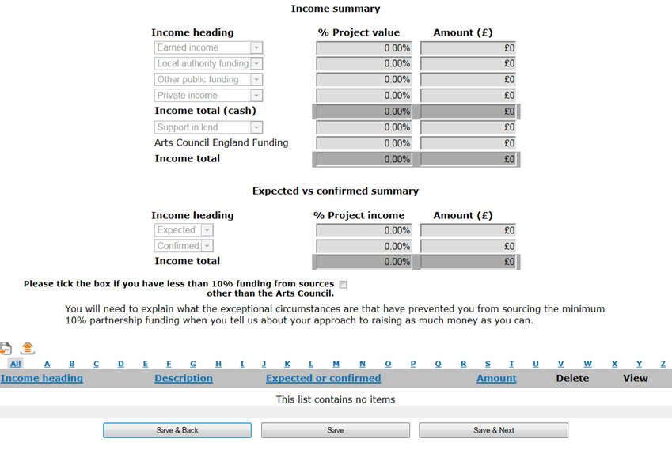

**Example blank budget - Expenditure section**

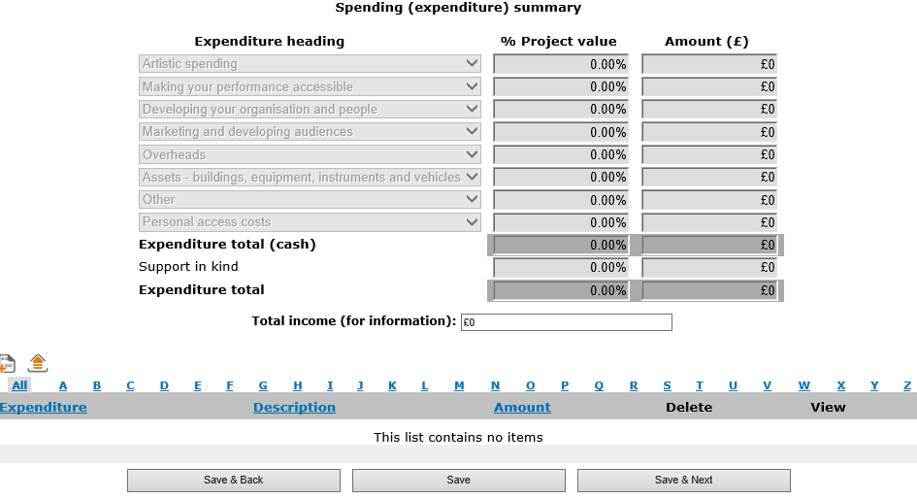

## 5.2 Example budget for an individual artist

An example application budget from an individual artist.

**Income section:**

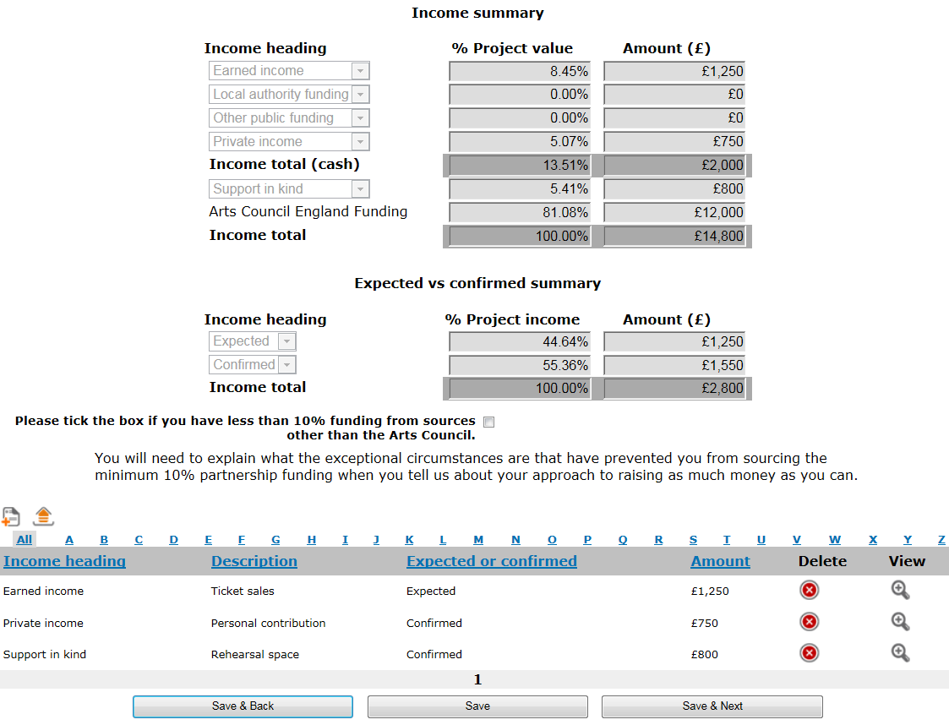

**Expenditure section:**

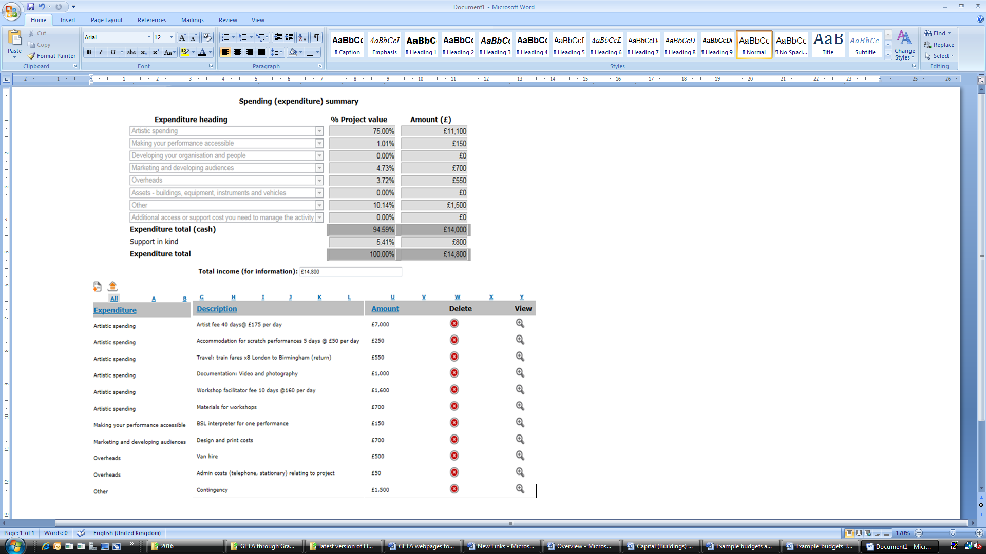

## 5.3 Example budget for an individual with personal access costs

An example application budget from an individual. Personal access costs of £350 are included, so the full amount requested is £15,350. This takes the application over the £15,000 threshold. This will not affect the turnaround times, and we will still reach a decision within six weeks.

**Income section:**

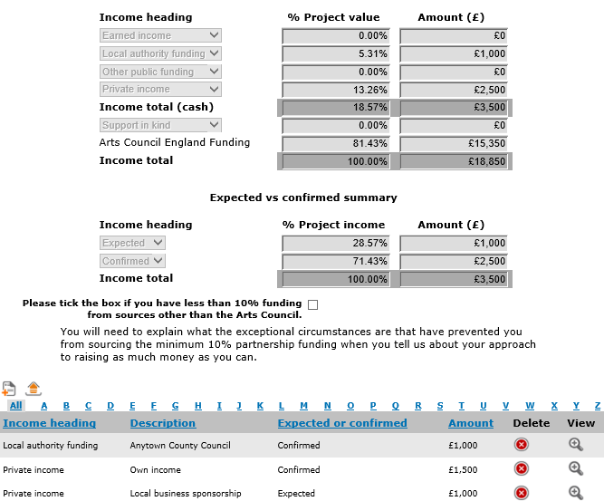

The expenditure related to your personal access costs (£350 in this example) should be detailed under the Expenditure heading ‘Personal access costs’.

**Expenditure section:**

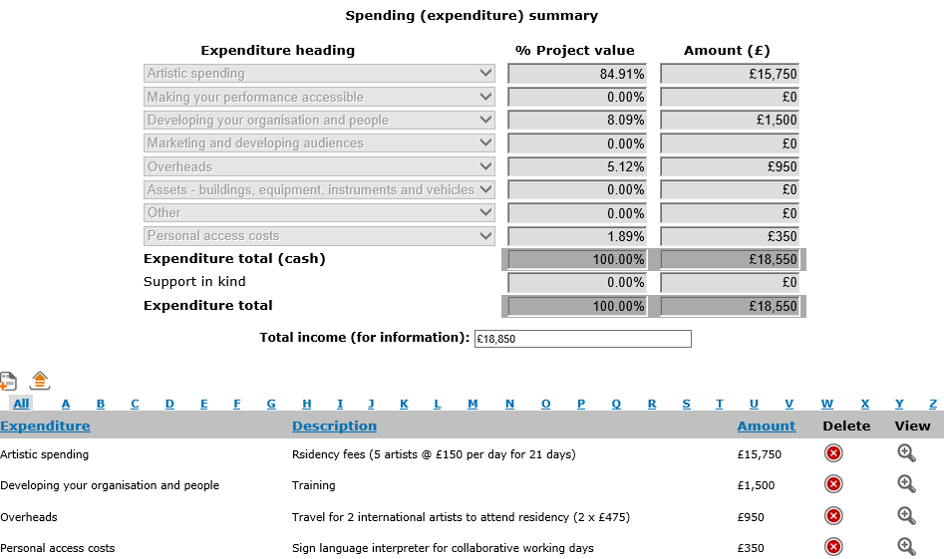

# 6 Contact us

**Phone:** 0845 300 6200, 0161 934 4317

**Textphone:** 0161 934 4428

**Email:** [enquiries@artscouncil.org.uk](mailto:enquiries@artscouncil.org.uk)

**Website:** [www.artscouncil.org.uk](http://www.artscouncil.org.uk)

**Post:**  Arts Council England - Grants for the Arts,

The Hive, 49 Lever Street, Manchester, M1 1FN

© Arts Council England September 2016