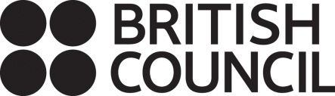
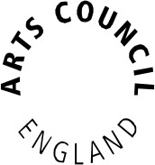

Arts Council England and British Council
Artists’ international development fund

Guidance for applicants

Round 14, application deadline 26 October 2016

Contents

Welcome 3
About the Artists’ international development fund 3
Three steps to apply for AIDF 7
Using this guidance 10
Eligibility 11
Who can apply 11
Who cannot apply 12
What artforms will be considered 12
What you cannot apply for 13
Where you can apply to work 13
How much you can apply for 14
When you can apply 15
How much time a proposal can cover 16
‘What if I’m awarded funding and have to change my plans?’ 16
Reapplying 17
Using our online system 18
Using our online system – an introduction 18
Using our online system – applicant profiles 20
Using our online system – the eligibility quiz 22
The application form 30
Filling in the application form 31

Applicant details and basic details 35
Artistic Quality 38
Public Engagement 41
Finance 42
Income for your activity 42
Expenditure for your activity 47
Finance questions 53
Management 55
Partners 55
Location 57
Activity plan 57
Evaluation 61
Attachments 61
Monitoring, the declaration and submitting your form 63
What happens to your application 65
1 Eligibility check 65
2 Risk check 66
3 Decision making 67
When we will reach a decision 68
If your application is successful 68
If your application is unsuccessful 69
Further information 70
Complaints procedure 70
What to do if you cannot accept National Lottery funding
for religious reasons 70
Making records of your activity available to us for audit 70
Freedom of Information Act 71
Public Sector Equalities Duty 71

Welcome

Thank you for your interest in the Artists’ international development fund (AIDF). This guidance should give you all the information you need to apply, so please read it carefully before you fill in the online application form.

About the Artists’ international development fund

The Artists’ international development fund is a jointly funded programme between the British Council and Arts Council England. This programme supports the shared objectives of the British Council and Arts Council England.

The Arts Council’s mission is ‘great art and culture for everyone’. We exist to create the conditions in which great art and culture can be made, experienced and appreciated by everyone. We work to get great art and culture to everyone by championing, developing and investing in artistic and cultural knowledge and experiences that enrich people’s lives. The British Council's arts programme lives and breathes the aspiration to inspire to transform lives – to offer creative artists, participants and audiences across the world life changing and life enhancing experiences. Our catalyst is the UK's profound cultural and artistic strength and diversity.

We have developed the Artists’ international development fund to help us achieve our aims within goal 1 of the Arts Council’s 10-year framework Great art and culture for everyone: talent and artistic excellence are thriving and celebrated. We want artists to be open to international perspectives and to expand their horizons. You can find out more about this in the Arts Council Plan 2015–18.

The Artists’ international development fund offers early stage development opportunities for individual freelance and self-employed artists and/or creative practitioners (including, for example: producers, curators, publishers, editors, translators, choreographers) based in England to spend time building links with artists, organisations and/or creative practitioners in another country.

Individual applicants who are employed by arts and culture organisations are now eligible to apply; a limited number of awards will be made to individual applicants working for organisations. However, our ambition to achieve a success rate of not less than 30% for individual freelance and self-employed artists and/or creative practitioners will be maintained.

We are particularly interested in receiving applications from individuals based outside London. We anticipate making a higher proportion of awards to areas of the country beyond the capital in this and subsequent rounds.

We are also particularly interested in receiving applications from practitioners and producers in the fields of theatre, dance, literature, music and cross-disciplinary work. Historically, AIDF has funded more individuals working in the field of visual arts than other disciplines.

The programme is open to emerging and mid-career artists and/or creative practitioners in any of the eligible artforms (see page 9):
- who have received recognition for their work in England
- who do not have extensive international experience or whose international experience is limited to countries other than those that are the subject of their proposal
- whose work will benefit from launching better international networks – either artistically or in terms of developing an audience for their work
- who can demonstrate an interest in their work from an overseas partner/host, demonstrated by a letter of support from the overseas partner/host.

Applicants can use the fund to do one or all of the following:

- develop their artistic practice through working internationally
- collaborate with and learn from artists and/or creative practitioners internationally
- create early relationships with artists and/or creative practitioners with a longer term view of developing international markets and audiences for their work in another country and building their profile internationally

Applicants will need to conduct their own research and have identified and communicated with a potential partner/host in the country they wish to visit. Applicants are asked to provide a letter from their host as part of the application process.

Applications should include either:
- one or two international visits, outside the UK (by the applicant) or
- one international visit, outside the UK (by the applicant) and one visit to England (by the overseas partners/collaborators)

Our aims for the programme

The British Council and the Arts Council want the programme to produce:
- artistic and/or market development for artists and creative practitioners
- a cohort of artists and creative practitioners in the UK (and also globally) who have experienced the benefits of international working between the UK and other countries and are advocates for it among their peers
- an increase in the amount of international collaboration among artists and/or creative practitioners between the UK and other countries across the arts and creative industries

FAQs

What does 'early stage development' mean? Does it refer to an artist being at an early stage in their career or a project being at an early stage?
It refers to the early stages of an artist working internationally in the country or countries where they are proposing to work.
An artist may have significant experience or an established reputation in other countries; further development work in these countries would not be eligible for support through this fund.
An artist's career will need to be reasonably well established in England in order to benefit from working in an international context through this fund.

How our staff will support the programme

Arts Council and British Council staff will:
- promote the programme to encourage diverse applicants from a range of artforms and geographical locations across England to apply
- work closely together to evaluate the programme and build on its success

Where possible (depending on capacity in that country) the British Council can provide advice to successful applicants on developing their collaboration and raising the profile of their activity.

British Council offices worldwide can be contacted via www.britishcouncil.org

For more information about British Council arts visit: www.britishcouncil.org/arts

Other sources of funding

If you want to apply for funding to research and develop a piece of work which may have an international element you can apply to Grants for the arts as an individual. Grants for individuals range from £1,000 to £100,000 and can cover activities lasting up to three years. We can award larger grants for more major projects. We do not give grants of less than £1,000.

Three steps to applying for funding

- Read this guidance carefully

This guidance explains the eligibility requirements for the Artists’ international development fund and how to complete your application form, so please read it carefully before you begin.

We are committed to being open and accessible, and want to make sure our services are accessible to everyone. We realise some applicants may experience barriers making a grant application or accessing our services. If you experience or anticipate any barriers within the application process or require help to make an application or accessing services and information, please contact us for information on the type of support that we can provide.

How to contact us

Phone: 0845 300 6200, 0161 934 4317
Textphone: 0161 934 4428
Email: enquiries@artscouncil.org.uk
Website: www.artscouncil.org.uk
Post: Arts Council England – Grant Management,
The Hive, 49 Lever Street, Manchester, M1 1FN

- Log in to our online application system (Grantium)

Applications to the Artists’ international development fund are made via our online application system, accessed through our website. There are full instructions for making an application using our online system in the Application form section of this guidance.

Arts Council England introduced a new grant management system in January 2016. The new system allows applicants to manage all of their projects online. All applications, along with decision letters, payment requests and any communication regarding your application, are managed through the online system.

Please visit our Grantium pages for a suite of guidance documents on how to use the system.

To make an application on our online system you must have a validated applicant profile. It should take no more than five working days for us to validate a profile but, due to the high volume of new applicant profiles we are currently receiving, for this round of applications to AIDF we are advising that, if you do not already have a validated applicant profile (as an individual) and if you have not submitted your applicant profile to us for validation by 5pm Wednesday 12 October 2016 we cannot guarantee that we will be able to validate your applicant profile in time for you to complete and submit your application by the application deadline of Wednesday 26 October. Please note, you will not be able to start your application until your applicant profile has been validated.
Please see the Applicant profiles section of this guidance and our guidance sheet on How to create and manage your user account and applicant profile for more information about applicant profiles.
If you need additional support using the online application system please contact us on 0845 300 6200.
- Fill in the online application form

In addition to information about your activity, the application form also asks for information that we may use to report to government or to monitor the different backgrounds of people who receive funding. We will not use this type of information when we consider your application.

Applicants must ensure they attach a letter of support from their partner/host in the country where their activity is taking place. We will not consider any additional information you send after you have submitted your application.
Once you have started your application you can save your work and come back at any time, up to the deadline for that round, to complete it.

We will use the information you give us in your application form to decide whether we will offer you a grant. If your application does not contain the information we need in the format we ask for it to be in, we might not be able to consider your application. After you have read this guidance, if you have any further questions please contact us. Be ready to clearly describe your activity to us, as this will help us give you good advice and will save time.

Our Customer Services team can offer advice around eligibility but please note that we can only make a definitive decision about whether an application is eligible once we have received your full application.

We wish you success with your application.

Using this guidance
This guidance document leads you through the process of applying to the Artists’ international development fund step by step. The colours of the headings tell you what type of information is in each section.
Green text
- Information about the programme (for example eligibility criteria, permissions needed, timescales and so on)

- Things you need to think about when planning your project and putting together your application

- What we expect to see in your answers to the questions we ask in the application form
Red text
- Explains how to use our online application system to make your application

- Our online application system has changed in January 2016, so even if you have applied to us before you will need to make sure you read these sections carefully

- Key guidance on using the system is highlighted under the title System note

Eligibility

Who can apply?

Individual artists and/or creative practitioners (including, for example: producers, curators, publishers, editors, translators, choreographers) can apply.

Although the Artists’ international development fund is aimed at individuals, small groups of artists and/or creative practitioners (including the applicant as ‘lead artist’) who normally collaborate in their work can also apply. This could include, for example, musicians and visual artists who usually create work together, or writers and their translators. Your bank or building society account must be in the name of the individual that applies for the grant. We will only make payments to your individual bank account. For groups of individuals, the individual named in the applicant profile used to submit the application form should take the lead on managing the grant and should therefore provide bank details.

Individual applicants who are employed by an arts and culture organisation will also be eligible to apply; a limited number of awards will be made to individual applicants working for organisations. However, our ambition to achieve a success rate of not less than 30% for individual freelance and self-employed artists will be maintained.

Resources do not cover residencies for larger groups such as whole theatre or dance groups, or curatorial work based from a gallery or museum involving researching and setting up an exhibition. The programme can cover the targeted exchange of key creative people to develop new concepts or relationships.

Who cannot apply?

The following cannot apply:
- anyone under the age of 18 at the time of application
- students, for projects related to their course of study or their tuition fees (by student we mean a person following a course of study in a school, a college or a university)
- individuals based (living) outside England (unless temporarily living outside England but retaining a home address in England and defined by Her Majesty’s Revenue & Customs as ‘resident in the UK’ for tax – see http://www.hmrc.gov.uk/international/residence.htm#5)
- small groups who cannot demonstrate that they have a history of working collaboratively
- companies or organisations (see above ‘Who can apply’ for information about individuals who are employed by arts and culture organisations.)

If you fall into one of these categories, your application will not be eligible to be considered for funding.

What artforms will be considered?

Your proposal can be in any of the following artforms:
- combined arts
- literature
- music
- theatre
- dance
- visual arts
- crafts and design (including architecture and fashion design)

What you cannot apply for

You cannot apply for the following proposals:
- projects that are not arts-related
- film or video production and cinema exhibition, unless it is in support of artists’ work in the moving image (including film and video)
- training or education projects
- projects which take place or start before we would be able to decide on your application (i.e. within seven weeks of the application deadline)
- costs that are already covered by other funding
- general running costs and overheads that are paid for by other income, including your own funds
- ongoing overheads related to equipment or buildings, such as insurance and maintenance costs
- fund-raising events, such as charity galas
- buying equipment and instruments
- projects in a formal education setting for educational purposes necessary by law
- projects with a primary focus on social development (we will not consider the proposal unless the focus of the project is clearly and primarily artistic)

Where you can apply to work

The Artists’ international development fund can support activities happening anywhere in the world, outside the UK. However, applicants should note that there may be some locations where visiting using British Council funding is under restriction. Applicants should contact the British Council before applying if in doubt on arts@britishcouncil.org

How much you can apply for

You can apply for a minimum of £1,000 up to a maximum of £5,000, not including any personal access costs you might have. Access costs are any extra costs relating to your own access needs (if you are deaf or disabled or experience learning difficulties, for example) that you will need to pay to help you manage your project. For example, payment for a sign language interpreter to help you manage your project is an access cost.

If your application includes personal access costs and you have any queries please contact us on 0845 300 6200 or enquiries@artscouncil.org.uk

When you can apply

The Artists’ international development fund has three funding rounds a year.

You may only make one application in any one 12 month period (ie if you applied to the Round 11 deadline of 13 January 2016, you will next be able to apply after 13 January 2017).

Round | Application Deadline | Date by which you should hear the outcome of your application | Previous applicants who cannot apply
13 | DEADLINE PASSED (5pm Wednesday 15 June 2016 ) | Wednesday 3 August 2016
14 | 5pm Wednesday 26 October 2016  (Note: new applicant profiles must be submitted for validation by 5pm Wednesday 12 October 2016) | Wednesday 14 December 2016 | Only those who previously applied to Rounds 11 (January 2016), 12 (April 2016) or 13 cannot apply.
15 | 5pm Wednesday 22 March 2017  (Note: new applicant profiles must be submitted for validation by 5pm Wednesday 8 March 2017) | Wednesday 10 May 2017 | Only those who previously applied to Rounds 12 (April 2016), 13 & 14 cannot apply.

To be considered for a particular funding round, applications must be submitted by 5pm on the deadline day for that round.

How much time a proposal can cover

There are restrictions on when activities can start and end. If your activity falls outside these dates, it will not be eligible for funding.

Round | Application deadline | Activities must start after | Activities must end before
13 | DEADLINE PASSED (5pm Wednesday 15 June 2016) | Wednesday 3 August 2016 | Thursday 3 August 2017
14 | 5pm Wednesday 26 October 2016 | Wednesday 14 December 2016 | Thursday 14 December 2017
15 | 5pm Wednesday 22 March 2017 | Wednesday 10 May 2017 | Thursday 10 May 2018

The Artists’ international development fund is intended to be flexible and responsive to individual needs. For example, you could apply for an initial visit followed up by a longer one, or for one intensive visit, or for a project which includes a return visit by the partner you are working with. All activity must be completed within the specified dates (12 months from the earliest activity start date) – please see the table above for the relevant start and end date restrictions.

‘What if I’m awarded funding and have to change my plans?’

Our terms and conditions of funding ask that you notify us immediately if, having been awarded funding, circumstances change and you cannot carry out your activity as described in your application. We acknowledge that international activity can be particularly vulnerable to circumstances outside your control so we will always consider adjustments to your planned activity (in terms of significant change to dates of activity, a different host partner or even a change to the country you will be visiting) so long as you have requested approval from us in advance.

Unless there are exceptional circumstances, any revised proposal would have to be deliverable within the time restrictions that applied to the original proposal (ie completed within 12 months of the date of our offer) and we would not be able to increase the value of the offer. Alternatively, you might choose to withdraw your acceptance of the grant; in these circumstances we would normally waive the restrictions on reapplying to allow you to submit a new proposal to the next application round.

If you do not complete the activity we have funded, for whatever reasons, and have not notified us as soon as you were aware that this was likely to be the case, we may withdraw the grant offer and recover any payment you have received.

Reapplying
If you have already been awarded a grant from the Artists' international development fund, you are unlikely to receive a second award because we want to use the fund to support as many individual artists and/or creative practitioners as possible.

FAQs

I want funding to undertake a residency, is this eligible?
This fund is to enable artists and/or creative practitioners to develop international contacts and networks and to collaborate internationally with specific partners. This fund is not intended to support residencies that are offered by organisations whose prime purpose is running residencies.

Can I apply to attend an international festival or conference for research and networking purposes?
No. Attending an international festival or conference can be part of your activity in another country but this is not a project in itself. You will need to describe what you are aiming to achieve through undertaking specific research or building a more particular network and how attending an international festival or conference will contribute to it.

Can I apply for activity that includes a two-way exchange, involving travelling to another country myself and hosting a return visit to England by my overseas partner?
Yes, such exchange projects are welcomed. However, international activity, outside the UK, should comprise at least 50% of your project activity and expenditure.

Using our online system – an introduction
All applications to the Artists’ international development fund are made using our online application system, accessed through our website.

When making an application you will use three different areas of the online system:

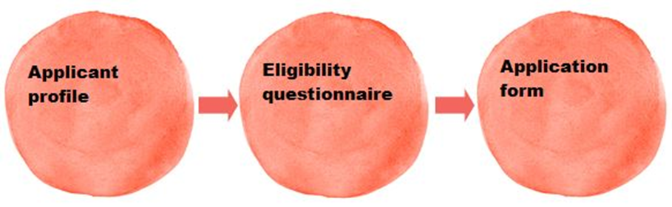

System notes:
When using the online system, please note that:

- Throughout the application system, any items marked with an asterisk (*) must be completed.

- Please navigate using the onscreen buttons only (such as the ‘Save and next’ button within the system).You are unable to use the navigation buttons at the top of your browser window (such as the browser ‘Back’ button). Always use the ‘Back’ or ‘Save and back’ buttons within the system.

- Any free text boxes in the application form have a strict character limit stated above them. Please stick to this limit as any text you add beyond this will be automatically deleted when you save your answers.

- Remember to save your work regularly as you go along – the system times out after 15 minutes of inactivity.

- The submission summary displays a list of all the steps you’ve worked through. It is the final screen in each section of the process, but you can refer to it at any time. If you have completed a step successfully, there will be a green tick beside it. If a step is incomplete or has not been completed successfully, this will be indicated by a red cross. A hyperlinked statement at the bottom of the page will tell you what part of each step needs attention. Click on this hyperlinked statement to go back to the step and make your amendments.

- It is your responsibility to keep the information in your applicant profile up to date. Before you start an application for any new project, please go through your applicant profile, ensure your information is correct, and update it if necessary.

- If at any time you would like to contact us, click Contact us in the left menu bar for contact information.

For more detailed guidance on using our online system, please see our information sheet ‘How to create and manage your user account and applicant profile’.

Using our online system – applicant profiles

Before you make an application, you will need an applicant profile. The ‘applicant’ is the person we will make a grant to if your application is successful, and an applicant profile is where all their contact information is held on the system.

Validation of your applicant profile
If you have applied to our Grants for the arts programme since 27 January 2016 (when we began using our new online system) you will already have created an applicant profile that will have been validated. If you have not, or if you are registering a new applicant, we will have to validate your applicant profile before you can start an application. Validation allows us to make sure that there is only one applicant profile per applicant on the system, and to check some basic contact information where relevant.

It is important that you factor in enough time to allow us to do this when you plan to make an application because you will not be able to start your application until your applicant profile has been approved.

Your applicant profile will be submitted to us when you have completed it, and we will would normally aim to approve it within five working days. However, due to the high volume of new applicant profiles we are currently receiving, for this round of applications to AIDF we are advising that, unless you already have a validated applicant profile (as an individual) and and if you have not submitted your applicant profile to us for validation by 5pm Wednesday 12 October 2016 we cannot guarantee that we will be able to validate your applicant profile in time for you to complete and submit your application by the application deadline of Wednesday 26 October. Please note, you will not be able to start your application until your applicant profile has been validated.

While you wait for you applicant profile to be validated, you cannot begin work on your application but should use this time to read this guidance thoroughly and begin to plan your application. You can also use this time to contact us with any queries.

You will receive an email notification when your profile has been approved. This will include instructions on how to access the eligibility quiz and application form.

The seven weeks we need to reach a decision on your application is in addition to this time for approving your profile. The seven week decision period begins on the date of the application deadline for this round.

How to create your applicant profile

If you do not already have an applicant profile you need to create one. Please follow the instructions in our guidance sheet ‘How to create and manage your user account and applicant profile’.

If your applicant profile has already been validated or your existing profile is up to date, please go straight to the Eligibility quiz section of this guidance.

If we are unable to validate your applicant profile

Sometimes we may not be able to able to validate your profile within our stated processing time, for example, if you submit a profile for an individual or organisation that is already registered on our system or if any of the information we need is missing or unclear. In these cases we will write to you and explain what you need to do next. Please remember that you cannot begin an application until your applicant profile has been validated.

Using our online system – the eligibility quiz

Once your applicant profile has been validated (or if you already have an existing and up to date applicant profile), you can complete the eligibility questionnaire for the Artists’ international development fund. You will receive an email notification when your profile has been approved. This will include instructions on how to access the eligibility quiz and application form.

This section of the guidance provides detailed, step-by-step instructions on how to complete the eligibility questionnaire. You should read it thoroughly before you begin, and follow the instructions carefully when you complete the questionnaire.

- Each screen that you will see as you work through the eligibility questionnaire is titled in ► bold with an arrow in this guidance, with explanatory text for that screen underneath.

- Any clickable onscreen links are shown underlined in this guidance.

Using the Registration Wizard

The Registration Wizard guides you through registering to apply, choosing the applicant you want to apply under, and setting up your project on the system.

To access the Registration Wizard:

- Browse programmes
To begin, click Browse programmes in the Workspace section of the left menu bar:


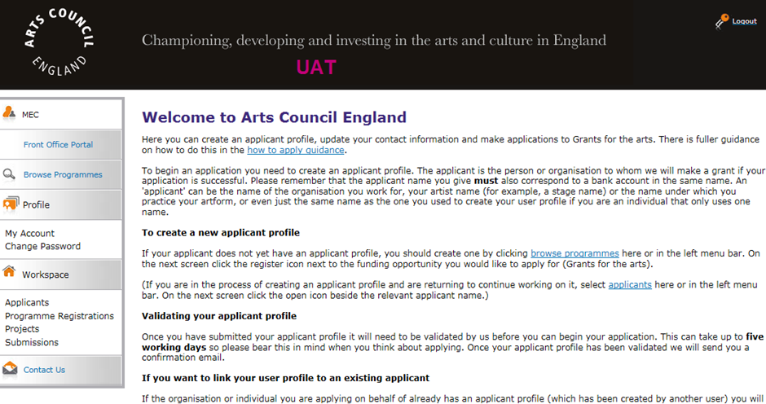

Click View on the far right of the screen next to AIDF Round 14:
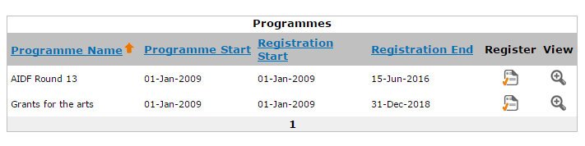

- Apply for funding
Click Apply Now at the bottom of the screen to begin your application.

- Applicant details
Select your applicant from the dropdown in the top half of the screen.

Use only the top section of this screen.
Do not use the bottom half of the screen called ‘Applicant type’. This is only used when a user is creating a new applicant through this screen, and if used it will generate a new applicant. You should always be using a validated applicant at this stage, and should be able to select it from the dropdown at the top of the screen:

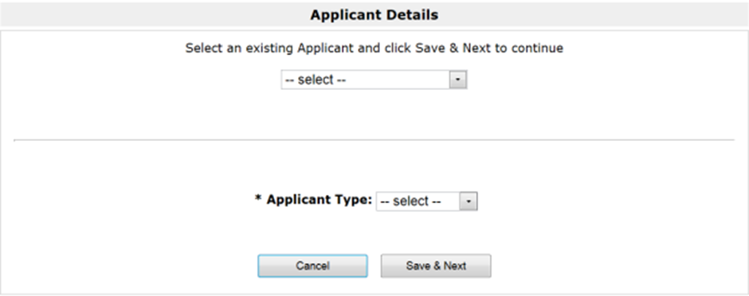
DO NOT USE THIS SECTION
SELECT YOUR APPLICANT HERE

Click Save & Next to continue.

- Applicant details (2)
The next screens show the information you entered in your applicant profile. Please review each screen to ensure that your contact information is correct. This is particularly important if you haven’t made an application to us using that profile for some time.

The contact details shown at this stage will be the details that pull through onto your application form. Making sure they are correct at this stage is important, because any changes that are made to your contact details after you have created a new project will not be changed in your application form.

For this programme, please note that only individuals are eligible to apply. An individual can apply on their own behalf, or on behalf of a small group of individual artists and/or creative practitioners (including the applicant as ‘lead artist’). Individual applicants who are employed by arts and culture organisations are also eligible to apply.

To move through the screens click Next.

It is your responsibility to keep the information in your applicant profile up to date. If you notice that you need to change any details, you should go to the Submission summary at the end of this section, click the ‘Edit’ button and go to the appropriate screen to make your changes.

Once all your details are correct, to proceed with your application please click Return to Registration Wizard in the left menu bar:

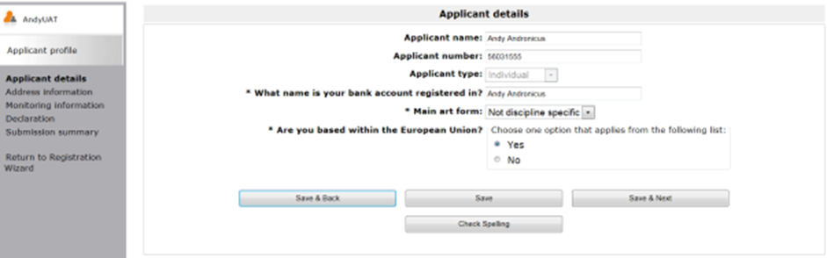
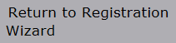

For more guidance on how to make changes to your details, please refer to the ‘Managing your contact details’ section of our guidance document, ‘How to create and manage your user account and applicant profile’.

- Complete applicant profile

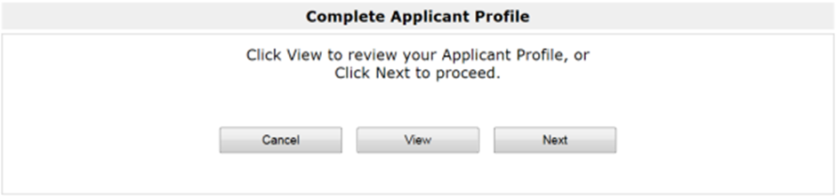

Click Next to proceed with your application.

- Create a project

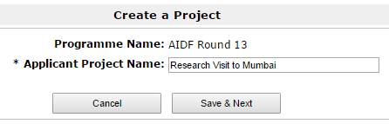

Please add the name of your project. This will be the project name that we use throughout the process (and if your application is successful we will use it to label all of your reports and payment requests) so please make sure it is correct and refers clearly to your project, for example ‘Research visit to Mumbai’.

Click Save & Next.

The eligibility questionnaire

Once you have given your project a name, you will be taken to an eligibility questionnaire. Before you begin completing an application form, we want to ensure that your proposed project meets some of our basic eligibility criteria.

The screens in the eligibility questionnaire will take you through some basic points of eligibility, but this questionnaire is not a full eligibility check. (We will complete a full eligibility check within 10 working days of the deadline for the round to which you apply.) You should read the Eligibility section of this guidance carefully before applying.

As you work through the eligibility questionnaire, if any of your answers indicate that your project does not appear to be eligible you will be taken to a screen that explains why.

- Submission summary
The submission summary displays a list of all the steps you’ve worked through. If you have completed a step successfully, there will be a green tick beside it. If a step is incomplete or has not been completed successfully, this will be indicated by a red cross. A hyperlinked statement will tell you what part of each step needs attention. Click on this hyperlinked statement to take you to the step and make your amendments.

(If the answers you have given indicate that your activity is not eligible you will not be able to continue on to the application form.)

When you have completed your eligibility questionnaire, click Submit.

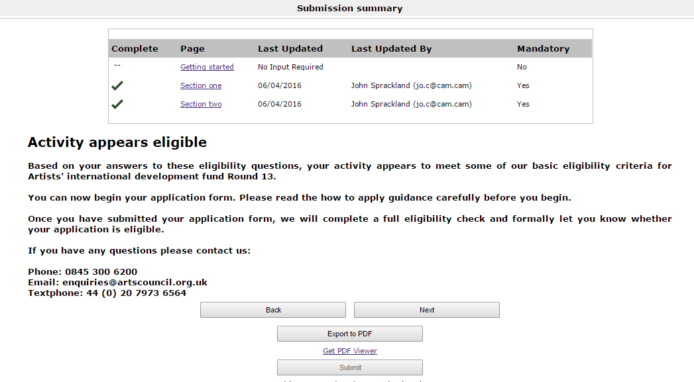



Finding your eligibility quiz if you don’t complete it immediately

The Submissions screen

If you don’t complete your Eligibility questionnaire immediately or you are logged out by the system at any point, you can always access it through the Submissions screen. (A ‘submission’ is anything that you submit to us using the online system, such as an eligibility questionnaire or an application form):

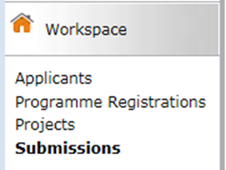

Listed on the Submissions screen are all the submissions that you have made or that are ready for you to complete. If something is ready to start or in progress, the Date submitted column will be blank. If something has already been submitted, the date and time it was submitted will appear here.

The column called Programme Name / Step Name will show you which submission is your eligibility questionnaire:
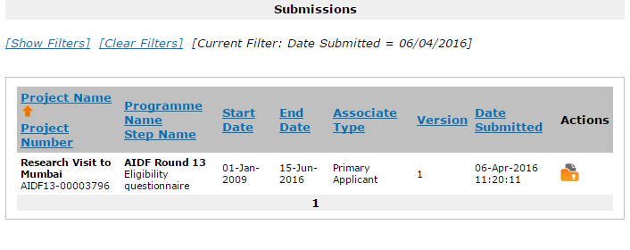
Click the ‘Open’ icon next to your eligibility quiz.

The application form – what we need to know…
…and using the online system to apply

When your applicant profile has been validated (or if your existing applicant profile is up to date) and you have completed the eligibility quiz successfully, you can start your application to the Artists’ international development fund.

This section of the guidance provides detailed, step-by-step instructions on how to complete the application form. It follows the structure of each of the screens you will see as you work through the application form. You should read it thoroughly before you begin, and follow the instructions carefully when you complete the form.

Using this guidance

- Each screen that you will see as you work through the application form is titled in ► bold with an arrow in this guidance with explanatory text for that screen underneath.

- The questions we ask in the application form are marked with ‘Question’ and are shown in bold and italics.

- Any clickable onscreen links are shown underlined in this guidance.

- Guidance on how to use the online system is shown outlined in red with the header System note

Finding your application form

The Submissions screen

Once you have submitted the eligibility questionnaire and we have told you your activity appears eligible, you will be taken to the Submissions screen. (A ‘submission’ is anything that you submit to us using the online system, such as an eligibility questionnaire or an application form):

Listed on the Submissions screen are all the submissions that you have made or that are ready for you to complete. If something is ready to start or in progress, the Date submitted column will be blank. If something has already been submitted, the date and time it was submitted will appear here.

The column called Programme Name / Step Name will show you which submission is your application form:
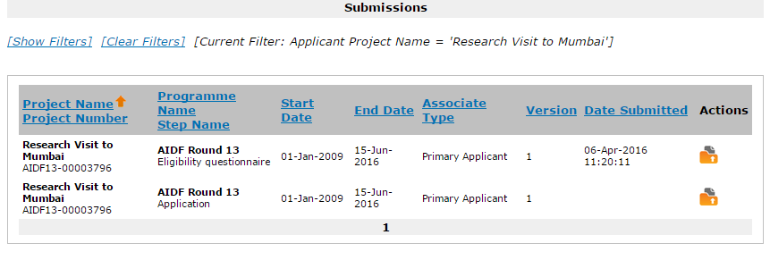

If you have made other applications to us using our Grantium online system you will also be able to see the submissions relating to them on this screen. You can use the dropdown filters at the top of the screen to choose the name of the project you are working on: 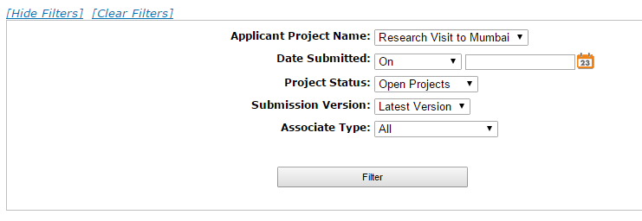

Starting the application form

To open and begin the application form, click the ‘Open’ icon next to your project’s Application in the list:

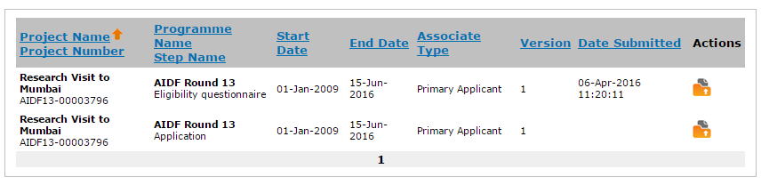

If you don’t complete your application form in one sitting, you can always access your in-progress form through this Submissions screen. To continue working on a particular submission, click the open icon on the right side of the screen.

About the application form

The application form takes you through a number of sections. These are listed in the navigation bar on the left of the screen:
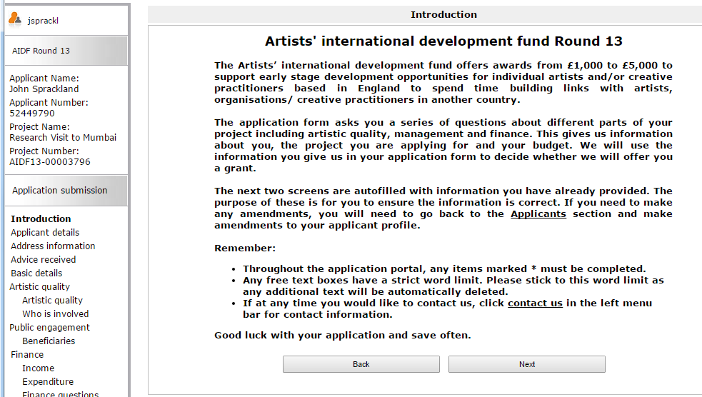

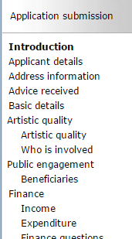

Some of the sections ask for basic information about your activity, and others ask for more detailed information. Please read this guidance carefully, and use it to help you complete each section of the application form.

The application form asks you a series of questions about different parts of your activity including:
- its artistic quality
- any beneficiaries or outcomes you expect
- how it will be managed
- the budget for your activity

We will use the information you give us in your application form to decide whether we will offer you a grant.

Things to remember:

- Throughout the application screens, any items marked * onscreen must be completed.

- Any free text boxes have a strict character limit, shown next to each question. Please stick to this word limit as any text you add beyond this will be automatically deleted when you save your answers.

- Remember to save your work regularly as you go along – the system times out after 15 minutes of inactivity.

If at any time you would like to contact us, return to the Submissions screen and click Contact us in the navigation bar on the left of the screen.

Applicant details and basic details

- Applicant details
At this stage, the Applicant details screen reappears to allow you to ensure that all your information is correct. If you have multiple applicant profiles linked to your user account, it is also an opportunity for you to ensure you have selected the correct applicant.

If any of the details are incorrect, you will need to exit the application form and go back into your applicant profile to make your amendments. Please see our information sheet ‘How to create and manage your user account and applicant profile’ for guidance on how to do this.

- Address information
As with the previous screen, the Address information screen reappears to allow you to ensure that all your information is correct.

- Advice received
If you have received any advice, please tell us about it here (please tick all options that apply).

- Basic details

Project information

Question:
Please give a concise description of the activity you are asking us to support.

This description gives us a brief summary of the key aspects of your activity, so please describe your activity simply and clearly.

You should include:
- the main details about the nature of your activity
- what will happen and where
- who your host is.

For example, a completed project description might look like this:

I will undertake a four-week project at the Japanese Ceramic Artists’ Guild, who will be my host organisation in Seto City, Japan. I will be working towards developing a new body of ceramic work informed by the historical and contemporary ceramic practices used in Seto City. The project will involve research and development work using the Guild’s archive, studio and material resources, and working collaboratively with the Guild’s resident artists and with other locally-based artists through a series of workshops.

Amount requested

Question:
Please tell us the total amount you are requesting from us, including any personal access costs.

Here we want you to tell us the amount you will be requesting from us, including any access costs. The figure you give should be the same as the figure you entered on the eligibility quiz.

Access costs are any extra costs relating to your own access needs (if you are deaf or disabled or experience learning difficulties, for example) that you will need to pay to help you manage your project. For example, payment for a sign language interpreter to help you manage your project is an access cost.

If your application includes personal access costs and you have any queries please contact us on 0845 300 6200 or enquiries@artscouncil.org.uk

Activity dates

Question:
Please enter the start and end date of your project.
Please enter the start and end date of your activity. You must allow enough time for us to process your application. We cannot fund any goods or services that you have bought, ordered or contracted before we can make a decision on your application.

We need seven weeks to process applications to the Artists’ international development fund. If you do not give us enough time before your activity starts, we may not be able to process your application.

Please give a start date for your activity that will give you enough time to complete all the stages of the activity that you are asking us to support.

There are restrictions on when activities can start and end. If your activity timeline shows dates that fall outside these dates it will not be eligible for funding (see section How much time can a proposal cover?).

Deciding on a start date and end date
Please give a start date and end date for your project that will give you enough time to complete all the main stages of the project that you are asking us to support. For example, if your activity is an overseas visit but you are asking us to support some preparatory activity before the trip and follow-up activity after the trip, you should give start and dates that include that preparatory and follow-up activity as well as the overseas visit itself.
Artistic quality
- Artistic quality
In this section we want you to tell us about you and your artistic work, some more detail about the international activity you would like to do, and how this activity will help you develop. We also ask about the organisations, artists and/or creative practitioners you are working with, what their role is, and why you have chosen to work with them.

Question:
Please provide a brief summary of your recent relevant artistic work, experience and achievements.
We ask you to provide this summary instead of a detailed artistic CV. This paragraph will tell us about your artistic track record and your career to date, so you should aim to present a clear, concise summary of your work.

The type of information you give us will depend on what kind of work you do, but you should tell us about:
- your key artistic achievements to date – for example exhibitions, productions, publications, etc
- any key commissions you’ve received
- key pieces of work you’ve completed
- if you’ve worked with any established artistic partners
- any other information relevant to your artistic track record

Please note that the Artists’ international development fund is intended to help artists and/or creative practitioners to develop their international practice and networks, so applicants who already have extensive international experience in the country or countries where they are proposing to work are unlikely to be successful.

Question:
What is your proposed artistic activity, and what do you want to achieve by doing it?
This is your opportunity to tell us more about your international activity, why you want to do it and who you are working with and why. You should tell us about:
- who you want to work with and how you will collaborate (if appropriate)
- the artistic idea behind the activity
- what you want to achieve by doing the activity
- why you want to work in the specific location you have chosen

Question:
Why is this activity important for your artistic development?
This is a question about how the international activity you are proposing will develop your practice or skills, and how it fits with your wider artistic career.’

You should think about how doing this activity will affect your artistic work, both immediately and/or in the longer term. For example, does your activity allow you to:
- work in new ways, new contexts or with new people
- develop new networks
- reach new or different audiences
- to try out new approaches
- achieve other types of development

- Who is involved
Although the Artists’ international development fund is aimed at individuals, small groups of artists and/or creative practitioners who normally collaborate in their work can also apply (for example, musicians and visual artists who usually create work together). If this applies to your application, please list here the other artists you normally collaborate with who will be involved in your activity. Do not include yourself, your overseas host partner, or other individuals who are helping you to manage your activity; please tell us about these later on in the separate Partners section of the application form.

If you are the sole artist involved in your activity please leave this screen blank.

If you are applying on behalf of a group of artists and/or creative practitioners, you should tell us about your previous experience working collectively together.
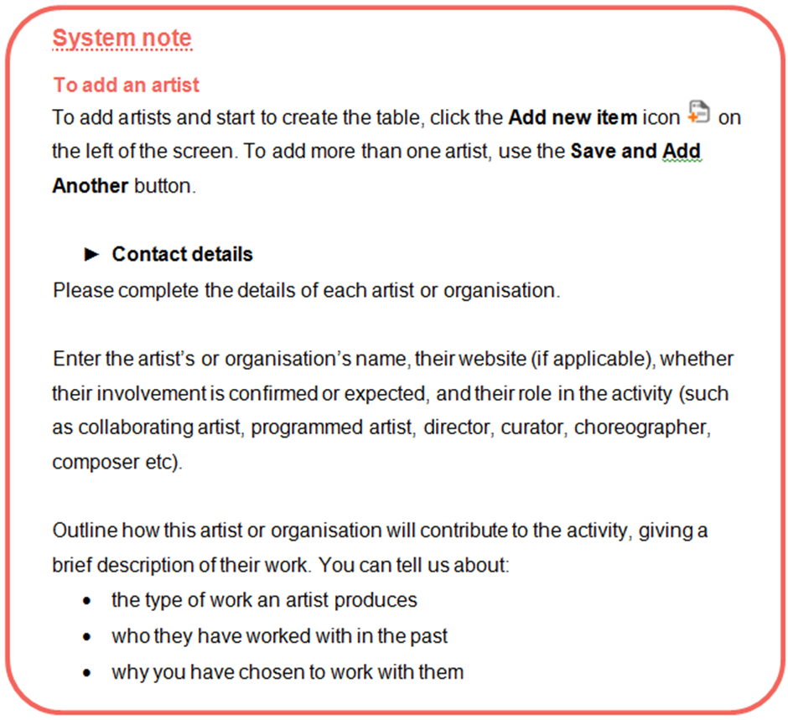

Public engagement
The focus of the Artists’ international development fund is on individual artistic development rather than wider public engagement. However, some projects do include some public outcomes and this section of the form allows you to tell us briefly if this applies to your activity.

- Beneficiaries

People who will benefit from your activity

If your activity will have public outcomes during the period of funded activity (eg performances, exhibitions, workshops), please give an estimate of the number of people you estimate will benefit from that activity. Please note that public outcomes of this nature are not a requirement of this programme; if none applies, enter '0'.

If possible, please also estimate how many people have benefited from your artistic/creative work in the last 12 months. 'Participants' means people doing the activity, including education workshops. 'Audience' includes people going to an exhibition or performance, and people getting access to work that is printed, recorded, broadcast or available online.

Results of your activity

In the section at the bottom of this screen, please also estimate the outcomes of your activity in the categories given. Enter ‘0’ (zero) for any item that is not relevant.

When providing a figure for the number of sessions for education, training or participation, divide the day into three sessions (morning, afternoon and evening). A session is any one of these.

Finance
The Finance section asks you to complete a budget for your project and to answer some questions about how you will manage your budget.

The Finance section is divided into three screens: Income, Expenditure and Finance questions. This guide will tell you how to complete each screen, step by step.

Key things to remember about budgets:

- Your budget has to balance
Your income needs to be the same as your expenditure.

- You can request a minimum of £1,000 and a maximum of £5,000 (not including any additional access costs you may have).

- We need to be able to see how you have worked your figures out
Please break them down clearly under the headings provided in the budget table.

- Your budget should be for the total cost of the project you are applying to do.

Please check your figures carefully. If you do not fill in this section correctly, we cannot process your application.

- Income

In this section we ask you to tell us about any other cash income for your activity. It is not mandatory for applicants to the Artists’ international development fund to show any other income for their project, but financial income from other sources can help to demonstrate partnership support for the activity, and that the activity is making the most of our investment.

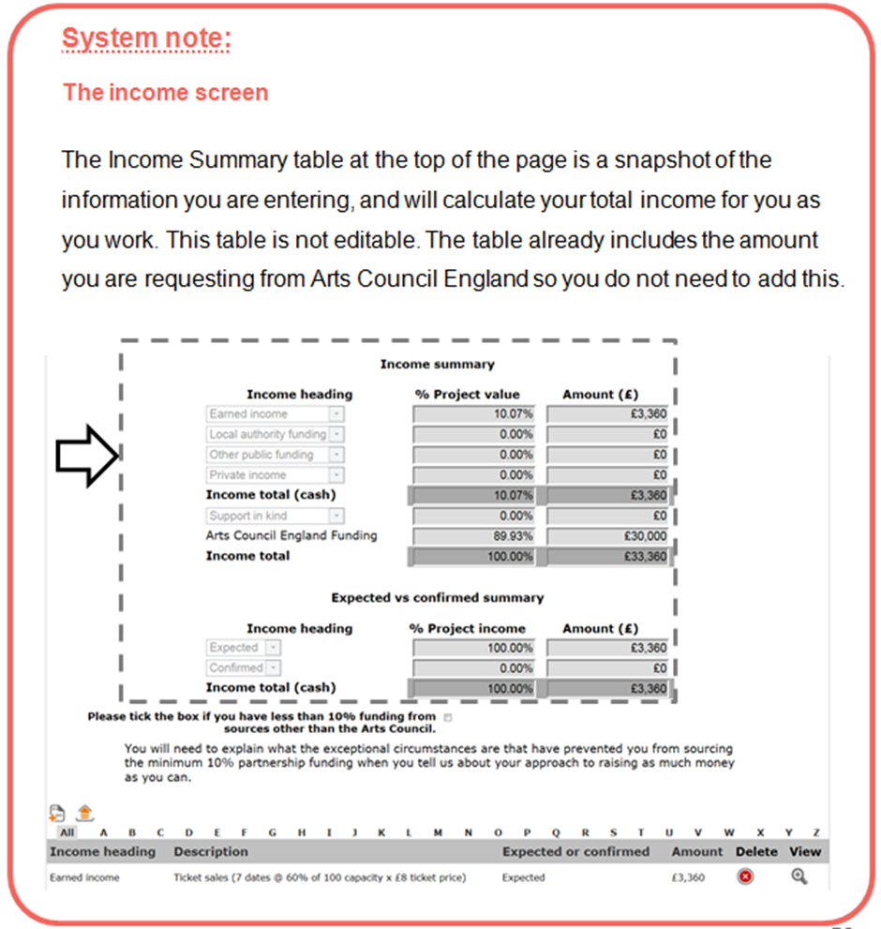

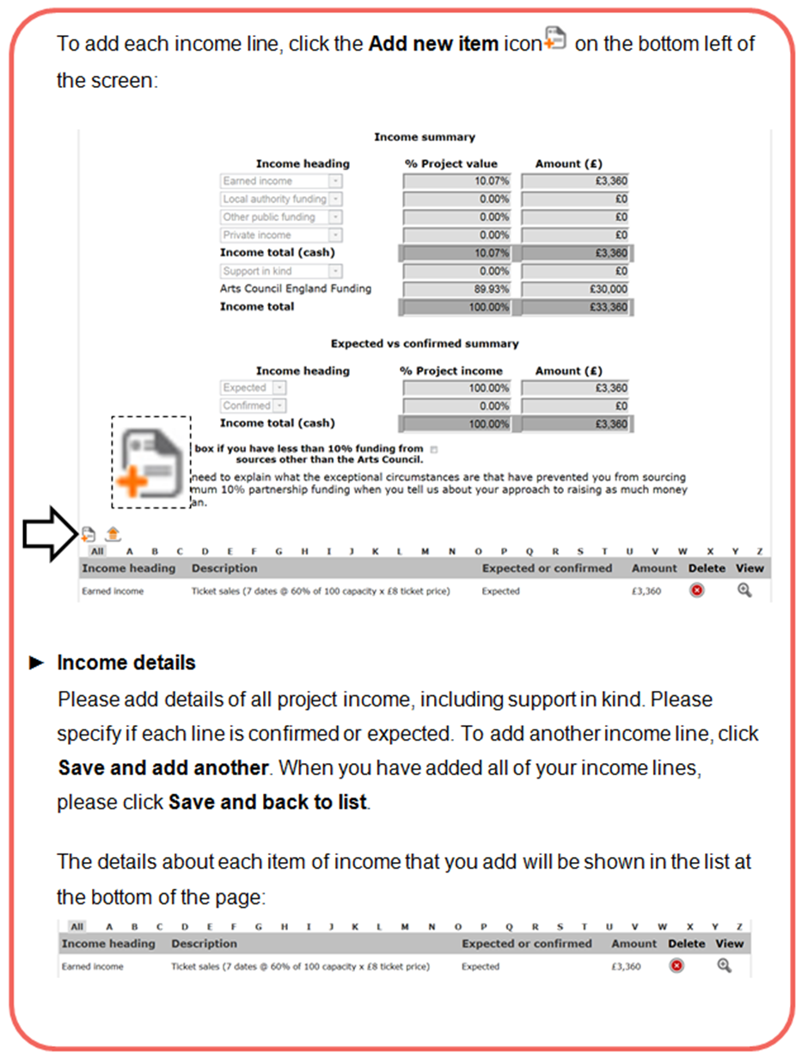

How to present your income lines

- You should make sure that you show how your figures have been calculated in the 'Description' field (see Earned income example below).

- You should enter all the cash income specific to this project on this page (excluding the amount you are applying to us for), as well as any Support in kind you will receive.

- Income from other sources is not a requirement of this funding programme but you should include any other income that is either confirmed or expected towards the project, including any applications to other funding bodies or trusts or foundations, under the appropriate budget headings. We may ask you to provide evidence of income you have shown as confirmed as a condition against your first payment if your application is successful.

- Please use full pounds only and no pence (for example, £1,167 not £1,167.21).

The budget headings (income)

Earned income
It is unlikely that an Artists’ international development fund project budget will include significant earned income (for example, from ticket sales, workshop fees or selling work or publications), due to the nature of the programme. If you do anticipate any earned income, please provide a clear breakdown for each entry to show us how you have reached your figures.

Example: Earned income
 | Expected | Confirmed | Income
Four performances at a venue with 60 seats and a 70 per cent full audience (42 people) is 4 x 42 tickets at £4 = £672 | x |  | £672

If VAT is charged on ticket sales or admission prices, do not include it in your earned income figures. For information about VAT and other taxes, contact HM Revenue & Customs (HMRC) through their website (www.hmrc.gov.uk).

Local authority funding
Include any funding you have received or applied for from local authorities for this activity. Please give us the name of each local authority and the amount.

Other public funding
Include any funding you have received or applied for from any other public organisation (for example, the British Council). Please give us the name of each organisation and the amount.

Private income
Include any income from private sources, for example from you or your organisation, donations or grants from trusts and foundations, or from crowdfunding. This should include funding you have already confirmed and funding you expect to receive (for example, applications you have made but have not received a decision on yet, or applications that you intend to make during the project). If you are an individual and you are providing some cash income towards the activity, please include it in this section. Please give us the details and the amounts.

Support in kind
Support in kind can be a valuable part of your activity.

Support in kind is used to describe any materials or services that you would otherwise have to pay for but that are being provided free of charge or at a reduced rate. The value of support in kind contributes towards the proportion of funding we require you to have from other sources.

Support in kind might include:
- equipment being provided free of charge that you would otherwise have to buy or hire
- the use of rehearsal or performance space that you would otherwise have to pay for
- accommodation that is provided by your host
- a discount given from the full price of goods or services (for example, printing costs). You should show the discount amount as support in kind, and show the reduced cost you will pay for the goods or services in the expenditure section of the budget.

Please include details of who is giving the support in kind, what it is and an estimate of its value.

- Expenditure

In this section we ask you to give details of all the items you will be paying for as part of your activity. You should break down the expenditure for your activity under the headings provided in the budget table.
All budget entries should be in £GBP.

An Artists’ international development fund grant may be used to cover travel, daily needs (per diems), material costs, and accommodation where this is not supplied by a host organisation. The purchase of second-hand equipment is excluded.

Please clearly show how you have calculated your figures.

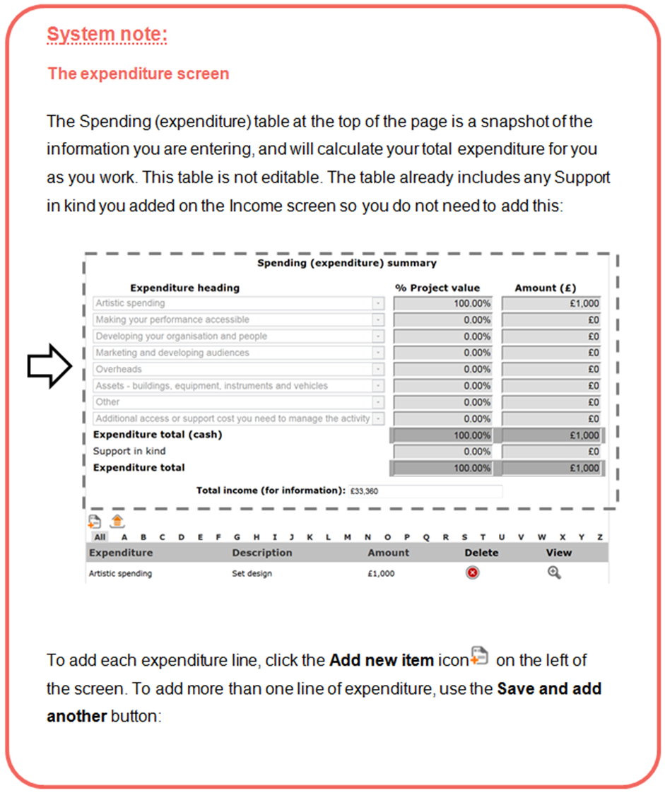

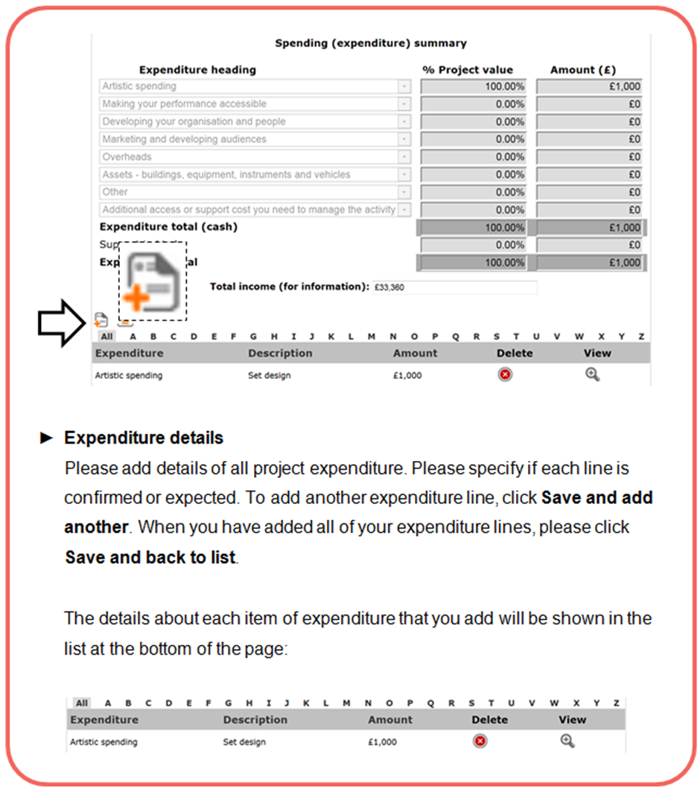

How to present your expenditure lines

- You should make sure that you show how all your figures have been calculated in the description field. For example, you should show the number of days and the daily rate for any accommodation costs shown:

Accommodation, 4 days @ £100 per day = £400

- If you are registered for VAT, your expenditure figures should not include VAT that you can claim back. If you are not registered for VAT, your costs should include VAT.

- You should get financial advice from your own accountant or the relevant tax office. For information about VAT and other taxes, contact HM Revenue & Customs (HMRC) through their website (www.hmrc.gov.uk).

The budget headings (expenditure)

Artistic spending
In this section, please include any of the artistic costs you need to pay for. Please show how you have reached your figures.

You need to show:

- the fees/ per diems of those involved in the activity (including yourself)
You will need to show clearly how you have worked this out (number of people, daily rate, number of days, etc).

- travel and accommodation (where this is not covered by the host)
You will need to show clearly how you have worked this out (rates, number of days, etc).

- the other arts-related costs of delivering the activity
Such as the costs of events, commissions, research and development, preparation, productions and residencies, including any materials or equipment you buy or hire to carry out these things.

Making your performance accessible
We are committed to making sure that everyone has access to the work we fund. As a result, we encourage you to include the costs of making your activity accessible as part of your artistic spending. It is unlikely that an Artists’ international development fund project budget will include significant accessibility costs due to the nature of the programme, but these may include any costs that you will need to pay to make your activity accessible to a wide range of people. Access costs might include costs of signed performances and materials in other formats such as in Braille or on CD, for example.

If you are disabled, deaf, or experience learning difficulties, and have personal access costs (costs relating to yourself that you will have to pay to manage your activity), please see our advice for applicants that encounter barriers making a grant application at the end of this section.

Developing your organisation and people
Include the costs of any part of the activity directly aimed at professional development. This could include things like mentoring or training, for example.

Marketing and developing audiences
Include all marketing and audience development costs that relate directly to the activity you are applying for. It is unlikely that an Artists’ international development fund project budget will include significant marketing costs due to the nature of the programme, but these may include design and print costs, direct mailing, website design, photography, or research.

Overheads
There are some overheads or running costs that we do not fund. We have listed ‘What you cannot apply for’ in the Eligibility section of this guidance.

It is unlikely that an Artists’ international development fund project budget will include significant overheads costs due to the nature of the programme. If your project does include overheads costs, you can apply for extra time-limited overhead costs that are directly related to the activity you are asking us to support. The amount you apply for must relate directly to the amount of time spent on the activity you are asking us to support, so please explain how you have worked this out.

Assets – buildings, equipment, instruments and vehicles
It is unlikely that an Artists’ international development fund project budget will include significant asset purchase costs due to the nature of the programme, but these may include any costs relating to buying assets including equipment or instruments. If your budget includes costs for buying equipment you will need to tell us why this equipment is specifically required to undertake this project. Equipment you would normally have to carry out your practice is not eligible. You should get competitive quotes from more than one business or supplier. While we do not ask you to send quotes with your application, we do ask you to tell us about them in the question below this section of the budget.

As part of our eligibility and risk checks we will look at whether any proposed asset purchases are justified and appropriate to the project. You may be asked to submit invoices for any purchases as a payment condition if your application is successful.

Other spending
Include any other spending for your activity that is not included elsewhere. This can include an amount for unexpected costs (contingency spending) such as changes in currency exchange rates that could impact on your budget.

If you are disabled, deaf, or experience learning difficulties or encounter barriers making a grant application
If you are disabled, deaf, or experience learning difficulties, there may be extra costs relating to your own access needs that you will need to pay to help you manage your activity. (For example, payment for a sign language interpreter to help you manage your activity.) Please include these costs under this budget heading in the table.

Before you start your application form, as part of the eligibility questionnaire we ask you to tell us whether your budget includes personal access costs.

- Finance questions

Question:
If relevant, please describe your approach to raising money from other sources.

It is not mandatory for applicants to the Artists’ international development fund to show any other income for their project, but financial income from other sources can help to demonstrate partnership support for the activity, and that the activity is making the most of our investment.

Please tell us:

- about any specific sources of funding you have applied to for this project, including when you expect to know if you have been successful (if you tell us about any applications you currently have under consideration with other funders here, you must include an appropriate figure in the income section of your budget otherwise we may treat your budget as unbalanced)
- if you have made (or intend to make) several applications for a total amount greater than what is required, on the basis that some of them will be unsuccessful, please tell us here about your approach here.
- if your budget includes earned income, tell us more about how you have worked this out.

Question:
Briefly tell us about your experience in managing budgets, and describe how you will manage the budget.

In this section we want you to list any relevant experience you have had managing budgets of a similar size. This information helps us to understand whether the budget is likely to be realistic and well managed. You can also tell us about any financial controls that are in place, such as:
- contingency (an amount in your budget for unexpected costs)
- your banking arrangements (for example, will you have a separate account for your activity to manage spending?)

Question:
Please describe how any fees, rates and purchases have been calculated.

We want to know that the costs in your budget are reasonable and realistic. Please tell us how you have worked out the cost of:
- the fees/ per diems of those involved in the activity (including yourself)
- travel and accommodation (where this is not covered by the host)
- the other arts-related costs of delivering the activity

Management
In this section of the application form we want you to tell us how you will manage your project. We will ask you to tell us about any other partners involved in the project, where it will be taking place and how you will manage and evaluate the project. We will ask you to complete a timeline of the key stages of your project.

- Partners

Question:
Please list any project partners using the tool on this page.

Here we ask you to tell us about any other partners involved in the project, their role in the project and the status of their involvement.

We want to know about who will be supporting the management and delivery of your activity. They could be an individual or an organisation, and will be working to support a specific aspect of the activity.

Please note that this question requires different information than the earlier question about artists involved in the activity. These partners might be completely separate to the artists who are involved in the activity, or they might be the same people or organisations performing different roles in your activity. (An artist you are working with might also be a partner. In the ‘Who’s involved’ section of the application form you will have told us about their artistic track record. In this section you should tell us about their management skills.)

You should enter your overseas host as the first name in this list, followed by other partners.

We ask you to include contact details for each of your project partners. As part of our risk check we may contact some of your listed partners to confirm their involvement.

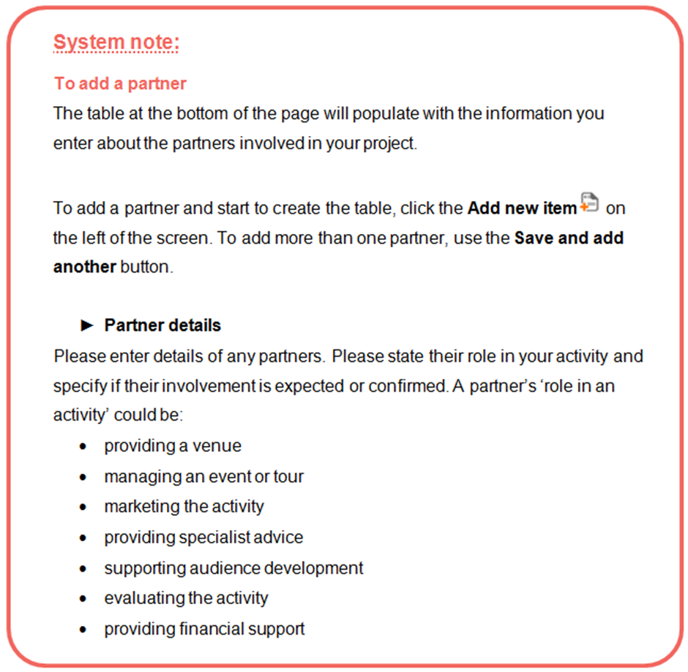

Remember: List your partners starting with your potential partner/host in the country you wish to visit as the first on the list
- Location

On the ‘Location details’ screen you should tell us each location and country where your activity takes place. You will need to add at least one location to the list.

For all International locations: Please enter the name of the venue or place (eg ‘Oneplace Arts Centre, Barcelona’). Then check the ‘No UK postcode available/International location’ box and select the country where the activity is happening (eg. Spain) from the dropdown list.

You do not need to add a local authority for any international (non-UK) locations.

For any UK locations relevant to your activity: Please enter the name of the venue or place and the postcode. Once you have entered the postcode, please click the ‘Get local authority’ button to add the authority for the location.
If no postcode is available for the location, please check the ‘No UK postcode available/International location’ box and select the local authority manually.
You should select ‘United Kingdom’ as the country for any UK locations relevant to your activity.

- Activity plan

To give us a clear understanding of how your project will be managed, we would like to know about your planning and preparation to date and to see an outline project plan for your proposed activity.

Question:
Please briefly identify the main stages of any planning and preparation activity completed to date.

We want to know what planning you have done to date so that we can understand if your activity is well considered and realistic. Please list the preparation you have done for this activity. For example:
- research
- developing partnerships
- scoping work
- considering potential risks
- planning the delivery of the activity (eg producing a timeline)
- securing commitment from partners

Please note this pre-application preparatory work should not be included in your budget, as we cannot fund any part of an activity that has already taken place.

Activity timeline

Question:
Please use the table on this screen to identify the main stages of the activity from the start date onwards, and to show who will lead on each element of the activity.

This table allows us to get an overview of the timeline of your international activity. Please use it to identify the main stages of the activity from the start date onwards, and to show who will take the lead on each element of the activity.

You can add as many lines as you need to this table to identify the main stages of the activity, for example: planning, partnership development, research, delivery (any performances/shows/exhibitions/workshops/ events), evaluation, and so on. Where an activity includes public performances or events (for example a showing or a festival) that happen during the activity period, these should be clearly identified using the timeline.

Please add the stages of the activity to the table in chronological order. Dates for the different stages of your activity can overlap (for example, if you will be marketing the activity at the same time as completing other stages). In the final column ‘task lead’ please tell us who will be managing each stage of the activity. This could be you, or one of your partners.

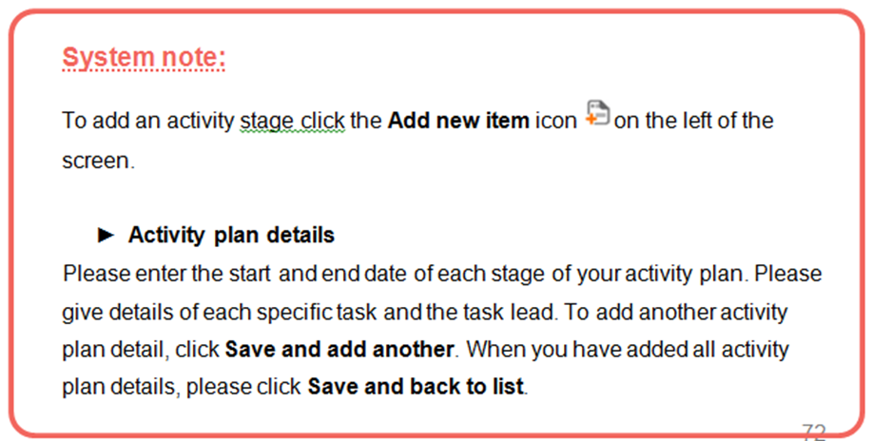
Example activity plan:

Start date | End Date | Activity or task | Task Lead
1/8/2016 | 15/8/2016 | Conclusion of project planning including confirmation of workshop schedule | John Smith  (project manager)
8/8/2016 | 22/8/2016 | Marketing | Community partners
19/8/2016 | 30/8/2016 | Workshop planning by artists | Lead artists
4/9/2016 | 4/9/2016 | Introductory workshop session at Newtown Community Centre | John Smith (project manager) with Newtown Community Centre
10/9/2016 | 10/9/2016 | Workshop session with Lead Artist 1 | Kate Jones (Lead artist 1)
17/9/2016 | 17/9/2016 | Workshop session with Lead Artist 2 | Adil Gupta (Lead artist 2)
24/9/2016 | 24/9/2016 | Workshop session with Lead Artist 3 | Jack Shaw (Lead artist 3)
1/10/2016 | 1/10/2016 | Workshop session with Lead Artist 4 | April Johnson (Lead artist 4)
11/10/2016 | 11/10/2016 | Final show of work at Newtown Community Centre | John Smith  (project manager)
15/10/2016 | 15/10/2016 | Feedback session with participants | John Smith  (project manager)
15/10/2016 | 31/10/2016 | Evaluation period | John Smith (project manager) and lead artists

- Evaluation

Question:
Please briefly tell us how you plan to monitor the progress of your activity and to evaluate your achievements throughout the activity.

If we give you a grant, we will ask you to evaluate your work and fill in an activity report form at the end of your activity.

Evaluation is a structured way of thinking about what has happened. Evaluation can help you to:
- make decisions during your activity
- shape future activities
- improve your work
- show what happened as a result of your activity

You can find a basic introduction to evaluating arts activities in the information sheet ‘Self evaluation’ on our website.

Attachments

- Letter of support
As you are applying to the Artists' international development fund you must attach your mandatory supporting letter from your host on this screen. You will be unable to submit your application without attaching the letter.
If you do not attach a relevant letter, your application will not be eligible for consideration.

This letter should be on headed paper (where possible), and should confirm the host’s commitment to the project, including any in kind and/or financial contributions, and an outline of their role. It should evidence that there has been shared planning undertaken by the applicant and the host.

An email from the host will be acceptable if the email is from a named individual and features their full contact details as a signature (name, address, phone number, email address and website).

If the document provided is not in English, you must provide the original and a full translation that can be independently verified. The translation must do all of the following:
- Confirm that it is an accurate translation of the original document;
- be dated;
- include the full name of the translator or authorised official of the translation company;
- include the translator or translation company's contact details

Restrictions:
- we can only accept one document
- the document can be a maximum of five pages
- the maximum file size you can upload is 10MB
- we can accept the following formats:
- pdf
- jpeg (image file)
- Microsoft Word

Please do not upload any material other than what we have asked for, or links to folders or sites containing lots of documents — we will not be able to take these into account.

Monitoring, the declaration and submitting your form

- Monitoring information
This screen show the information you entered in your applicant profile. Please review the information to ensure that it is correct. This is particularly important if you haven’t made an application to us using that profile for some time.

We may use this information to report to the government or to monitor the different backgrounds of people who receive grants. We will not use this information to appraise your application. If you do not know some of the information or you would prefer not to provide it, you can fill in the ‘Prefer not to say' box.

- Declaration
This screen contains a tick box asking you to confirm that the information provided is correct and that you are authorised to submit it on behalf of the applicant. It also includes a number of important questions about you and your application. Please read the declarations carefully before you respond to them.

- Submission summary
The submission summary displays a list of all the steps you’ve worked through. If you have completed a step successfully, there will be a green tick beside it. If a step is incomplete or has not been completed successfully, this will be indicated by a red cross. A hyperlinked statement will tell you what part of each step needs attention. Click on this hyperlinked statement to take you to the step and make your amendments.

Submitting your application

By clicking Submit, you are submitting your application for our consideration.

The system will return you to the Submissions screen, where you will see a submission time and date next to the Application form submission for your project.
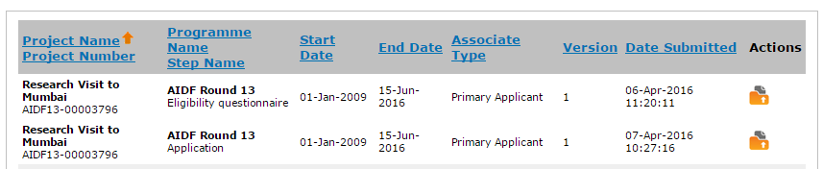

What happens to your application

You’ve submitted your application. What happens next?

1 Eligibility check

We will contact you within ten days of the deadline for the round to which you have applied. More information on eligibility can be found in the Eligibility section of this guidance.

If your application is not eligible, this means that we cannot process it any further and it will not be considered for funding. If your application is not eligible we will notify you via the online system, and will explain our decision.

If your application is eligible, we will send you a confirmation email. The email will include your project number, which we will use whenever we contact you about your application. Please quote your project number if you need to contact us.

We will complete our eligibility check within 10 working days of the deadline for the round. If you have not heard from us within this time you can contact us at enquiries@artscouncil.org.uk, or on 0845 300 6200.

2 Risk check
If your application is eligible, we will carry out a risk check. This check looks at how realistic and achievable your management plans and budget are.

The things we look at as part of the risk check include (but are not limited to):
- timeline
For example: Is the timeline achievable and detailed enough?
- partnerships
For example: Are appropriate partnerships in place to support the activity, and are they confirmed?
- planning
For example: Is the activity sufficiently well planned?
- evaluation
For example: Are plans to evaluate the activity appropriate?
- budget
For example: Is the budget reasonable and appropriate for the activity you’ve proposed?
- financial management
For example: Are there appropriate measures in place to manage the budget?
- equipment purchase
For example: Are any asset purchases justified clearly, and are the costings based on quotes?

How we look at risk
We can give any of these factors a risk rating of major, moderate or minor.

Major risk means that a particular issue gives us concern that the activity is not likely to be managed successfully and/or there are serious concerns about your budget.

If we consider any aspects of your activity’s management or finances to be major risk, we cannot process it any further and it will not be funded. If your application is unsuccessful at the risk check stage, we will notify you via the online system, and will explain our decision.

Moderate risk means that although a particular issue represents some risk to the successful delivery of the activity, we have decided that this can be addressed.

If you are awarded funding, we will ask you to send us additional information before we will release your first payment. We call these additional pieces of information ‘payment conditions’. For example, we might ask for confirmation that the other income for the activity is in place.

Minor risk means that although we have noted a particular issue we do not think it represents risk to the successful delivery of the activity, and we will take no action.

3 Decision making
After completing the risk check, we will consider the strength of the opportunity for artistic and/or market development presented by your activity. We will also use the knowledge of our staff across the country to inform our appraisal of applications, and will request comments from British Council staff as part of the appraisal process.

We will consider your activity alongside other applications and will look at the range of projects we support. We want the projects we fund to cover a broad range of artforms, activity types and geographical areas. Please remember that the Artists’ international development fund is a highly competitive programme.

When we will reach a decision
We will aim to reach a decision on all eligible applications within seven weeks from the date of the deadline for the application round to which you submitted.

If we are not able to meet our published turnaround times we will let you know by email as soon as we can.

Once a decision is made
Once we have made a decision, we will advise you by email to log in and check the outcome of your application via the online system.

If your application is successful
If you are awarded funding, your online account will show an offer letter and additional information that will allow you to accept the grant via the online system.
We might also list some additional information you will need to provide us with before we will release your first payment (we call these additional pieces of information ‘payment conditions’). For example, we might ask for confirmation that the other income for the activity is in place.

Please also be aware that as a condition of accepting your grant we may ask you to contribute to the British Council’s cultural relations brief, for example by attending an event in country, or contributing to publicity activities during the period we provide funding for.

Accepting your offer
We will ask you to acknowledge and accept your offer letter and our terms and conditions via the system using the ‘Acknowledge offer letter’ submission.

Everyone who receives a grant must accept our standard conditions. These conditions are attached to any offer, and are also available on our website or you can contact us for a copy (enquiries@artscouncil.org.uk, 0845 300 6200).

You will also need to print out and complete the bank details form, and send this back to us in hardcopy (this is for security reasons).

Please note the guidance on page 16 that addresses the question, ‘What if I’m awarded funding and have to change my plans?’

Requesting your first payment from us
For each payment of your grant, there will be a submission called ‘Payment request’ in the Submissions area of the online system that you must complete before we can release any payments. This submission also allows you to upload any information needed to meet the payment conditions we have set.

Please see our guidance sheet for step by step instructions on accepting a grant and requesting a payment.

If your application is unsuccessful
If we decide not to fund your activity, your online account will show a letter explaining our decision and outlining your next steps. This contains the full level of feedback that we are able to provide.

You can apply again, but not within a 12 month period. This means that if you have been unsuccessful in round 14 (closing 26 October 2016) you will not be eligible to apply again until the deadline after 26 October 2017.
Further information

Complaints procedure
If you are not happy with the way we dealt with your application, please contact us and we will discuss this with you. If you are still unhappy, you can ask us for a copy of our complaints procedure. Details are in Making a complaint, which is available on our website, www.artscouncil.org.uk or by contacting us by email to enquiries@artscouncil.org.uk or by phoning 0845 300 6200.

Please note that you can only complain if you believe we have not followed our published procedures when processing your application. You cannot appeal against the decision.

What to do if you cannot accept National Lottery funding for religious reasons
The funding we can provide from other sources is very limited, but we can arrange other funding if you cannot accept National Lottery funding for religious reasons. You should apply using our normal application materials and tick the box in the Basic details section to state that you cannot accept National Lottery funding. We will process your application in the same way that we process all applications. If we decide to offer you a grant, it will not come from our budget from the National Lottery.

Making records of your activity available to us for audit
Applicants should be aware that Arts Council England conducts checks on a sample of applications every year to ensure that our funding is being used appropriately. We reserve the right to ask successful applicants for access to all or part of their documentation relating to their activity, and therefore grantholders must keep clear records of project management and financial records (including all invoices) for us to access when required.

Freedom of Information Act
The Arts Council is committed to being as open as possible. We believe that the public has a right to know how we spend public funds and how we make our funding decisions.

We are also listed as a public authority under the Freedom of Information Act 2000. By law, we may have to provide your application documents and information about how we have reached our decision to any member of the public who asks for them under the Freedom of Information Act 2000.

We may not release those parts of the documents which are covered by one or more of the exemptions under the Act. Please see the Freedom of Information website at www.ico.gov.uk for information about freedom of information generally and the exemptions.

We will not release any information about applications whilst we are making a decision, as this may interfere with the decision-making process.

You can find out more about the Freedom of Information Act in the information sheet ‘How we treat your application under the Freedom of Information Act’, on our website.

Public Sector Equalities Duty
Your application form gives us information we may use to report to the Government or to monitor the different backgrounds of people who receive grants.

Under the Public Sector Equalities Duty we must research and monitor the different backgrounds of people who receive our grants.

Arts Council England

Phone: 0845 300 6200, 0161 934 4317
Textphone: 0161 934 4428
Email: enquiries@artscouncil.org.uk
Website: www.artscouncil.org.uk
Post: Arts Council England – Grant Management,
The Hive, 49 Lever Street, Manchester, M1 1FN

Charity registration no. 1036733

© Arts Council England April 2016

