Arts Council England’s response to the Call For Evidence on the simplification of Gift Aid

October 2015

Arts Council England’s mission is 'great art and culture for everyone' and we work to achieve this by championing, developing and investing in arts and cultural experiences that enrich people's lives, enabling new artistic developments, realising talent, and championing culture in public policy. As the national development agency for the arts, museums and libraries, we support a range of activities from theatre to music, reading to dance, photography to digital art, carnival to crafts. We support and invest in high quality arts practice and the best emerging practitioners whom we believe are the backbone of a dynamic creative economy.

In 2014/15 Arts Council England invested £851.8 million in arts and cultural organisations. A significant proportion of this investment went to National Portfolio Organisations and Major Partnership Museums. 80% of these organisations are registered charities eligible for Gift Aid as are many recipients of other Arts Council England investment. In 2012/13 the arts and cultural sector had a turnover of over £15 billion and provided more than one in 20 jobs in the United Kingdom. Therefore, the impact of any changes to Gift Aid on the arts and cultural sector and the UK economy more broadly, should not be underestimated.

Arts Council England welcomes the level of detail in this call for evidence and is supportive of arts and cultural organisations who have responded.
We welcome the proposed simplification of Gift Aid, to allow arts and cultural organisations to incentivise giving and maximise the financial benefit of every donation.

We ask that flexibility is retained to ensure organisations are able to apply rules to suit the size and type of organisation. We would hope that unnecessary administrative burden, which might deter an organisation from accessing Gift Aid, is minimised.

We attach a copy of a letter sent to The Rt Hon George Osborne in February outlining the position of key umbrella bodies representing the arts and cultural sector. The responses in this letter remain relevant.

We welcome involvement in conversations on this matter and will submit a full response to the future consultation. We are keen to support further simplification and would be happy to further discuss sector-specific implications of any proposed changes.

For more information, please contact:
Marie-Claire Daly
Officer, Policy and Research
marieclaire.daly@artscouncil.org.uk

19 February 2015

The Rt Hon George Osborne Chancellor of the Exchequer HM Treasury
Horse Guards Road
London
SW1A 2HQ

Dear Chancellor,

We, the undersigned, very much welcome the tax reforms made in recent months for the benefit of the cultural sector including the Theatre Tax relief and Orchestra Tax relief.

Following on from this, we would also welcome further focus being given to Gift Aid. This is a valuable benefit to charities providing a tax-based incentive for donors and encouraging increased philanthropy. Tax incentives, although not the primary driver of philanthropic donations, can influence the extent and manner of donations – an increasingly important source of income for arts and cultural organisations, required to diversify their income in order to become more resilient.

Take up of Gift Aid remains short of optimum levels amongst all areas of the voluntary sector and we are concerned there is a significant amount of unclaimed Gift Aid within the arts and cultural sector.

We welcome the commitment shown by HM Treasury to engage with the sector in relation to Gift Aid but we would urge that further action is considered in advance of your Budget on 18 March 2015 ahead of the General Election.

We are aware that the Charity Finance Group has been working hard to improve Gift Aid over recent years and they have produced five key asks to be considered ahead of the General Election.

We are fully supportive of the five points listed below and have sought to provide further observations from a cultural perspective.

1. Reform the Gift Aid Small Donations Scheme.
Enabling any charity registered for Gift Aid to claim through the scheme as well as removing the matching requirement for donations. The government should also consider allowing charities to claim on non-cash donations.

The introduction of the Gift Aid Small Donations Scheme has been welcomed, however, take up amongst the arts and cultural sector has been variable. We would like you to consider reducing the requirement for a two year history of regular Gift Aid claims which we believe will encourage an increased claim rate by
arts and cultural organisations.

2. Support a new promotional campaign to boost Gift Aid.
Government should invest in a sector-led campaign to improve public awareness and understanding of Gift Aid. This builds on HMRC’s research which shows that one of the main ways we can improve uptake is through making sure the public understands Gift Aid and its
value to charities.

We welcome the progress achieved through your support of the GREAT Britain Campaign which showcases the best of what the UK has to offer to inspire the world and encourage people to visit, do business, invest and study in the UK. Arts and cultural organisations are central to this campaign and we would welcome investment in a similar campaign that seeks to improve public awareness of arts
and cultural organisations as charities and increases understanding of Gift Aid.

3. Simplify Gift Aid donor benefits.
Many charities are put off by the complexity of the Gift Aid donor benefit rules. The government should work with the sector to simplify the rules and potentially increase the range of benefits that can be
provided by charities and still receive Gift Aid.

We welcome the current consultation by HMRC regarding donor benefits following the position outlined in your Autumn Statement:

2.82 Charity donor benefits and Gift Aid entrance and membership fees – The government will continue and extend the review of donor benefits launched at Budget
2014 to include consideration of the rules for claiming Gift Aid on membership and entrance fees. An update will be provided at Budget 2015. The government will also work with the sector on updating the guidance and making it easier to understand.

There have been recent inconsistencies in decisions implemented by HMRC with regard to this issue for the arts and cultural sector. This has highlighted the need for simplification of guidelines to reduce the threat of impacting on individual philanthropy.

We are aware that a group of representatives from the performing arts sector has been invited to meet with HMRC to put together a set of draft guidelines, including clarity around how benefits are valued. Currently benefits are valued on the perceived value by the donor but it would be advantageous if they were valued on the basis of the cost to the charity in providing the benefit. Your support in progressing this matter would be appreciated.

Presently buildings that are charities can ask customers to make a donation of
10% or more on top of the admission price and then claim gift aid on the entrance price and donation.

If this was extended to theatres and other arts organisations that are charities it would mean an additional £4 donation on top of a £40 transaction would be worth
£15 to the organisation.

We believe that if the new government extended Gift Aid to attendance at charities presenting arts events it would further encourage philanthropy and provide much
needed support.

4. Give higher rate taxpayers the option of giving tax relief to charities.
At present, higher rate taxpayers that claim Gift Aid have to receive the tax benefit themselves. The government should give higher rate taxpayers the option of passing that tax relief onto the charities,
further boosting the value of their donations.

We would favour a simplification of the system for higher rate taxpayers and would encourage further collaborative work with HM Treasury to take place which seeks to provide workable suggestions as to how this could take place. It is known that higher rate tax reclaim is underused by donors, due to a combination of lack of awareness and perceived complexity.
Arts and cultural organisations appeal to a very broad range of individuals including higher rate tax payers and simplification would lead to increased tax relief reaching the sector.

5. Review corporate Gift Aid.
Corporate Gift Aid was reformed in 2000 to try to simplify the system and increase giving by companies. This has had limited effect and we believe that corporate Gift Aid should be reviewed and consideration given to allowing charities to claim Gift Aid on
corporate donations.

We welcome the recent HM Treasury consultation on Gift Aid and digital giving and await the introduction of legislation to allow regulations to be made which will give intermediaries a greater role in administering Gift Aid (Finance Bill 2015).

These measures will benefit the sector substantially and particularly those arts and cultural organisations which have limited resource and capacity to enable them to maximise Gift Aid claims on donations received.

Yours sincerely,

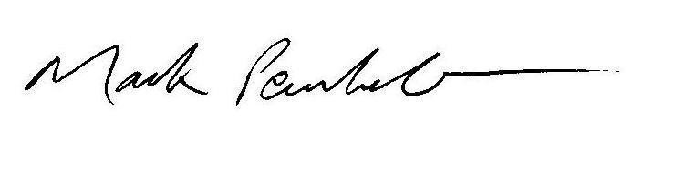
Mark Pemberton
Chief Executive of Association of British Orchestras
Representing over 175 organisations.

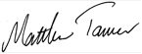
Matthew Tanner MBE
Chair of Association of Independent Museums
Representing 750 member charities.

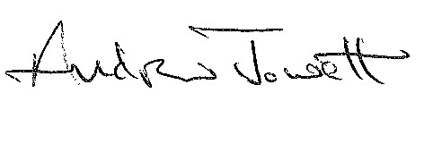
Andrew Jowett OBE
Chair of British Association of Concert Halls
Representing 31 members.

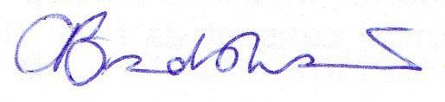
Caron Bradshaw
Chief Executive Officer of Charity Finance Group
Representing over 2,200 members.

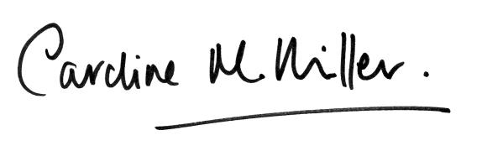
Caroline Miller
Director of Dance UK
Representing approximately 1,600 individual members and 200 company members consisting of theatres, dance companies and dance organisations.

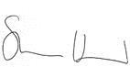
Sharon Heal
Director of Museums Association
Representing over 7,500 individual, institutional and corporate members.

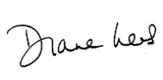
Diane Lees CBE
Chair, National Museum Directors’ Council
Representing 39 leaders of the UK’s national collections and major regional museums.

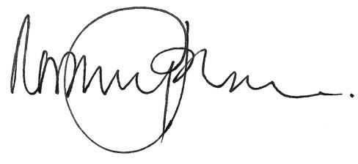
Rosemary Johnson
Executive Director of Royal Philharmonic Society

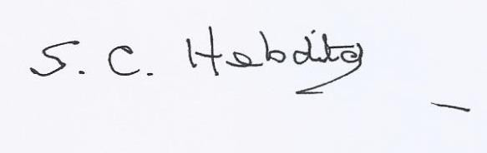
Simon Hebditch
Chair, Small Charities Coalition
Representing over 6,800 members.

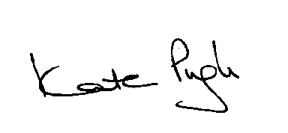
Kate Pugh OBE
Chief Executive of The Heritage Alliance
Representing 99 independent heritage organisations.

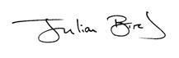
Julian Bird
Chief Executive of UK Theatre & Society of London Theatre
Society of London Theatre (SOLT) represents approximately 190 London-based producers, theatre owners and managers. UK Theatre represents approximately 270 theatres, concert halls, dance companies, producers and arts centres throughout the UK.

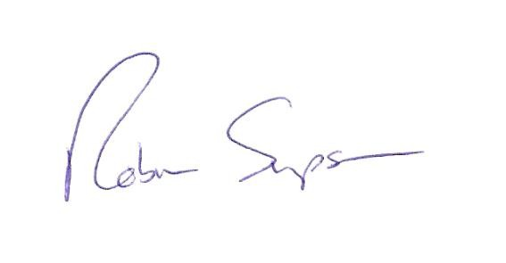
Robin Simpson
Chief Executive Officer of Voluntary Arts
Voluntary Arts provides a universal voice for approximately 63,000 voluntary arts groups across the
UK and Ireland.

Cc: The Rt Hon Sajid Javid MP, Secretary of State for Culture, Media and Sport

Contribution of the arts and culture industry to the national economy An update of our analysis of the macroeconomic contribution of the arts and culture industry to the national economy CEBR Report for Arts Council England

