Transforming Governance Case Studies

The following document provides a series of Case Studies for participants of the Transforming Governance Programme.

Governance and the Arts Council Investment Principles
This module provides an overview of the Arts Council England Investment Principles, looking at Ambition & Quality, Dynamism and Environmental Responsibility, and seeks to support boards to work with the Investment Principles as drivers of change.

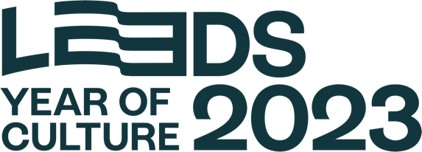
Leeds 2023
Leeds 2023 is an independent, not-for-profit Year of Culture supporting hundreds of creative and cultural events across the city and beyond, spotlighting the city as an exciting and vibrant cultural destination.

The charity recruited Neighbourhood Hosts in every ward in the city to co-create elements of the city’s year of culture. An anthropologist based at the Centre for Cultural Value is working with these hosts to ensure the programme’s evaluation is many-voiced and socially engaged.

In conversation with their community, in Summer 2023 Hosts worked together to imagine, shape and create events and activities in every ward of the city – the result was Year of Culture celebrations all across the city in each ward’s style.

“This is the main aim of My LEEDS 2023 – to give the stage to the people of Leeds and allow them to show off their creativity and culture. The Neighbourhood Hosts, as experts in their wards, are central to this ambition.”
Kully Thiarai, CEO and Creative Director

Leeds 2023’s strategic approach puts the needs of its key audience at its forefront, structuring its programme around the distinct local voices in each ward. This investment in and acknowledgement of local skills and knowledge creates a symbiosis between the organisation and its people, with a structural model that echoes its socially engaged mission.

More information here

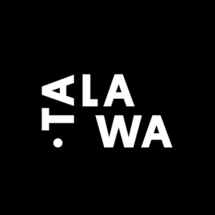
Talawa Theatre Company
Talawa Theatre Company used the Impact and Insight Toolkit to conduct three training-related evaluations, mainly assessing the ‘Contribution’, ‘Feedback’ and ‘Clarity’ metrics.

“Sharing and reflecting on the results of the surveys with the team really helped to make the process and value tangible. It was also for us the occasion to celebrate; it was a real feel-good moment to discover the comments and reflect on what the data told us.”
Melise Bicep, Development and Marketing Coordinator

Utilising the toolkit supported Talawa in overcoming the challenge of a previously-held perception that evaluation was little more than a box-ticking exercise, and allowed the team to take stock of its achievements.

Evaluation via the impact and insight toolkit is now embedded within Talawa’s artistic and business goals and has influenced subsequent business modelling including a fundraising strategy review and the construction of an evaluation strategy.

More information here

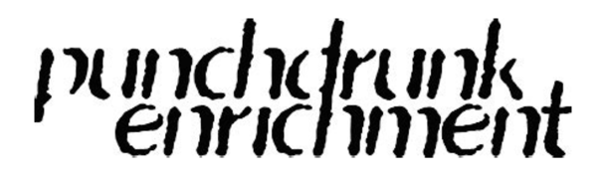
Punchdrunk Enrichment
Punchdrunk Enrichment is a charity that creates transformational theatre for education, community and family audiences. It credits the success of its recent school projects to its work with teachers.

The charity’s ongoing consultation with teachers allowed it to better understand the curriculum, ensure delivery was easily integrated into their workload, and ensure all teachers had the adequate resources and support.

“We began to explore how we could create projects that would reimagine and disrupt everyday school life and put teachers in the driving seat. This led to the creation of a new strand of work, our teacher-led programme.”
JoJo Tyhurst, Head of Communications

Since 2016, the teacher-led programme has been delivered in 114 primary schools and continues to make a big impact on pupils, encouraging reluctant writers to put pen to paper and boosting speaking and listening skills.

Understanding how to meaningfully empower teachers to deliver immersive learning projects has been widely beneficial for Punchdrunk – it also fed into its programme for families, particularly supporting work with parents and carers delivering digital projects at home.

“Listening to audiences and partners is an essential component in the development of our work, it can bring fresh perspectives and opportunities and ultimately makes our projects stronger.”
JoJo Tyhurst, Head of Communications

Punchdrunk’s journey in developing its teacher-led programme speaks to the Arts Council’s Investment Principle theme of Progression; and Collaboration and Refinement.

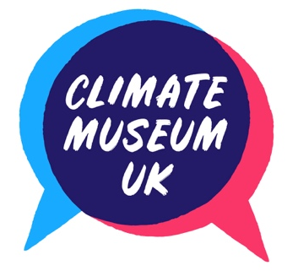
More information here

Climate Museum
Climate Museum UK, founded by Bridget McKenzie, is an experimental museum that curates and gathers responses to the Earth crisis, made up of a collective of creatives from across the country. It delivers events and resources for public and professional groups on various climate-led themes to build awareness and action on the Earth crisis.

Climate Museum UK has provided a lens through which arts, culture and heritage organisations can be active in the climate space, prioritising environmental learning as a key part of programmes and goal-setting. Climate Museum UK has defined eight pathways for cultural action on climate:

- Global Action: Collaboration for system change
- Design for Life: Biocentric innovation & imagination
- Transition: Resilient & localised economies
- Care: Cultural therapy and social aid
- Decolonise: Reparations and representation in culture & society
- Protect: Preparation & adaptation of infrastructure, heritage & places
- Footprint: Decarbonise and limit harm in your cultural practice
- Tell truths: Arts, Science and Engagement

Bridget also co-founded Culture Declares, a movement in which individuals and organisations in arts, culture and heritage can declare a climate and ecological emergency, joining a growing community that enables shared learning and action.

“There is a lot of positivity about Environmental Responsibility being a new principle, that it will ensure the funded sector considers its environmental impact and agency.”
Bridget McKenzie, Founder, Climate Museum

More information here

