Gender pay gap analysis
31 March 2022
Change from 2021 to 2022
Gender Pay Gap Analysis – March 2022
 |  |  | %
1. Mean gender pay gap - Ordinary pay |  |  | 6.8%
2. Median gender pay gap - Ordinary pay |  |  | 2.2%
3. Mean gender pay gap - Bonus pay in the 12 months ending 31 March |  |  | 10.6%
4. Median gender pay gap - Bonus pay in the 12 months ending 31 March |  |  | 0.0%
5. The proportion of male and female employees paid a bonus in the 12 months ending 31 March |  | Male | 76.5%
 |  | Female | 73.3%
6. Proportion of male and female employees in each quartile:
Quartile | Female % | Male %
First (lower) quartile | 62.3% | 37.7%
Second quartile | 69.4% | 30.6%
Third quartile | 68.8% | 31.3%
Fourth (upper) quartile | 71.1% | 28.9%
 | %
Mean | -1.6%
Median | 1.0%
Bonus - Mean | 1.4%
Bonus - Median | 0.0%
% Bonus - M | -15.8%
% Bonus - F | -17.3%
Quartile | %
First quartile | -7.7%
Second quartile | 2.0%
Third quartile | -3.9%
Fourth quartile | 11.7%

Our median pay gap has increased slightly from 2021, when it was 1.2%. This nevertheless reflects well on the organisation’s pay policy of ensuring that salaries for individual roles are generally kept on a par with one another.

The change in the mean pay gap from 8.4% in 2021 to 6.8% in 2022 is an improvement and reflects the return to our established staffing structure, which had been increased in 2020/21 to support the additional Culture Recovery Fund and Emergency Response Fund programmes.

The bonus is only paid as £250 as a flat rate (hence the median being zero). However, the gender gap in the mean bonus reflects the fact that we do not pay this (only £250 as a flat rate) to staff on probation (in their first six months of service) reflects the large number of new employees who were female in 2022.

As a comparator, the Civil Service median pay gap in 2022 is 11.3% (Arts Council England’s is 2.2%) and its mean pay gap is 8.5% (Arts Council England’s is 6.8%).

In comparison to our pay gap analysis in 2021, it can be seen that there has been significant positive improvement in the % of men and women in the 4th (upper) quartile. In 2021, 40.7% of this quartile were men and 59.3% were women, whereas in 2022 this improved to 28.9% men and 71.1% women, which is almost exactly proportionate to the ratio of men and women in the whole organisation.
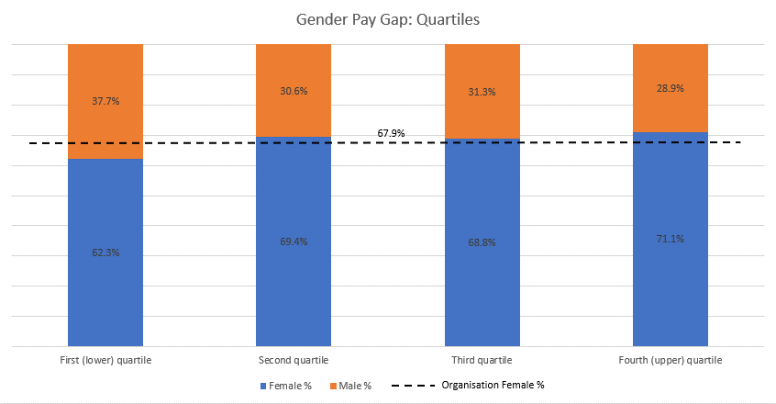

Ethnicity Pay Gap Analysis
31 March 2022
Ethnicity Pay Gap Analysis – March 2022
Change from 2021 to 2022
 |  |  | %
1. Mean ethnicity pay gap - Ordinary pay |  |  | -4.0%
2. Median ethnicity pay gap - Ordinary pay |  |  | -5.6%
3. Mean ethnicity pay gap - Bonus pay in the 12 months ending 31 March |  |  | 16.4%
4. Median ethnicity pay gap - Bonus pay in the 12 months ending 31 March |  |  | 0.0%
5. The proportion of Non BME and BME employees paid a bonus in the 12 months ending 31 March |  | Non BME | 76.3%
 |  | BME | 63.5%
6. Proportion of Non BME and BME employees in each quartile:
Quartile | BME % | Non BME %
First (lower) quartile | 11.3% | 88.8%
Second quartile | 6.3% | 93.8%
Third quartile | 16.1% | 83.9%
Fourth (upper) quartile | 22.4% | 77.6%
 | %
Mean | -3.3%
Median | -1.4%
Bonus - Mean | -1.1%
Bonus - Median | 0.0%
% Bonus - Non BME | -17.7%
% Bonus - BME | -14.9%
Quartile | %
First quartile | -5.9%
Second quartile | -4.0%
Third quartile | -1.0%
Fourth quartile | 6.6%

We should note at the outset that, as there is no statutory requirement to report an ethnicity pay gap then there is no statutory guidance on how to construct the dataset. Here, we have used the same principles of pay calculation used in the gender pay figures and applied them to two separate staff groups of i) white British or European origin and, ii) Black, Asian, and ethnically diverse colleagues.

Both the mean and median pay gaps are negative – meaning that the average pay for those in group (ii) exceeds that for group (i). This is a very positive figure and reflects our commitment to equality and diversity.

Black, Asian and ethnically diverse staff constitute a proportionally smaller group than those in the gender pay analysis (ie male and female) and so this figure is likely to be more volatile year to year, as it can be affected by small changes in headcount.

The bonus is only paid as £250 as a flat rate (hence the median being zero). However, the gender gap in the mean bonus reflects the fact that we do not pay this (only £250 as a flat rate) to staff on probation (in their first six months of service) and reflects the large number of new employees who were Black, Asian and ethnically diverse in 2022.

As a comparator, the Civil Service median ethnicity pay gap is 22.6% (Arts Council England’s is -4.0%) and its mean ethnicity pay gap is 31.3% (Arts Council England’s is -5.6%).

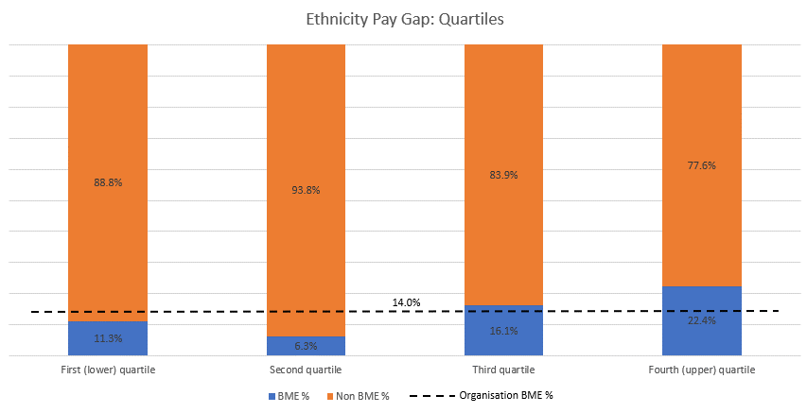

In summary, it can be seen that Arts Council England performs more favourably than the Civil Service in both gender and ethnicity pay gaps. These are important comparators as Arts Council England is bound by the Civil Service pay structure and pay remits.

https://www.gov.uk/government/statistics/civil-service-statistics-2022/statistical-bulletin-civil-service-statistics-2022#gender-pay-gap
https://www.gov.uk/government/publications/mhra-ethnicity-pay-gap-report/ethnicity-pay-gap-report-april-2021-to-march-2022

