Arts Council Emergency Response Fund: For organisations outside the National Portfolio

Application Questions

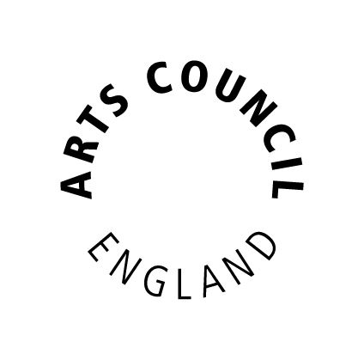

Please read this first

This document gives applicants the questions they need to answer to apply for the above fund. Applicants should use this document for drafting their application.

If you wish to submit an application, you will need to do this using Arts Council England’s online grant system, Grantium. We will not accept this document as an application form.

This document does not automatically count how many characters or words you have entered. You can use www.charactercountonline.com to check if each of your answers is within the character limit for that question.

Version 2 – now including Expenditure table

Section: Financial Background

What was your organisation’s turnover in the last full financial year? (£) If you are a new organisation, please estimate your income for the first year.

Please tell us about your reserves position, including restricted and unrestricted reserves:
(Up to 1,000 characters)

Section: Your Work

Tell us about the losses your organisation has incurred due to the Covid-19 emergency. (we might contact you to ask for evidence of this at a later date).
(Up to 1,800 characters, approximately 300 words)

Tell us about your organisation’s work and its track record working in the publicly funded arts and culture sector.
(Up to 1,800 characters, approximately 300 words)

Tell us what difference an emergency grant from this fund would make to your organisation, and how you might use the funding within the next six months.
Please also detail here any other emergency funding that you are reasonably expecting to receive from other sources.
(Up to 1,800 characters, approximately 300 words)

Up to a further 1,000 characters if needed)

How will any funding you receive now help you to contribute to delivering our new Strategy for 2020-2030: Let's Create, in the future?
(Up to 1,800 characters, approximately 300 words)
You should only answer this question if you are applying for funds for the development and delivery of activity specifically designed to be deliverable during the next six months:

How will any immediate activity you are planning (including delivery or organisational development), help your organisation contribute to delivering our new Strategy for 2020-2030: Let's Create?
(Up to 1,800 characters, approximately 300 words)

Section: Attachment

You will need to submit a cashflow with your application. By cashflow we mean a document showing the flow of income and expenditure over the next six months. You should include any other income and expenditure you have.

The document can be up to 10MB and we accept PDF,
MS Word, MS Excel, MS PowerPoint and JPEG files.

Section: Amount Requested

Tell us the total amount you are requesting from us: (£):

Do you, or does your organisation object to receiving National Lottery funding for religious reasons?
Yes

No

Please enter all your cash expenditure. Your cash expenditure should equal the total amount you are applying for from Arts Council England.

You should break you expenditure down into one of the following two headings: Either Emergency costs or Activity costs.

Expenditure Heading: Emergency costs or Activity costs:

Description:
Amount (£):

Expenditure Heading: Emergency costs or Activity costs:

Description:
Amount (£):

Expenditure Heading: Emergency costs or Activity costs:

Description:
Amount (£):

Expenditure Heading: Emergency costs or Activity costs:

Description:
Amount (£):

Expenditure Heading: Emergency costs or Activity costs:

Description:
Amount (£):

Expenditure Heading: Emergency costs or Activity costs:

Description:
Amount (£):

Expenditure Heading: Emergency costs or Activity costs:

Description:
Amount (£):

End of Questions
Transcribed into Large Print by: A2i Transcription Services
Unit 4 Montpelier Central, Station Road, Bristol BS6 5EE
01179 44 00 44 info@a2i.co.uk www.a2i.co.uk

We welcome feedback so please get in touch!
Ref number: 32443

