Arts Council England Emergency Response Fund: For National Portfolio Organisations and Creative People and Places lead organisations

Application Questions
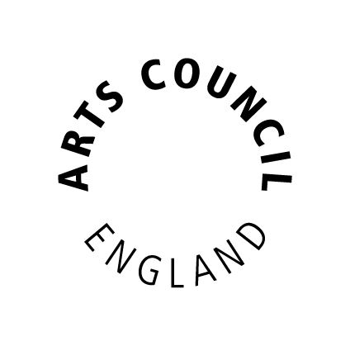

Please read this first

This document gives applicants the questions they need to answer to apply for the above fund. Applicants can use this document for drafting their application.

Before starting to complete your application, you should read the Guidance for applicants carefully. (https://www.artscouncil.org.uk/funding/financial-support-npos-and-lead-cpp-organisations)

If you wish to submit an application, you will need to do this using Arts Council England’s online grant system, Grantium. We will not accept this document as an application form.
(https://www.artscouncil.org.uk/welcome-grantium)

This document does not automatically count how many characters or words you have entered. You can use www.charactercountonline.com to check if each of your answers is within the character limit for that question.

Section: Financial Viability

Tell us about your organisation’s actual and planned income and expenditure from 1 March 2020 to 30 September 2020, how it is essential for your organisation’s survival and how it meets the aims of the emergency fund.
(Up to 1,800 characters, approximately 300 words)

Tell us how your organisation is making use of its free reserves and/or investments to sustain the organisation to 30 September 2020. Please explain any decision your organisation’s board may have made not to make full use of the organisation’s reserves and/or investments.
(Up to 1,800 characters, approximately 300 words)

Note: I confirm that the cash flow forecast provided in support of this application includes all our organisation’s available cash resources and that no other cash is held by our organisation.
Tick box

Section: Making the Case

Confirm that your organisation has exhausted all available government schemes and reliefs (including the Coronavirus Job Retention Scheme), alternative income sources (including using reserves and converting ticket sales to donations) and has undertaken all appropriate cost-cutting measures. You should provide detail on actions taken by your organisation to date.
(Up to 1,800 characters, approximately 300 words)

To the best of your knowledge, tell us how your organisation has been and will be impacted by the Covid-19 pandemic to 30 September 2020. This includes:
- identifying any losses your organisation has incurred and will likely incur to 30 September, making clear how this is as a direct result of the Covid-19 pandemic
- identifying any reductions in activity that have been and will be made to 30 September as a result of the Covid-19 pandemic
- how NPO and other funding is being used and/or repurposed, and where this funding isn’t sufficient to support activity
(Up to 1,800 characters, approximately 300 words)

(Up to a further 1,800 characters, if needed)

Tell us how a grant would help to sustain your organisation to 30 September 2020, including how your organisation would use the funding during the period to 30 September 2020.
(Up to 1,800 characters, approximately 300 words)

Tell us what difference an emergency grant from this fund would make to your ability to sustain your organisation beyond 30 September 2020.
(Up to 1,800 characters, approximately 300 words)

Tell us how an emergency grant from this fund would help you to contribute to sustaining and supporting the arts and culture sector beyond 30 September 2020.
(Up to 1,800 characters, approximately 300 words)

Section: Attachments

You must provide a budget and cash flow forecast, format as detailed below, in support of your application.

The attached budget/schedule of activity must:

- include actual income and expenditure for the period from 1 March 2020 to 30 May 2020
- include all budgeted/projected income and expenditure for the period 1 May 2020 to 30 September 2020
- include prior year actuals to show comparisons
- be provided as an Excel document (on a single tab)

The attached cash flow forecast must:

- include an opening balance
- include closing cash balances for each month and include all cash transactions, income and expenditure, for the period to at least 30 September 2020
- be provided as an Excel document (on a single tab)
- include all cash available to the organisation. Where cash is restricted, organisations should make this clear by separating restricted and unrestricted cash transactions and cash balances in the cash flow forecast

The limit on file size is 10 megabytes.

Section: Amount Requested

Tell us the total amount you are requesting from us: (£):

Do you, or does your organisation object to receiving National Lottery funding for religious reasons?
Yes

No

End of Questions
Transcribed into Large Print by: A2i Transcription Services
Unit 4 Montpelier Central, Station Road, Bristol BS6 5EE
01179 44 00 44 info@a2i.co.uk www.a2i.co.uk

We welcome feedback so please get in touch!
Ref number: 32443

